**Data warehousing**

**Assignment 1**

**Submitted to TA\ Alaa Adel**

|  |  |
| --- | --- |
| **Name** | **ID** |
| **Abdallah Saleh** | **20200302** |
| **Abdallah Mahmoud** | **20200307** |
| **Abdeltwab Mohamed** | **20200274** |
| **Nagi mohamed** | **20200580** |
| **Nour eldeen mahmoud okbi** | **20200608** |

* Dataset URL : <https://drive.google.com/file/d/10Ikpr_T8wgcFru-WgUABaAecq3VYjvKY/view?usp=share_link>
* ERD for the database :

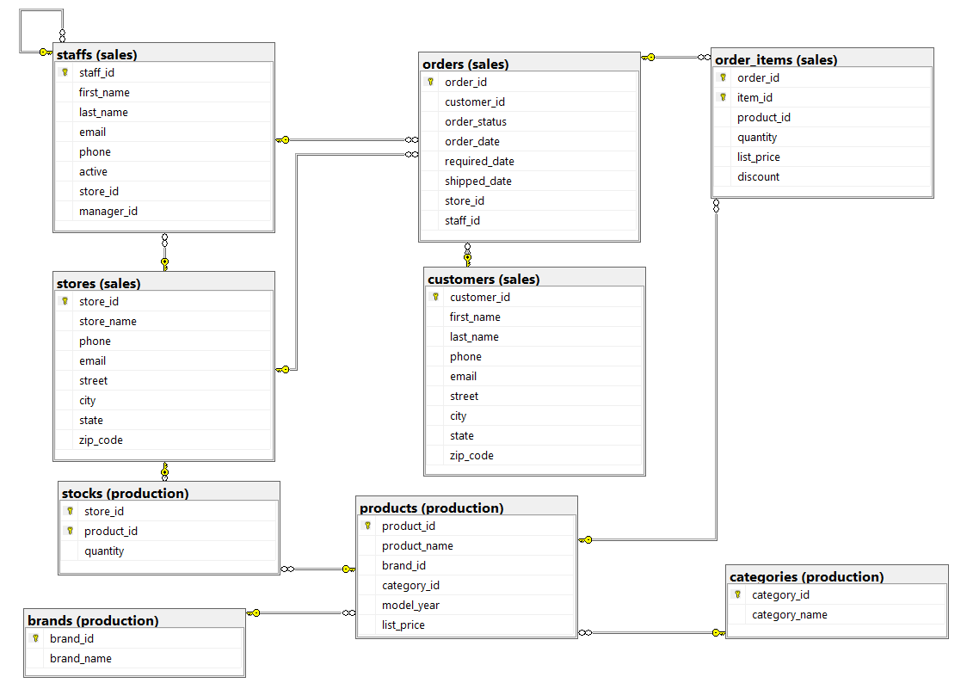

**Dimensional model.**

* **The business processes that we will model:**
  + Analyzing sales data to gain insights into product performance, store performance, and customer segments.
  + Managing inventory levels and stock movements across multiple stores.
  + Segmenting customers based on demographics, purchase history, and other factors to improve marketing and sales efforts.
  + Tracking employee performance to identify training needs and improve workforce management practices.
  + Creating reports and dashboards to gain insights into revenue, expenses, and profitability.
* **Example statements for the DW model:**
* Sales of a certain brand from each store last month.  
  Number of orders that every staff has done last week.
* Number of customers who bought a certain brand from all stores last year.
* Number of different categories that we have had it in our Stocks last year.
* The number of orders that are requested from each customer through each staff in each store on daily base .
* **Define the dimensions.**
* Time Dim : Includes information about the date of the sale such as day, month, year.
* Staffs Dim : Includes information about the order date , first Name, last name , phone, email, and statues.
* Store Dim: Includes information about store name ,phone , email, city, street, state, and ZIP Code.
* Customer Dim: Includes information about first Name, last name , phone, email, city, street, and state.
* Order Dim: Includes information about customer who take order and order status ,order date,required date ,shipped date , store id, staff id
* Product Dim: Includes information about product name, brand id ,category id , model year ,list price
* **Define the measures that will appear in the fact tables.**
* Orders Fact Table
* Order Num: the number of orders that are requested.
* Customers_brands Fact table:
* Customer num: number of customers who bought a certain brand from all stores last year.
* Staff Orders Fact table:
* Staff orders num: Number of orders that every staff has done last week.

