Menoufia National University | Kilo 70 Cairo-Alexandria Agricultural Road, Menoufia Governorate

Library Management System DataBase (DB)

Team Members:

1. Abdallah Waleed Kamal Mousa ID: 20230192
2. Saif Sameh Fathy Elsawy ID: 20230142
3. Abdelrahman Fathy Elbahrawey ID: 20230176
4. Abdelrahman ALi Ghonemi Ayad ID: 20230174
5. Marco Wael EBrahim ID: 20230250

2025

* **Create Book Table:**

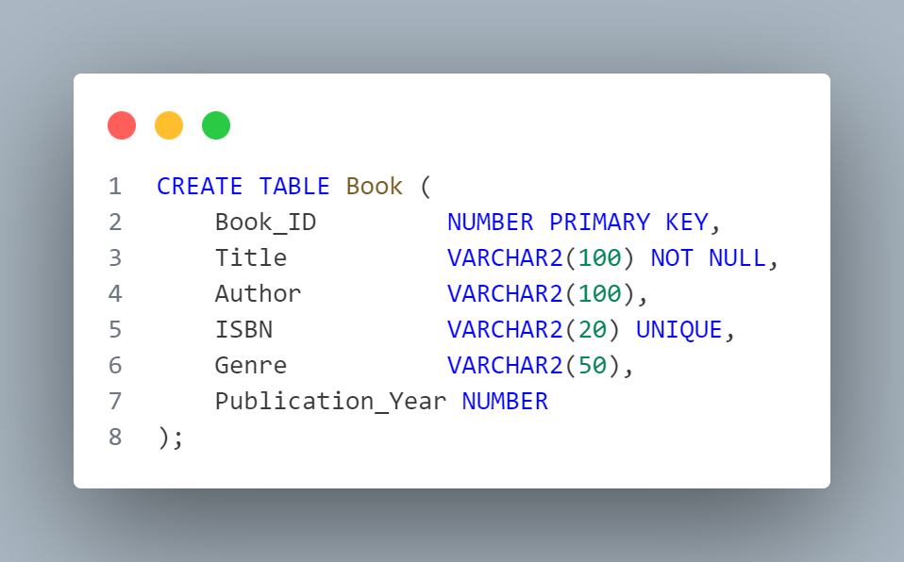

* **Output:**

**Book Table is Successfully Created**

* **Create Member Table:**

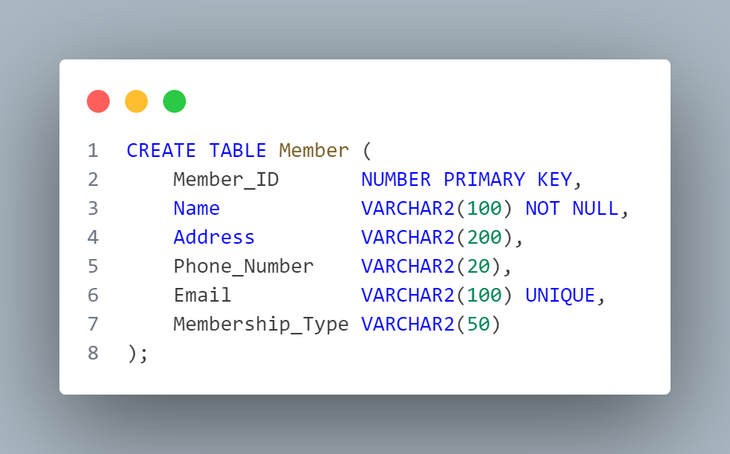

* **Output:**

**Member Table is Successfully Created**

* **Create Librarian Table:**

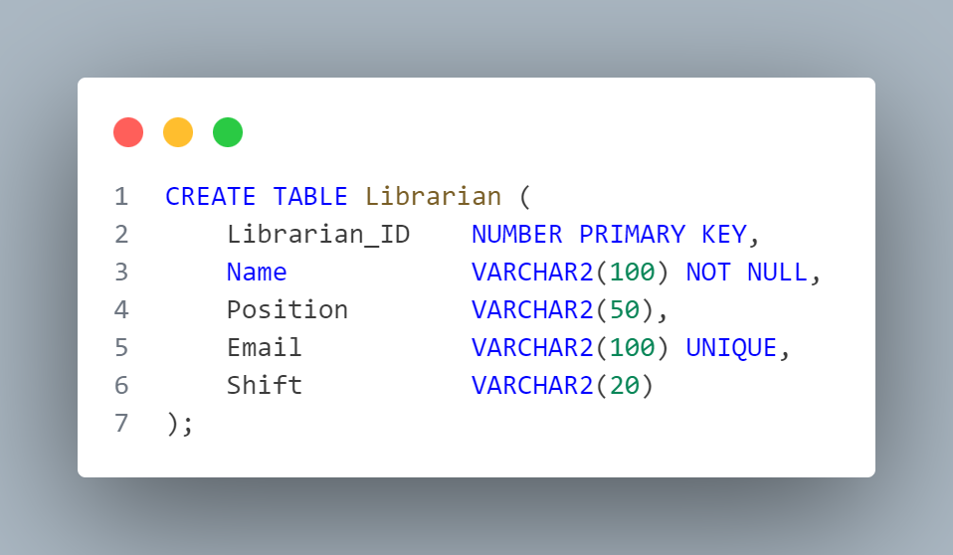

* **Output:**

**Librarian Table is Successfully Created**

* **Create Transaction Table:**

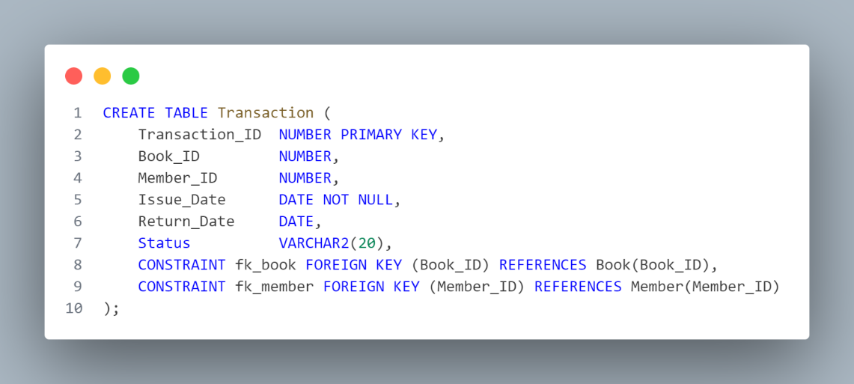

* **Output:**

**Transaction Table is Successfully Created**

* **INSERT INTO Book Statements and Output:**

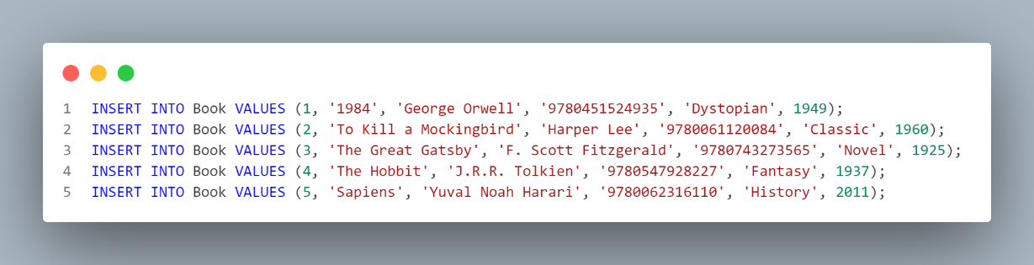

* **Output:**

|  |  |  |  |  |  |
| --- | --- | --- | --- | --- | --- |
| **Book_ID** | **Title** | **Author** | **ISBN** | **Genre** | **Publication_Year** |
| 1 | 1984 | George Orwell | 9780451524935 | Dystopian | 1949 |
| 2 | To Kill a Mockingbird | Harper Lee | 9780061120084 | Classic | 1960 |
| 3 | The Great Gatsby | F. Scott Fitzgerald | 9780743273565 | Novel | 1925 |
| 4 | The Hobbit | J.R.R. Tolkien | 9780547928227 | Fantasy | 1937 |
| 5 | Sapiens | Yuval Noah Harari | 9780062316110 | History | 2011 |

* **INSERT INTO Member Statements and Output:**

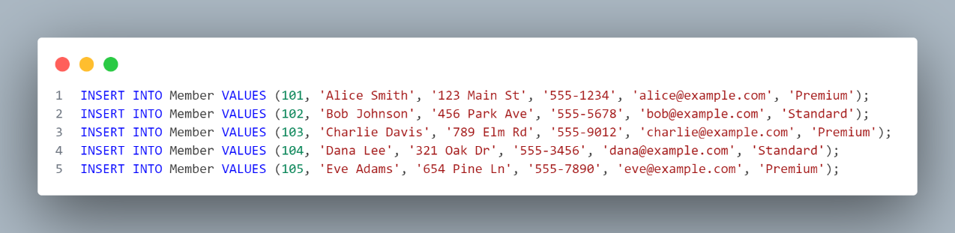

* **Output:**

|  |  |  |  |  |  |
| --- | --- | --- | --- | --- | --- |
| **Member_ID** | **Name** | **Address** | **Phone_Number** | **Email** | **Membership_Type** |
| 101 | Alice Smith | 123 Main St | 555-1234 | alice@example.com | Premium |
| 102 | Bob Johnson | 456 Park Ave | 555-5678 | bob@example.com | Standard |
| 103 | Charlie Davis | 789 Elm Rd | 555-9012 | |  | | --- | |  |  |  | | --- | | charlie@example.com | | Premium |
| 104 | Dana Lee | 321 Oak Dr | |  | | --- | |  |  |  | | --- | | 555-3456 | | dana@example.com | Standard |
| 105 | Eve Adams | |  | | --- | |  |  |  | | --- | | 654 Pine Ln | | 555-7890 | eve@example.com | |  | | --- | |  |  |  | | --- | | Premium | |

* **INSERT INTO Librarian Statements and Output:**

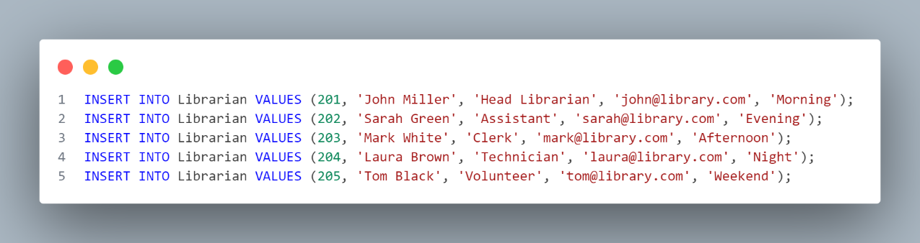

* **Output:**

|  |  |  |  |  |
| --- | --- | --- | --- | --- |
| **Librarian_ID** | **Name** | **Position** | **Email** | **Shift** |
| 201 | John Miller | Head Librarian | john@library.com | Morning |
| 202 | Sarah Green | |  | | --- | |  |  |  | | --- | | Assistant | | sarah@library.com | Evening |
| 203 | |  | | --- | |  |  |  | | --- | | Mark White | | Clerk | mark@library.com | Afternoon |
| 204 | Laura Brown | Technician | laura@library.com | Night |
| 205 | Tom Black | Volunteer | tom@library.com | Weekend |

* **INSERT INTO Transaction Statements and Output:**

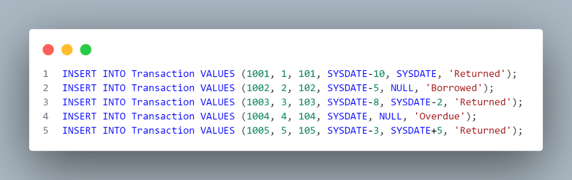

* **Output:**

|  |  |  |  |  |  |  |  |
| --- | --- | --- | --- | --- | --- | --- | --- |
| **Transaction_ID** | **Book_ID** | **Member_ID** | **Issue_Date** | |  | | --- | |  |  |  | | --- | | **Return_Date** | | **Status** |
| 1001 | 1 | 101 | 2025-04-01 | 2025-04-10 | Returned |
| 1002 | 2 | 102 | 2025-04-05 | NULL | Borrowed |
| 1003 | 3 | 103 | 2025-04-02 | 2025-04-12 | Returned |
| 1004 | 4 | 104 | 2025-04-10 | NULL | Overdue |
| 1005 | 5 | 105 | 025-04-07 | 2025-04-15 | Returned |

* **1. WHERE Clause + INNER JOIN:**

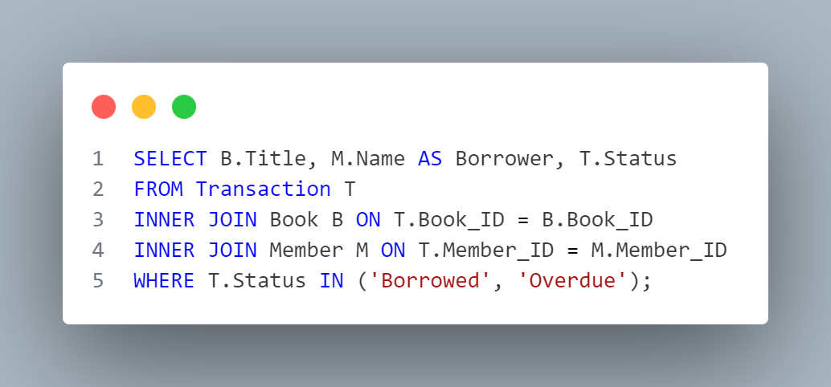

* **Output:**

|  |  |  |
| --- | --- | --- |
| **Title** | **Borrower** | **Status** |
| To Kill a Mockingbird | Bob Johnson | Borrowed |
| The Hobbit | Dana Lee | Overdue |
| 1984 | Alice Smith | Borrowed |

* **2. GROUP BY + HAVING:**

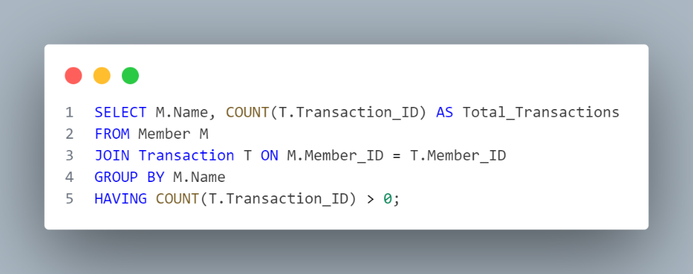

* **Output:**

|  |  |
| --- | --- |
| **Name** | **Total_Transactions** |
| Charlie Davis | 1 |
| Dana Lee | 1 |
| Eve Adams | 1 |
| Alice Smith | 2 |
| Bob Johnson | 1 |

* **3. INNER JOIN + Multiple Columns:**

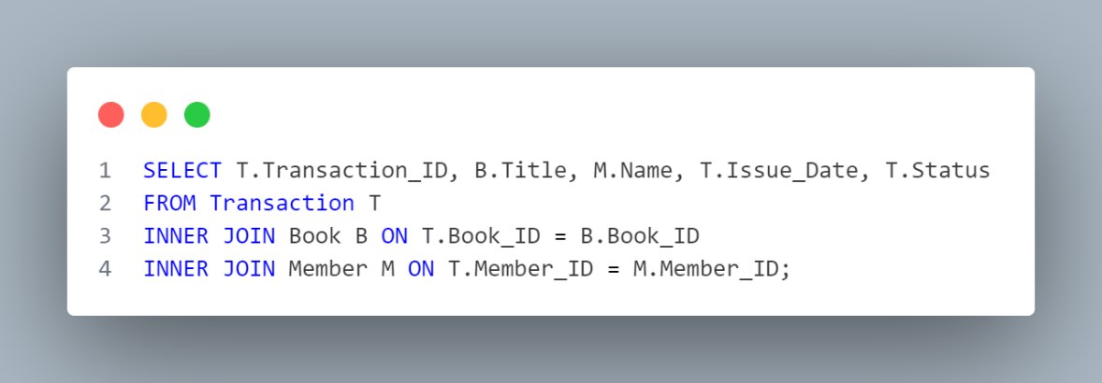

* **Output:**

|  |  |  |  |  |
| --- | --- | --- | --- | --- |
| **Transaction_ID** | **Title** | **Name** | **Issue_Date** | **Status** |
| 1001 | 1984 | Alice Smith | 27-APR-25 | Returned |
| 1006 | 1984 | Alice Smith | 07-MAY-25 | Borrowed |
| 1002 | To Kill a Mockingbird | Bob Johnson | 02-MAY-25 | Borrowed |
| 1003 | The Great Gatsby | Charlie Davis | 29-APR-25 | Returned |
| 1004 | The Hobbit | Dana Lee | 07-MAY-25 | Overdue |
| 1005 | Sapiens | Eve Adams | 04-MAY-25 | Returned |

* **4. LEFT JOIN + WHERE Clause:**

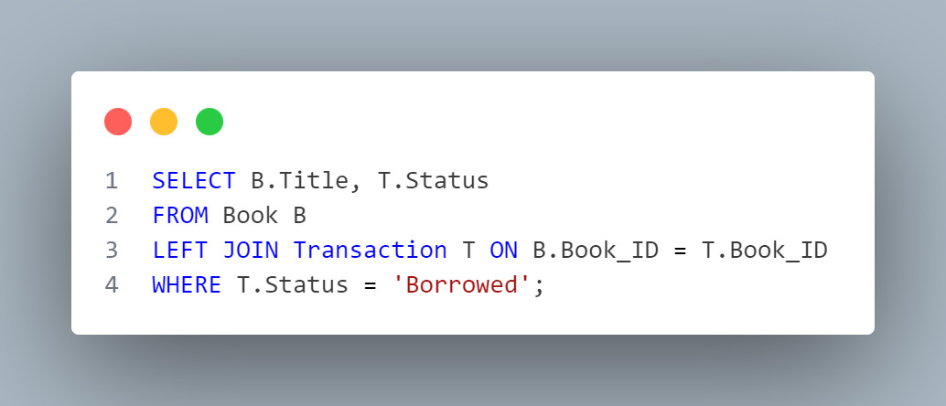

* **Output:**

|  |  |
| --- | --- |
| **Title** | **STATUS** |
| To Kill a Mockingbird | Borrowed |
| 1984 | Borrowed |

* **5. Subquery:**

**Query:** List members who borrowed books written by *George Orwell*.

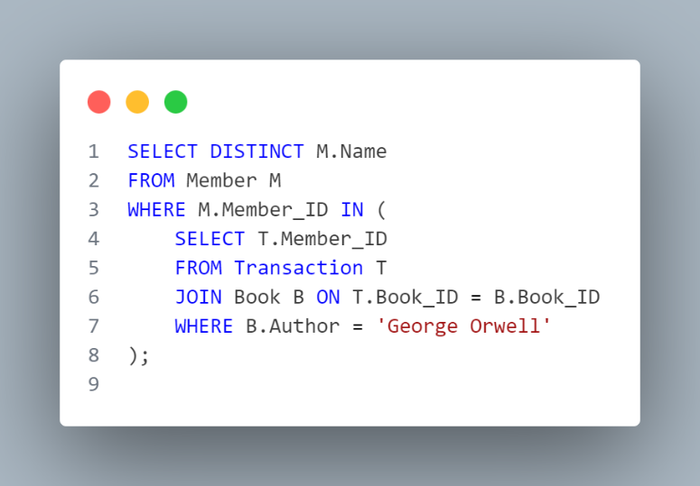

* **Output:**

|  |
| --- |
| **Name** |
| Alice Smith |

* **Advanced SQL (self-study)**:
* **Sequence:**

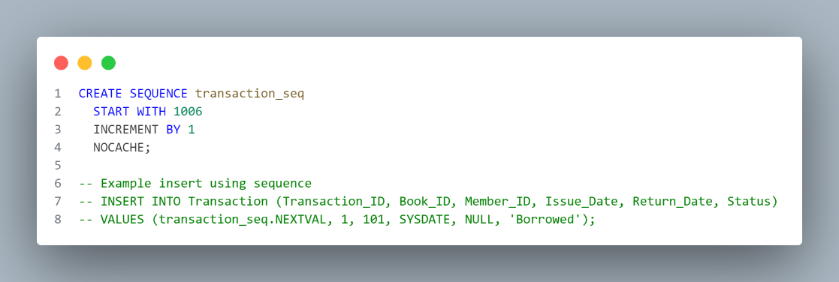

**ERD**

