**HTML Syntax, Element Paragraph, Headings**

**Duration 4h (Totally 10 )**

This task will cover text formatting such as:( italic, bold, del, mark, del)

## Basic

## 1. As on the beginning of coding We need to create html page call “hello_world” and contains the following:

## Page title should be Hello world.

## Add favicon to webpage.

## Add language meta tag.

## Add viewport meta tag.

## Add keywords meta tag contain (HTML, CSS, JS, Coding Academy, Orange)

## 

## 

## 

## 

## 2. Create the following:

## 1. Create html page and change the title to “Orange Academy”

2. Add your name

3. Add your major

4. Add horizontal line

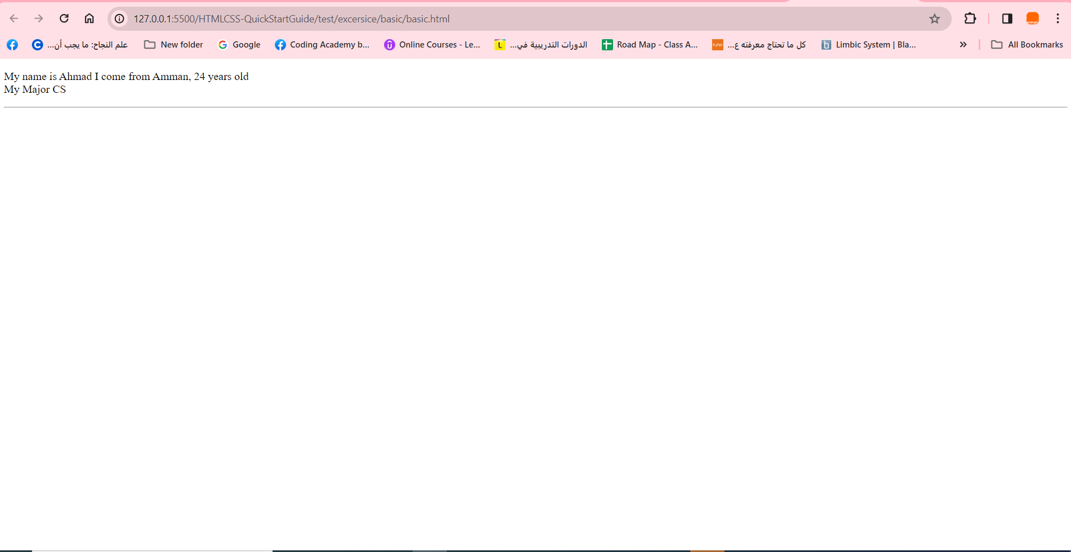

**3.Create webpage contain heading:**

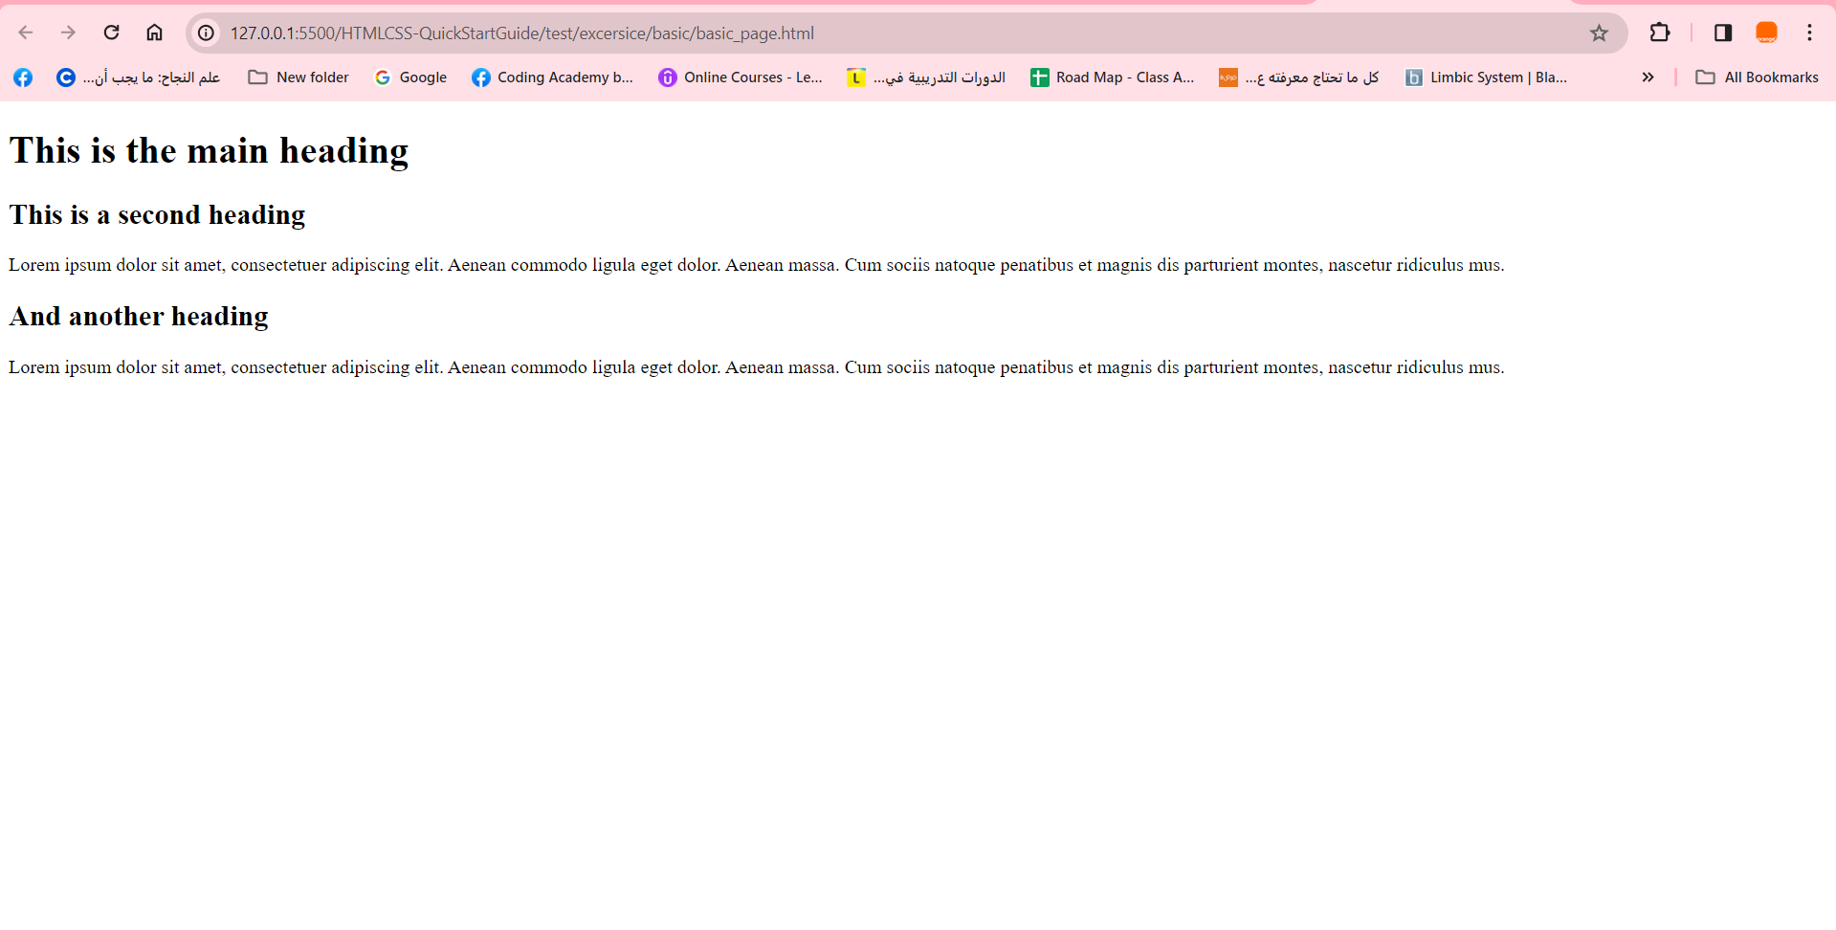

**4.Create the following webpage contain Heading:**

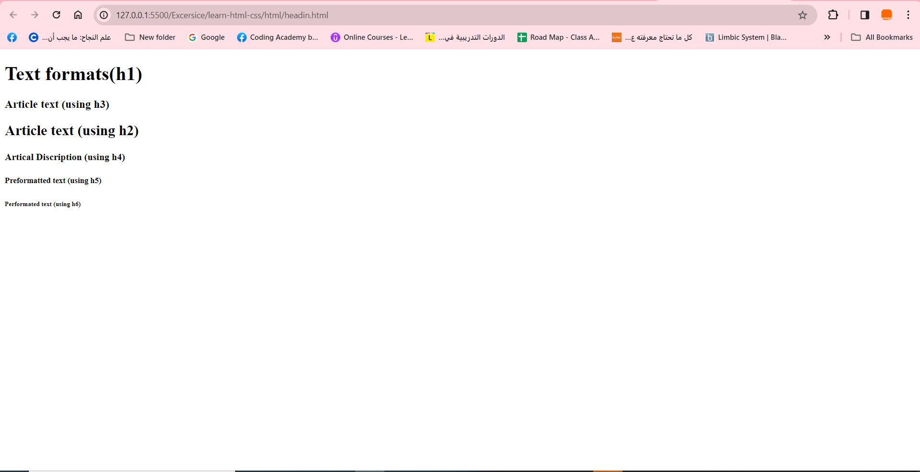

**5. Add paragraph contains the following:**

1. Title must be <h1>
2. When hover on “Coding Academy” must show abbreviation contain “Orange”.
3. Add mark to paragraph.
4. Add quotation “Train and Empower Youth to enhance their opportunities in the digital sector in Jordan”.
5. Add comment for the code contain “I’m build webpage structure”.

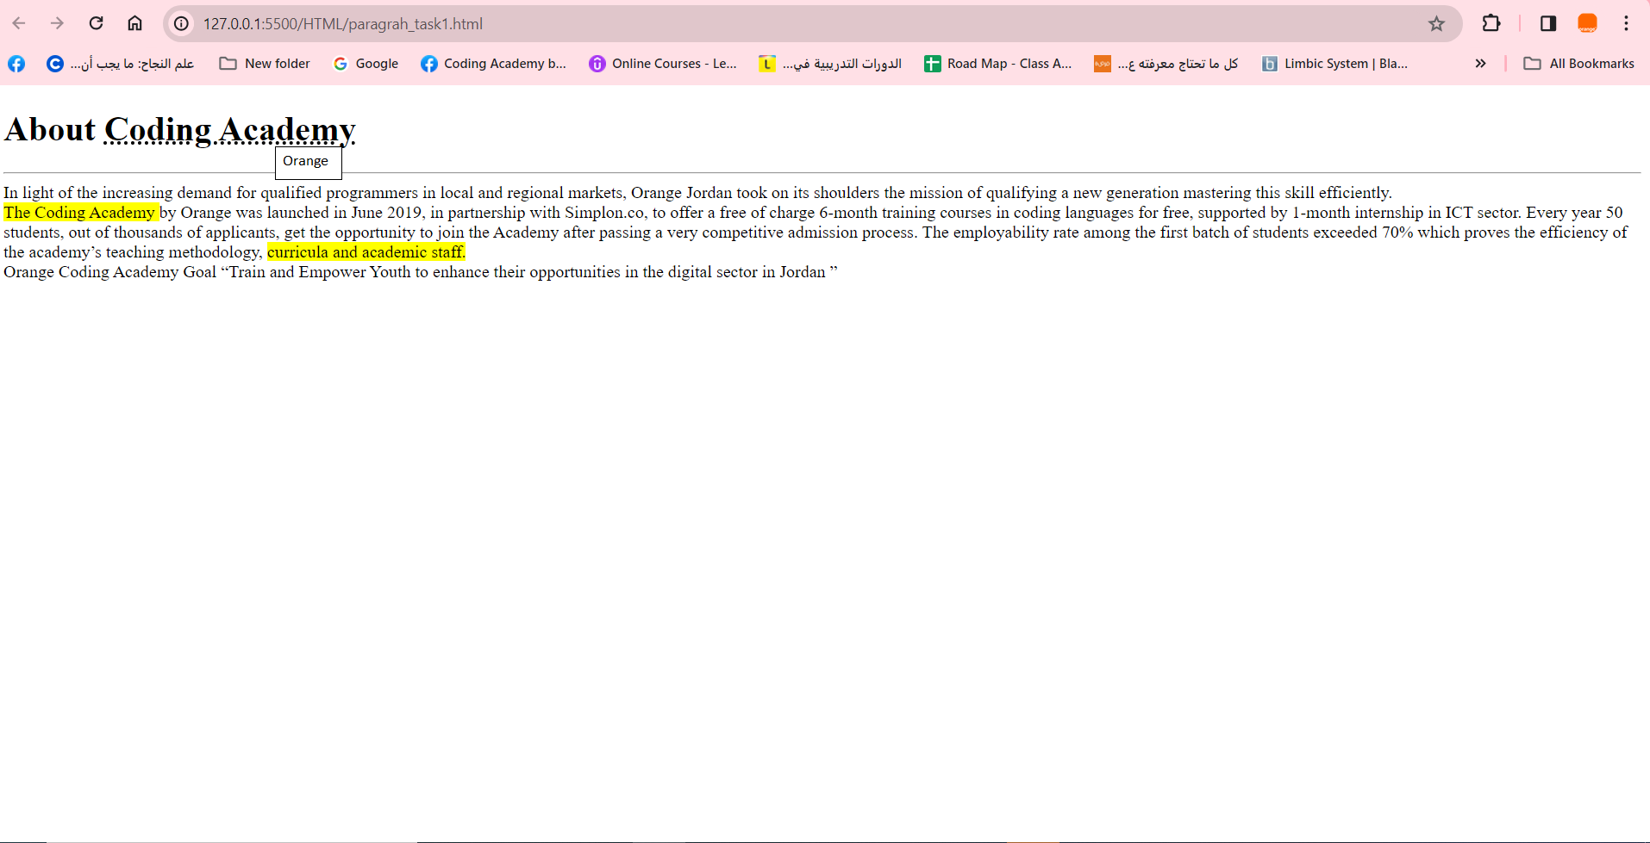

**Intermediate**

**6. Create webpage contain (italic, bold, del, mark, del) formatting:**

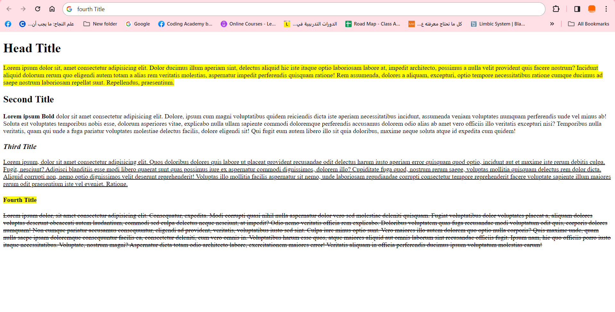

**7.Create webpage contain the following**

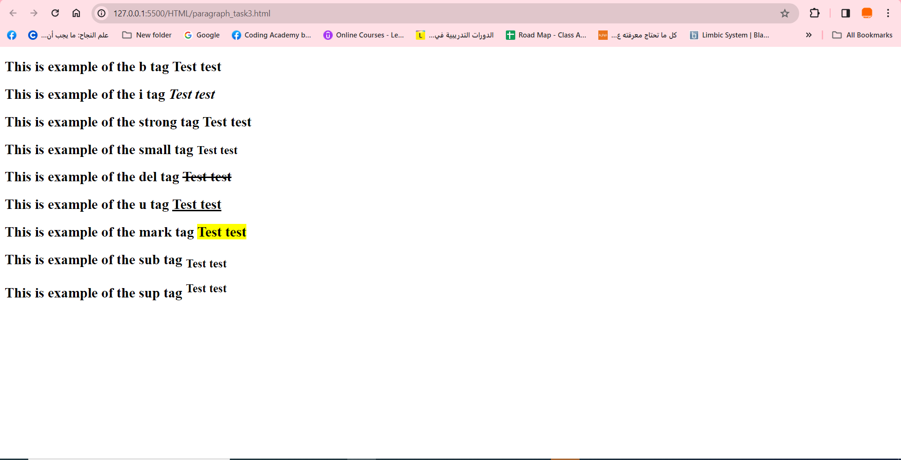

**8.Webpage contain sup**

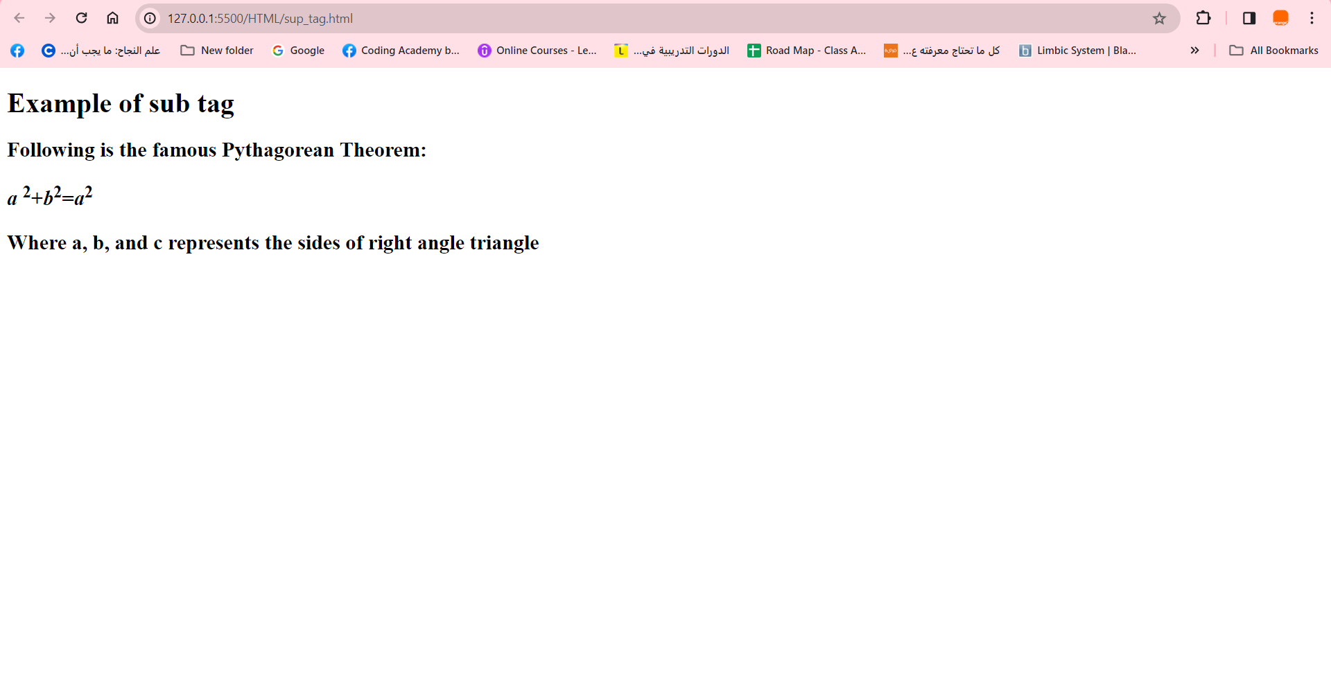

**9. Webpage contain sub**

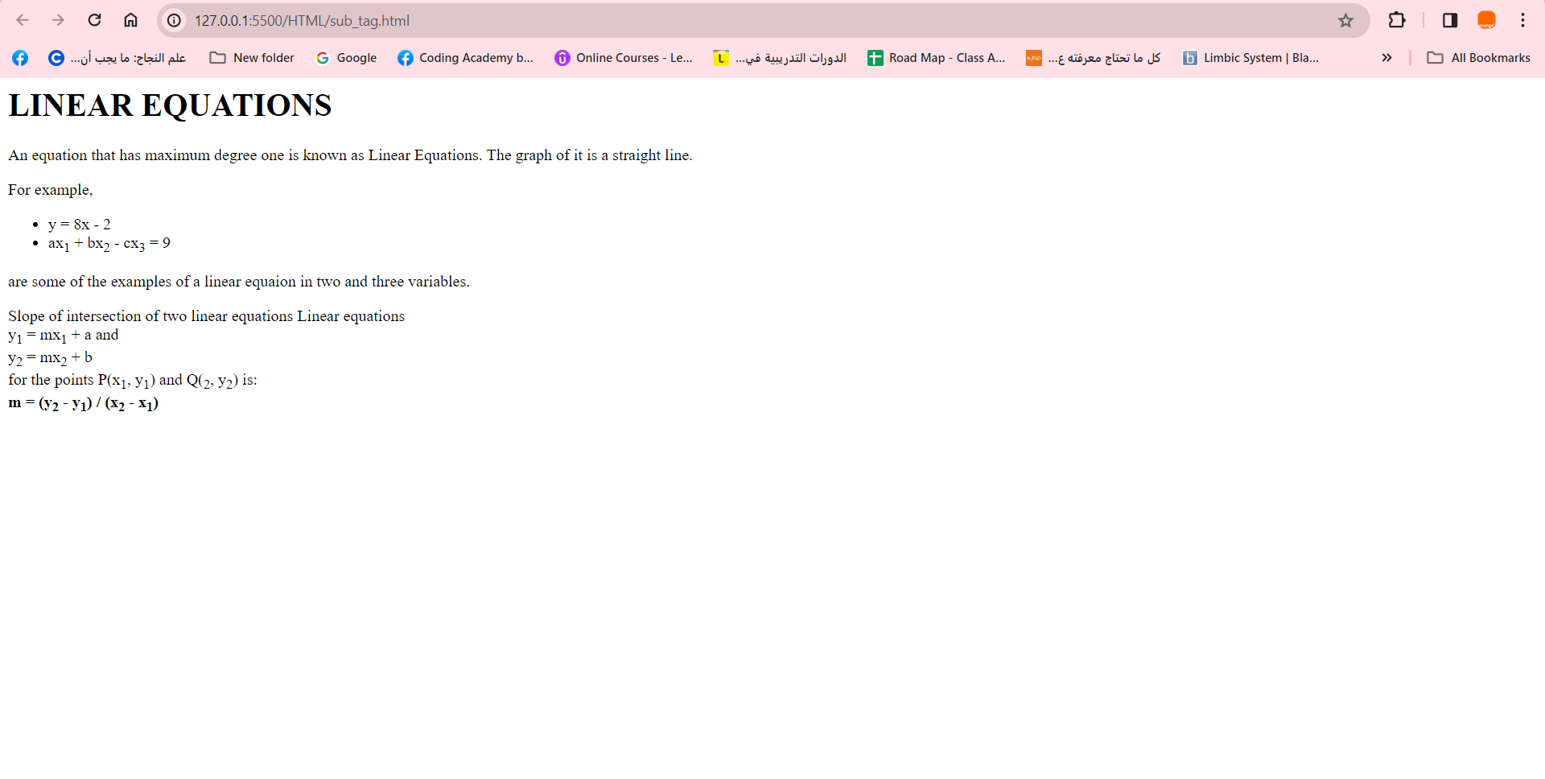

**Advance**

**10. Create the following webpage**

