**HTML Elements ( Links, Image)**

**Duration 4h (Totally 8)**

**Basic**

**1. Create web page contain with the following**

Create a link to the [google.com](https://www.google.com/) and  
\**On click of the link it should open it in a new page*

**2. Create webpage contain:**

1. **The title contain link hyper link for “https://www.codecademy.com/catalog/language/html-css”**
2. **Title should be h1**
3. **Paragraph 1 should be h2**
4. **Title 2 should be h2**
5. **Html on second title should connect to “https://www.w3schools.com/html/default.asp”**
6. **Paragraph 1 should be h4**
7. **CSS on second paragraph should connect to “https://www.w3schools.com/css/”**
8. **Add the require text formatting**

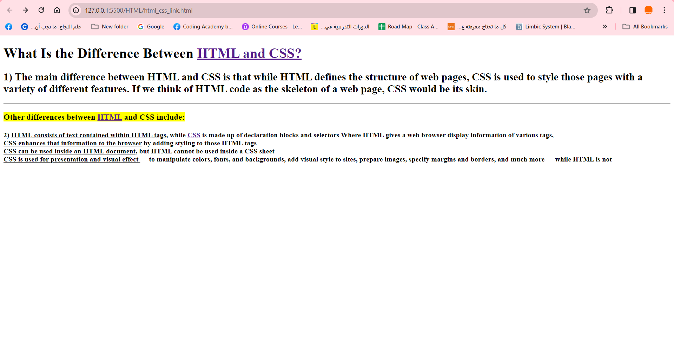

**3.Create the following web page contain (image, Link, p):**

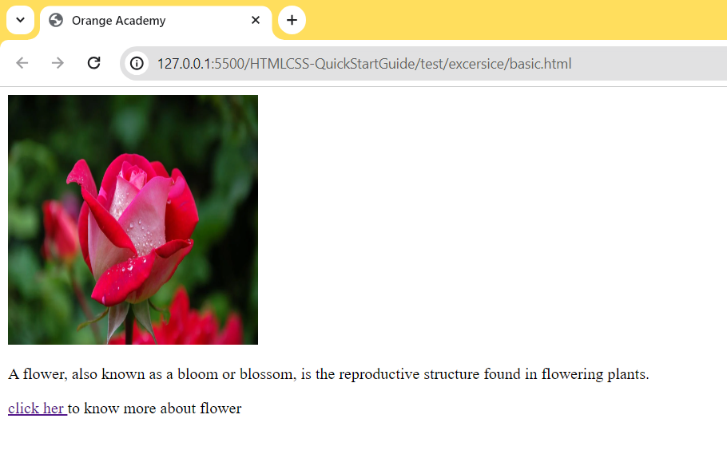

**4. Create webpage**

1. **Add image with hyper link to “**[**https://en.wikipedia.org/wiki/Fish**](https://en.wikipedia.org/wiki/Fish)**”**
2. **Add title**
3. **Add paragraph**

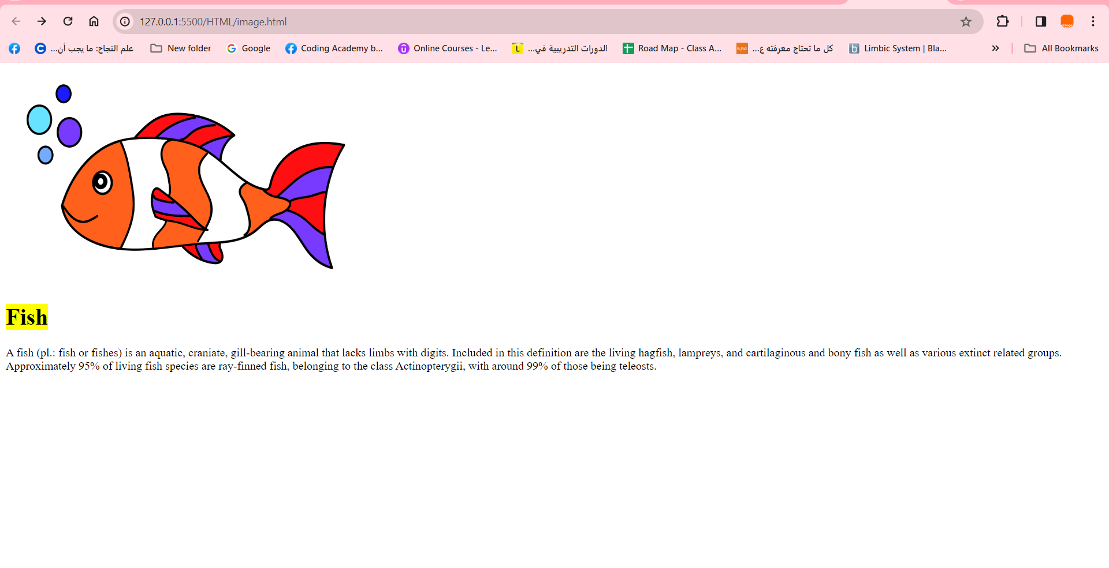

**Intermediate**

**5.Create the following webpage:**

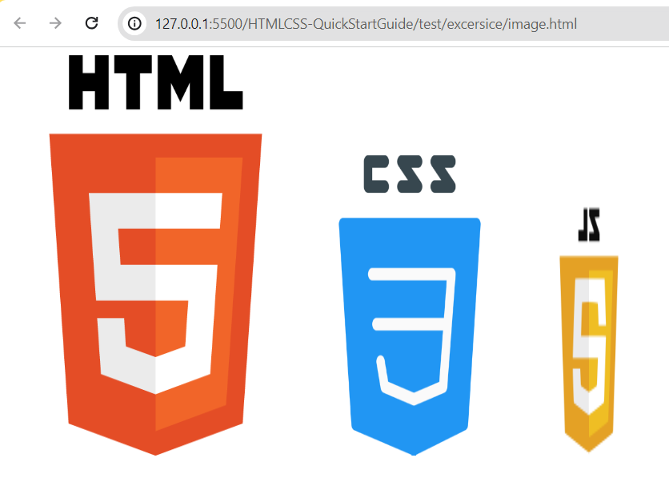

**6. Create the following (where when you click on go to end it will move to the end of the page go to top)**

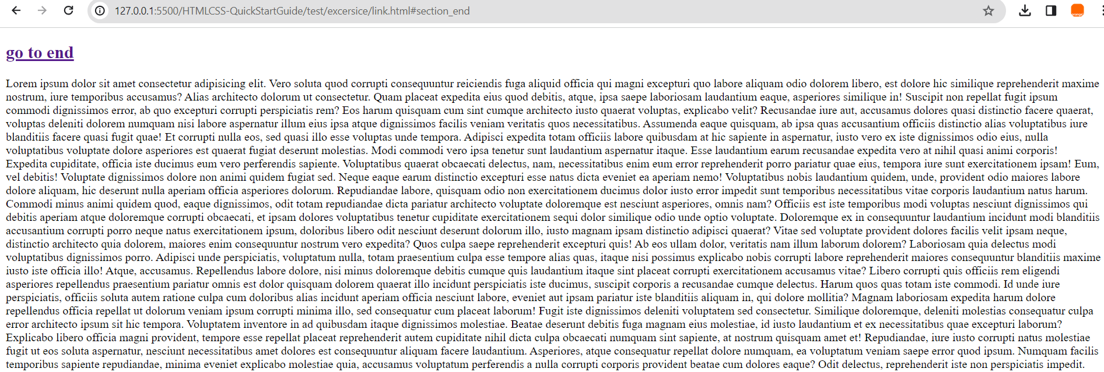

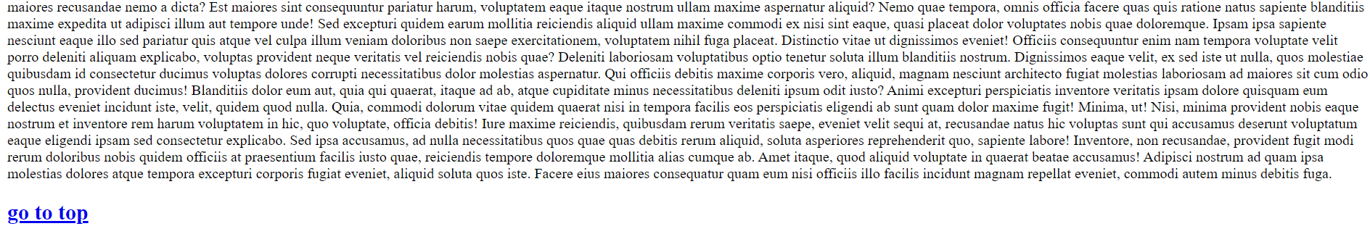

**Advance:**

**7. Create the following page as show on the image contain image, horizontal line, heading:**

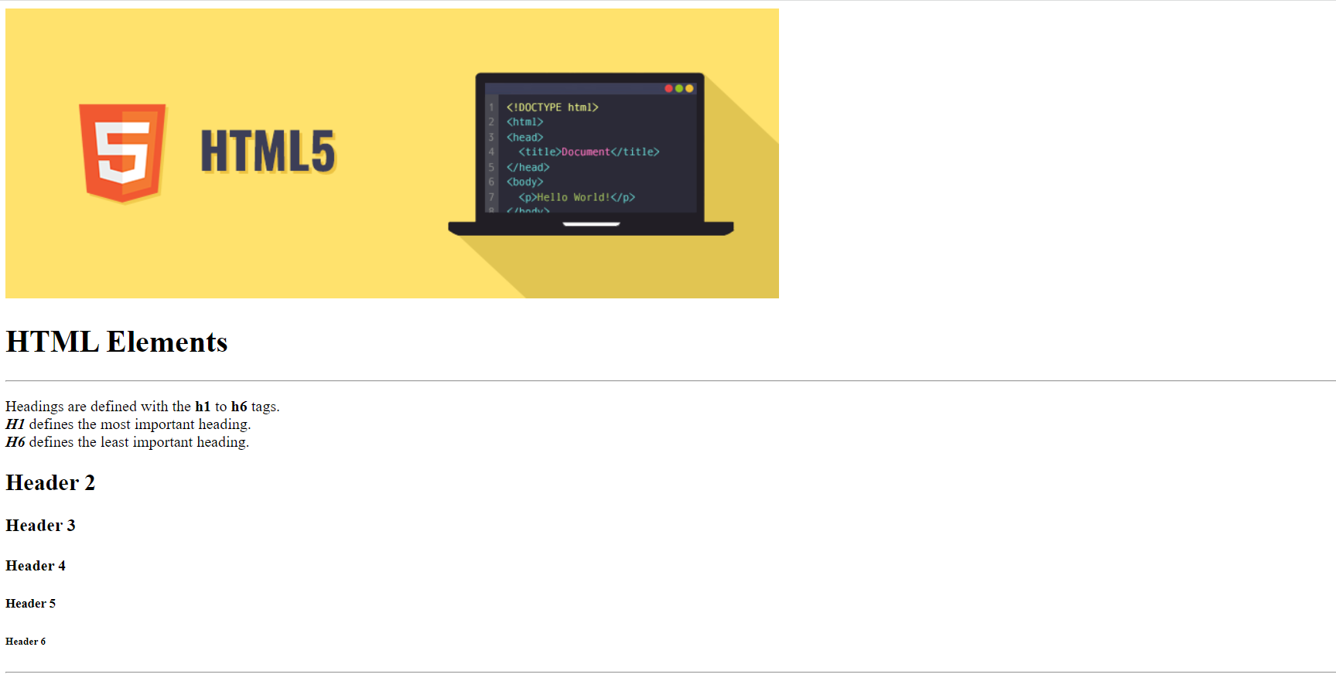

**8.Create the following:**

1. **Title one h1, title hyperlink with “https://en.wikipedia.org/wiki/Computer_programming“**
2. **Add hyperlink connect to the end of webpage**
3. **Add image with different size as show on the image**
4. **Image on last section hyperlink to “https://www.codecademy.com/article/what-is-programming”**

