**CSS (Inline, Embedded, External, color, id , class, background-image, background-color)**

**Duration 4h (Totally 17)**

**Basic**

**1.Create following web site and color the paragraph as following:  
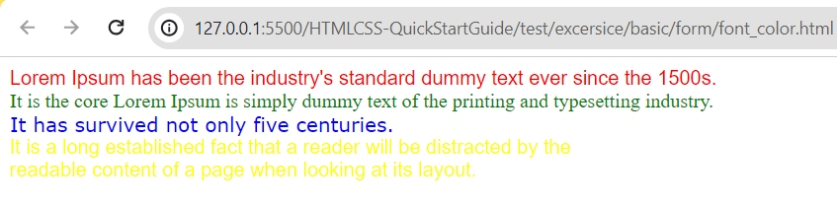**

**2.Inline, internal, External style with font Color:**

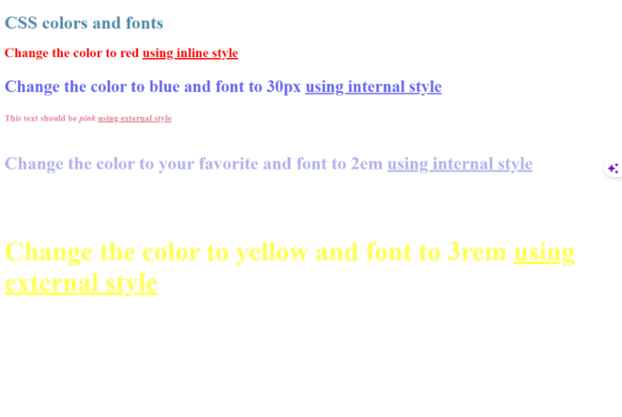

**3.Create the following:**

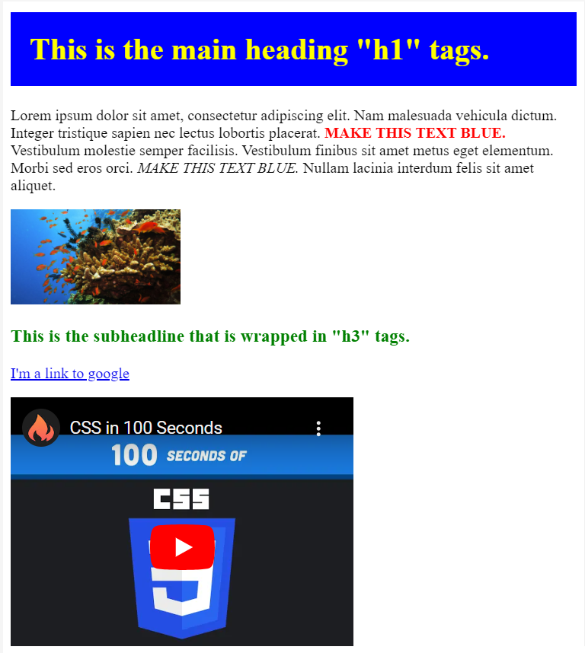

**4.Add background color and background image:**

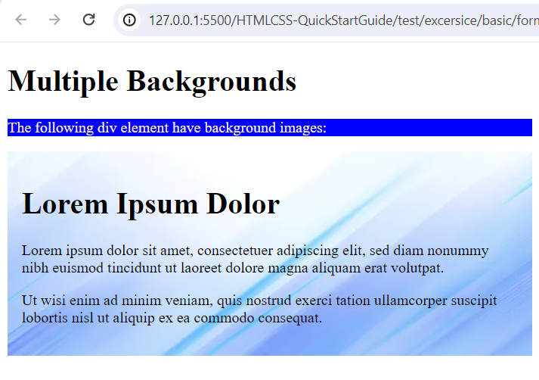

**5.Add background image vertical (repeat-y):**

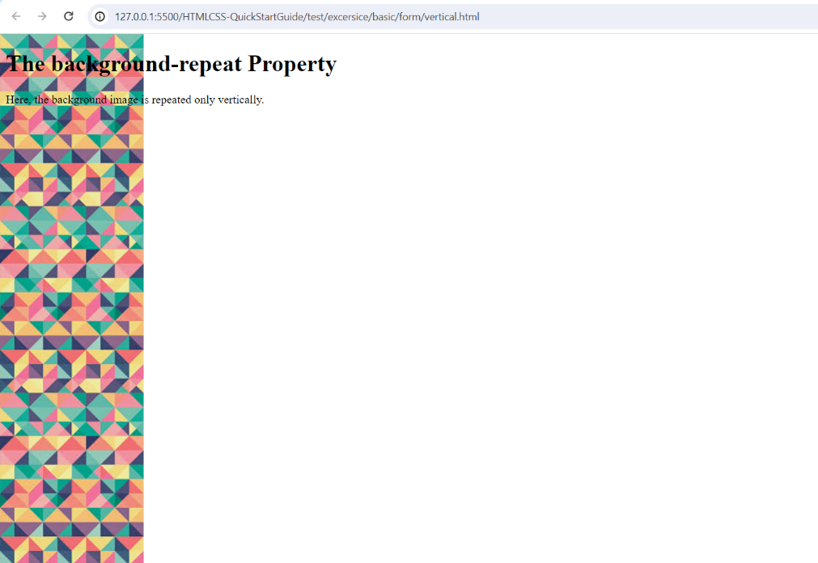

**6.Use class to add color for paragraph:**

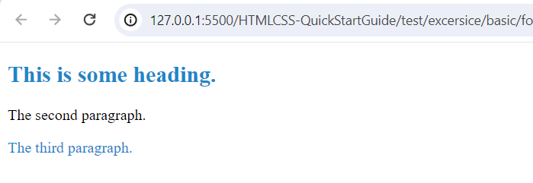

**7. Use id to add color for paragraph:**

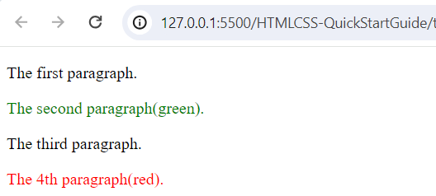

**Intermediate**

**8.insert image for paragraph background:**

**last paragraph you should use two background**

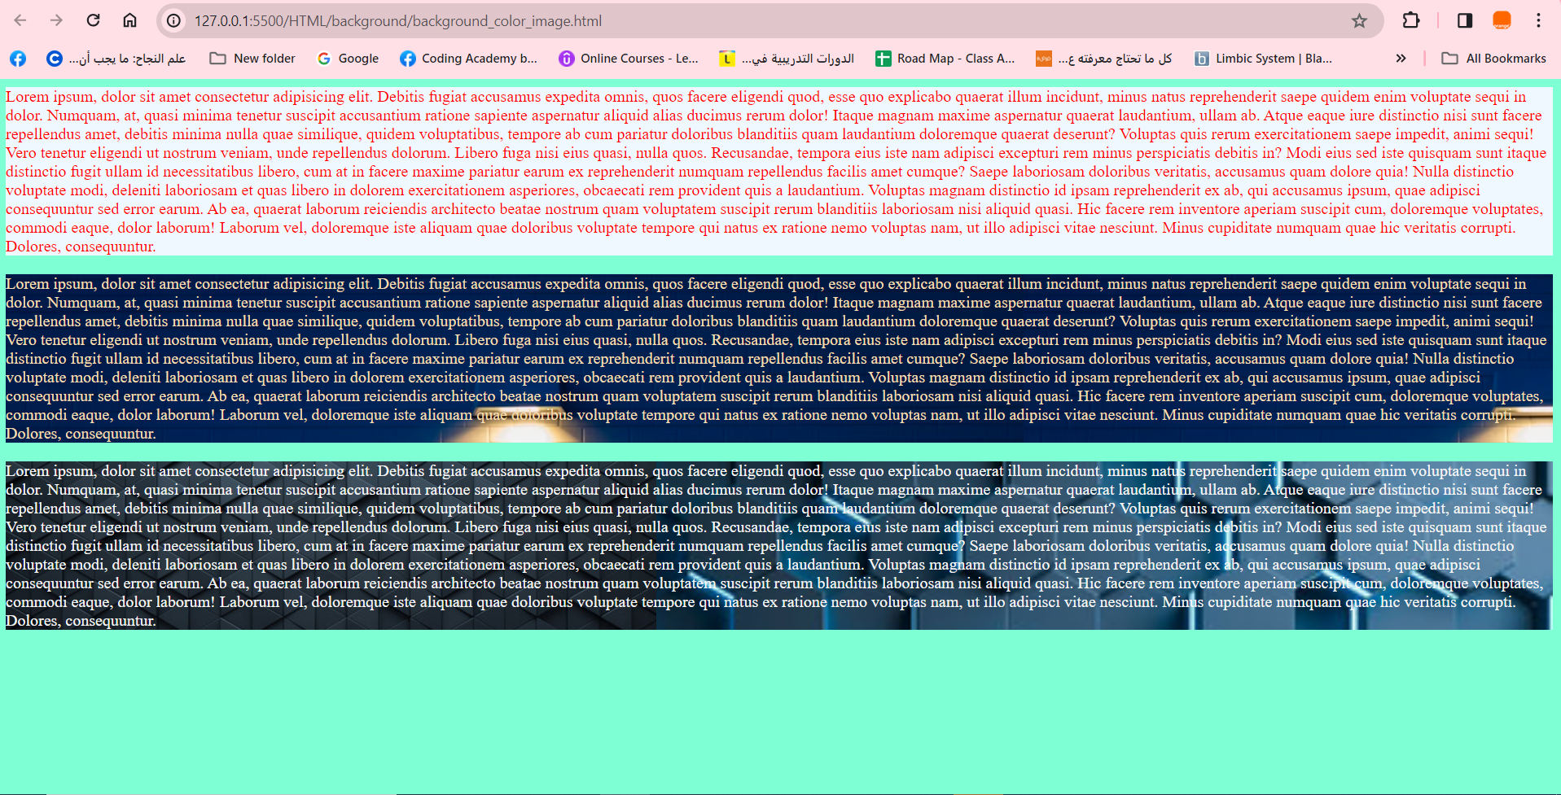

**9.Selector Class and Id:**

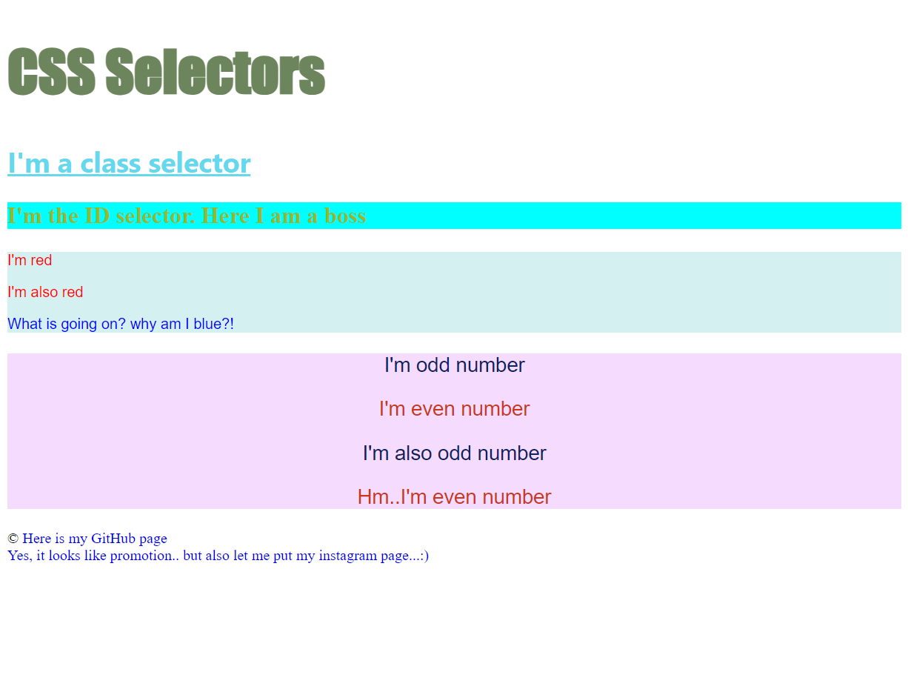

**10.Selector (id, class):**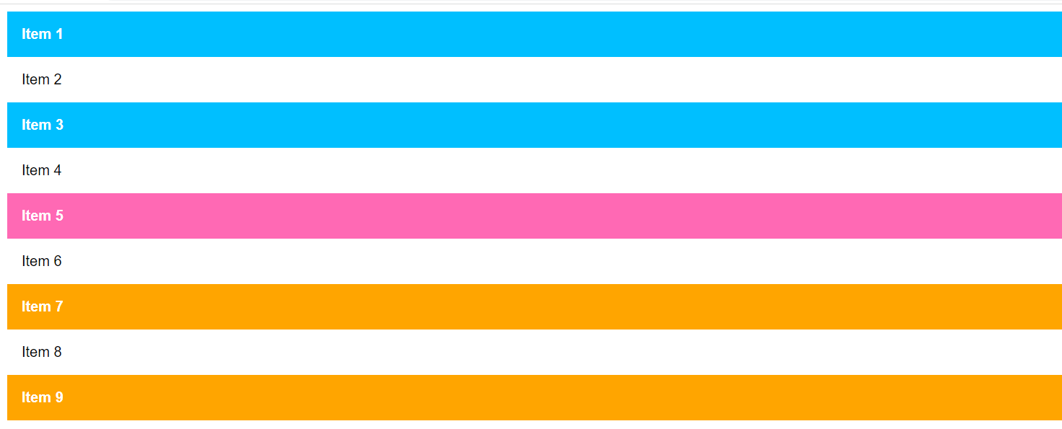

**11.Add color for the form:**

**12.Add 4 color for background as following:**

1. **#1f1f7a= 0%**
2. **#80005a= 50%**
3. **#d4ff00= 50%**
4. **#05c605= 100%**

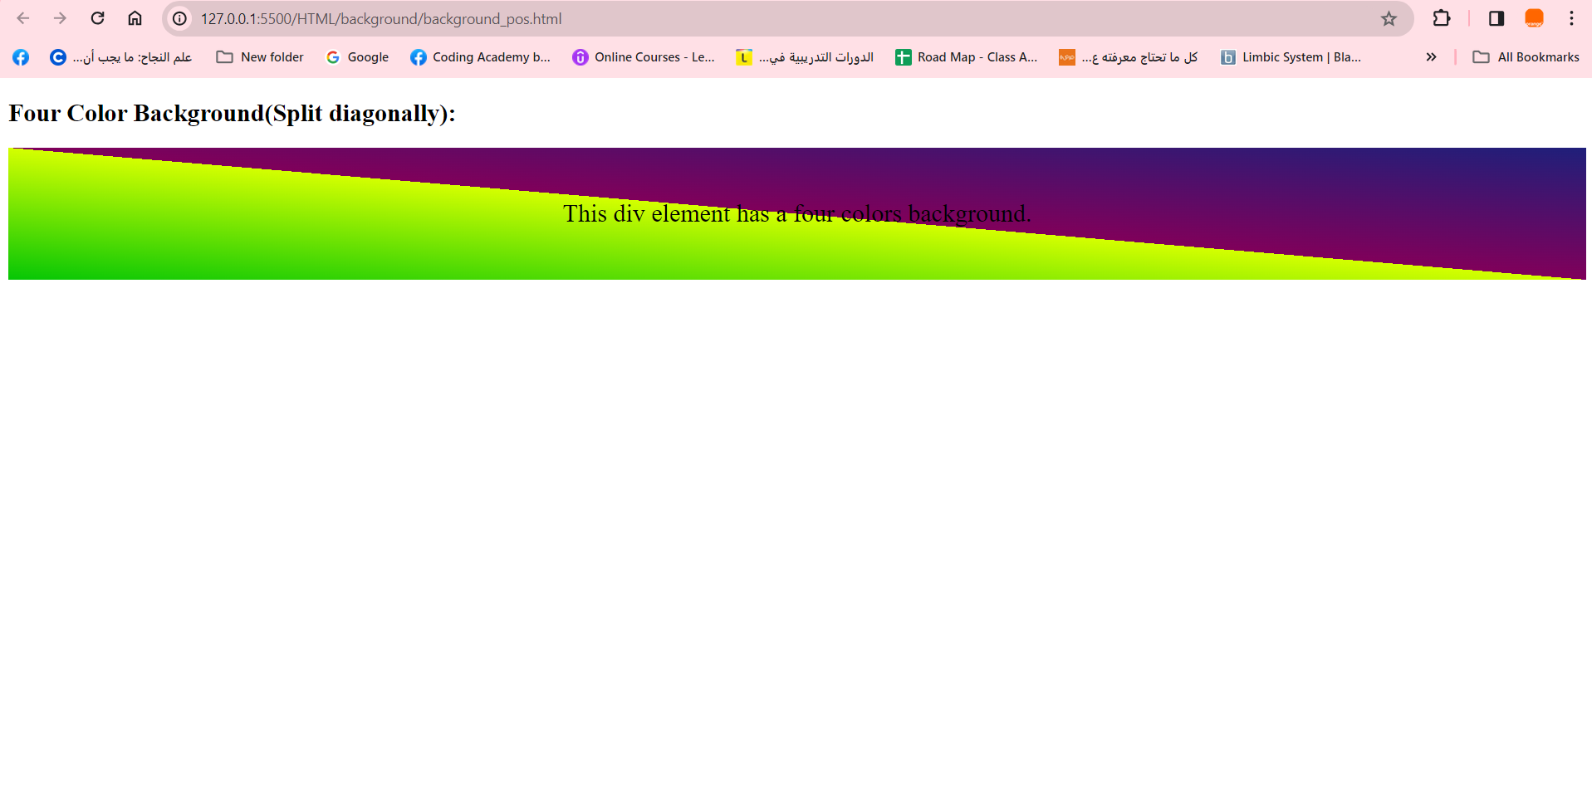

**Advanced**

**13.Create the following:**

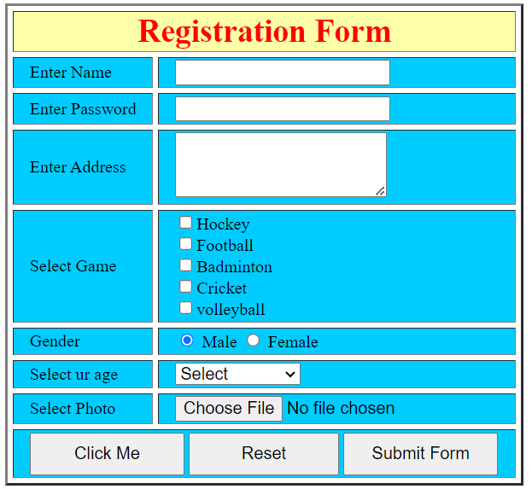

**14.Add background image horizontal and vertical (repeat-y, repeat-x):**

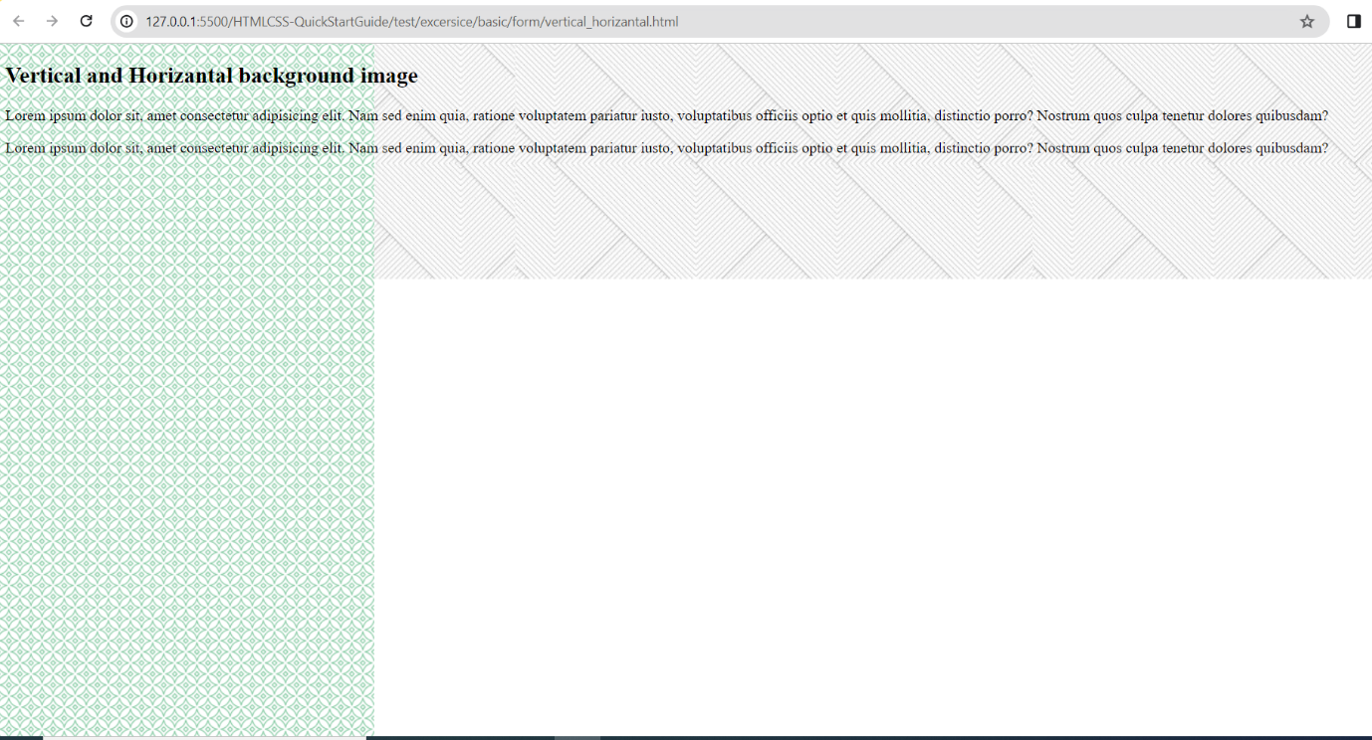

**15.Create the following web page:**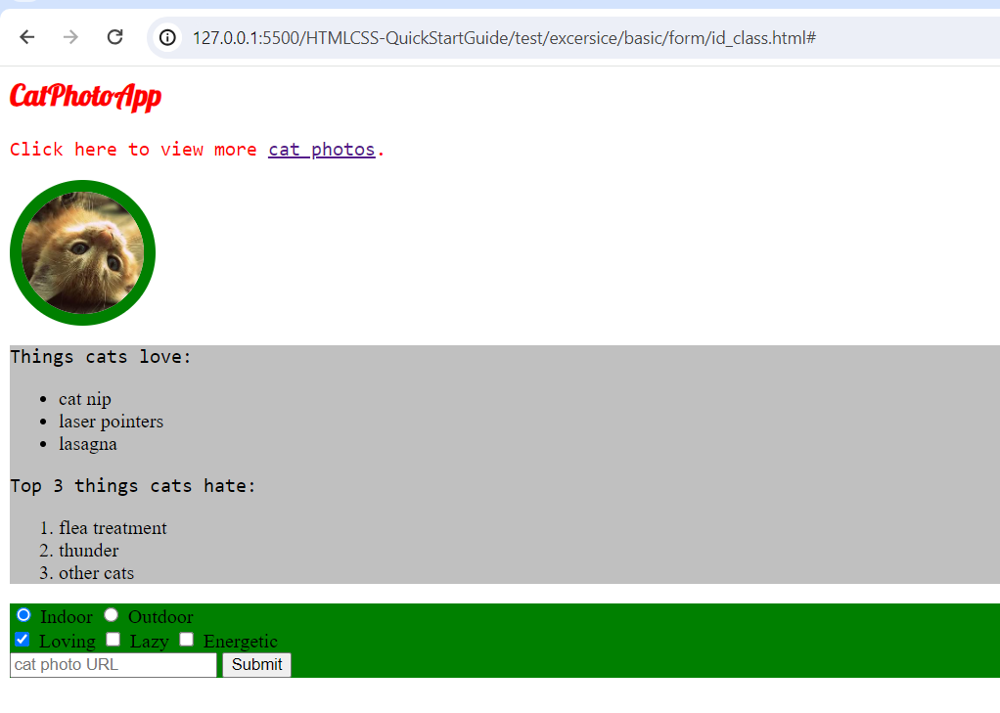

**16.Create the following web page:**

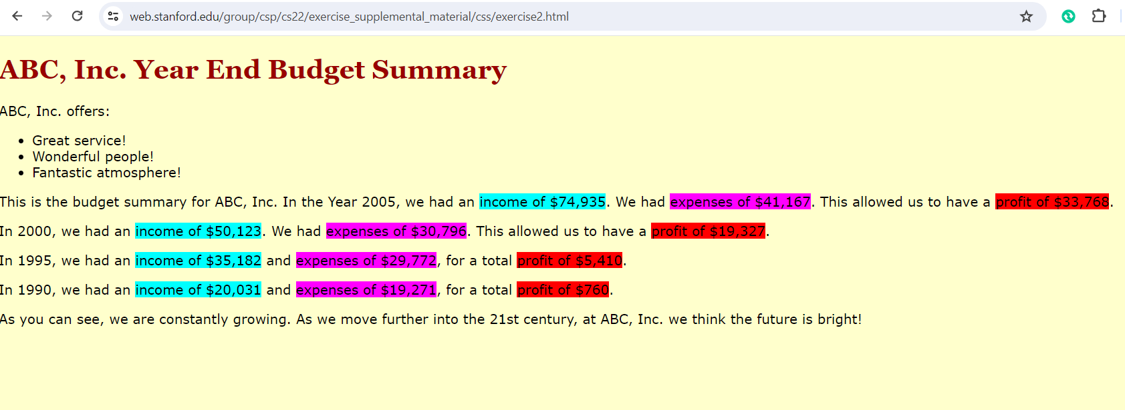

**17. Selector (css diner):**

[**https://flukeout.github.io/**](https://flukeout.github.io/)