**CSS (Flex)**

**Duration 4h (Totally 13)**

**Basic**

**1.Create a row of 4boxes using flexbox (good to start from box size 200px by 200px):**



**2.Create navbar using flexbox**

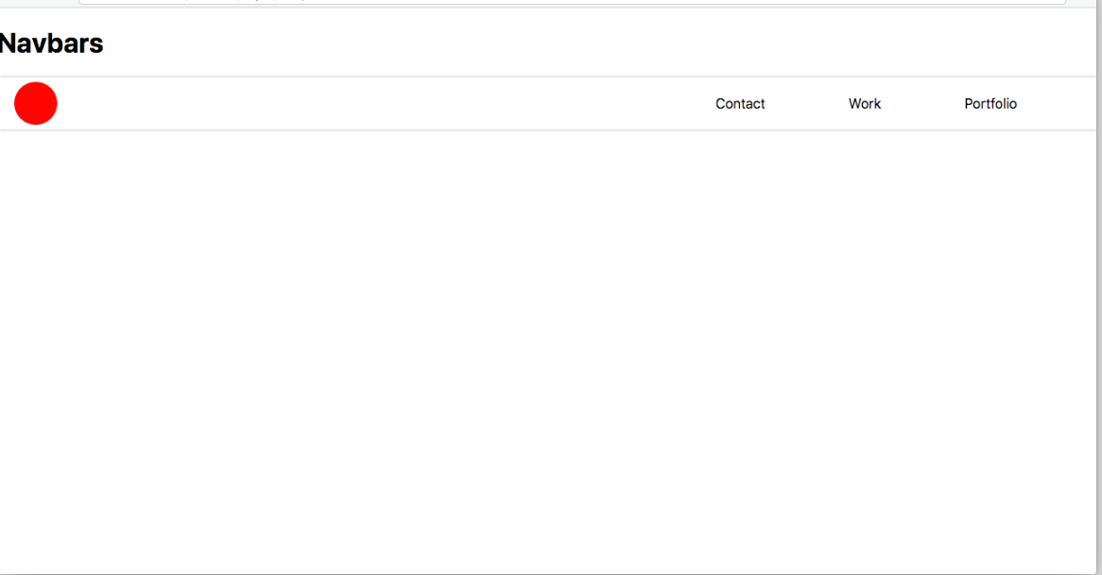

**3.Center div as the following using flexbox**

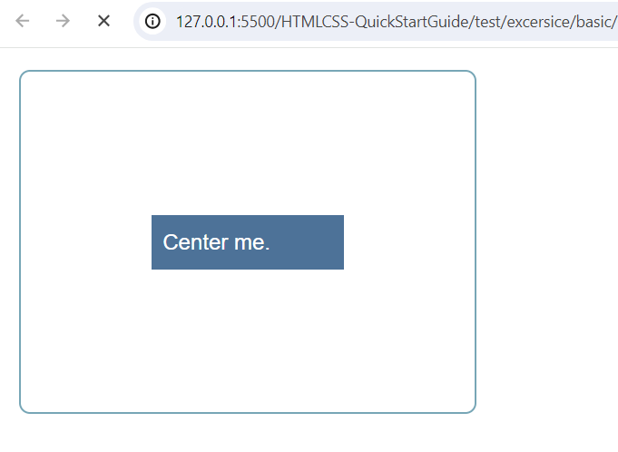

**4.Create the following using flexbox**

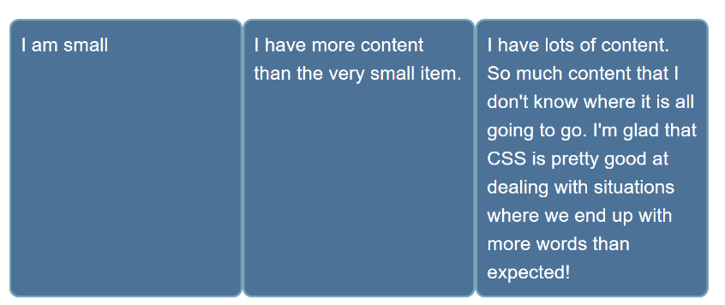

**5.Create the following using flexbox**

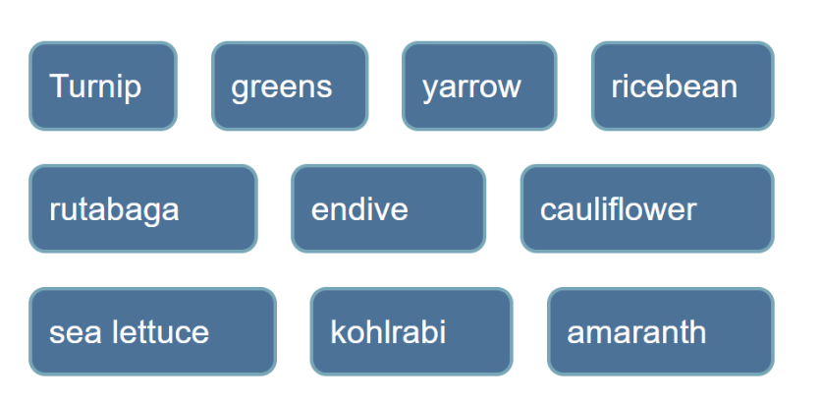

**Intermediate**

**6.Solve the following based on flex property align-self:**

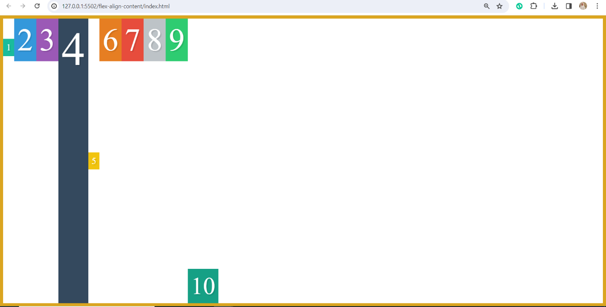

**7. Control flex direction**

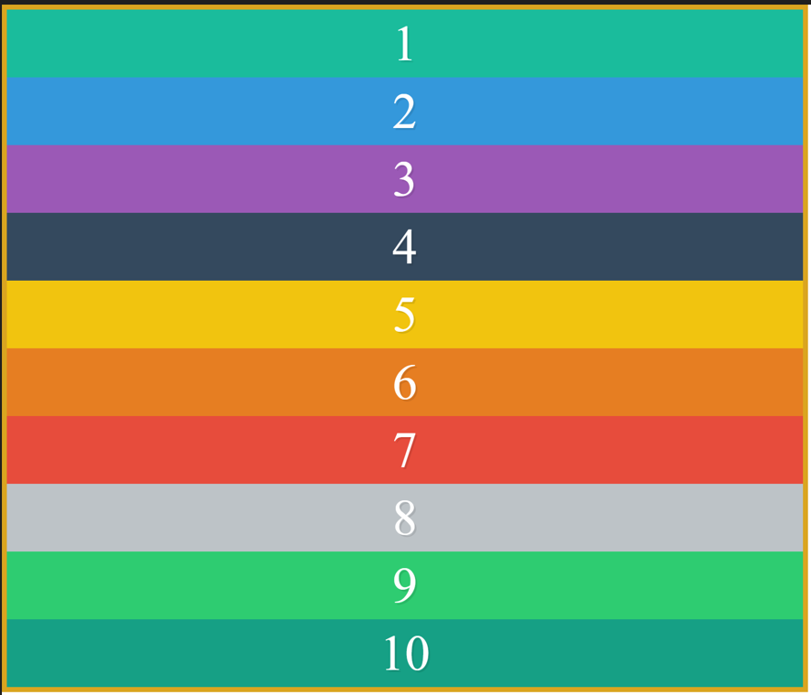

**8.control flex size**

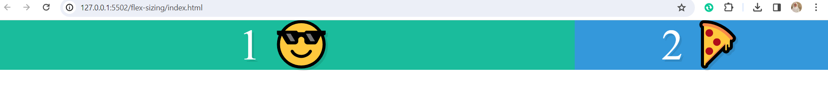

**9.Use flex wrap.**

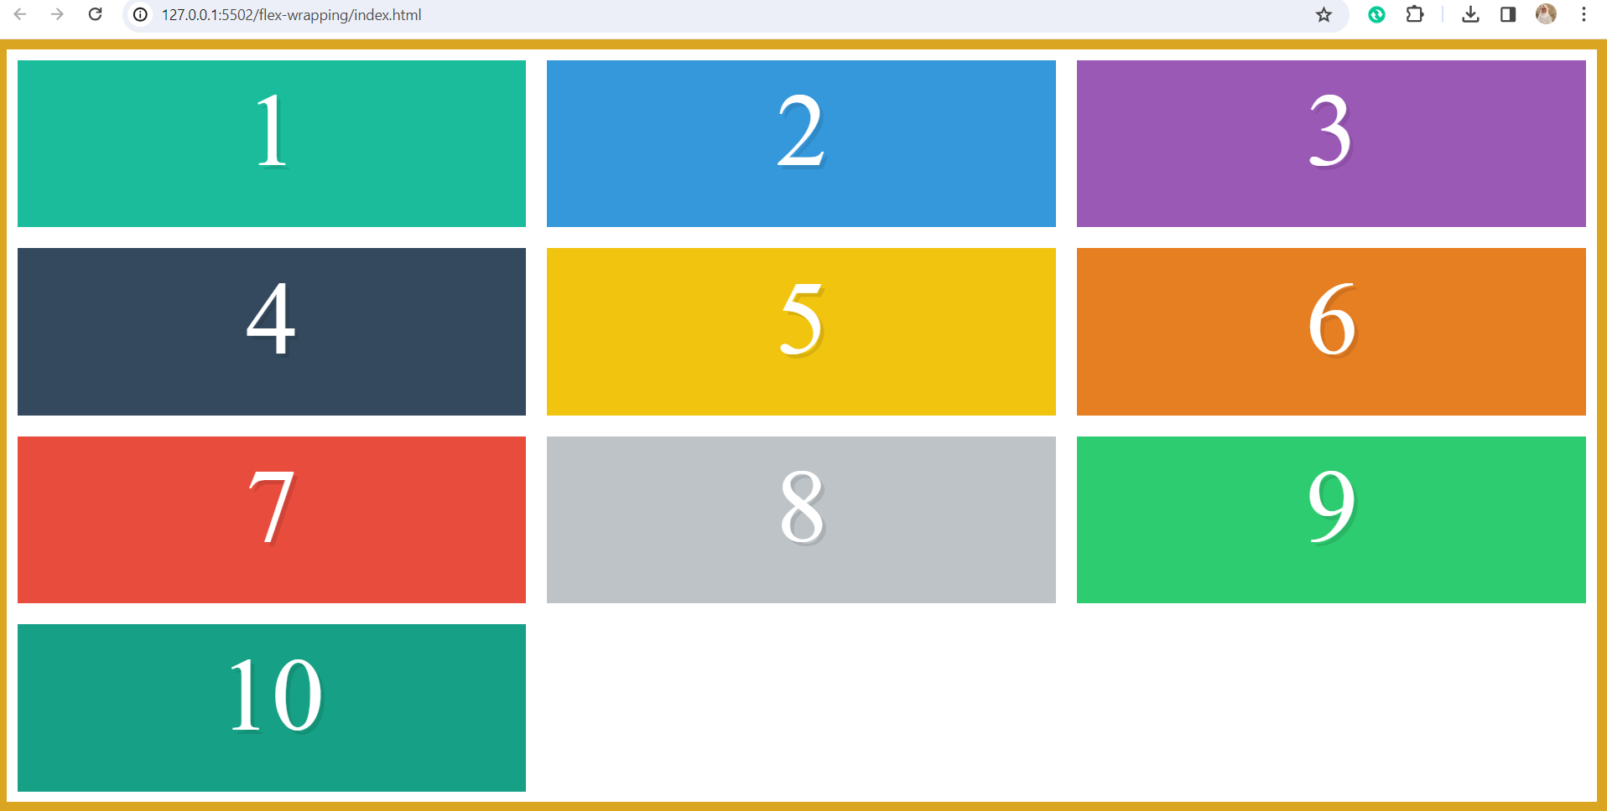

**10.Create the following web page**

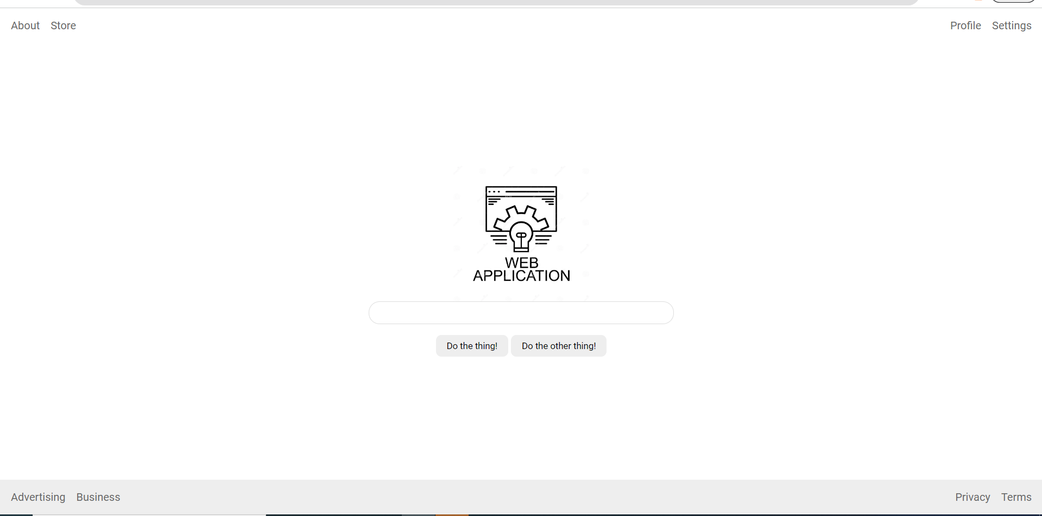

**Advanced**

**11.Create the following (using Grid):**

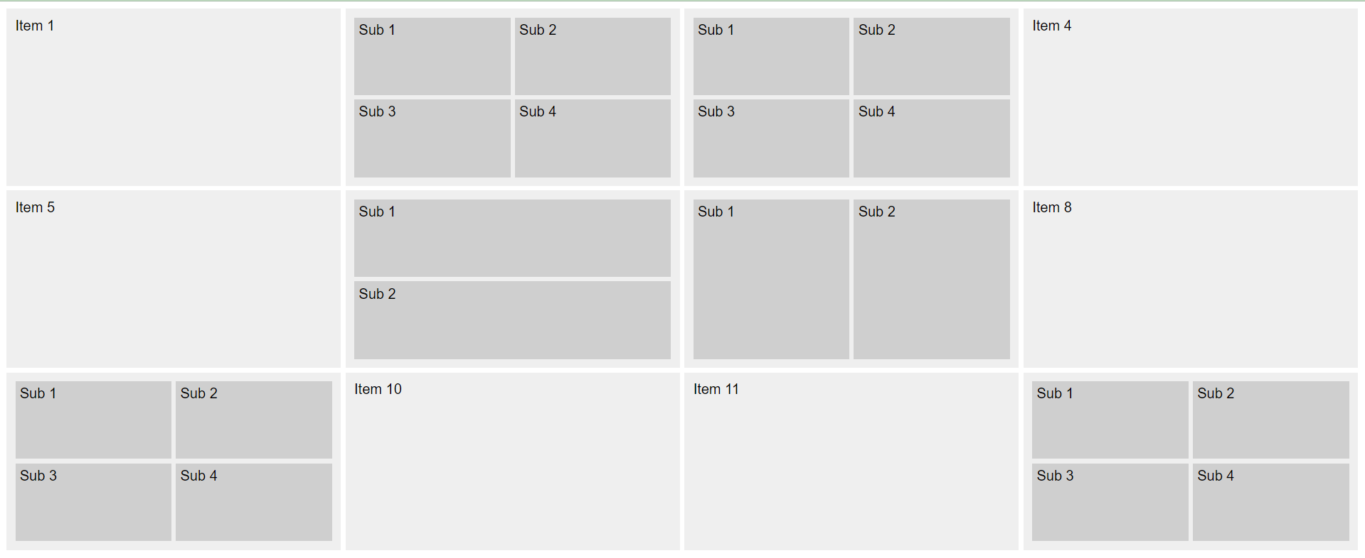

**12.Go to** [**www.youtube.com**](http://www.youtube.com) **and mock the layout page**

**13. play froggy game**

[**https://flexboxfroggy.com/**](https://flexboxfroggy.com/)

Pov: your output must cover SEO rules