**Elements (Lists, Inline, Block)**

**Duration 4h (Totally 11)**

**Basic**

**1.Create the following:**

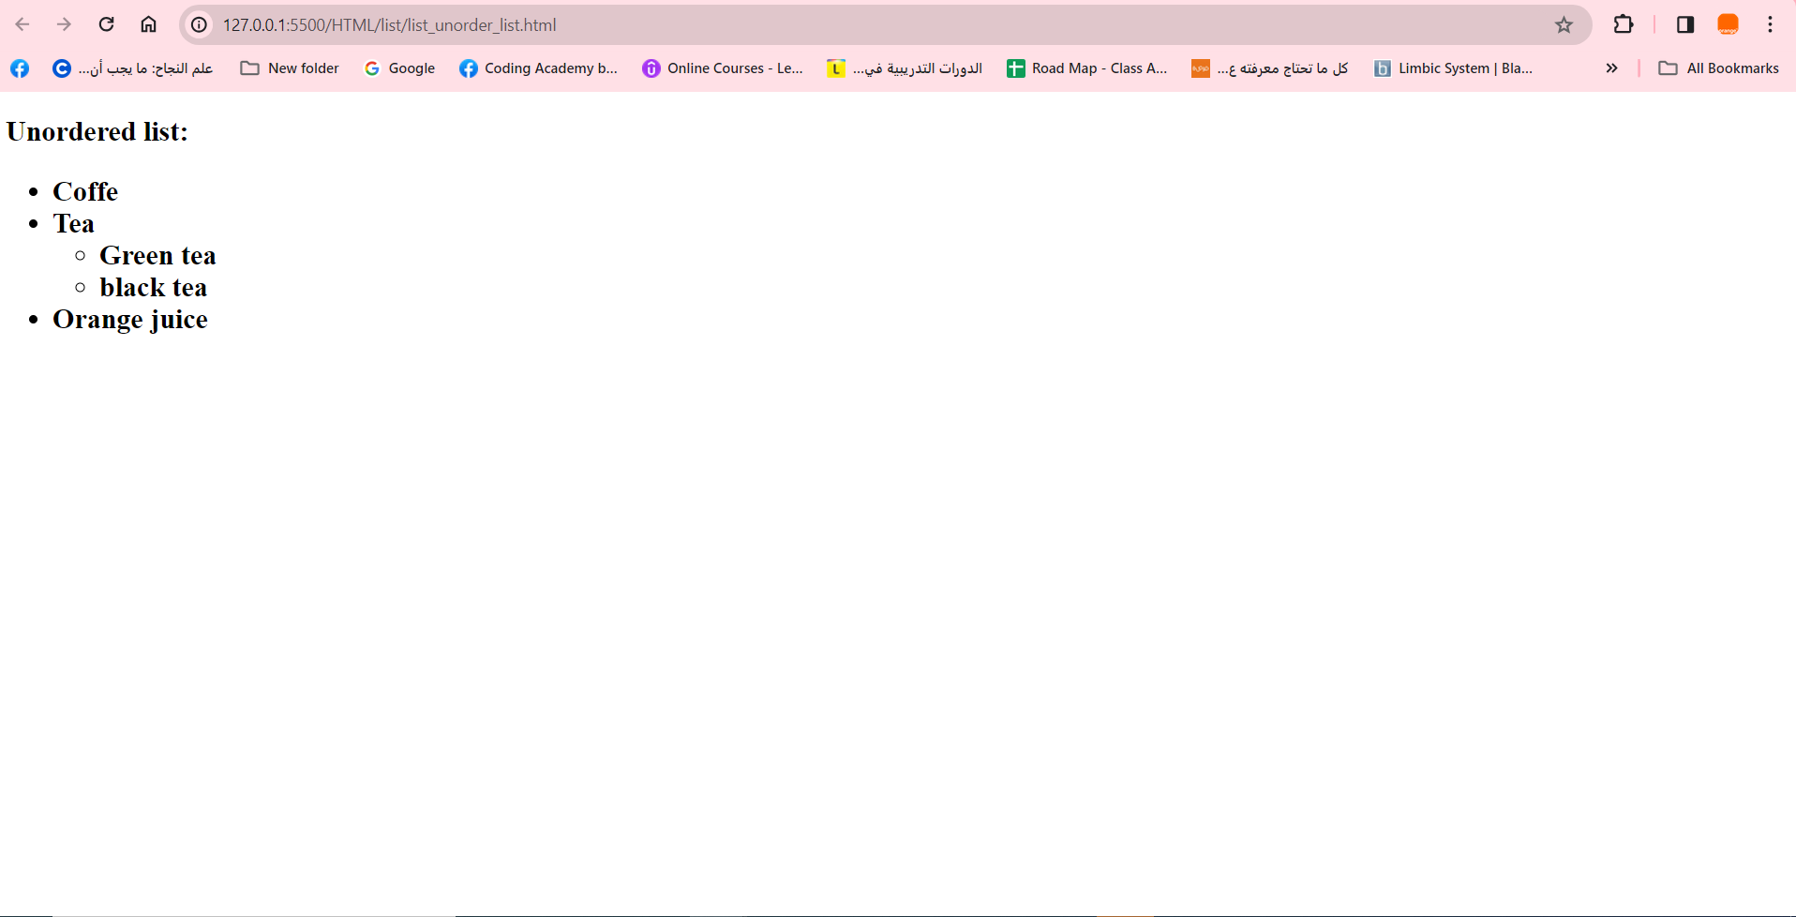

**2.Create the following:**

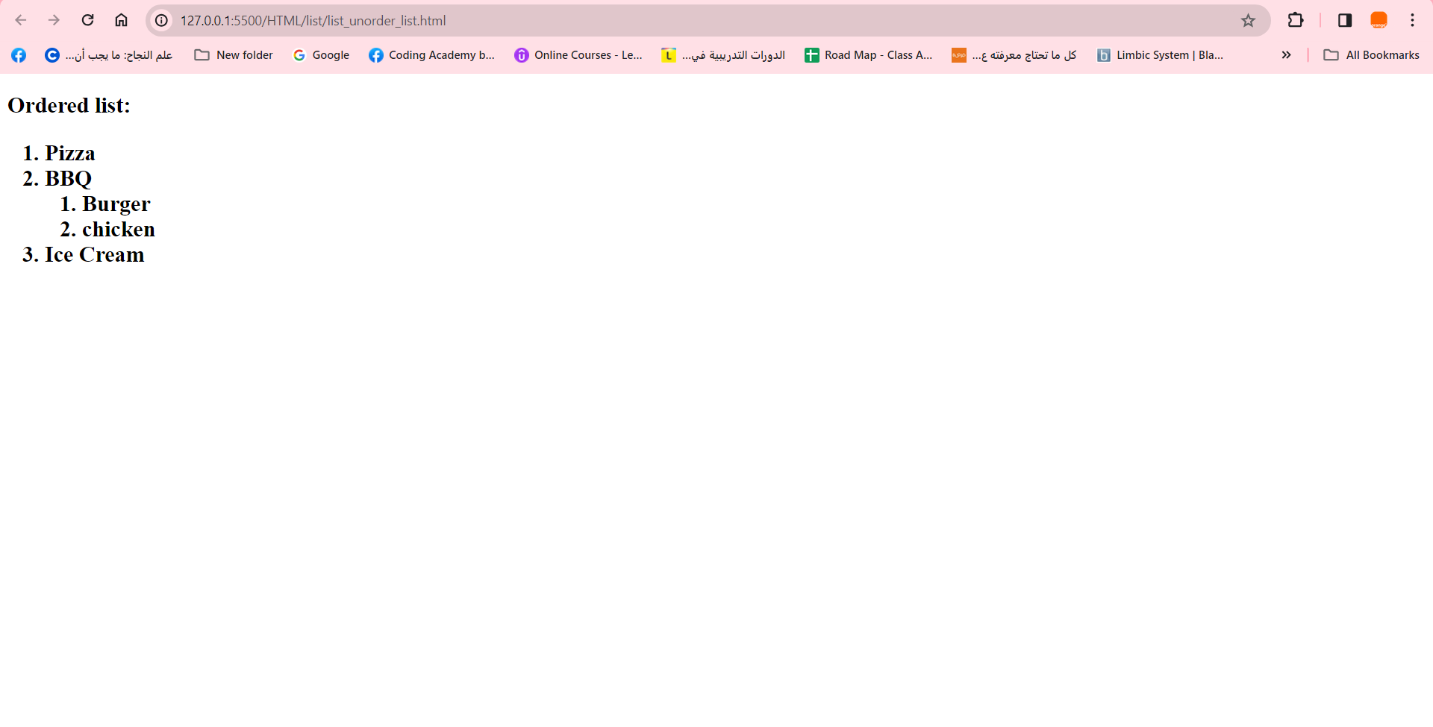

**3. Create Description list:**

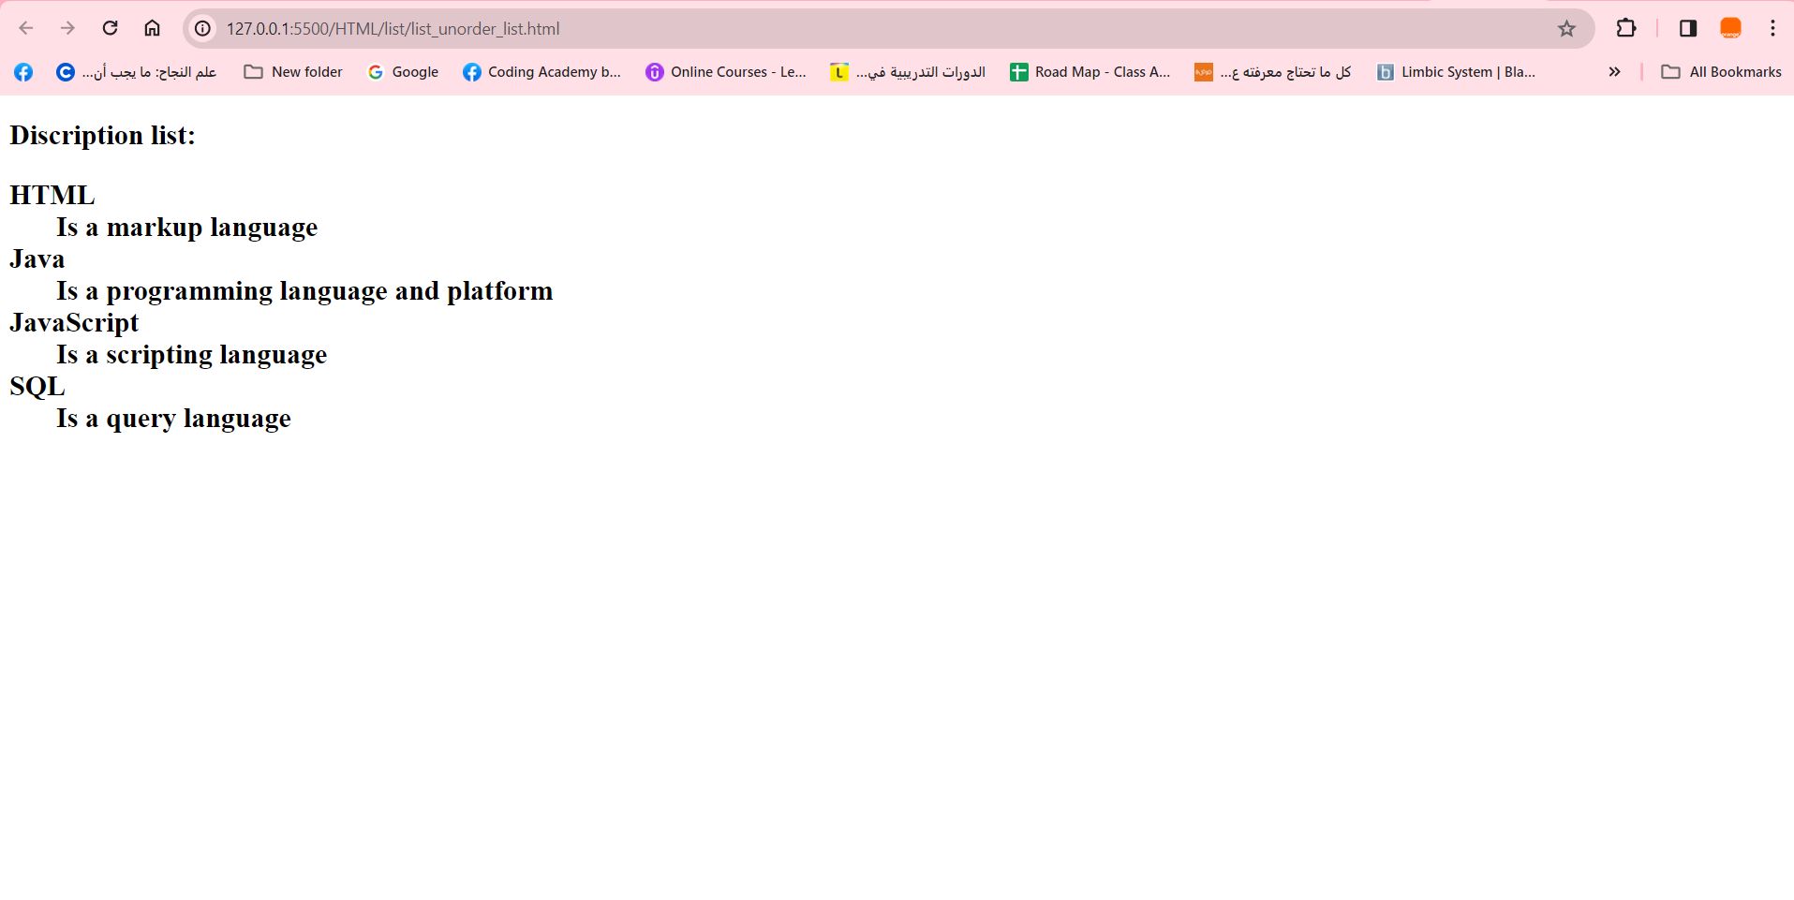

**4.Insert the following:**

1. Insert 2 div.
2. Inside each one of them it must contain paragraph talk about subject you selected
3. Image related to subject.
4. Add order list and unordered list regarding what we learn.

Pc: Write in list the different between inline & block based on solve the previous task

For example:

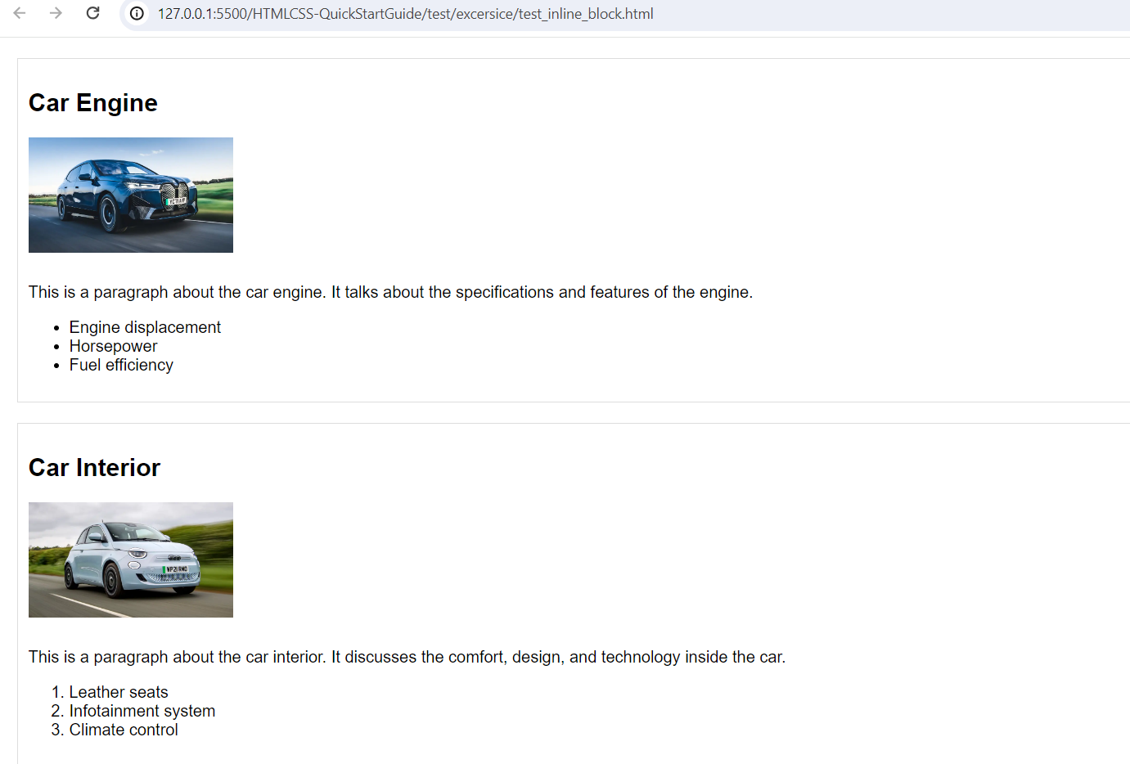

**Intermediate**

**5. Create the following:**

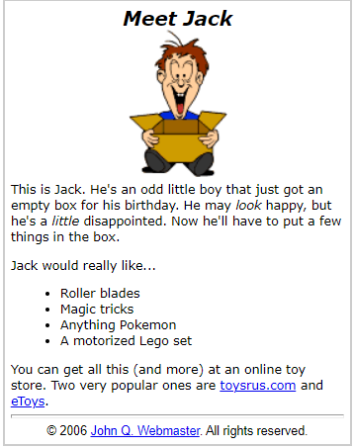

**6.Create the following page conatin table, order list, unorder list, Definition List, with drop down list**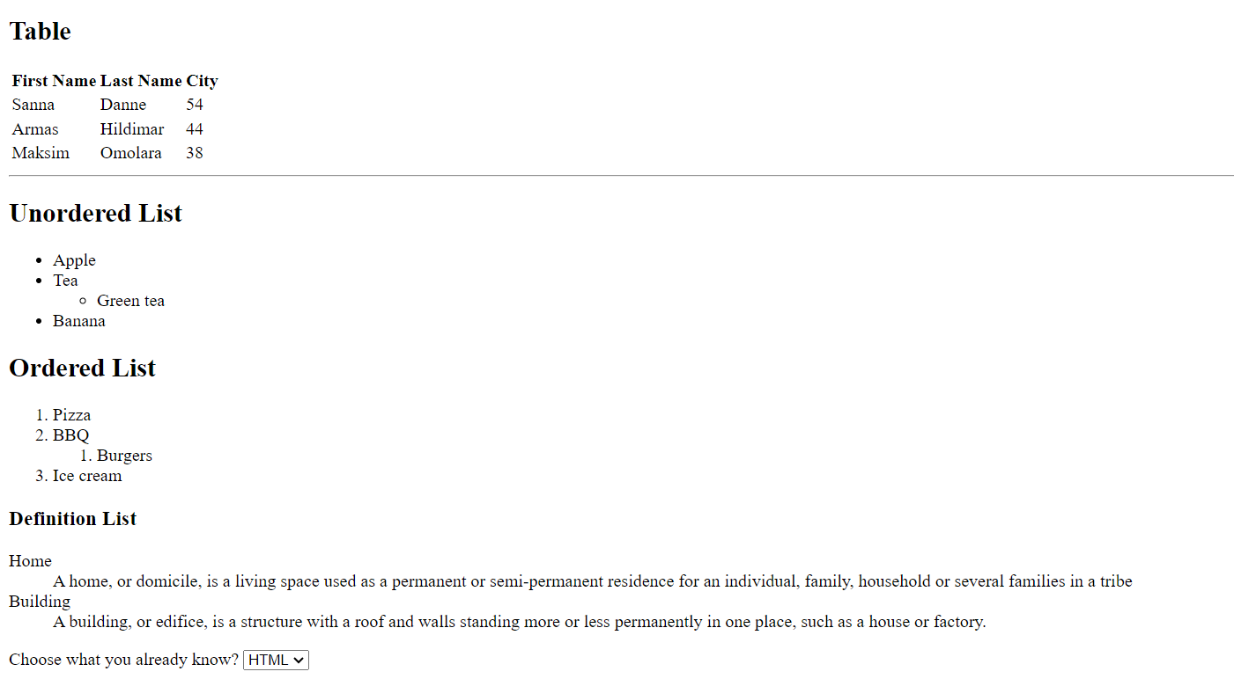

**7. Create the following nested list**

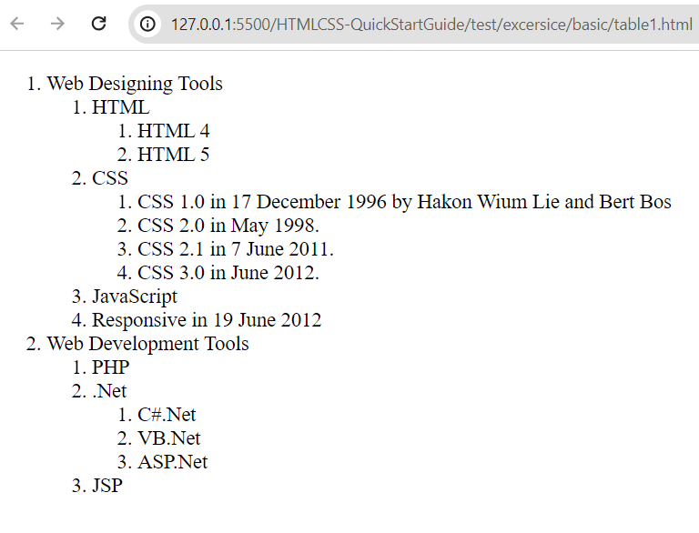

**8.Create the following:**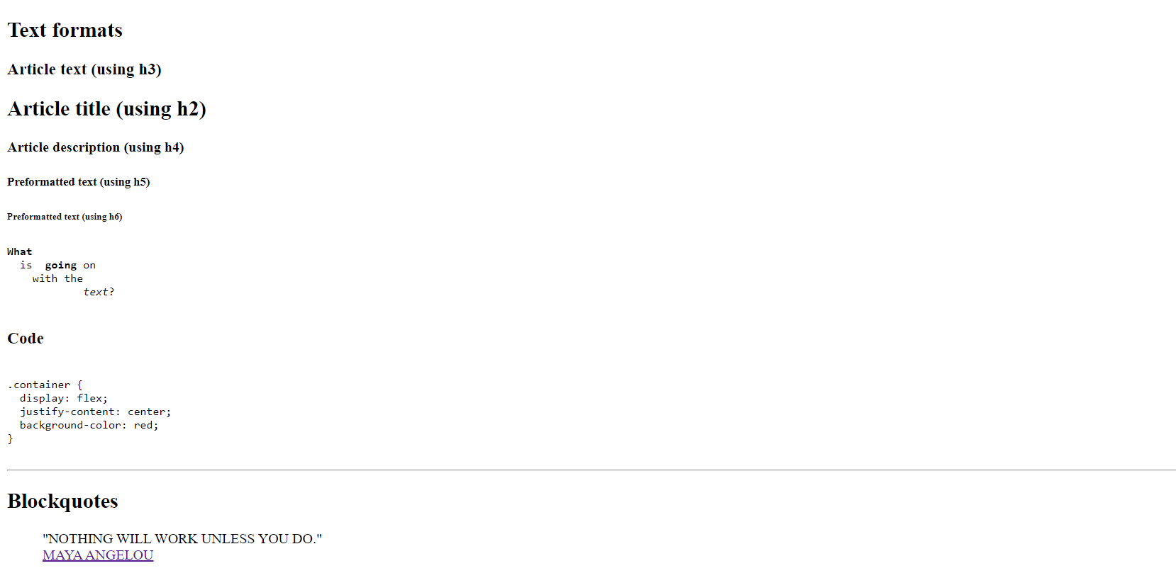

**9.Create the following:**

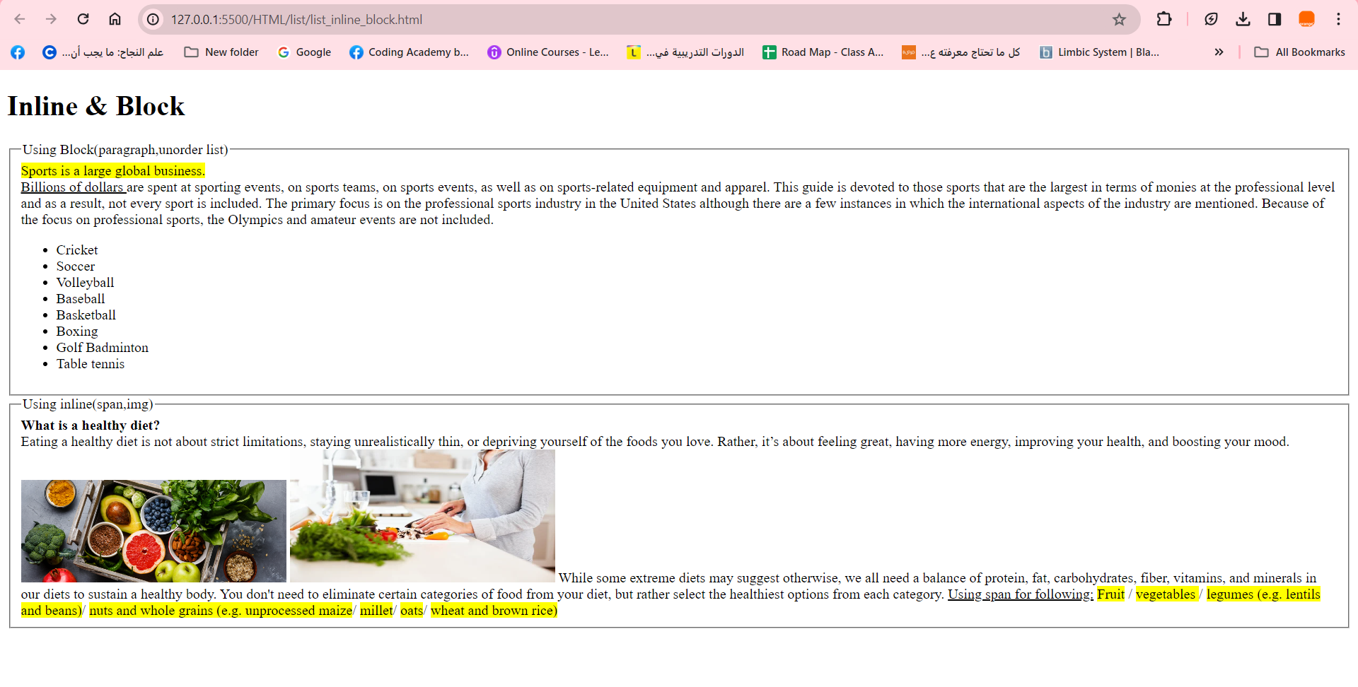

**Advanced**

**10.Add the previous task to the web page and create a navigation bar that connects to specific link:**

Classics: "<https://www.juwelo.com/gemstone-information/quartz/>"

History "<https://www.gia.edu/UK-EN/rose-quartz-history-lore#:~:text=Quartz%20crystals%20were%20valued%20by,Assyrians%20around%20800%2D600%20BC>."

Gems "<https://www.gemstones.com/showcases/quartz-gemstones>"

Contact_Me “your linkedIn profile”

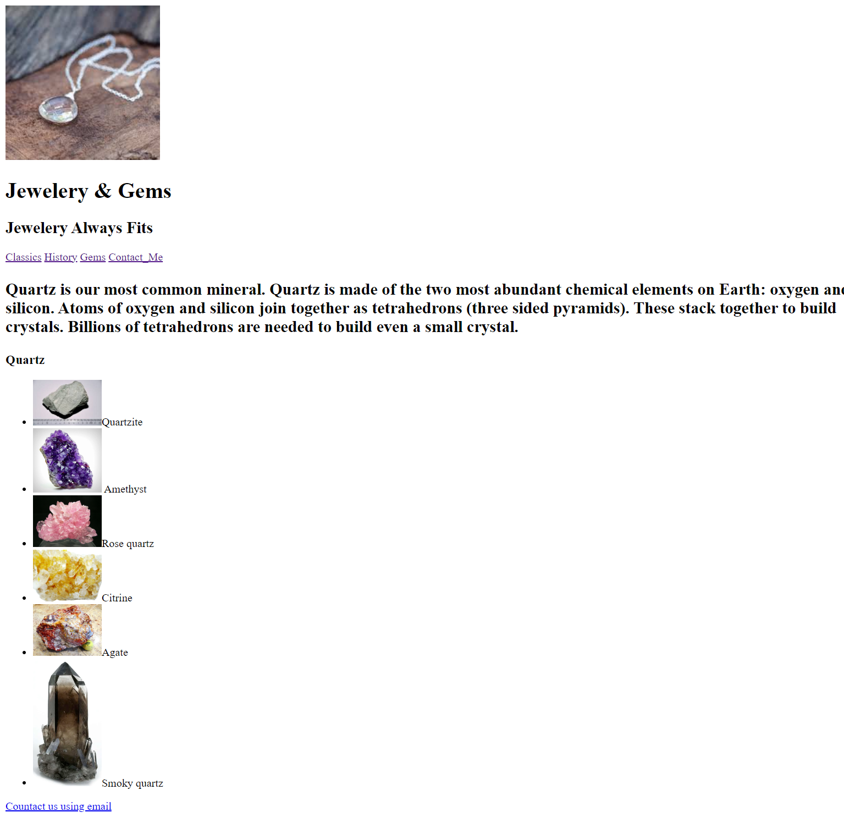

**11.create the following page:**

1. Basketball Dog hyperlink to

**“https://edu.gcfglobal.org/en/”**

