**Element Tables**

**Duration 4h (Totally 8)**

**Basic**

**1.Create Table:**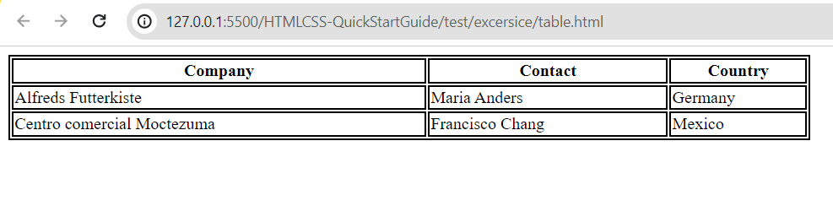

**2.Create the following table:**

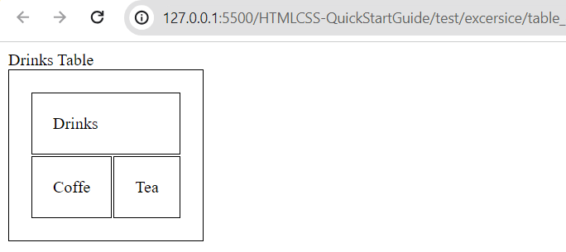

**3. Create the following:**

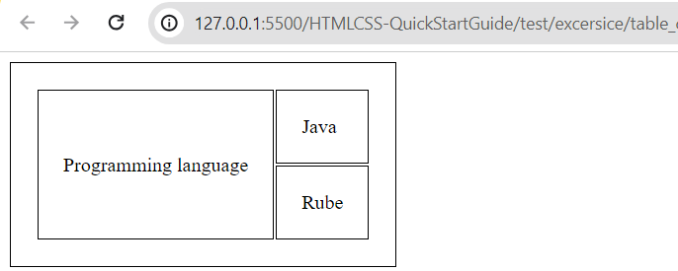

**Intermediate**

**4.Create table and merge cells using rowspan**

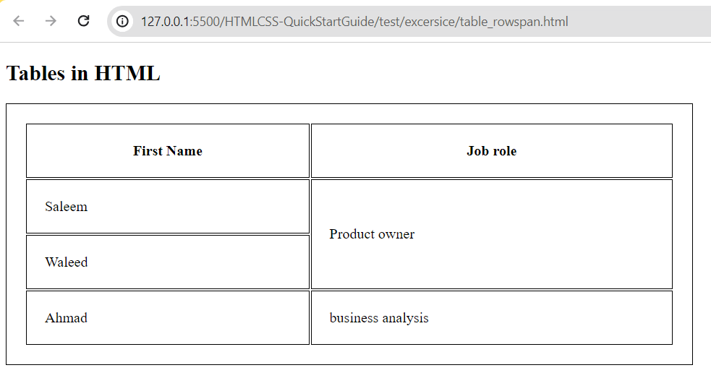

**5.Create table and merge cell using colspan**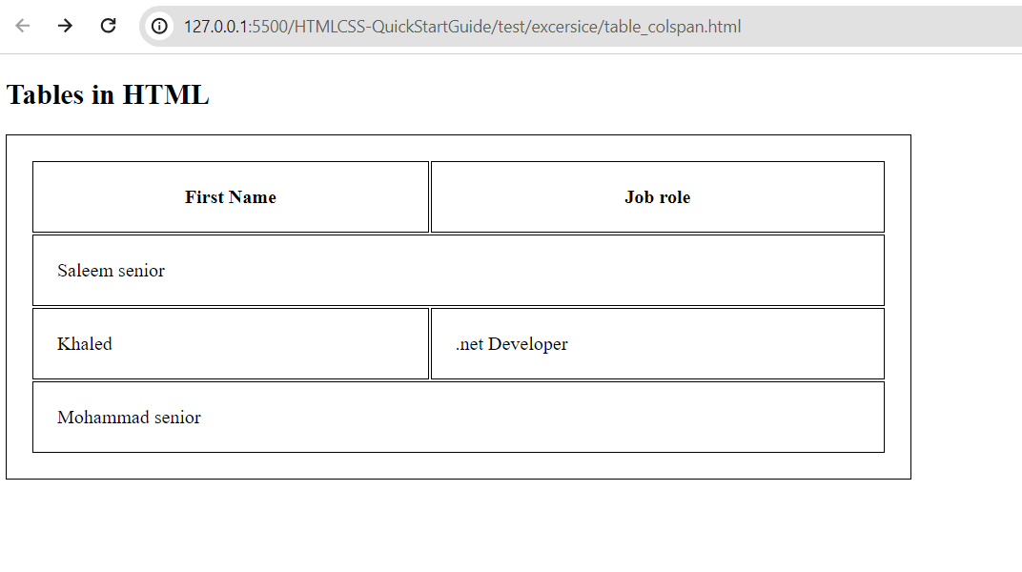

**6.create table**

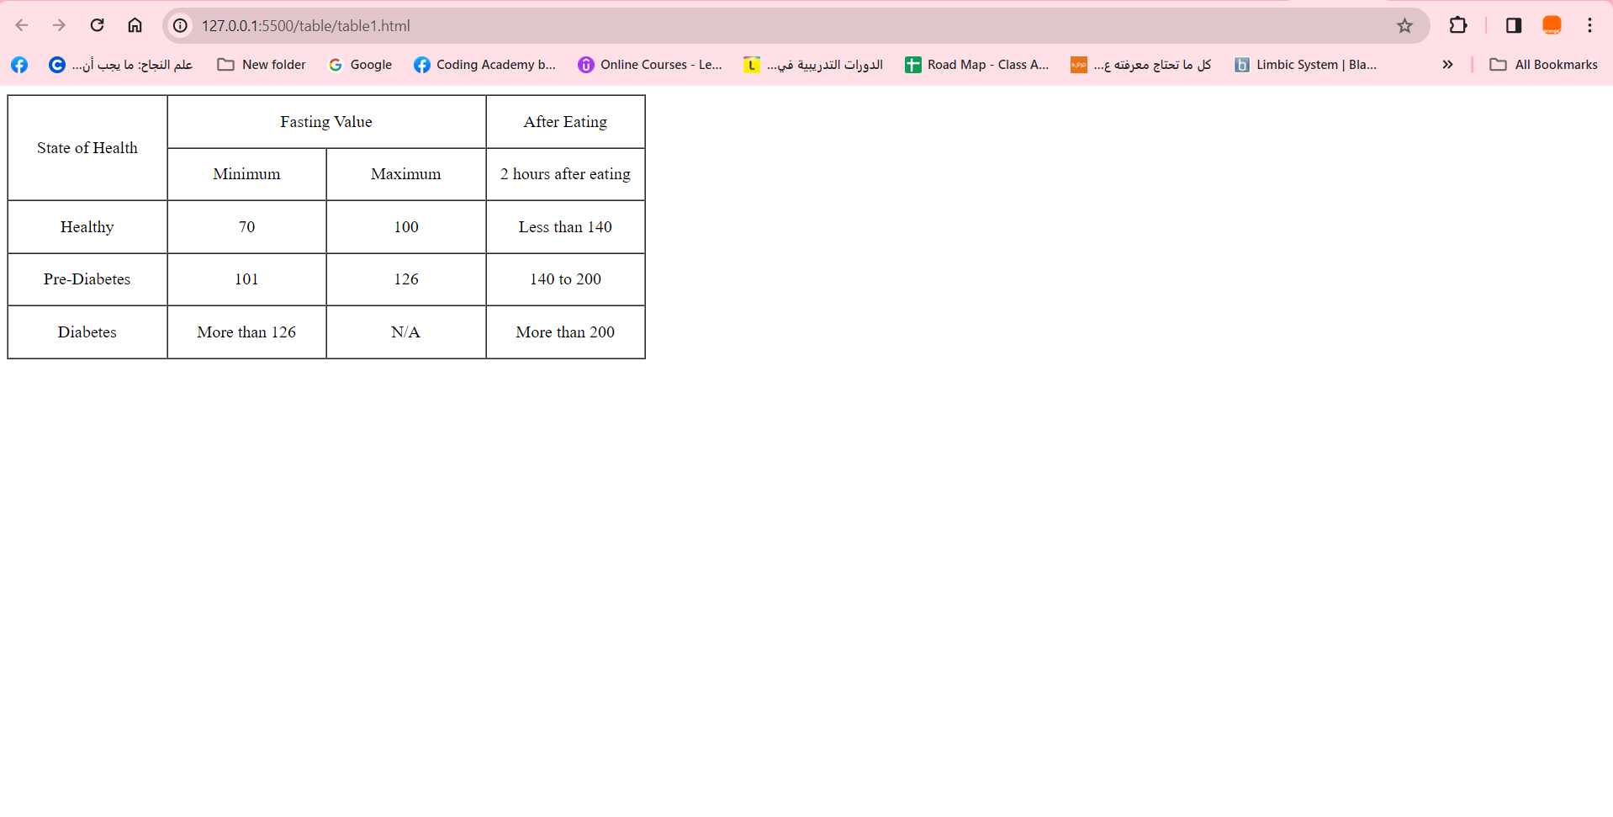

**Advance**

**7. Create the following**

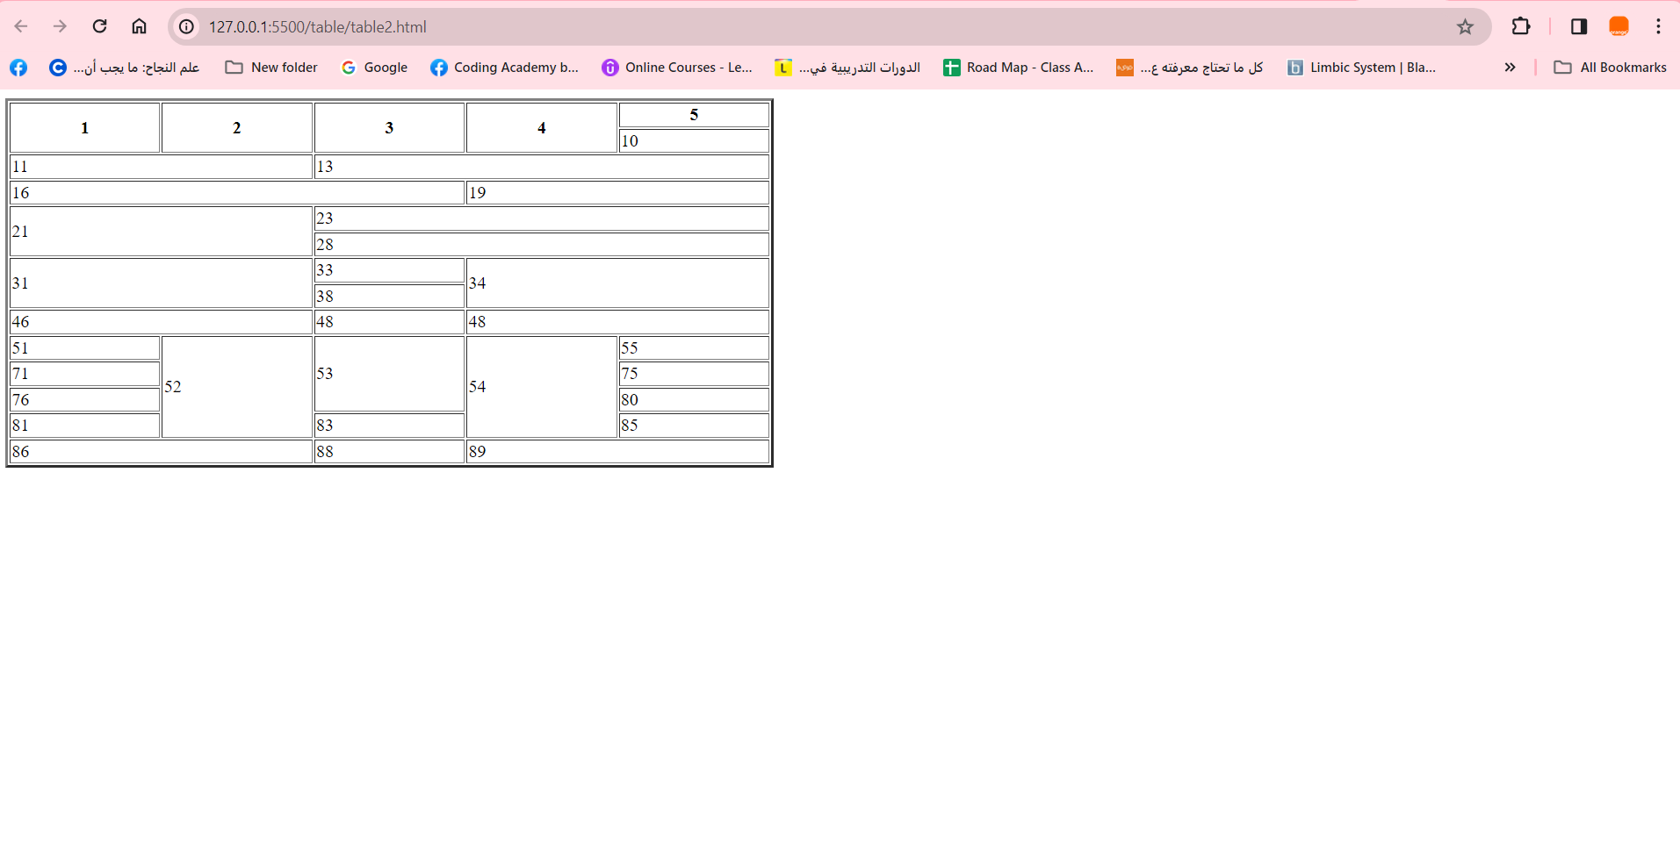

**8.Create table contain animal name and image:**

1. **Animal should be hyperlink to:**

**Giraffes ”https://en.wikipedia.org/wiki/Giraffe”**

**Tiger “https://en.wikipedia.org/wiki/Tiger”**

**Fox “ https://en.wikipedia.org/wiki/Fox”**

**Sheep “https://en.wikipedia.org/wiki/Sheep “**

**Dog “ https://en.wikipedia.org/wiki/Dog“**

