**CSS (Bootstrap, responsive)**

**Duration 4h (Totally 11)**

**Basic**

**1.Use bootstrap heading**

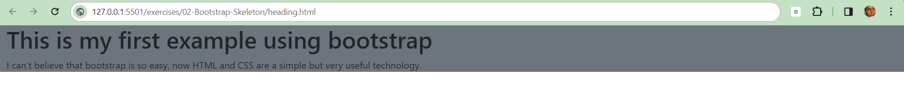

**2.Bootstrap add the following button** 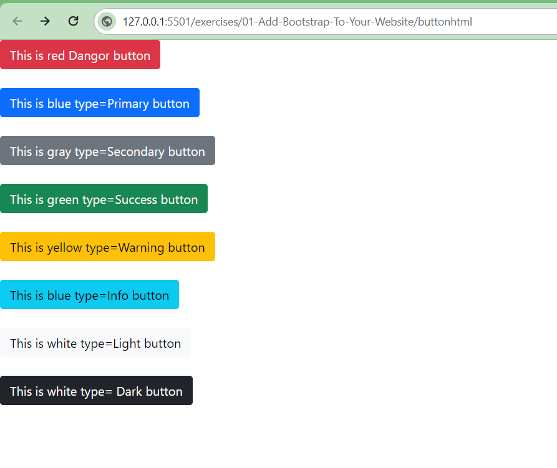

**3.Add navbar**

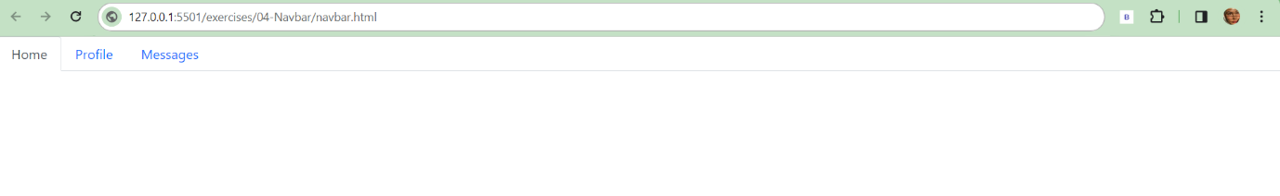

**4.The image will change when width and height less than 600px and 1500px.**

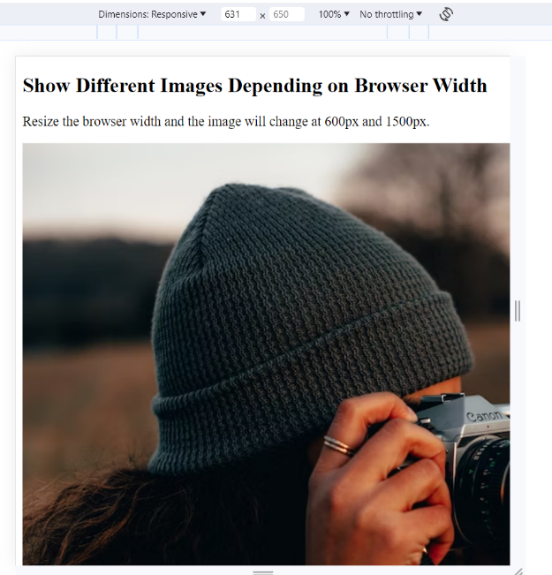

**Intermediate**

**5. Add side bar using bootstrap**

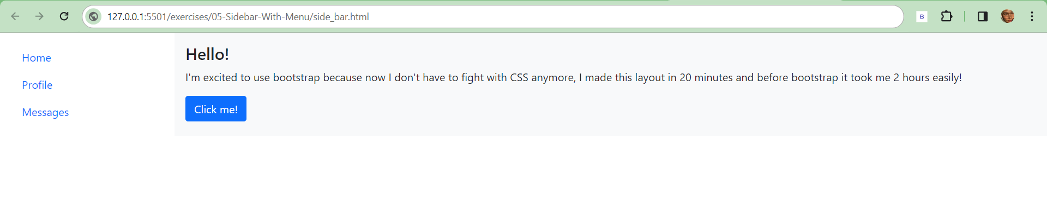

**6.Create the following webpage using Bootstrap**

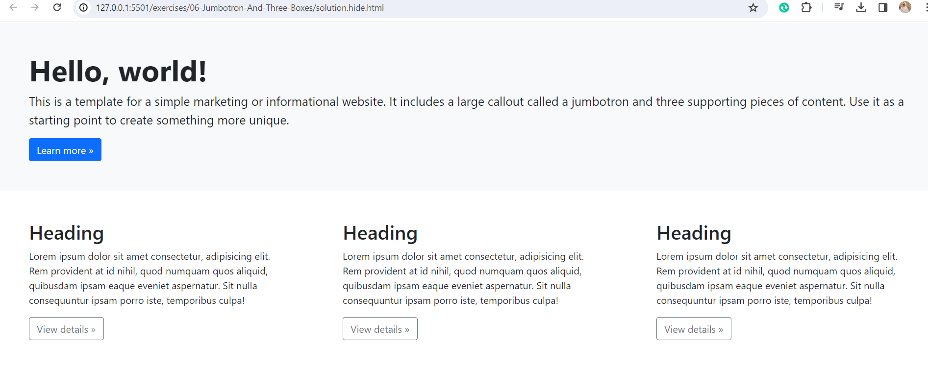

**7.Create the following**

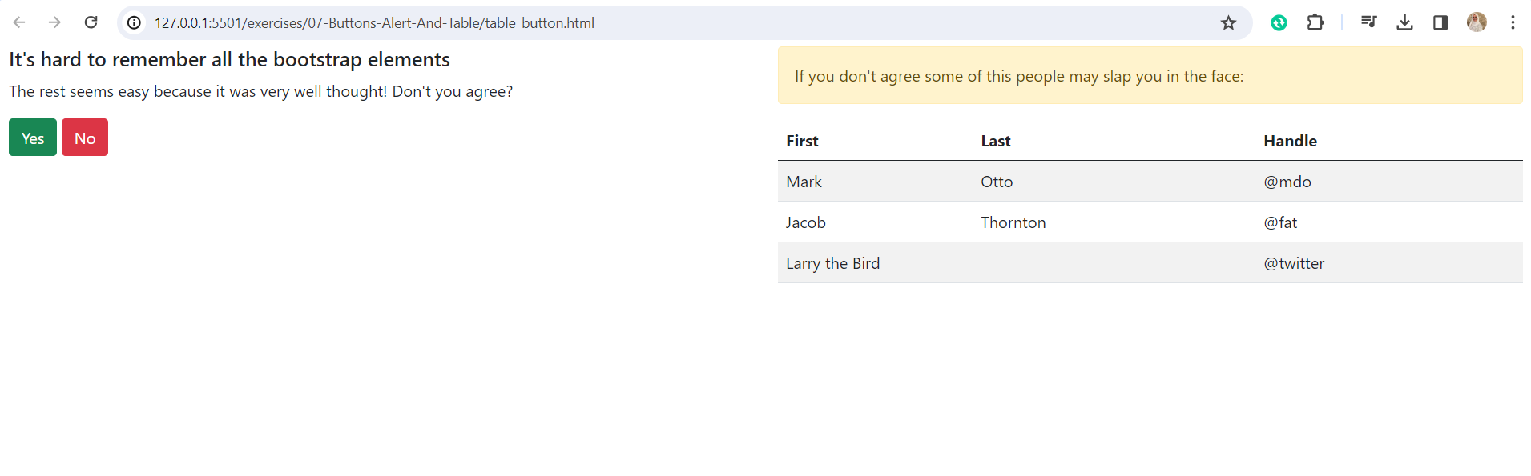

**8. change website layout when width less than 800px**

Before

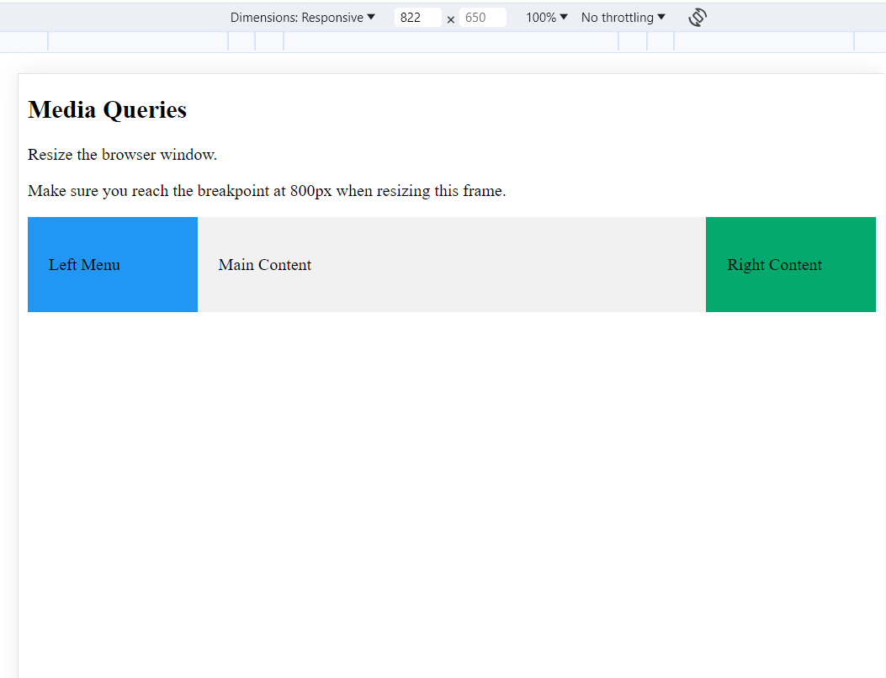

After

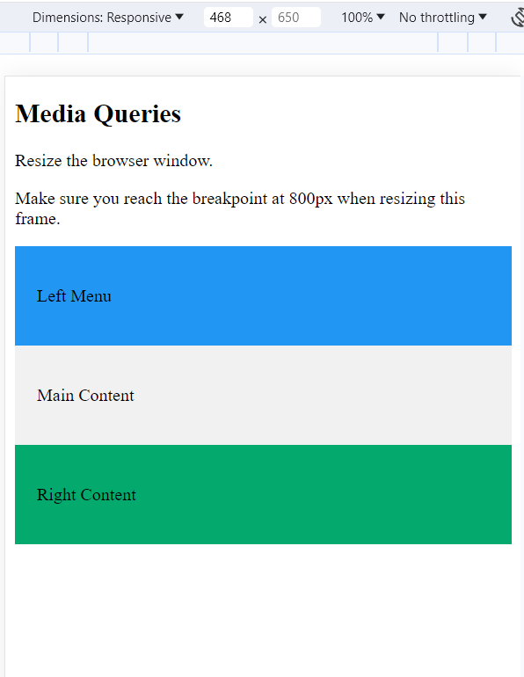

**Advanced**

**9.Create the following website:**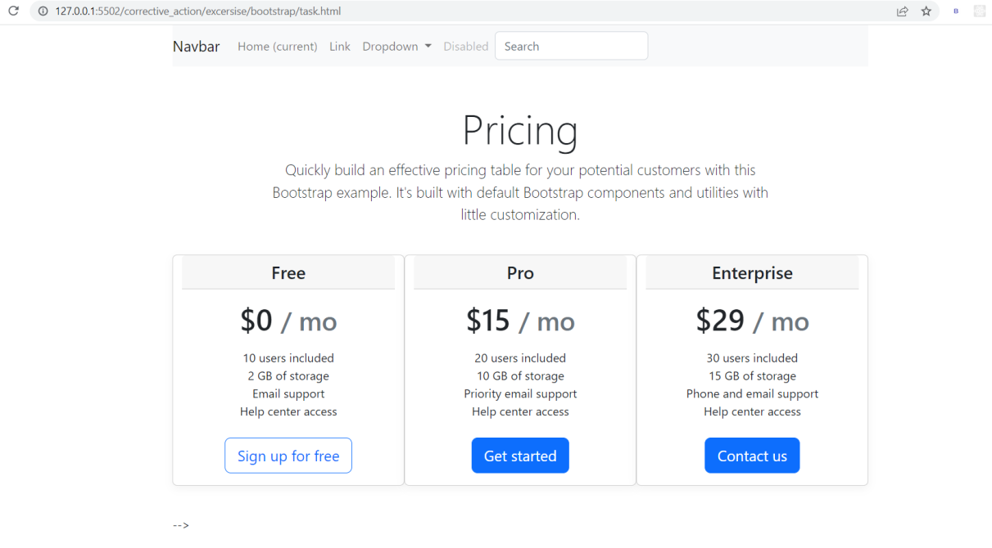

**10.Create login page using bootstrap:**

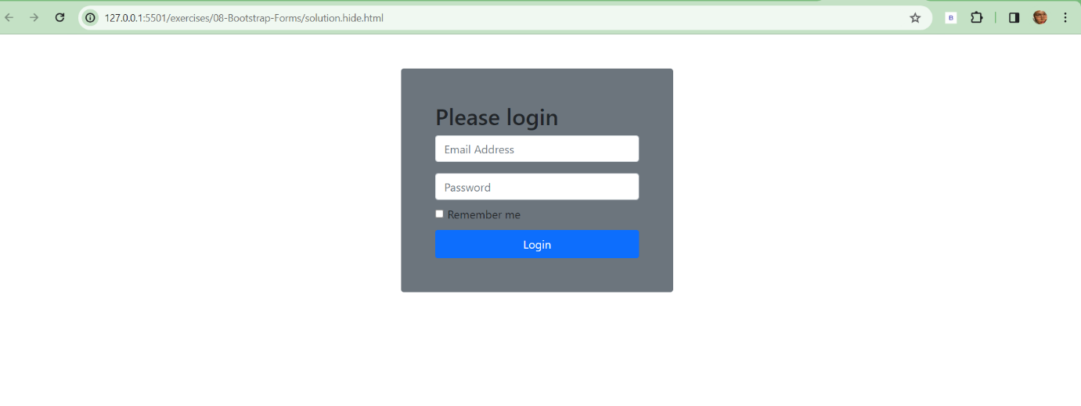

**11.Control website layout:**

(Before)

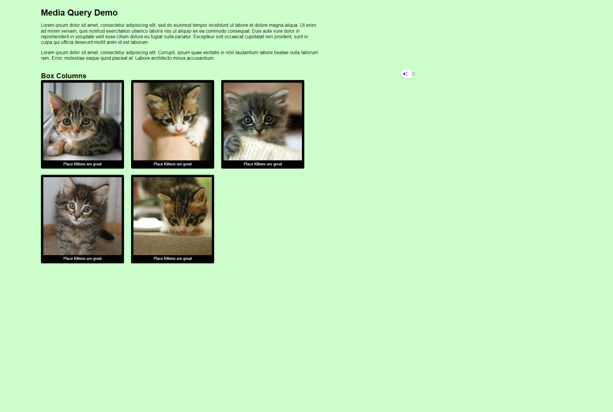

(after)

