TASK 1
A)
Pin Number | Pin Name | Description
1 | MCLR/Vpp | MCLR is used during programming, mostly connected to programmer like PicKit
2 | RA0/AN0 | Analog pin 0 or 0th pin of PORTA
3 | RA1/AN1 | Analog pin 1 or 1st pin of PORTA
4 | RA2/AN2/Vref- | Analog pin 2 or 2nd pin of PORTA
5 | RA3/AN3/Vref+ | Analog pin 3 or 3rd pin of PORTA
6 | RA4/T0CKI/C1out | 4th pin of PORTA
7 | RA5/AN4/SS/C2out | Analog pin 4 or 5th pin of PORTA
8 | RE0/RD/AN5 | Analog pin 5 or 0th pin of PORTE
9 | RE1/WR/AN6 | Analog pin 6 or 1st pin of PORTE
10 | RE2/CS/AN7 | 7th pin of PORTE
11 | Vdd | Ground pin of MCU
12 | Vss | Positive pin of MCU (+5V)
13 | OSC1/CLKI | External Oscillator/clock input pin
14 | OSC2/CLKO | External Oscillator/clock output pin
15 | RC0/T1OSO/T1CKI | 0th pin of PORT C
16 | RC1/T1OSI/CCP2 | 1st pin of POCTC or Timer/PWM pin
17 | RC2/CCP1 | 2nd pin of POCTC or Timer/PWM pin
18 | RC3/SCK/SCL | 3rd pin of POCTC
19 | RD0/PSP0 | 0th pin of POCTD
20 | RD1/PSPI | 1st pin of POCTD
21 | RD2/PSP2 | 2nd pin of POCTD
22 | RD3/PSP3 | 3rd pin of POCTD
23 | RC4/SDI/SDA | 4th pin of POCTC or Serial Data in pin
24 | RC5/SDO | 5th pin of POCTC or Serial Data Out pin
25 | RC6/Tx/CK | 6th pin of POCTC or Transmitter pin of Microcontroller
26 | RC7/Rx/DT | 7th pin of POCTC or Receiver pin of Microcontroller
27 | RD4/PSP4 | 4th pin of POCTD
28 | RD5/PSP5 | 5th pin of POCTD
29 | RD6/PSP6 | 6th pin of POCTD
30 | RD7/PSP7 | 7th pin of POCTD
31 | Vss | Positive pin of MCU (+5V)
32 | Vdd | Ground pin of MCU
33 | RB0/INT | 0th pin of POCTB or External Interrupt pin
34 | RB1 | 1st pin of POCTB
35 | RB2 | 2nd pin of POCTB
36 | RB3/PGM | 3rd pin of POCTB or connected to programmer
37 | RB4 | 4th pin of POCTB
38 | RB5 | 5th pin of POCTB
39 | RB6/PGC | 6th pin of POCTB or connected to programmer
40 | RB7/PGD | 7th pin of POCTB or connected to programmer

B)
1) ALU: it is responsible for making the arithmetic and logic operations such as addition, AND, OR and XOR in 8-bit operands.
2) Status and Control: The Status and Control block contains various flags and control registers that are used to manage the operation of the microcontroller such that, the Status Register (SR) contains flags that indicate the status of the last operation performed by the ALU.
3) Program Counter (PC): The Program Counter is a register that holds the address of the next instruction to be executed. It is automatically incremented after each instruction execution.
4) Flash Program Memory: The Flash Program Memory is where the program code is stored. It is non-volatile, which means that the code remains stored even when the power is turned off. The PIC16f877A has 14KB of Flash Program Memory, which can hold up to 8192 instructions.
5) Instruction Register (IR): The Instruction Register is a temporary storage location that holds the instruction that is currently being executed. The IR is loaded from the Flash Program Memory during instruction fetch cycles.
6) Instruction Decoder: The Instruction Decoder is responsible for decoding the instruction in the IR and generating the control signals that operate the various blocks of the microcontroller. The decoder determines the instruction type and selects the appropriate ALU operation, memory address, and register to be used for the operation.

C)
RA4 :
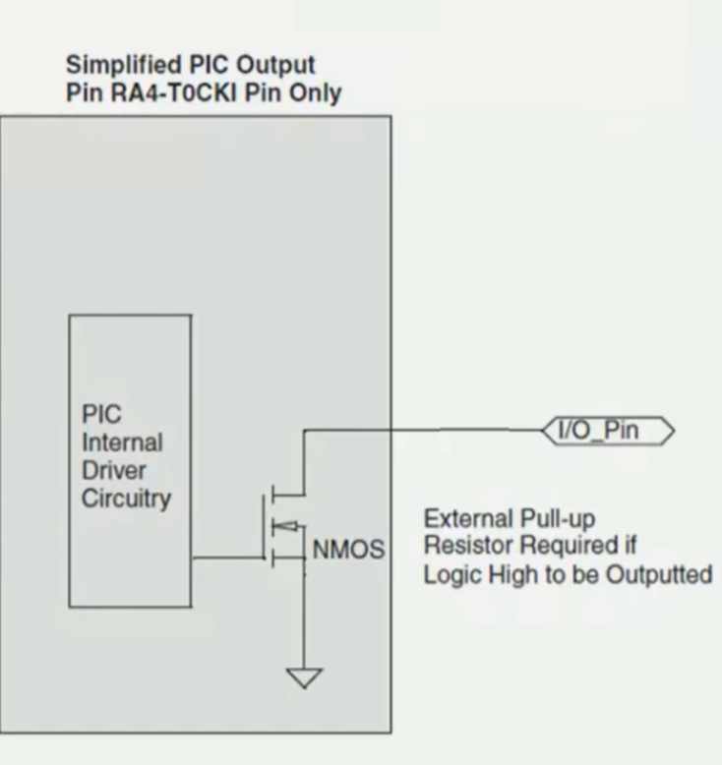
In source case : the anode is connected to ground then if we put porta.b4=0, the cathode will be low which make the led off, and if we make porta.b4=1, the cathode will be high which make it open circuit.
In sink case: the anode is connected to high volt then if we put RA4=0 the cathode will be low which make the led on but if we put RA4=1 then the cathode will be connected to open circuit and the led is off.
So porta.b4 is not preferred to use as output.

D)

 | ATMega328P | PIC16f877A
Memory size | 32KB | 14KB
Power consumption | 3.6mA at 5V | 20mA at 5 V
Pin count | 28 | 40

The 2 examples where atmega328p is better than pic16f877a:
- Battery-powered portable devices: The AtMega328p is known for its low power consumption in comparison, the PIC16f877A has a higher power consumption.
- Audio processing applications: The ATMega328P has a built-In analog-to-digital converter. Additionally, the ATMega328P has a higher clock frequency (up to 20 MHz) compared to the PIC16f877A.

