

FACULTY OF ENGINEERING & TECHNOLOGY
ELECTRICAL AND COMPUTER ENGINEERING DEPARTMENT
ADVANCED DIGITAL DESIGN ENCS3310
COURSE PROJECT

Dr. Abdellatif Abu-Issa

Objective:

The task is to design a generic multiplier structurally using two different algorithms(structures) and then to write a complete code for verification.

The Task:

Your task is to create a clocked library element that has the following appearance:

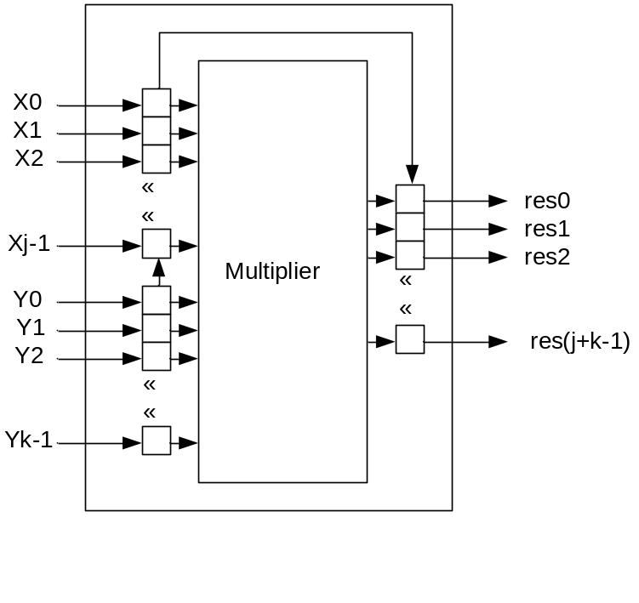

The multiplier has two inputs: the multiplier x which is J bits, and the multiplicand y which is K bits. Also it has one output called res which is J+K bits. The inputs and the output are fed through clocked flip-flops.

Stages of the project:

The project is split into two stages (https://www.electronicshub.org/binary-multiplication/)

Stage 1

The multiplier should multiply J-bits multiplier by K-bits. The Multiplier has the following structural shape (for 4-bit * 4-bit multiplier).

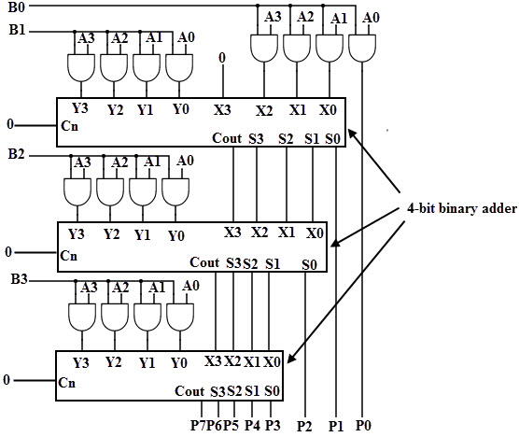

You should produce complete verification to demonstrate the multiplier working with J = 7 and K = 4. Also, you should introduce an error in your design and to do a verification that will discover the error and write it to the console screen and to a file.

Stage 2
The multiplier should multiply J-bits multiplier by K-bits. The Multiplier has the following structural shape.
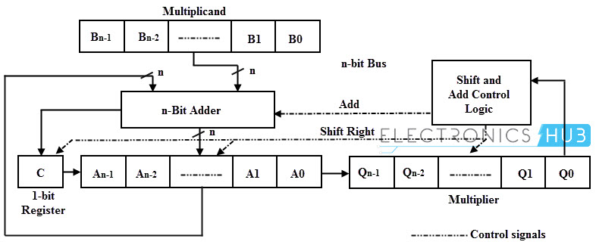
You should produce complete verification to demonstrate the multiplier working with J = 7 and K = 4. Also, you should introduce an error in your design and to do a verification that will discover the error and write it to the console screen and to a file.

Format of the report:
This project should be written as formal report. The report should include sections on the following:
- Brief introduction
- Brief theoretical overview
- Design philosophy
- Simulation Results
- Conclusion and Future works

The report shouldn’t exceed 8 pages (excluding the code) with
- 1.5 line spacing.
- Times new roman.
- Font = 12 point

The code should be included in the appendix. Also the code should be sent as one file with extension .vhd to the instructor.

Key Points:

- Any type of plagiarism will be penalized by 0 mark, and the cheaters will be treated according to the university laws.

- This Project will take 25% of the final mark in the course.

- The design description should include a justification of the decisions made.

- Technical achievement in design is linked to the degree of functionality that was attempted, as explained below.

- Technical achievement in implementation is based on the quality of your VHDL code. This includes issues such as legibility of code, use of meaningful variable names, good comments, clear structure, and modifiability of the design.

- Technical achievement in evaluation is based on the quality of your simulation results.

Mark scheme for technical achievement:

Design Attempted | Successful Implementation, using of comments and meaningful variable names, good simulation, good structure of the code…etc.
Stage 1 | Up to 75%
Stage 1 and 2 | Up to 100%

Deadline:

- The report + Code should be submitted till Friday 21/5/2021 midnight.
- Late submission is penalized at a rate of 10% marks per day.

Assessment Form (Feedback) :

The following is the assessment form for this project.

Electrical and Computer Engineering Department
Project Assessment Feedback
Advanced Digital Design (ENCS3310)

Instructor: Abdellatif Abu-Issa

Marks

Report Presentation (10%)

Language (Spelling and Grammar), style of the report, caption of figures, page
numbering…etc.

Design Process and Outcome (70%)

- Description of the system and design process (20%)

- Technical Achievement in System Design and Evaluation (50%)

Judgement and Creativity (20%)

Demonstration of good judgment, imagination and creativity
in selecting and applying design methods. Good discussion and
analysing of the system and suggested improvements.

Total Mark (Out of 100)

Deducted Marks: late days * 10% per day

FINAL ALLOCATED MARK (Out of 100)

Any evidence for any type of cheating: yes no

