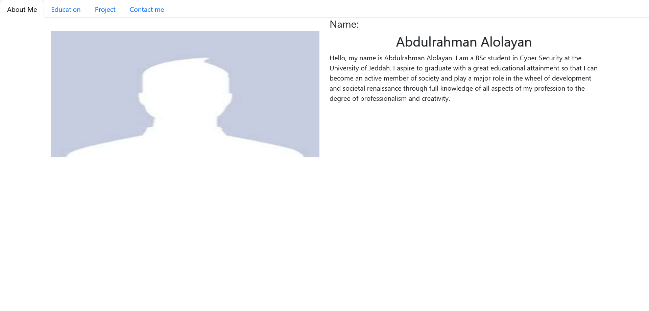

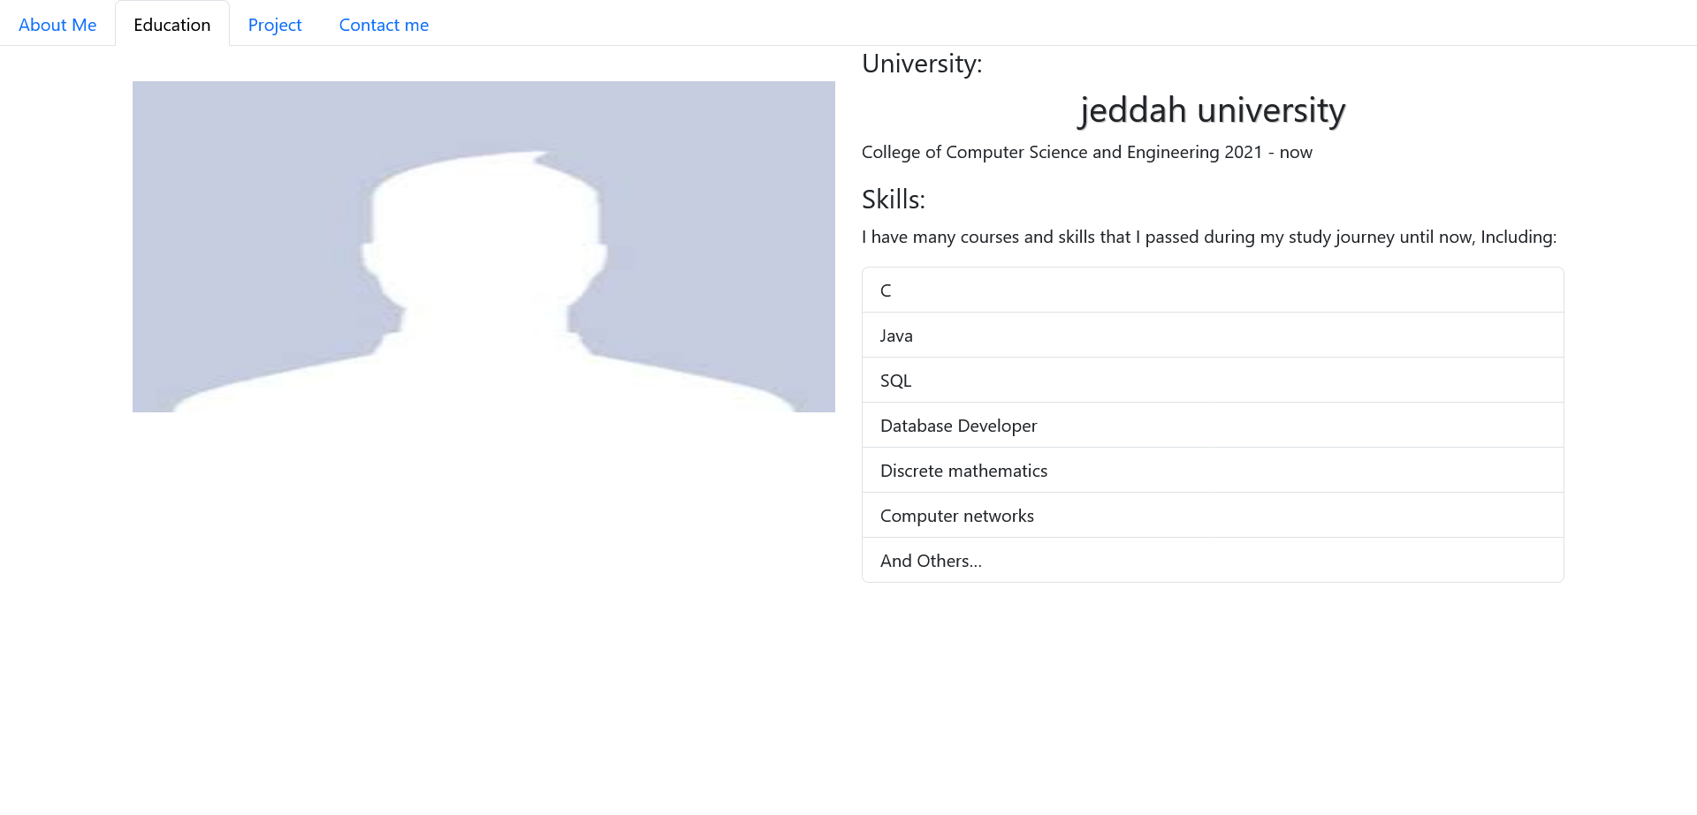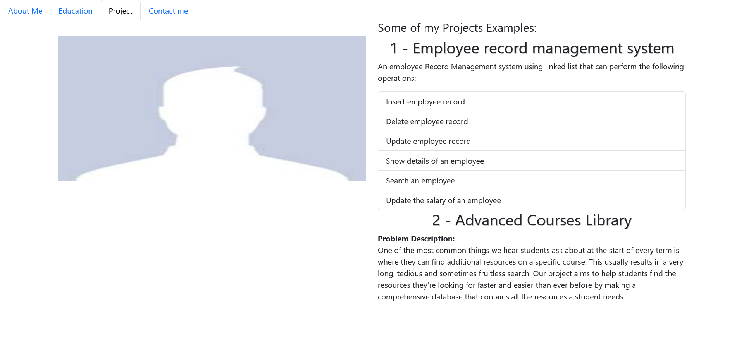

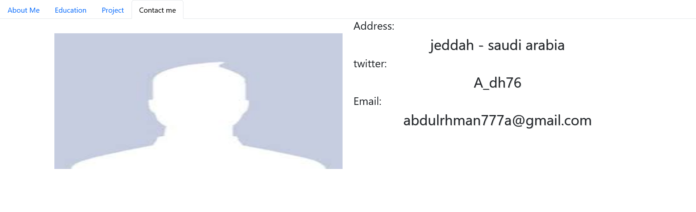

# 992 px

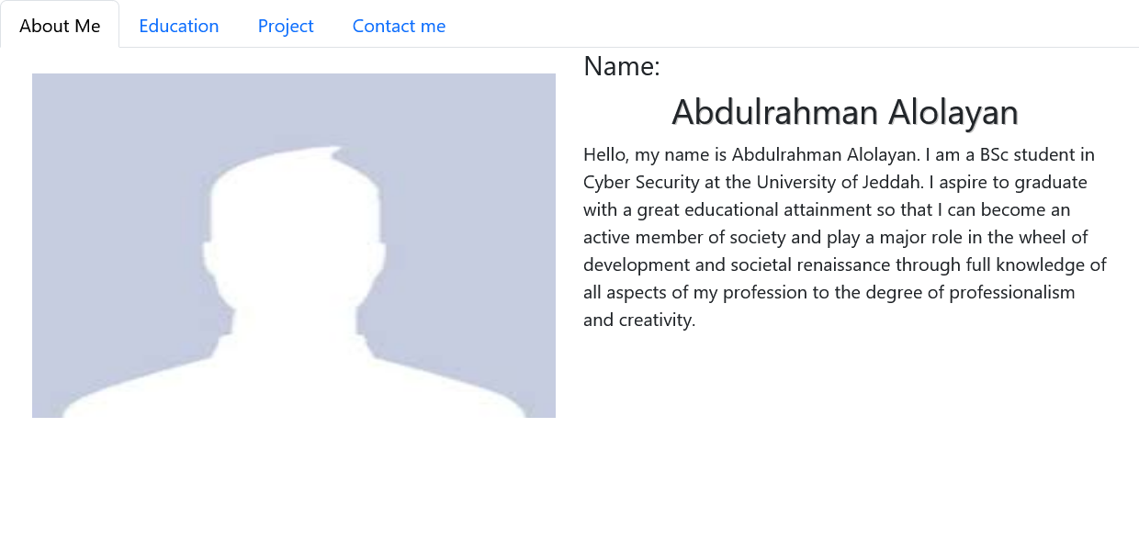

# 768 px

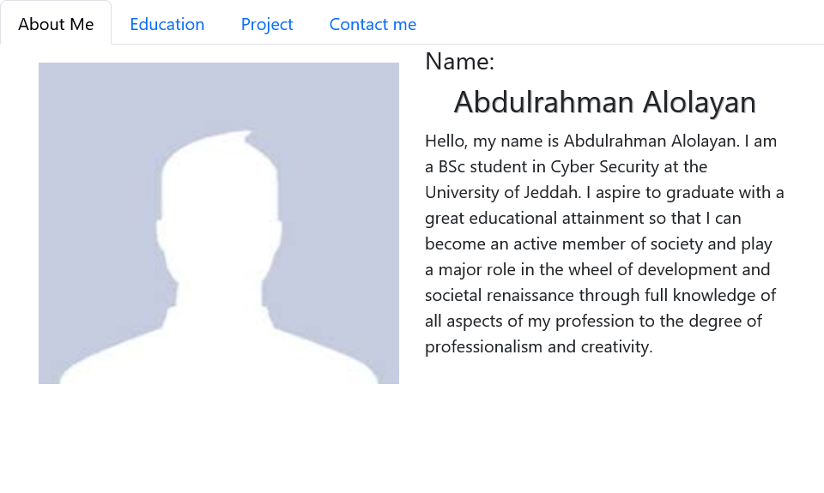

# 576 px

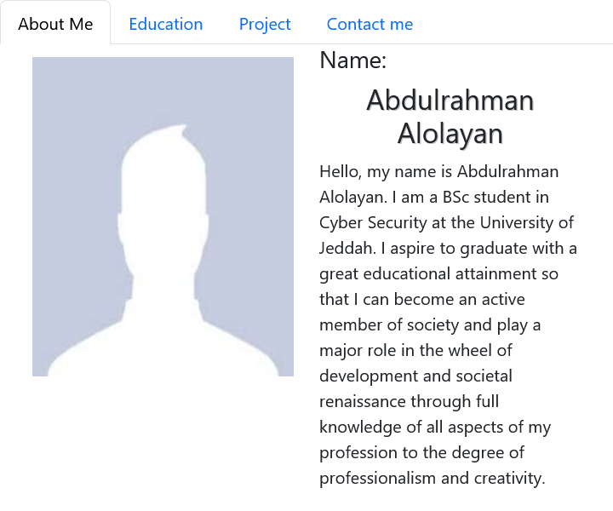

Html validation

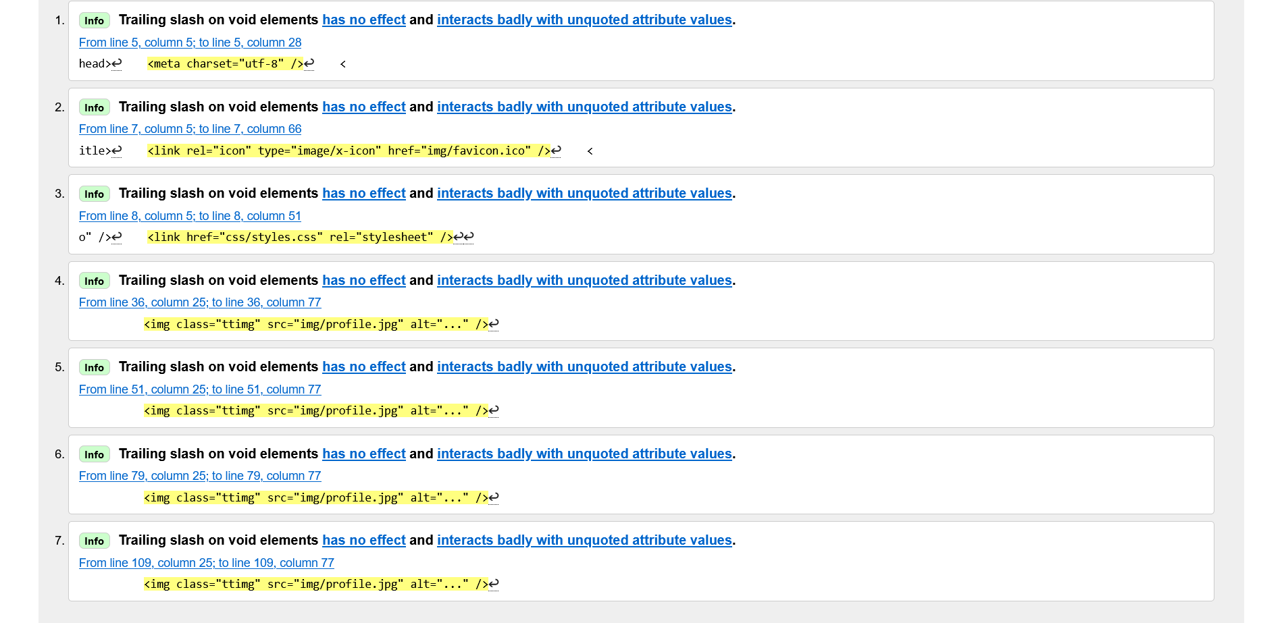

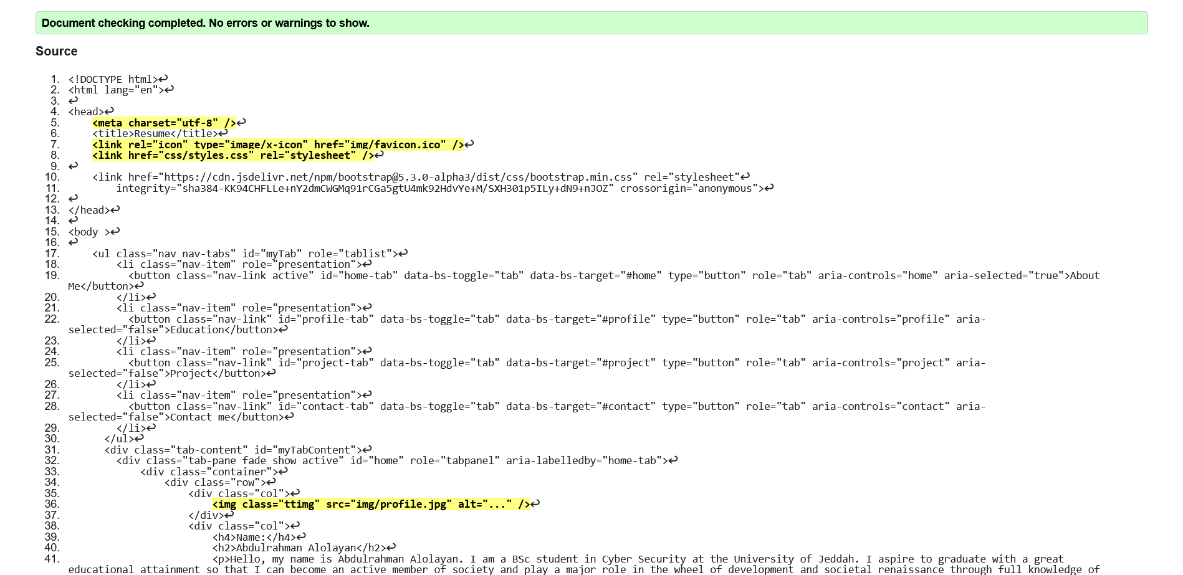

Code

<!DOCTYPE html>

<html lang="en">

<head>

    <meta charset="utf-8" />

    <title>Resume</title>

    <link rel="icon" type="image/x-icon" href="img/favicon.ico" />

    <link href="css/styles.css" rel="stylesheet" />

    <link href="https://cdn.jsdelivr.net/npm/bootstrap@5.3.0-alpha3/dist/css/bootstrap.min.css" rel="stylesheet"

        integrity="sha384-KK94CHFLLe+nY2dmCWGMq91rCGa5gtU4mk92HdvYe+M/SXH301p5ILy+dN9+nJOZ" crossorigin="anonymous">

</head>

<body >

    <ul class="nav nav-tabs" id="myTab" role="tablist">

        <li class="nav-item" role="presentation">

          <button class="nav-link active" id="home-tab" data-bs-toggle="tab" data-bs-target="#home" type="button" role="tab" aria-controls="home" aria-selected="true">About Me</button>

        </li>

        <li class="nav-item" role="presentation">

          <button class="nav-link" id="profile-tab" data-bs-toggle="tab" data-bs-target="#profile" type="button" role="tab" aria-controls="profile" aria-selected="false">Education</button>

        </li>

        <li class="nav-item" role="presentation">

          <button class="nav-link" id="project-tab" data-bs-toggle="tab" data-bs-target="#project" type="button" role="tab" aria-controls="project" aria-selected="false">Project</button>

        </li>

        <li class="nav-item" role="presentation">

          <button class="nav-link" id="contact-tab" data-bs-toggle="tab" data-bs-target="#contact" type="button" role="tab" aria-controls="contact" aria-selected="false">Contact me</button>

        </li>

      </ul>

      <div class="tab-content" id="myTabContent">

        <div class="tab-pane fade show active" id="home" role="tabpanel" aria-labelledby="home-tab">

            <div class="container">

                <div class="row">

                    <div class="col">

                        <img class="ttimg" src="img/profile.jpg" alt="..." />

                    </div>

                    <div class="col">

                        <h4>Name:</h4>

                        <h2>Abdulrahman Alolayan</h2>

                        <p>Hello, my name is Abdulrahman Alolayan. I am a BSc student in Cyber Security at the University of Jeddah. I aspire to graduate with a great educational attainment so that I can become an active member of society and play a major role in the wheel of development and societal renaissance through full knowledge of all aspects of my profession to the degree of professionalism and creativity.</p>

                    </div>

                </div>

            </div>

        </div>

        <div class="tab-pane fade" id="profile" role="tabpanel" aria-labelledby="profile-tab">

            <div class="container">

                <div class="row">

                    <div class="col">

                        <img class="ttimg" src="img/profile.jpg" alt="..." />

                    </div>

                    <div class="col">

                        <h4>University:</h4>

                        <h2>jeddah university</h2>

                        <p>College of Computer Science and Engineering

                            2021 - now</p>

                        <h4>Skills:</h4>

                        <p>I have many courses and skills that I passed during my study journey until now, Including: </p>

                        <ul class="list-group">

                            <li  class="list-group-item">C</li>

                            <li  class="list-group-item"> Java</li>

                            <li class="list-group-item"> SQL</li>

                            <li class="list-group-item">Database Developer </li>

                            <li class="list-group-item">Discrete mathematics  </li>

                            <li class="list-group-item">Computer networks  </li>

                            <li class="list-group-item">And Others… </li>

                        </ul>

                    </div>

                </div>

            </div>

        </div>

        <div class="tab-pane fade" id="project" role="tabpanel" aria-labelledby="project-tab">

            <div class="container">

                <div class="row">

                    <div class="col">

                        <img class="ttimg" src="img/profile.jpg" alt="..." />

                    </div>

                    <div class="col">

                        <h4>Some of my Projects Examples:</h4>

                        <h2>1 - Employee record management system</h2>

                        <p>An employee Record Management system using linked list that can perform the following operations:</p>

                        <ul class="list-group">

                            <li  class="list-group-item"> Insert employee record</li>

                            <li  class="list-group-item"> Delete employee record</li>

                            <li class="list-group-item"> Update employee record</li>

                            <li class="list-group-item">Show details of an employee </li>

                            <li class="list-group-item">Search an employee </li>

                            <li class="list-group-item">Update the salary of an employee  </li>

                        </ul>

                        <h2>2 - Advanced Courses Library</h2>

                        <b>Problem Description:</b>

                        <p>One of the most common things we hear students ask about at the start of every term is where they can find additional resources on a specific course. This usually results in a very long, tedious and sometimes fruitless search.

                            Our project aims to help students find the resources they're looking for faster and easier than ever before by making a comprehensive database that contains all the resources a student needs</p>

                    </div>

                </div>

            </div>

        </div>

        <div class="tab-pane fade" id="contact" role="tabpanel" aria-labelledby="contact-tab">

            <div class="container">

                <div class="row">

                    <div class="col">

                        <img class="ttimg" src="img/profile.jpg" alt="..." />

                    </div>

                    <div class="col">

                        <h4>Address:</h4>

                        <h2>jeddah - saudi arabia</h2>

                        <h4>twitter:</h4>

                        <h2> A_dh76 </h2>

                        <h4>Email:</h4>

                        <h2> abdulrhman777a@gmail.com </h2>

                    </div>

                </div>

            </div>

        </div>

      </div>

      <script src="https://cdn.jsdelivr.net/npm/bootstrap@5.2.3/dist/js/bootstrap.bundle.min.js" integrity="sha384-kenU1KFdBIe4zVF0s0G1M5b4hcpxyD9F7jL+jjXkk+Q2h455rYXK/7HAuoJl+0I4" crossorigin="anonymous"></script>

</body>

</html>