

**Arab International University**

**Faculty of Informatics and Communication Engineering**

**Fuzzy Project Report on**

**Predict Chaotic Time-Series**

Submitted to

Department of Informatics Engineering

Submitted by

**Abdalrahman Almalah Ezzat Almalm**

Under the Supervision of:

**Tarek Barhoum**

**May 2023**

**© AIU Arab International University**

**All Rights Reserved**

**30 May 2023**

**Contents:**

Chapter 1: Abstract

**1.1Aim of the projet*:*** *…………………………………………………………………………………………….****5***

Chapter 2:

**System input, output and Type:** *………………………………………………………………………………****6***

Chapter 3:

Input and Output membership functions:

**3.1 Input membership function:**

*………………………………………………………………………………………………………………………..****7***

**3.2 Output membership function**: *…………………………………………………………………………………………………………………………****7***

**3.3 System Result**  *…………………………………………………………………………………………………………………………..****7***

Chapter 4:

***Dataset:*** *………………………………………………………………………………………………………………..****8***

Chapter 5:

**ANFIS FIS Structure:** *……………………………………………………………………………………………….****8***

Chapter 6:

**Compare Original and Predicted Series:** *……………………………………………………………………………………………………………………..…****9***

**6.1 Sample Result:** *……………………………………………………………………………………………………………………..…****10***

**6.2 Refrance:** *……………………………………………………………………………………………………………………..…****10***

**Chapter 1:** **Abstract**

**1.1Aim of project:**

The aim of this project is to use Adaptive Neuro-Fuzzy Inference System (ANFIS) to predict a chaotic time-series generated by the Mackey-Glass equation. The project focuses on training an ANFIS model using the provided time series data and evaluating its performance in predicting future values.

This time series is chaotic with no clearly defined period. The series does not converge or diverge, and the trajectory is highly sensitive to initial conditions. This benchmark problem is used in the neural network and fuzzy modeling research communities.

To obtain the time series value at integer points, the fourth-order Runge-Kutta method was used to find the numerical solution to the previous MG equation. It was assumed that *x*(0)=1.2, *τ*=17, and *x*(*t*)=0 for *t*<0. The result was saved in the file mgdata.dat.

Load and plot the MG time series

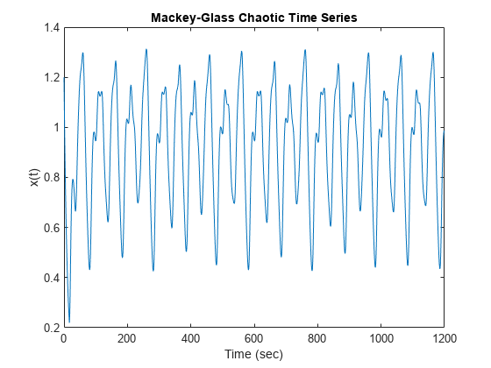

**Chapter2: System Inputs Output and Type:**

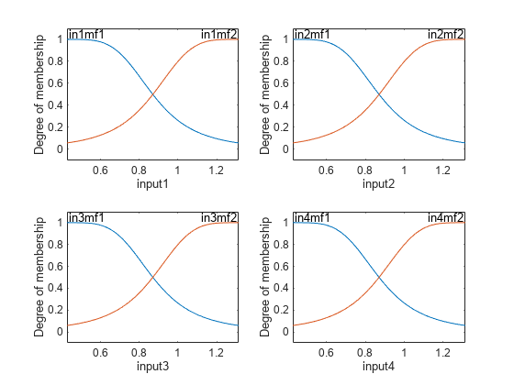

The generated FIS object contains 24 = 16 fuzzy rules with 104 parameters (24 nonlinear parameters and 80 linear parameters). To achieve good generalization capability, it is important that the number of training data points be several times larger than the number parameters being estimated. In this case, the ratio between data and parameters is approximately five (500/104), which is a good balance between fitting parameters and training sample points.

**System Inputs:**

The ANFIS model takes a four-dimensional input vector, denoted as w(t), at each time point. The elements of w(t) are defined as follows: w(t) = [x(t-19), x(t-12), x(t-6), x(t)]

**System Output:**

The ANFIS model predicts the future value of the time series, denoted as s(t), at each time point.

s(t) = x(t+6)

**Type:**

The ANFIS model used in this project is based on the Sugeno type fuzzy inference system.

**Chapter 3: Input and output membership function:**

3.1 Input Membership Functions**:**

The input membership functions are determined automatically by the genfis function with grid partitioning. By default, two generalized bell membership functions are created for each input variable (four inputs in total).

**3.2 Output Membership Functions:**

The output membership functions are determined based on the training data and the fuzzy inference rules learned by the ANFIS model.

**3.3 System Results:**

The ANFIS model learns the fuzzy inference rules from the training data. The number of fuzzy rules in the trained model is 16.

**Chapter 4: Dataset:**

The dataset used in this project consists of 1000 input/output training samples, derived from the Mackey-Glass time series. The first 500 samples are used for training (trnData), and the second 500 samples are used for validation (chkData).

**Chapter 5:ANFIS FIS Structure:**

The ANFIS model is constructed using the grid partitioning method to determine the initial fuzzy inference system. The grid partitioning creates equally spaced and comprehensive membership functions for each input variable.

ANFIS info:

Number of nodes: 55

Number of linear parameters: 80

Number of nonlinear parameters: 24

Total number of parameters: 104

Number of training data pairs: 500

Number of checking data pairs: 500

Number of fuzzy rules: 16

Designated epoch number reached. ANFIS training completed at epoch 10.

Minimal training RMSE = 0.00254972

Minimal checking RMSE = 0.00250247

fis1 is the trained fuzzy inference system for the training epoch where the training error is smallest. Since you specified validation data, the fuzzy system with the minimum checking error, fis2, is also returned. The FIS with the smallest checking error shows the best generalization beyond the training data.

.

**Chapter 6 : Compare Original and Predicted Series:**

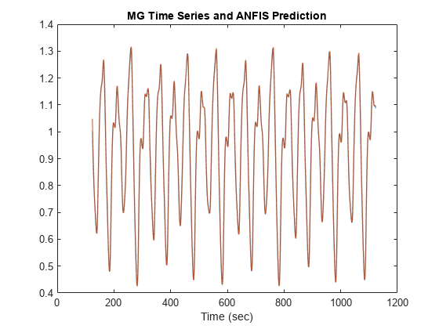

To check prediction capability of the trained system, evaluate the fuzzy system using the training and checking data, and plot the result alongside the origina

The predicted series is similar to the original series.

6.1 Sample of Results: 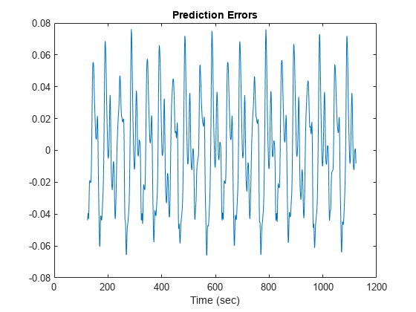

The scale of the prediction error plot is about one-hundredth of the scale of the time-series plot. In this example, you trained the system for only 10 epoch. Training for additional epochs can improve the training results.

6.2 Reference : [MathWorks - MATLAB and Simulink Conferences - MATLAB & Simulink](https://ch.mathworks.com/)