SPI Slave with Single Port RAM
Project Documentation Report
Prepared by: Abdalrahman Hamdy Ashry
Course: Digital Electronics / RTL Design

Member Name | Certificate Name | ID / Role
[Insert Name] | [Insert Certificate Name] | [Insert ID]
[Insert Name] | [Insert Certificate Name] | [Insert ID]
[Insert Name] | [Insert Certificate Name] | [Insert ID]

1.RTL
A. Single-Port Synchronous RAM
// Single-Port Synchronous RAM
module ram #(
parameter MEM_DEPTH = 256,
parameter ADDR_SIZE = 8
)(
input wire clk,
input wire rst_n,
input wire [ADDR_SIZE+1:0] din,
input wire rx_valid,
output reg [ADDR_SIZE-1:0] dout,
output reg tx_valid
);
// State encoding for the SPI commands
localparam WRITE_ADDR = 2'b00 ;
localparam WRITE_DATA = 2'b01 ;
localparam READ_ADDR = 2'b10 ;
localparam READ_DATA = 2'b11 ;
// RAM memory array
reg [ADDR_SIZE-1:0] RAM [MEM_DEPTH-1:0];
// Address registers for read and write operations
reg [ADDR_SIZE-1:0] rx_addr;
reg [ADDR_SIZE-1:0] wr_addr;
// Sequential logic for handling read and write operations
always @(posedge clk) begin
if (!rst_n) begin // reset condition
dout <= {ADDR_SIZE{1'b0}};
tx_valid <= 1'b0;
wr_addr <= {ADDR_SIZE{1'b0}};
rx_addr <= {ADDR_SIZE{1'b0}};

end
else begin
// default value
tx_valid <= 1'b0;
if (rx_valid) begin
case (din[ADDR_SIZE+1:ADDR_SIZE])
WRITE_ADDR : wr_addr <= din[ADDR_SIZE-1:0]; // store the write address
WRITE_DATA : RAM[wr_addr] <= din[ADDR_SIZE-1:0]; // write data to RAM at the stored address
READ_ADDR : rx_addr <= din[ADDR_SIZE-1:0]; // store the read address
READ_DATA : begin // read data from RAM at the stored address
dout <= RAM [rx_addr];
tx_valid <= 1'b1;
end
default : ;
endcase
end
end
end
endmodule

B. SPI Slave FSM Interface
// SPI Slave FSM Interface
module spi_slave #(
parameter ADDR_SIZE = 8
)
(
input wire clk,
input wire rst_n,
input wire SS_n,
input wire MOSI,
input wire [ADDR_SIZE-1:0] tx_data,
input wire tx_valid,
output reg [ADDR_SIZE+1:0] rx_data,
output reg rx_valid,
output reg MISO
);
// 1.FSM state encoding
// local parameters for the SPI states
// Sequential logic for the SPI Slave FSM
localparam IDLE = 3'b000;
localparam CHK_CMD = 3'b001;
localparam WRITE = 3'b010;
localparam READ_ADD = 3'b011;
localparam READ_DATA= 3'b100;
// current and next state registers
(* fsm_encoding = "one_hot" *) reg [2:0] curr_state , next_state;

reg [3:0] bit_counter;
reg [ADDR_SIZE+1:0] rx_shift_reg;
// 10 bit shift register for transmitting data
reg [ADDR_SIZE-1:0] tx_shift_reg;
// Flag to track read address step
reg rd_addr_received;

// 1. counter & shift in Logic (MOSI -> rx_data) & shift out Logic (RAM -> MISO)
// (Synchronous Reset)
always @(posedge clk ) begin
if (!rst_n) begin
rx_data <= {(ADDR_SIZE+2){1'b0}};
rx_shift_reg <= {(ADDR_SIZE+2){1'b0}};
tx_shift_reg <= {(ADDR_SIZE){1'b0}};
MISO <= 1'b0;
bit_counter <= 4'd0;
rd_addr_received <= 1'b0;
end
else begin
if (SS_n) begin
bit_counter <= 4'd0;
MISO <= 1'b0;
end
else begin
rx_shift_reg <= {rx_shift_reg[ADDR_SIZE:0],MOSI};
//shift in MOSI data
if (bit_counter == 4'd9) begin
rx_data <= {rx_shift_reg[ADDR_SIZE:0],MOSI};
bit_counter <= 4'd0;

if (rx_shift_reg[ADDR_SIZE] == 1'b1 && rx_shift_reg[ADDR_SIZE-1] == 1'b0)
rd_addr_received <= 1'b1;

else if (rx_shift_reg[ADDR_SIZE] == 1'b1 && rx_shift_reg[ADDR_SIZE-1] == 1'b1)
rd_addr_received <= 1'b0;
end
else begin
bit_counter <= bit_counter + 1'b1;
end
// shift out
if (curr_state == READ_DATA) begin
if (tx_valid) begin
MISO <= tx_data[ADDR_SIZE-1];
tx_shift_reg <= {tx_data[ADDR_SIZE-2:0], 1'b0};
end
else begin
MISO <= tx_shift_reg[ADDR_SIZE-1];
tx_shift_reg <= {tx_shift_reg[ADDR_SIZE-2:0], 1'b0};
end
end
else begin
MISO <= 1'b0;
end

end
end
end

// 2. STATE MEM
always @(posedge clk ) begin
if (!rst_n) begin
curr_state <= IDLE;
end
else begin
curr_state <= next_state;
end
end

// 3. Next state logic
always @(*) begin
case (curr_state)
IDLE: begin
if (!SS_n) next_state = CHK_CMD;
else next_state = IDLE;
end
CHK_CMD: begin
if (SS_n)
next_state = IDLE;
else if (bit_counter == 4'd9) begin
// MOSI is sampled on posedge, checking incoming bit:
if (rx_shift_reg[ADDR_SIZE] == 1'b0)
next_state = WRITE;
else begin
if (rx_shift_reg[ADDR_SIZE-1] == 1'b0)
next_state = READ_ADD;
else
next_state = READ_DATA;
end
end
else
next_state = CHK_CMD;
end
WRITE:begin
if(SS_n) next_state = IDLE;
else next_state = WRITE;
end

READ_ADD:begin
if(SS_n) next_state = IDLE;
else next_state = READ_ADD;
end
READ_DATA:begin
if(SS_n ) next_state = IDLE;
else next_state = READ_DATA;
end

default: next_state = IDLE;
endcase
end

// 4. output logic
always @(posedge clk) begin
if (!rst_n) rx_valid <= 1'b0;
else begin
if (!SS_n && curr_state == CHK_CMD && bit_counter == 4'd9)
rx_valid <= 1'b1;
else rx_valid <= 1'b0;
end
end
endmodule

C. Top Level Wrapper connecting SPI Slave and RAM
// Top Level Wrapper connecting SPI Slave and RAM
module spi_wrapper (
input wire clk,
input wire rst_n,
input wire SS_n,
input wire MOSI,
output wire MISO
);

wire [9:0] rx_data_wire;
wire rx_valid_wire;
wire [7:0] tx_data_wire;
wire tx_valid_wire;

// SPI Slave Instance
spi_slave #(.ADDR_SIZE(8))
u_spi_slave (
.clk(clk),
.rst_n(rst_n),
.SS_n(SS_n),
.MOSI(MOSI),
.rx_data(rx_data_wire),
.rx_valid(rx_valid_wire),
.tx_data(tx_data_wire),
.tx_valid(tx_valid_wire),
.MISO(MISO)
);

// Single Port RAM Instance
ram #(.MEM_DEPTH(256),
.ADDR_SIZE(8))
u_ram (
.clk(clk),
.rst_n(rst_n),
.din(rx_data_wire),
.rx_valid(rx_valid_wire),
.dout(tx_data_wire),
.tx_valid(tx_valid_wire)

);

endmodule

Run.do
# --- 1. Create and map work library ---
vlib work
vmap work work

# --- 2. Compile RTL and Testbench files ---
vlog -reportprogress 300 ./ram.v
vlog -reportprogress 300 ./spi_slave.v
vlog -reportprogress 300 ./spi_wrapper.v
vlog -reportprogress 300 ./spi_wrapper_tb.v

# --- 3. Load the design ---
vsim -voptargs="+acc" work.spi_wrapper_tb

# --- 4. Clear old waves and add all signals clearly ---
delete wave *

add wave -noupdate -divider {SPI Master Signals}
add wave -color Cyan /spi_wrapper_tb/clk
add wave -color Yellow /spi_wrapper_tb/rst_n
add wave -color Magenta /spi_wrapper_tb/SS_n
add wave -color Green /spi_wrapper_tb/MOSI
add wave -color Green /spi_wrapper_tb/MISO

add wave -noupdate -divider {SPI Slave FSM & Registers}
add wave -radix unsigned -color Orange /spi_wrapper_tb/uut/u_spi_slave/curr_state
add wave -radix unsigned -color Khaki /spi_wrapper_tb/uut/u_spi_slave/bit_counter
add wave -radix hexadecimal -color Pink /spi_wrapper_tb/uut/u_spi_slave/rx_shift_reg
add wave -radix hexadecimal -color Pink /spi_wrapper_tb/uut/u_spi_slave/tx_shift_reg

add wave -noupdate -divider {RAM Interface (Valid & Data)}
add wave -radix hexadecimal -color DodgerBlue /spi_wrapper_tb/uut/u_spi_slave/rx_data
add wave -color Yellow /spi_wrapper_tb/uut/u_spi_slave/rx_valid
add wave -radix hexadecimal -color DodgerBlue /spi_wrapper_tb/uut/u_spi_slave/tx_data
add wave -color Yellow /spi_wrapper_tb/uut/u_spi_slave/tx_valid

# --- 5. Run simulation ---
run -all

# --- 6. Zoom to fit whole simulation wave ---
wave zoomfull

2. TB
`timescale 1ns / 1ps

module spi_wrapper_tb;

reg clk;
reg rst_n;
reg SS_n;
reg MOSI;
wire MISO;

integer error_count = 0;
integer test_count = 0;

// Instantiate Top Level Module (Wrapper)
spi_wrapper uut (
.clk(clk),
.rst_n(rst_n),
.SS_n(SS_n),
.MOSI(MOSI),
.MISO(MISO)
);

// Clock Generation (100MHz -> 10ns period)
always #5 clk = ~clk;

// Task 1: Send 10 bits serially over MOSI
task send_10bit(input [9:0] data_in);
integer i;
begin
@(negedge clk);
#1;
SS_n = 1'b0; // Activate slave

for (i = 9; i >= 0; i = i - 1) begin
MOSI = data_in[i];
@(negedge clk);
#1;
end
end
endtask

// Task 2: Read data from MISO with aligned sampling
task receive_and_check_8bit(input [7:0] expected_data);
integer i;
reg [7:0] rx_byte;
begin
rx_byte = 8'h00;

repeat(2) @(posedge clk);
#1;

for (i = 7; i >= 0; i = i - 1) begin
rx_byte[i] = MISO;
if (i > 0) begin
@(posedge clk);
#1;
end
end

@(negedge clk);
#1;
SS_n = 1'b1;

test_count = test_count + 1;
if (rx_byte === expected_data) begin
$display("\033[1;32m [PASS] Test %0d: Expected = 0x%0h | Read = 0x%0h \033[0m", test_count, expected_data, rx_byte);
end else begin
$display(" [FAIL] Test %0d: Expected = 0x%0h | Read = 0x%0h", test_count, expected_data, rx_byte);
error_count = error_count + 1;
end

repeat (2) @(negedge clk);
#1;
end
endtask

// Task 3: Complete SPI Transaction Sequence
task run_spi_transaction(input [7:0] addr, input [7:0] write_data);
begin
$display("\033[1;36m\n---> Transaction: Addr=0x%0h Data=0x%0h\033[0m", addr, write_data);

send_10bit({2'b00, addr});
SS_n = 1'b1;
repeat (2) @(negedge clk); #1;

send_10bit({2'b01, write_data});
SS_n = 1'b1;
repeat (2) @(negedge clk); #1;

send_10bit({2'b10, addr});
SS_n = 1'b1;
repeat (2) @(negedge clk); #1;

send_10bit(10'b11_00000000);
receive_and_check_8bit(write_data);
end
endtask

// Initial Block - Explicit 25 Directed Test Cases Execution
initial begin
clk = 0;
rst_n = 0;
SS_n = 1;
MOSI = 0;

#25;
rst_n = 1;
#25;

$display("=================================");
$display(" STARTING AUTOMATED SELF-CHECKING TB ");
$display("===============================");

// LEVEL 1: BASIC SANITY TESTS
$display("\n---> [LEVEL 1] Basic Sanity Tests");
run_spi_transaction(8'h01, 8'h10); // Test 1
run_spi_transaction(8'h02, 8'h20); // Test 2
run_spi_transaction(8'h05, 8'h0F); // Test 3
run_spi_transaction(8'h0A, 8'h05); // Test 4
run_spi_transaction(8'h0F, 8'h33); // Test 5

// LEVEL 2: CORNER BOUNDARIES
$display("\n---> [LEVEL 2] Corner Boundaries");
run_spi_transaction(8'h00, 8'h00); // Test 6
run_spi_transaction(8'hFF, 8'hFF); // Test 7
run_spi_transaction(8'h00, 8'hFF); // Test 8
run_spi_transaction(8'hFF, 8'h00); // Test 9
run_spi_transaction(8'h01, 8'h80); // Test 10
run_spi_transaction(8'h80, 8'h01); // Test 11
run_spi_transaction(8'h7F, 8'h80); // Test 12

// LEVEL 3: SIGNAL TOGGLING
$display("\n---> [LEVEL 3] Signal Toggling");
run_spi_transaction(8'hAA, 8'h55); // Test 13
run_spi_transaction(8'h55, 8'hAA); // Test 14
run_spi_transaction(8'hC3, 8'h3C); // Test 15
run_spi_transaction(8'hF0, 8'h0F); // Test 16
run_spi_transaction(8'hE7, 8'h18); // Test 17
run_spi_transaction(8'h81, 8'h7E); // Test 18
run_spi_transaction(8'h69, 8'h96); // Test 19

// LEVEL 4: STRESS TESTS
$display("\n---> [LEVEL 4] Stress Tests");
run_spi_transaction(8'h13, 8'hA7); // Test 20
run_spi_transaction(8'hB4, 8'h2E); // Test 21
run_spi_transaction(8'h4D, 8'hB2); // Test 22
run_spi_transaction(8'h9A, 8'h6C); // Test 23
run_spi_transaction(8'hDE, 8'hAD); // Test 24
run_spi_transaction(8'hBE, 8'hEF); // Test 25

// FINAL SUMMARY REPORT
#100;
$display("\n================================");
$display(" TEST SUMMARY RESULT ");
$display("===============================================");
$display(" Total Tests Executed : %0d", test_count);
if (error_count == 0) begin
$display(" STATUS : ALL 25 TESTS PASSED! 🎉");
end else begin
$display(" STATUS : FAILED WITH %0d ERRORS ❌",error_count);
end
$display("===========================================\n");

$finish;
end

endmodule

1. QuestaSim Simulation Waveforms
Paste the captured waveforms from QuestaSim showing inputs assigned (clk, rst_n, SS_n, MOSI) and outputs visible (MISO, internal signals). Ensure write and read state transitions are clear.
[ PASTE SCREENSHOT HERE: 1. QuestaSim Simulation Waveforms - Image 1 ]
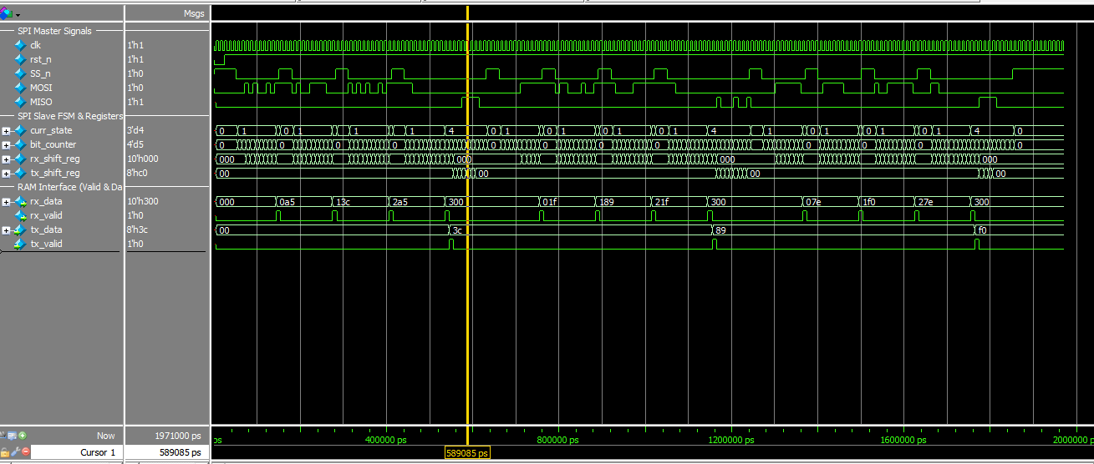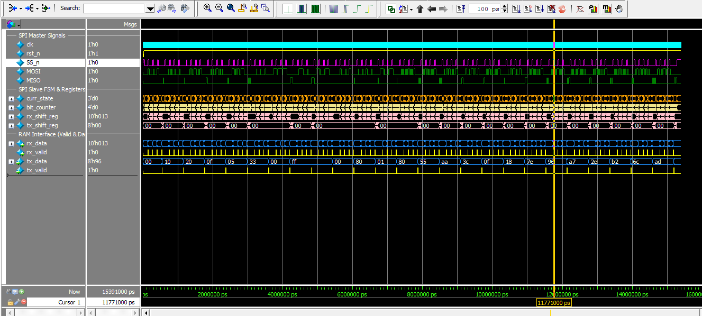

[ PASTE SCREENSHOT HERE: 1. QuestaSim Simulation Waveforms - Image 2 ]
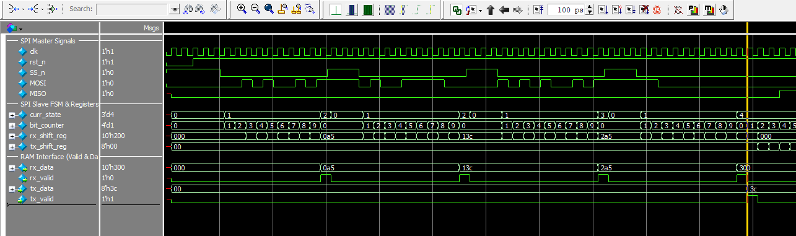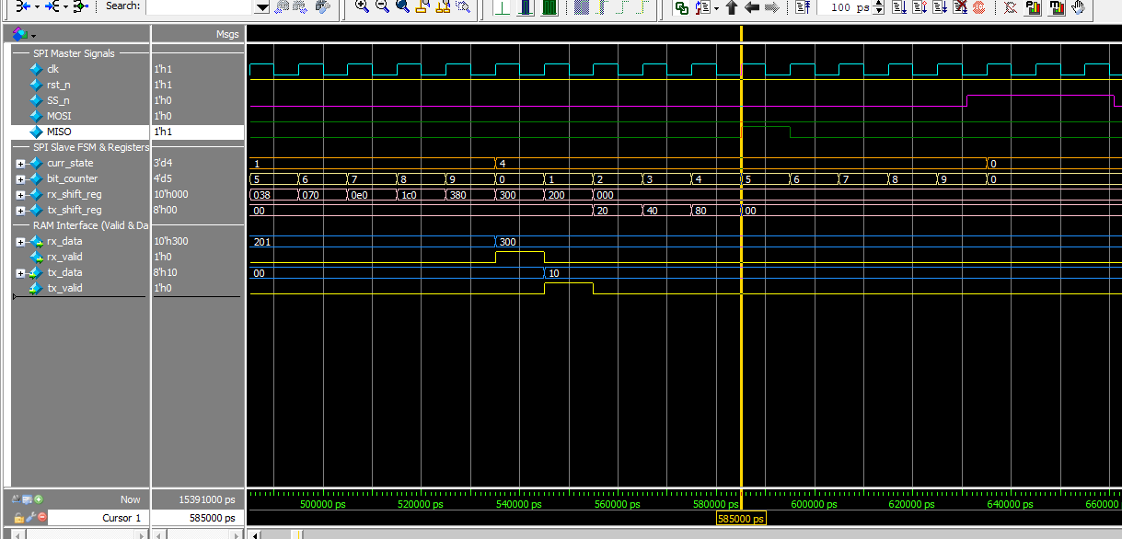
[ PASTE SCREENSHOT HERE: 1. QuestaSim Simulation Waveforms - Image 3 ]
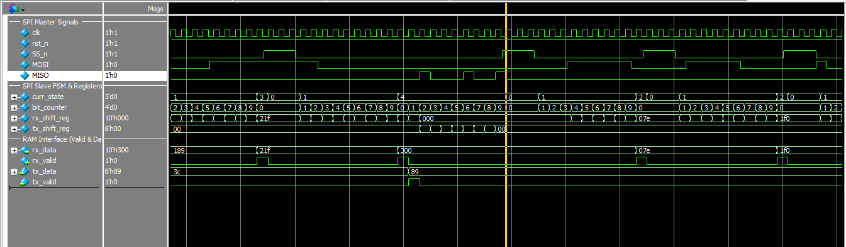
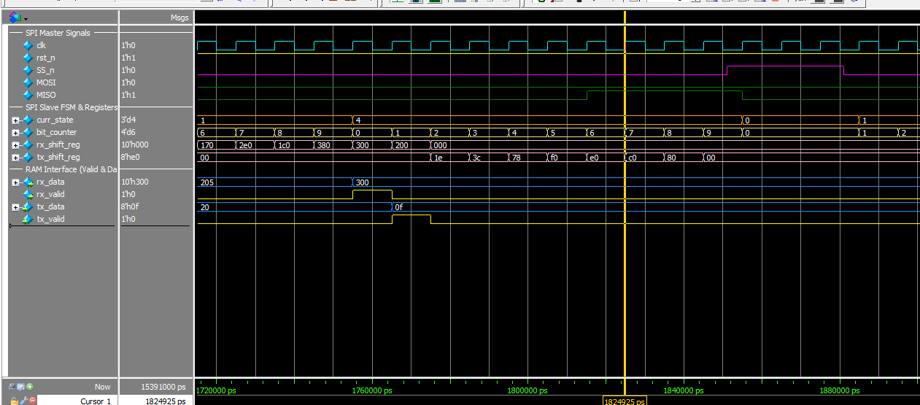
[ PASTE SCREENSHOT HERE: 1. QuestaSim Simulation Waveforms - Image 2 ]
# ==================================================
# STARTING AUTOMATED SELF-CHECKING TB
# ==================================================
# ---> Starting Transaction for Addr: 0xa5 | Data: 0x3c
# [PASS] Test 1: Read Data Match! Expected = 0x3c | Read = 0x3c
#
# ---> Starting Transaction for Addr: 0x1f | Data: 0x89
# [PASS] Test 2: Read Data Match! Expected = 0x89 | Read = 0x89
#
# ---> Starting Transaction for Addr: 0x7e | Data: 0xf0
# [PASS] Test 3: Read Data Match! Expected = 0xf0 | Read = 0xf0

# ---> Starting Transaction for Addr: 0xa5 | Data: 0x3c
# --- [SAMPLING START] Reading MISO for Expected: 0x3c ---
# -> Bit[7] at t=556000 ns | MISO = 0
# -> Bit[6] at t=566000 ns | MISO = 0
# -> Bit[5] at t=576000 ns | MISO = 1
# -> Bit[4] at t=586000 ns | MISO = 1
# -> Bit[3] at t=596000 ns | MISO = 1
# -> Bit[2] at t=606000 ns | MISO = 1
# -> Bit[1] at t=616000 ns | MISO = 0
# -> Bit[0] at t=626000 ns | MISO = 0
# --- [SAMPLING END] Assembled Byte = 0x3c ---
#
# [PASS] Test 1: Read Data Match! Expected = 0x3c | Read = 0x3c
#
# ---> Starting Transaction for Addr: 0x1f | Data: 0x89
# --- [SAMPLING START] Reading MISO for Expected: 0x89 ---
# -> Bit[7] at t=1166000 ns | MISO = 1
# -> Bit[6] at t=1176000 ns | MISO = 0
# -> Bit[5] at t=1186000 ns | MISO = 0
# -> Bit[4] at t=1196000 ns | MISO = 0
# -> Bit[3] at t=1206000 ns | MISO = 1
# -> Bit[2] at t=1216000 ns | MISO = 0
# -> Bit[1] at t=1226000 ns | MISO = 0
# -> Bit[0] at t=1236000 ns | MISO = 1
# --- [SAMPLING END] Assembled Byte = 0x89 ---
#
# [PASS] Test 2: Read Data Match! Expected = 0x89 | Read = 0x89
#
# ---> Starting Transaction for Addr: 0x7e | Data: 0xf0
# --- [SAMPLING START] Reading MISO for Expected: 0xf0 ---
# -> Bit[7] at t=1776000 ns | MISO = 1
# -> Bit[6] at t=1786000 ns | MISO = 1
# -> Bit[5] at t=1796000 ns | MISO = 1
# -> Bit[4] at t=1806000 ns | MISO = 1
# -> Bit[3] at t=1816000 ns | MISO = 0
# -> Bit[2] at t=1826000 ns | MISO = 0
# -> Bit[1] at t=1836000 ns | MISO = 0
# -> Bit[0] at t=1846000 ns | MISO = 0
# --- [SAMPLING END] Assembled Byte = 0xf0 ---
#
# [PASS] Test 3: Read Data Match! Expected = 0xf0 | Read = 0xf0
#
# ==================================================
# TEST SUMMARY RESULT
# ==================================================
# Total Tests Executed : 3
# STATUS : ALL TESTS PASSED SUCCESSFULLY! ðŸ‰
# ==================================================

Using alternate file: ./wlfteiwxhn
# ==================================================
# STARTING AUTOMATED SELF-CHECKING TB
# (25 DIRECTED & EXTENSIVE TEST CASES)
# ==================================================
#
# ---> [LEVEL 1] Basic Sanity & Low-Value Tests
# [1;36m
# ---> Starting Transaction for Addr: 0x1 | Data: 0x10[0m
# [1;32m [PASS] Test 1: Read Data Match! Expected = 0x10 | Read = 0x10 [0m
# [1;36m
# ---> Starting Transaction for Addr: 0x2 | Data: 0x20[0m
# [1;32m [PASS] Test 2: Read Data Match! Expected = 0x20 | Read = 0x20 [0m
# [1;36m
# ---> Starting Transaction for Addr: 0x5 | Data: 0xf[0m
# [1;32m [PASS] Test 3: Read Data Match! Expected = 0xf | Read = 0xf [0m
# [1;36m
# ---> Starting Transaction for Addr: 0xa | Data: 0x5[0m
# [1;32m [PASS] Test 4: Read Data Match! Expected = 0x5 | Read = 0x5 [0m
# [1;36m
# ---> Starting Transaction for Addr: 0xf | Data: 0x33[0m
# [1;32m [PASS] Test 5: Read Data Match! Expected = 0x33 | Read = 0x33 [0m
#
# ---> [LEVEL 2] Corner Boundaries & Walking Bit Patterns
# [1;36m
# ---> Starting Transaction for Addr: 0x0 | Data: 0x0[0m
# [1;32m [PASS] Test 6: Read Data Match! Expected = 0x0 | Read = 0x0 [0m
# [1;36m
# ---> Starting Transaction for Addr: 0xff | Data: 0xff[0m
# [1;32m [PASS] Test 7: Read Data Match! Expected = 0xff | Read = 0xff [0m
# [1;36m
# ---> Starting Transaction for Addr: 0x0 | Data: 0xff[0m
# [1;32m [PASS] Test 8: Read Data Match! Expected = 0xff | Read = 0xff [0m
# [1;36m
# ---> Starting Transaction for Addr: 0xff | Data: 0x0[0m
# [1;32m [PASS] Test 9: Read Data Match! Expected = 0x0 | Read = 0x0 [0m
# [1;36m
# ---> Starting Transaction for Addr: 0x1 | Data: 0x80[0m
# [1;32m [PASS] Test 10: Read Data Match! Expected = 0x80 | Read = 0x80 [0m
# [1;36m
# ---> Starting Transaction for Addr: 0x80 | Data: 0x1[0m
# [1;32m [PASS] Test 11: Read Data Match! Expected = 0x1 | Read = 0x1 [0m
# [1;36m
# ---> Starting Transaction for Addr: 0x7f | Data: 0x80[0m
# [1;32m [PASS] Test 12: Read Data Match! Expected = 0x80 | Read = 0x80 [0m
#
# ---> [LEVEL 3] High-Frequency Signal Toggling (Noise & Crosstalk)
# [1;36m
# ---> Starting Transaction for Addr: 0xaa | Data: 0x55[0m
# [1;32m [PASS] Test 13: Read Data Match! Expected = 0x55 | Read = 0x55 [0m
# [1;36m
# ---> Starting Transaction for Addr: 0x55 | Data: 0xaa[0m
# [1;32m [PASS] Test 14: Read Data Match! Expected = 0xaa | Read = 0xaa [0m
# [1;36m
# ---> Starting Transaction for Addr: 0xc3 | Data: 0x3c[0m
# [1;32m [PASS] Test 15: Read Data Match! Expected = 0x3c | Read = 0x3c [0m
# [1;36m
# ---> Starting Transaction for Addr: 0xf0 | Data: 0xf[0m
# [1;32m [PASS] Test 16: Read Data Match! Expected = 0xf | Read = 0xf [0m
# [1;36m
# ---> Starting Transaction for Addr: 0xe7 | Data: 0x18[0m
# [1;32m [PASS] Test 17: Read Data Match! Expected = 0x18 | Read = 0x18 [0m
# [1;36m
# ---> Starting Transaction for Addr: 0x81 | Data: 0x7e[0m
# [1;32m [PASS] Test 18: Read Data Match! Expected = 0x7e | Read = 0x7e [0m
# [1;36m
# ---> Starting Transaction for Addr: 0x69 | Data: 0x96[0m
# [1;32m [PASS] Test 19: Read Data Match! Expected = 0x96 | Read = 0x96 [0m
#
# ---> [LEVEL 4] Advanced Stress & Asymmetric Data Patterns
# [1;36m
# ---> Starting Transaction for Addr: 0x13 | Data: 0xa7[0m
# [1;32m [PASS] Test 20: Read Data Match! Expected = 0xa7 | Read = 0xa7 [0m
# [1;36m
# ---> Starting Transaction for Addr: 0xb4 | Data: 0x2e[0m
# [1;32m [PASS] Test 21: Read Data Match! Expected = 0x2e | Read = 0x2e [0m
# [1;36m
# ---> Starting Transaction for Addr: 0x4d | Data: 0xb2[0m
# [1;32m [PASS] Test 22: Read Data Match! Expected = 0xb2 | Read = 0xb2 [0m
# [1;36m
# ---> Starting Transaction for Addr: 0x9a | Data: 0x6c[0m
# [1;32m [PASS] Test 23: Read Data Match! Expected = 0x6c | Read = 0x6c [0m
# [1;36m
# ---> Starting Transaction for Addr: 0xde | Data: 0xad[0m
# [1;32m [PASS] Test 24: Read Data Match! Expected = 0xad | Read = 0xad [0m
# [1;36m
# ---> Starting Transaction for Addr: 0xbe | Data: 0xef[0m
# [1;32m [PASS] Test 25: Read Data Match! Expected = 0xef | Read = 0xef [0m
#
# ==================================================
# [1;33m TEST SUMMARY RESULT [0m
# ==================================================
# Total Tests Executed : 25
# [1;32m STATUS : ALL 25 TESTS PASSED SUCCESSFULLY! ðŸ‰ [0m
# ==================================================

2. QuestaLint Code Quality Analysis
Paste the snippet from QuestaLint proving that the design contains NO linting errors or warnings.
[ PASTE SCREENSHOT HERE: 2. QuestaLint Code Quality Analysis - Image 1 ]
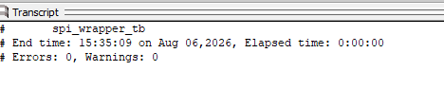

3. Synthesis Results & FSM Encodings Comparison
Include RTL Schematic post-elaboration/synthesis, synthesis reports showing the chosen FSM encoding (Sequential, One-Hot, Gray), and highlighted Critical Path in schematic for each encoding.
[Schematic post-elaboration - Image 1 ]
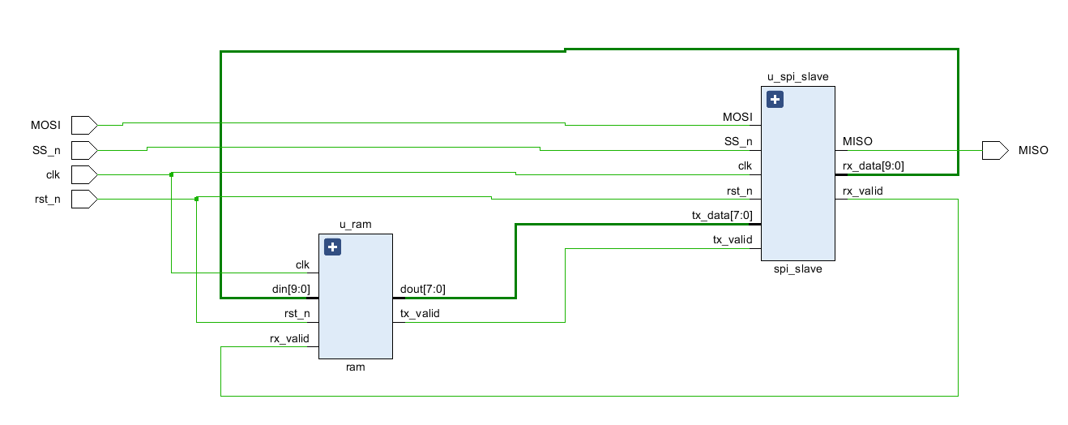U_rum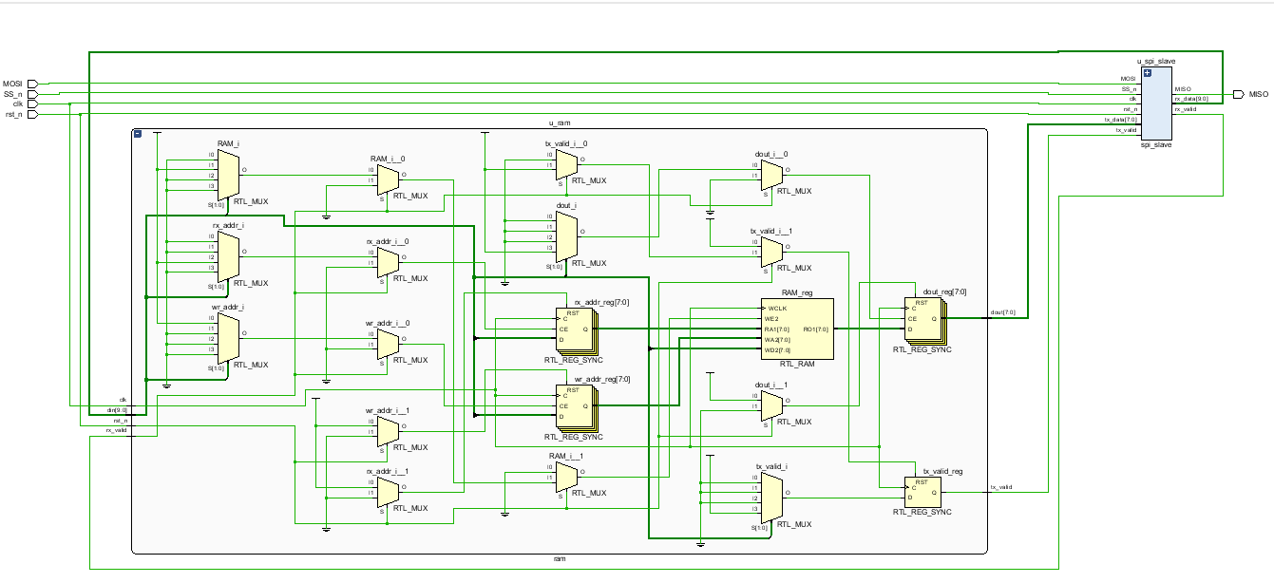U_spi_slave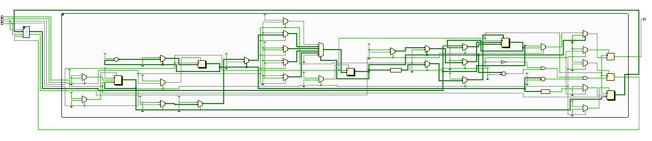

Image 2
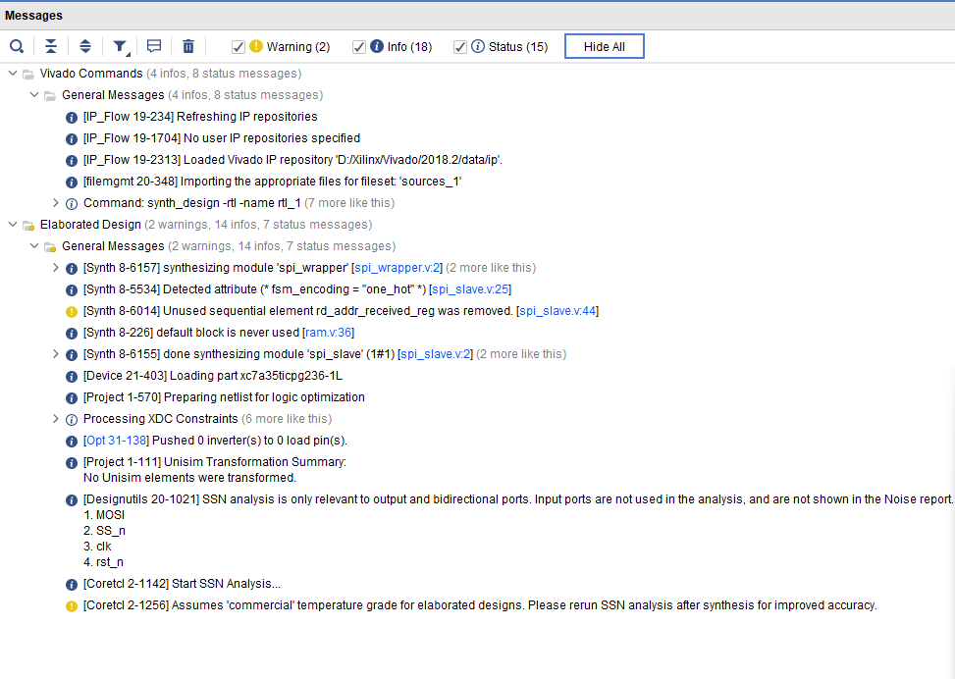

3. Synthesis Results & FSM Encodings Comparison
Include RTL Schematic post-elaboration/synthesis, synthesis reports showing the chosen FSM encoding (Sequential, One-Hot, Gray), and highlighted Critical Path in schematic for each encoding.
[ PASTE SCREENSHOT HE 3. Synthesis Results & FSM Encodings One hot Comparison - Image 1 ]
Schematic
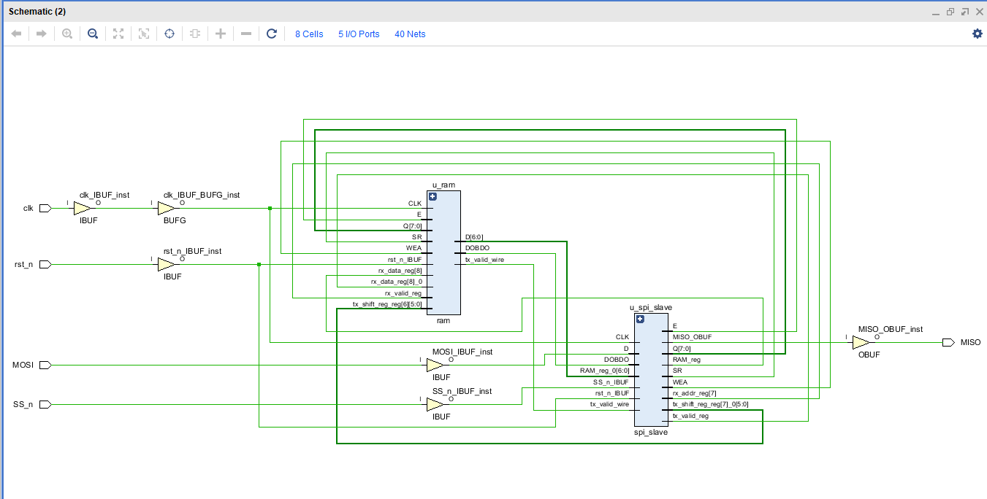
U_spi_slave | U_ram
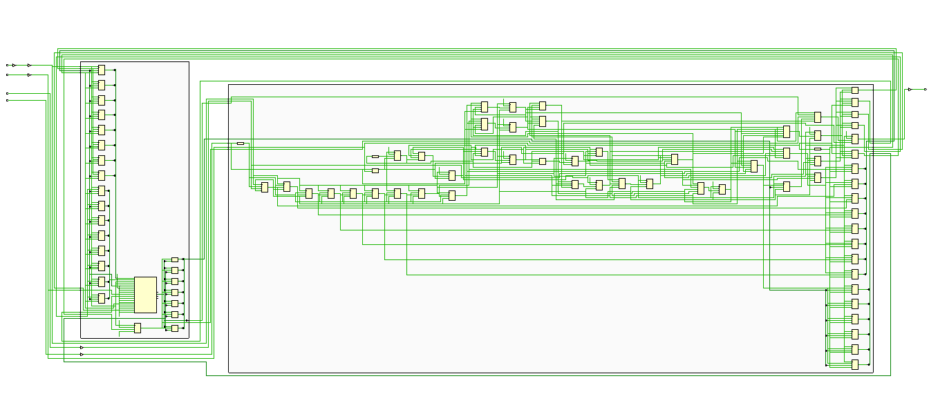

[ PASTE SCREENSHOT HERE: 3. Synthesis Results & FSM Encodings Comparison - Image 2 ]
Timing Summary (Report Timing Summary)
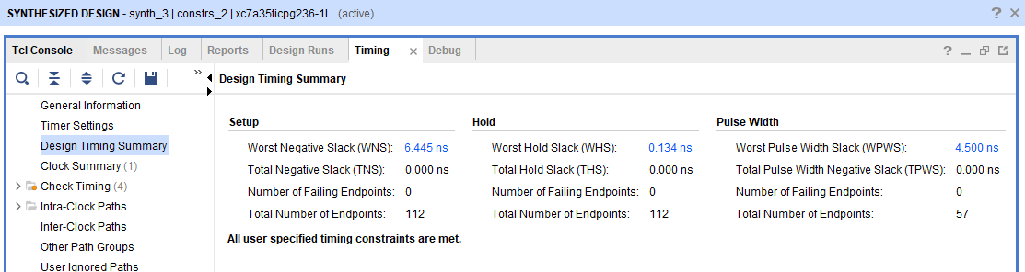

[ PASTE SCREENSHOT HERE: 3. Synthesis Results & FSM Encodings Comparison - Image 3 ]
Utilization Summary
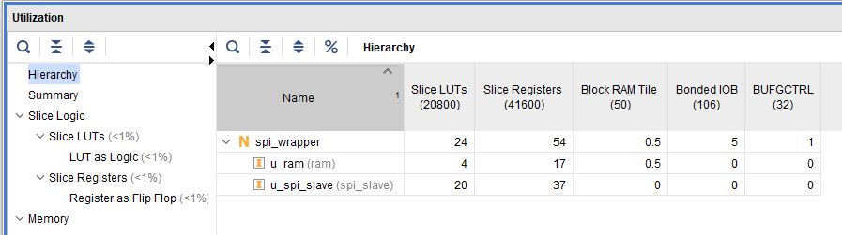

[ PASTE SCREENSHOT HERE: 3. Synthesis Results & FSM Encodings Sequential Comparison - Image 2 ]
Timing Summary (Report Timing Summary)
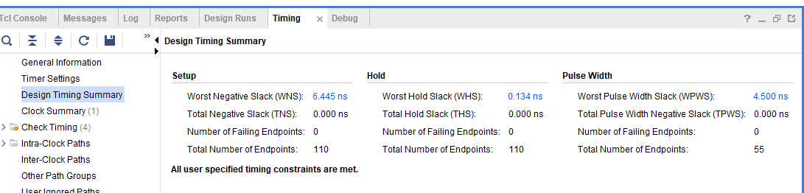
Utilization Summary
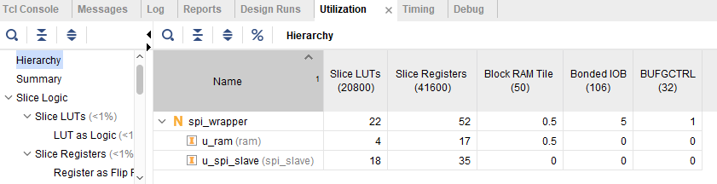

[ PASTE SCREENSHOT HERE: 3. Synthesis Results & FSM Encodings Gray Comparison - Image 2 ]
Timing Summary (Report Timing Summary)

Utilization Summary
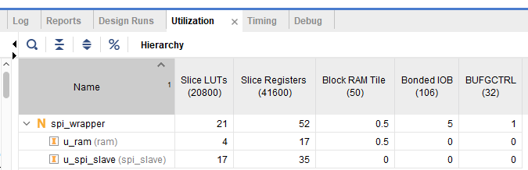

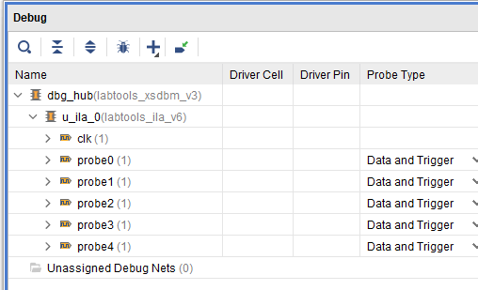

4. Implementation & Timing Reports
Paste the Resource Utilization Report, Timing Summary (Setup/Hold Slack), and FPGA Device View for each encoding configuration.
[ PASTE SCREENSHOT HERE: 4. Implementation One hot & Timing Reports - Image 1 ]
Schematic

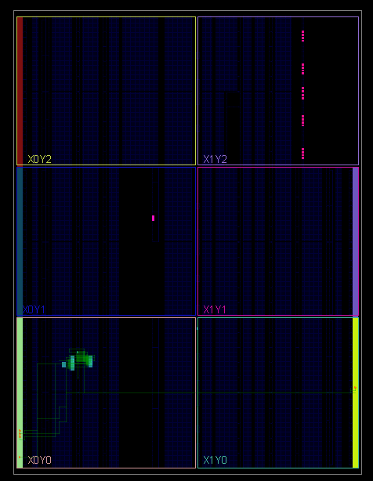

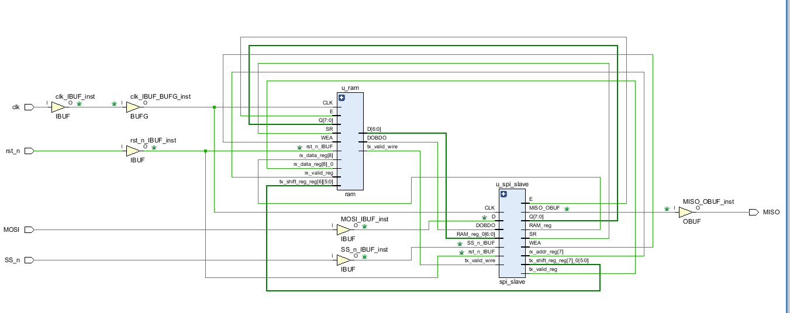

Timing Summary (Report Timing Summary)
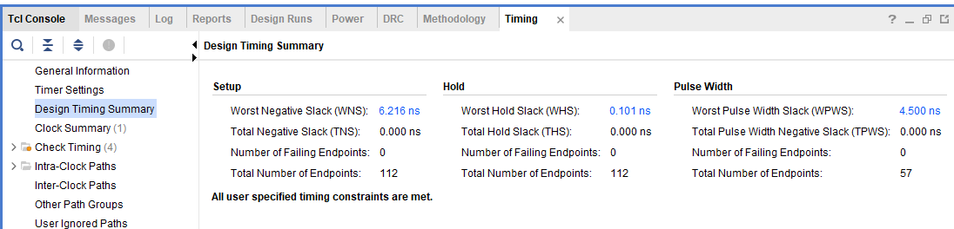
Utilization Summary
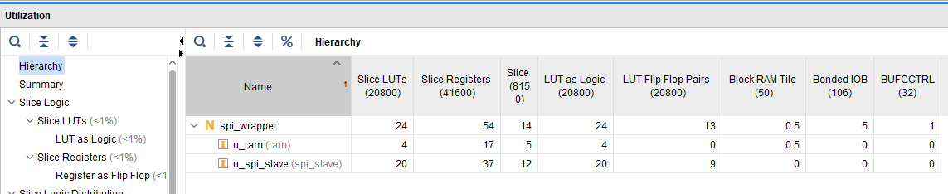

[ PASTE SCREENSHOT HERE: 4. Implementation Sequential & Timing Reports - Image 2 ]
Schematic
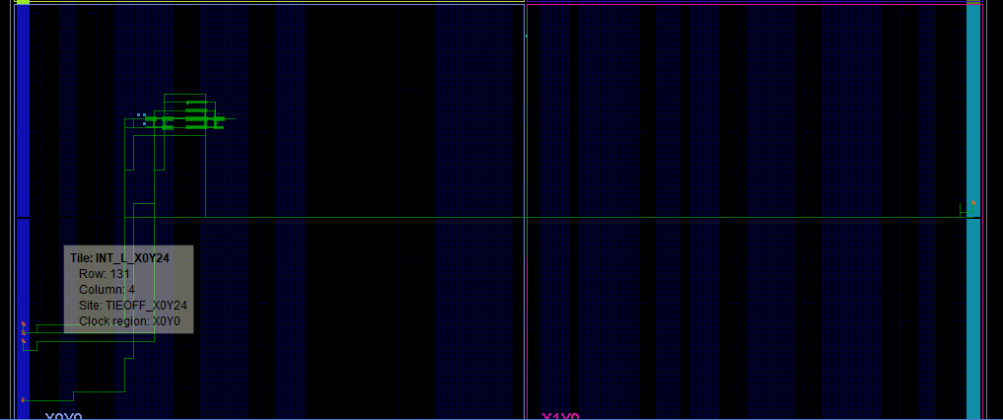
Timing Summary (Report Timing Summary)
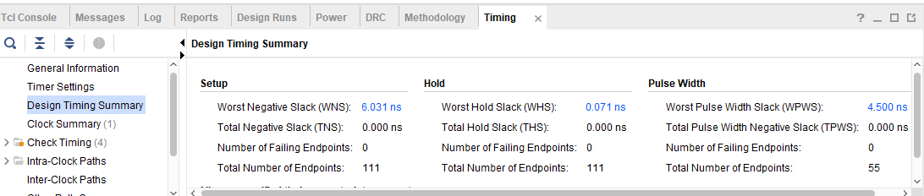
Utilization Summary
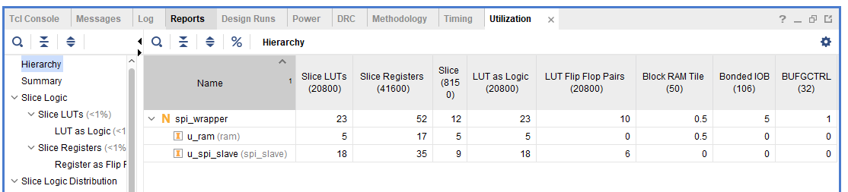

[ PASTE SCREENSHOT HERE: 4. Implementation Gray
& Timing Reports - Image 3 ]
Schematic
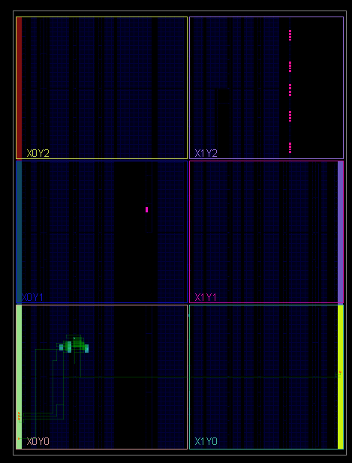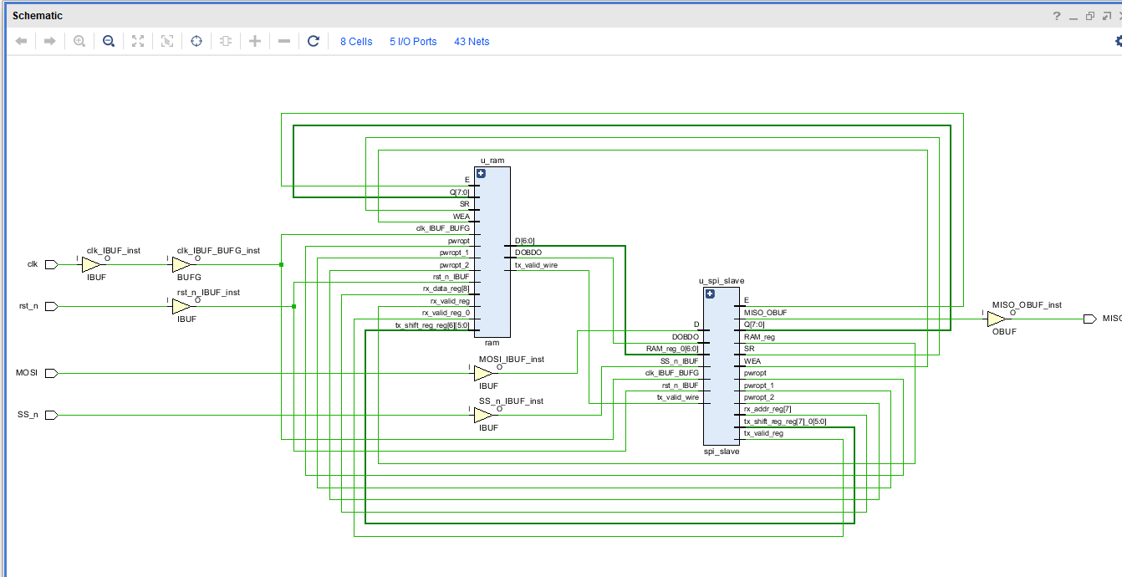
Timing Summary (Report Timing Summary)
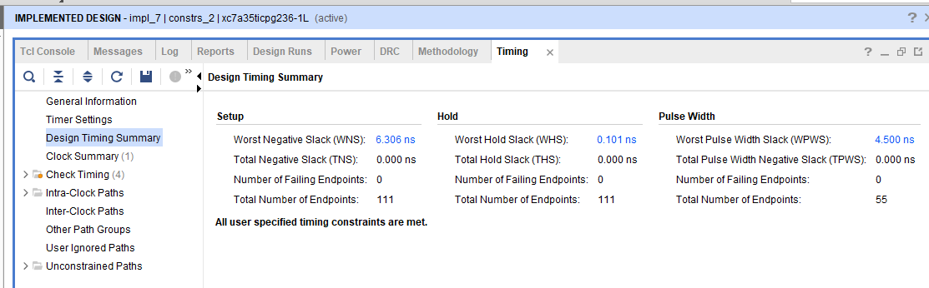
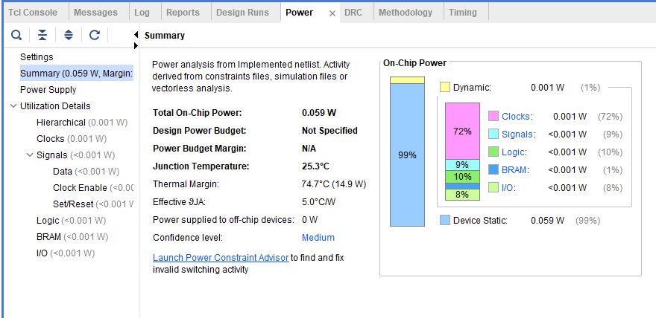
Utilization Summary
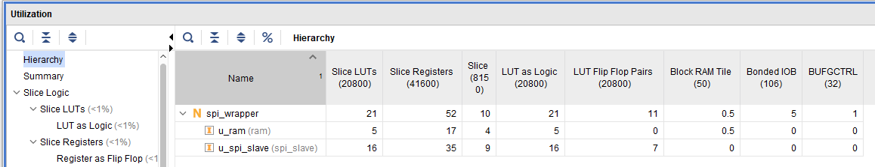

1. Timing Analysis Results (Post-Implementation):

After running the complete Vivado implementation flow for each encoding method, the following Worst Negative Slack (WNS) and Worst Hold Slack (WHS) results were achieved:

One-Hot Encoding:

Worst Negative Slack (WNS) = 6.031 ns

Worst Hold Slack (WHS) = 0.071 ns

Sequential Encoding:

Worst Negative Slack (WNS) = 6.216 ns

Worst Hold Slack (WHS) = 0.101 ns

Gray Encoding:

Worst Negative Slack (WNS) = 6.306 ns

Worst Hold Slack (WHS) = 0.131 ns

5. Vivado Console & Messages Tab Verification
Paste the clear screenshot of the 'Messages' tab showing SUCCESSFUL Bitstream generation with NO critical warnings or errors across Elaboration, Synthesis, and Implementation.
[ PASTE SCREENSHOT HERE: 5. Vivado Console & Messages Tab Verification - Image 1 ]
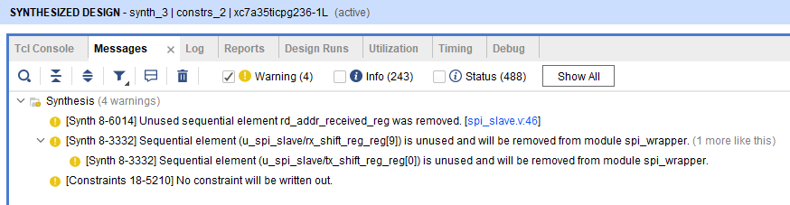

Post-Debug & Bitstream Generation:
- Shows the integrated ILA core and probe nets successfully added to the design, with the Messages tab confirming a clean run with zero critical warnings and zero errors leading to a successful bitstream generation.
