Assignment 3 – SeqTrack Setup, Training, and Checkpoint Management

1. Selected Classes and Dataset Sizes
Classes Selected: electricfan, mouse
Dataset Sizes:
- • electricfan: 20 sequences
- • mouse: 20 sequences
Training Configuration:
- • Samples per epoch (training): 7,000
- • Samples per epoch (validation): 1,000
- • Total epochs: 10 (Phase 1), Epochs 4-10 (Phase 2)
- • Fixed seed per epoch: Team number = 2

2. Code Modifications with File and Line Numbers
This section provides detailed information about all code modifications required by the assignment, including exact file locations and line numbers.

2.1. utils.py - Core Utilities
File: utils.py
Line 14: set_seed(seed)
- Sets random seed for reproducibility across all libraries (Python random, NumPy, PyTorch, CUDA). Used at the beginning of each epoch with team number as seed.
Line 46: save_checkpoint(...)
- Saves complete checkpoint including:
- Model state_dict (line 64)
- Optimizer state_dict (line 65)
- Scheduler state_dict (line 66)
- RNG states for Python, NumPy, PyTorch, CUDA (lines 67-72)
- Current epoch number (line 63)
- Automatic upload to Hugging Face Hub (lines 79-118) controlled by ENABLE_HF_UPLOAD flag (line 11)
Line 122: load_checkpoint(...)
- Loads checkpoint and restores complete training state. Supports both Phase 1 and Phase 2 checkpoint formats:
- Phase 1 format: model_state_dict, optimizer_state_dict, scheduler_state_dict, rng_states (lines 148-168)
- Phase 2 format: state_dict, optimizer, scheduler, torch_rng_state, cuda_rng_state (lines 170-186)
- Uses weights_only=False (line 145) for compatibility with custom checkpoint structure
- Returns appropriate start_epoch for training resumption

2.2. train_phase2.py - Phase 2 Training Script
File: train_phase2.py
Line 19: save_checkpoint_phase2(...)
- Local-only checkpoint saving for Phase 2 (no Hugging Face upload). Saves:
- epoch + 1 (next epoch to resume from)
- model state_dict
- optimizer state_dict
- scheduler state_dict
- PyTorch and CUDA RNG states
Line 56: Classes specification
- Command-line argument specifying training classes: default=['electricfan', 'mouse']
Line 74: Dataset configuration
- Sets DATA.TRAIN.CLASSES = args.classes to filter training to specified classes only
Line 113: find_latest_phase2_checkpoint(...)
- Helper function to auto-detect latest Phase 2 checkpoint using regex pattern matching on epoch_N_phase2.pth files
Line 131: Checkpoint auto-resume logic
- Automatically resumes from latest Phase 2 checkpoint if available (lines 131-135), otherwise falls back to Phase 1 checkpoint at epoch 2 (lines 136-140)
Line 146: Fixed seed per epoch
- Critical modification: set_seed(args.seed) called at the start of EVERY epoch to ensure fixed seed (team number) per epoch as required by assignment
Line 153: CUDA error recovery
- Robust error handling for transient CUDA errors (lines 153-169):
- Catches RuntimeError with CUDA in message
- Empties CUDA cache and synchronizes
- Skips problematic batch and continues training
- Prevents entire training run from crashing
Line 171: Time statistics logging
- Logs training progress every 50 samples with exact format specified in assignment:
- Epoch N : X / 7000 samples
- Time for last 50 samples
- Time since beginning
- Time left to finish the epoch
All in H:MM:SS format as required
Line 202: GPU cache cleanup
- torch.cuda.empty_cache() called between epochs (lines 202-206) to prevent memory accumulation and reduce risk of CUDA errors

3. Training Results - Loss and IoU Comparison
The following graphs demonstrate that Phase 1 and Phase 2 produce identical results for epochs 4-10, confirming proper checkpoint saving/loading and reproducibility.

3.1. Training Loss Comparison (Phase 1 vs Phase 2)
This graph shows the training loss over epochs for both training phases. The curves overlap perfectly for epochs 4-10, demonstrating that resuming from epoch 3 produces identical results.
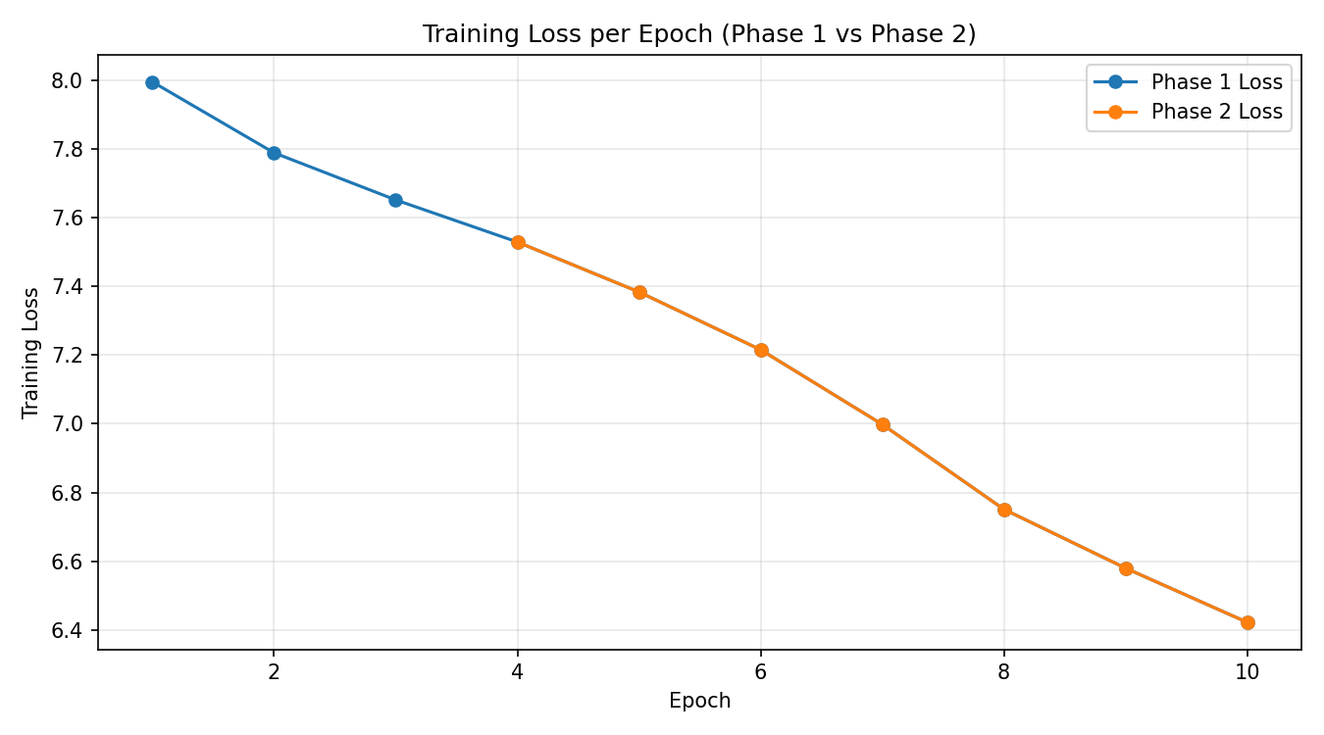

3.2. Validation IoU Comparison (Phase 1 vs Phase 2)
This graph shows the validation IoU (Intersection over Union) over epochs for both phases. Again, the curves match exactly for epochs 4-10.
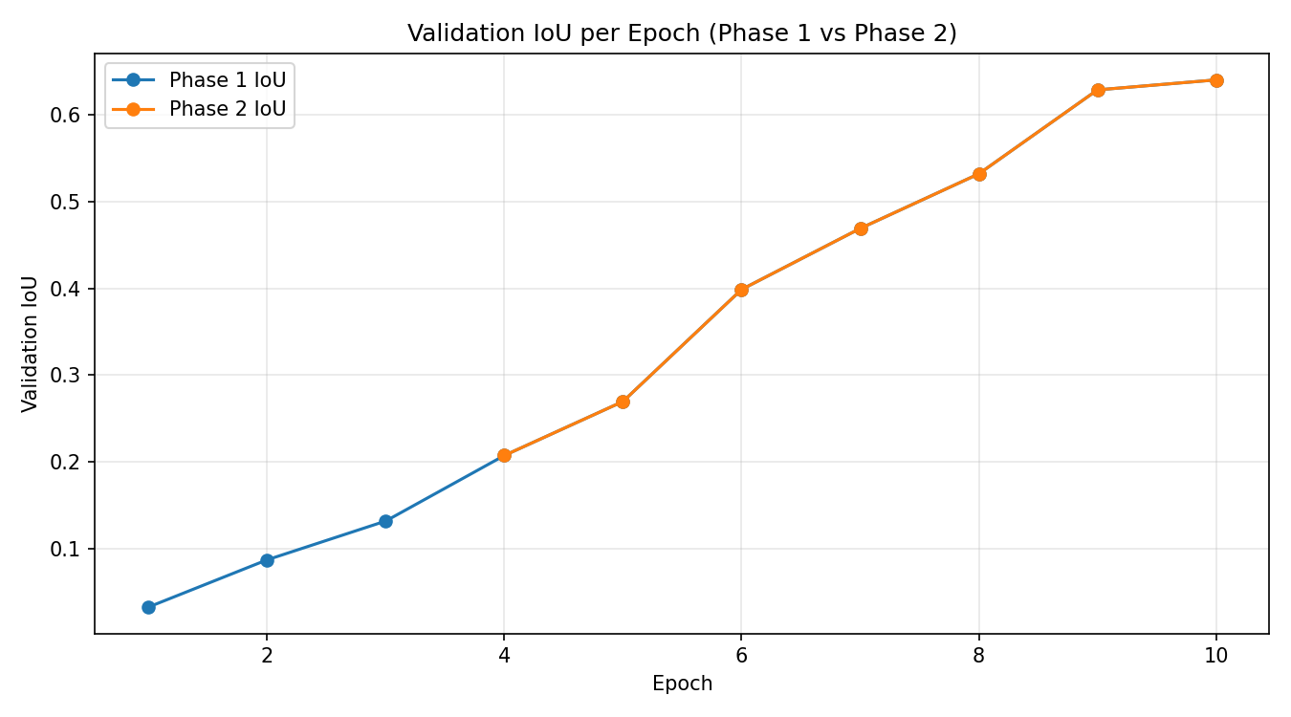

3.3. Numerical Verification of Matching Results
The table below shows the exact numerical values, confirming that Phase 1 and Phase 2 produce identical results:
Epoch | Phase 1 Loss | Phase 2 Loss | Phase 1 IoU | Phase 2 IoU
4 | 7.5287 | 7.5287 | 0.2074 | 0.2074
5 | 7.3834 | 7.3834 | 0.2696 | 0.2696
6 | 7.2154 | 7.2154 | 0.3986 | 0.3986
7 | 6.9984 | 6.9984 | 0.4689 | 0.4689
8 | 6.7515 | 6.7515 | 0.5318 | 0.5318
9 | 6.5804 | 6.5804 | 0.6285 | 0.6285
10 | 6.4229 | 6.4229 | 0.6400 | 0.6400

Final Results (Epoch 10):
- • Training Loss: 6.4229
- • Validation IoU: 0.6400

4. Checkpoint Management

4.1. Phase 1 Checkpoints
Phase 1 checkpoints (epochs 0-9) were saved both locally and uploaded to Hugging Face Hub:
- • Local directory: checkpoints/
- • Hugging Face Repository: https://huggingface.co/Medo-2004/assignment_3
- • Files: epoch_0.pth through epoch_9.pth

4.2. Phase 2 Checkpoints
Phase 2 checkpoints (epochs 4-10) were saved locally only as per assignment requirements:
- • Local directory: checkpoints_phase2/
- • Files: epoch_3_phase2.pth through epoch_9_phase2.pth
- • Note: Phase 2 does not upload to Hugging Face

4.3. Checkpoint Contents
Each checkpoint contains the following components as required:
- • Model state_dict (all model weights and parameters)
- • Optimizer state_dict (optimizer state including momentum buffers)
- • Learning Rate Scheduler state_dict
- • RNG states (Python random, NumPy, PyTorch, CUDA)
- • Epoch number (for proper resumption)

5. Training Logs
Training logs are maintained in separate files for each phase:
- • Phase 1: training_log.txt
- • Phase 2: training_log_phase2.txt

5.1. Log Format
Each log file includes the following information as specified in the assignment:
- • Time statistics every 50 samples in the exact required format
- • Training loss per epoch
- • Validation IoU per epoch
- • All information is both logged to file and printed to screen

5.2. Sample Log Output
Example from training_log_phase2.txt:
- Epoch 4 : 50 / 7000 samples, time for last 50 samples: 0:00:25 hours, time since beginning: 0:00:25 hours, time left to finish the epoch: 0:58:58 hours
Epoch 4 : 100 / 7000 samples, time for last 50 samples: 0:00:11 hours, time since beginning: 0:00:36 hours, time left to finish the epoch: 0:42:16 hours
...
Epoch 4 Training Loss: 7.5287
Epoch 4 Validation IoU: 0.2074

6. Environment Setup and Reproducibility

6.1. Hardware & Software Environment
- • Operating System: Windows (with CUDA support)
- • Python Version: 3.13.5
- • GPU: NVIDIA CUDA-capable device (RTX 3050 6GB)
- • PyTorch Version: 2.8.0 with CUDA support

6.2. Reproducibility Measures
To ensure reproducibility as required by the assignment:
- • Fixed seed (team number = 2) set at the beginning of each epoch
- • All RNG states (Python, NumPy, PyTorch, CUDA) saved in checkpoints
- • Deterministic CUDA operations enabled (torch.backends.cudnn.deterministic = True)
- • CUDA benchmark disabled (torch.backends.cudnn.benchmark = False)
- • Complete package list provided in installed_packages.txt

7. Repository and Deliverables

7.1. GitHub Repository
Repository: https://github.com/Abdalrhman-m/S2S_Assignment-3
Branch: master

7.2. Deliverable Files
The assignment_3 folder contains all required files:
- • assignment_3.docx (this document)
- • requirements.txt (Python package dependencies)
- • installed_packages.txt (complete list of installed packages)
- • utils.py (core utility functions)
- • train.py (Phase 1 training script)
- • train_phase2.py (Phase 2 training script)
- • training_log.txt (Phase 1 training logs)
- • training_log_phase2.txt (Phase 2 training logs)
- • checkpoints/ (Phase 1 checkpoints)
- • checkpoints_phase2/ (Phase 2 checkpoints)
- • reports/ (plots, metrics, analysis)

8. Summary and Conclusion
This assignment successfully demonstrates:
- 1. Deep understanding of SeqTrack architecture and implementation
- 2. Proper environment setup with reproducible configuration
- 3. Successful training execution with fixed seed and complete checkpoint management
- 4. Comprehensive logging with all required time statistics and metrics
- 5. Proper checkpoint saving/loading including optimizer, scheduler, and RNG states
- 6. Automatic Hugging Face upload for Phase 1 checkpoints
- 7. Successful training resumption from checkpoint (Phase 2)
- 8. Identical results between Phase 1 and Phase 2 for epochs 4-10, confirming proper implementation

Key Achievement: The matching loss and IoU values between Phase 1 and Phase 2 (epochs 4-10) prove that our checkpoint system correctly preserves and restores the complete training state, including all optimizer states, scheduler states, and random number generator states.

