

**Birzeit University**

**Faculty Of Engineering And Technology**

**Electrical and Computer Engineering Department**

**Samples Architecture project**

**ENCS4370**

**Prepared by:**

**Abdalrhman Juber 1211769**

**Ismail Tarteer 1211243**

**Instructor: Dr.Aziz Qaroush**

**2024-2025**

# First sample:

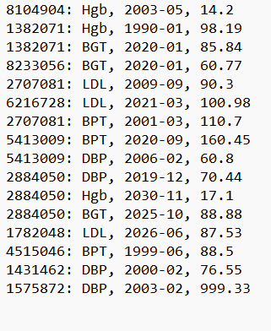

## Add a new patiant test:

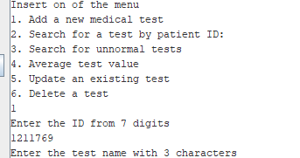

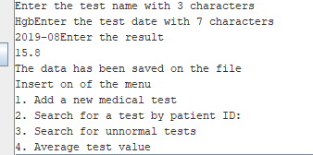

New test saved into the file :

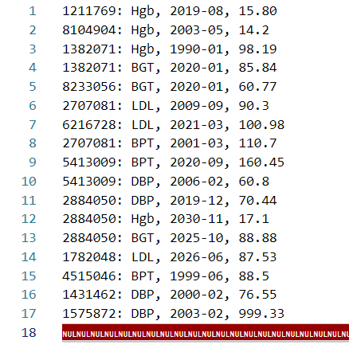

## Search for a test by patiant ID :

### Retrieve all patient tests:

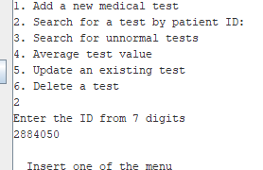

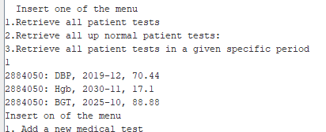

### Retrieve all up normal patient tests:

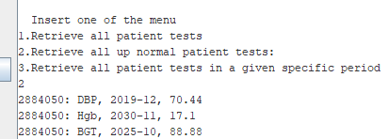

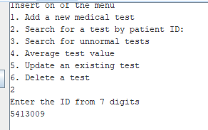

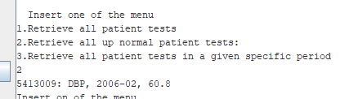

### Retrieve all patient tests in a given specific period:

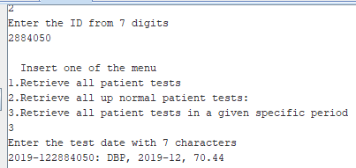

### Average test value:

Calculated values:

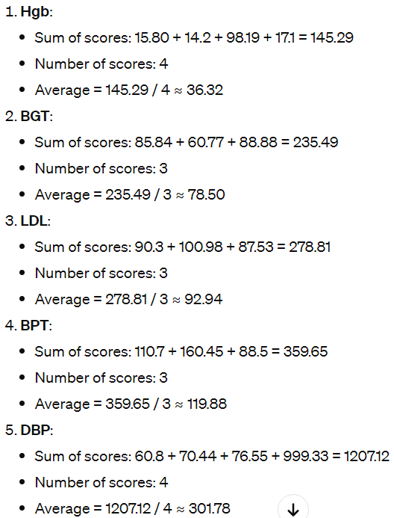

Mips calculated :

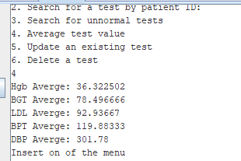

### Update an existing test:

Before updating on first row:



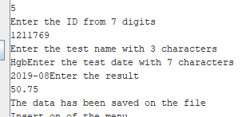

After updating on first row:

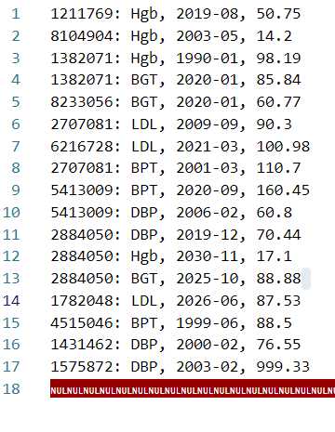

And with 7 row:

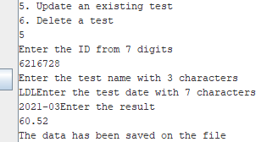

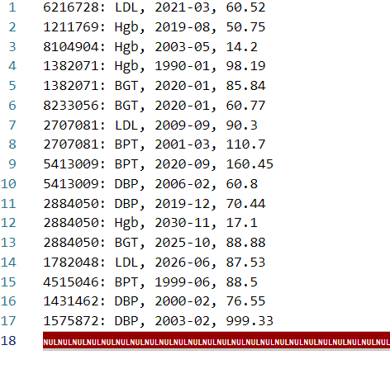

### Delete a test:

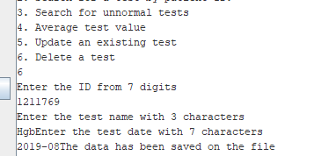

After deleting:

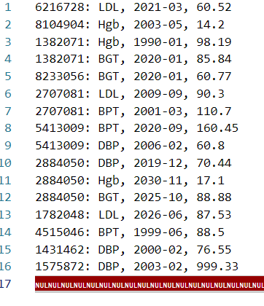

And: with row 8

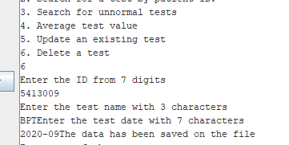

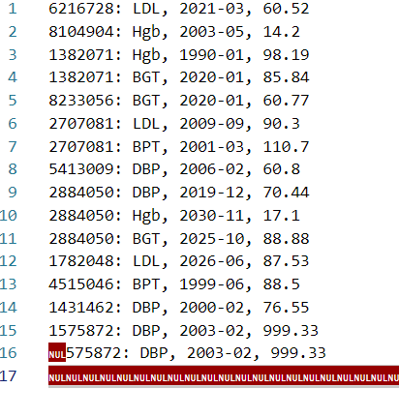

# Second sample: