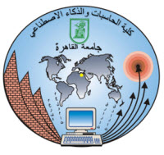 

**Cairo University**

**Faculty Of Computers And Artificial Intelligence**

**DENTAL CLINIC SYSTEM**

|  |  |  |  |
| --- | --- | --- | --- |
| **Group** | **ID** | **Name** | # |
| S7 | 20200540 | Mostafa Shaban Abdelrasoul | 1 |
| S7 | 20200310 | Abdaltawab Hussein Abdeltawab | 2 |
| S7 | 20200703 | Rahaf Alhadi Mustafa Abdallah | 3 |
| S7 | 20200904 | Mohamed Abdelaziz Elsayed Atia | 4 |
| S7 | 20200156 | Hassan Mohamed Nafed | 5 |