Freight Rate Prediction: Approach, Validation and December Forecast
Spotter ML Engineer take-home. Seed 42. All numbers below come from code in this repository (scripts/01-06); no accuracy is claimed on validation.csv, which has no labels. Spotter computes the final score.

1. Summary
- Data: train_test.csv (48,000 labelled loads, 2025-01-01 to 2025-10-31); validation.csv (12,000 unlabeled loads, 2025-11-01 to 2025-12-31), i.e. the future of the training data.
- Validation: time-based only. Expanding monthly folds on Jan-Aug (6 folds) for tuning, a Sep-Oct holdout, then a refit on all of train. No random split anywhere in model evaluation.
- Chosen model: a hybrid (Ridge on log(rate) with distance, equipment and market_index, plus LightGBM on its residuals). Mean CV MAPE 2.18% (fold std 0.71), Sep-Oct holdout MAPE 2.70% on clean rows.
- Data quality: 677 corrupted labels (1.41%) excluded from training, sign-flipped weights fixed, quote_signal excluded as unstable, 8 validation-only cities handled with a fallback model.

2. How the data was split and validated (key section)

2.1 Why a random split is wrong here
The final predictions are for 2025-11-01 to 2025-12-31, one day after the last labelled row. This is a forecasting problem. The strongest feature, market_index, is a daily market series that moves from month to month (train mean 1.083, range 0.68-1.47; validation mean 0.927). A random K-fold would place rows from the same day, and therefore the same market regime, in both the training and evaluation folds, so the model would be scored on interpolation of conditions it has already seen. That overstates accuracy and rewards hyper-parameters that memorise day-level structure. A time-based split reproduces the real task: fit on the past, score on a later period.

2.2 The splits
split | train rows | train from | train to | eval rows | eval from | eval to | corrupted labels in eval
fold_m03 | 9255 | 2025-01-01 | 2025-02-28 | 5036 | 2025-03-01 | 2025-03-31 | 71
fold_m04 | 14291 | 2025-01-01 | 2025-03-31 | 4819 | 2025-04-01 | 2025-04-30 | 66
fold_m05 | 19110 | 2025-01-01 | 2025-04-30 | 4913 | 2025-05-01 | 2025-05-31 | 62
fold_m06 | 24023 | 2025-01-01 | 2025-05-31 | 4783 | 2025-06-01 | 2025-06-30 | 63
fold_m07 | 28806 | 2025-01-01 | 2025-06-30 | 4912 | 2025-07-01 | 2025-07-31 | 65
fold_m08 | 33718 | 2025-01-01 | 2025-07-31 | 4759 | 2025-08-01 | 2025-08-31 | 68
holdout_sep_oct | 38477 | 2025-01-01 | 2025-08-31 | 9523 | 2025-09-01 | 2025-10-31 | 144
cold_start_sep_oct | 28431 | 2025-01-01 | 2025-08-31 | 2516 | 2025-09-01 | 2025-10-31 | 39

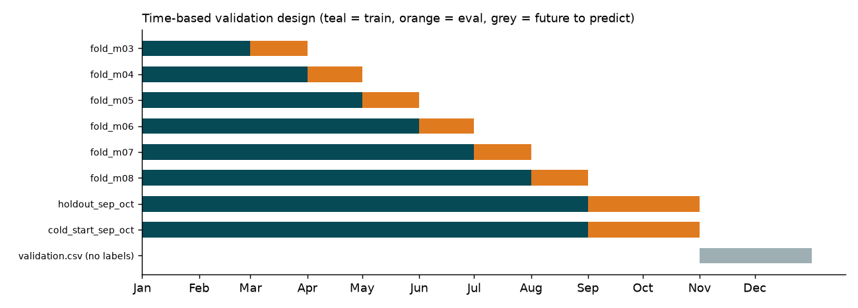
Figure 1. Validation design (teal = train, orange = evaluation, grey = validation.csv to predict).
- Expanding-window CV: fold k trains on every month before k and evaluates on month k, for k = March..August. Optuna (max 20 trials per model, seed 42) tunes only on these folds.
- Final holdout: train Jan-Aug, evaluate on Sep-Oct. It was scored once per tuned candidate, to choose among them and to report; nothing was tuned on it. Note: the model-selection rule was revised after seeing these results (disclosed in decision_log.md #17).
- Cold-start diagnostic: like the holdout, but 8 seeded cities are removed from training and only Sep-Oct rows touching them are scored. It mimics the 8 cities that exist only in validation.csv (12.1% of its rows).
- Final model: refit on all clean train rows (Jan-Oct) and predict validation.csv.
- Every split satisfies max(train date) < min(eval date) with a one-day gap, as between train and validation. This is asserted by pytest for every fold.

2.3 Leakage controls
- Lane target statistics (shrunk mean of month-demeaned log rate-per-mile for the lane and its reverse lane) are computed from the training slice only. For a training row, only rows from strictly earlier months are used (out-of-fold, time-respecting); evaluation rows see the whole training slice. A pytest changes labels in month 3 and checks that no row from month 3 or earlier changes, and that evaluation labels are never read.
- No calendar-time feature (month, day-of-year) is used; Nov/Dec are outside the training range and CV showed it hurts (MAPE 3.35 vs 3.14).
- The label-outlier flag (which rows are excluded) came from a 6-parameter structural fit on all train rows. It only decides which rows to drop and is not fold-specific; we disclose it.

2.4 How validation.csv features were used (no labels, no leakage)
validation.csv has no labels. Its features were used for exactly two purposes: (a) adversarial validation, a drift diagnostic; and (b) filling market_index and quote_signal for the 31 fixed December rows. No model was fit on it, and it was not used to impute or scale the 12,000 validation predictions (null market_index in validation uses a constant taken from the last 7 train days).
Adversarial validation (LightGBM, train vs validation, date excluded): AUC 0.876; 0.755 without market_index; 0.727 without market_index and geography. As a control, Sep-Oct vs Jan-Aug inside train gives 0.925, so the train-to-validation shift is not larger than ordinary month-to-month drift. The drift is concentrated in market_index (univariate AUC 0.779) and in the 8 new cities (0.560); distance, weight and equipment are stable (about 0.50). Validation market_index (0.72-1.10) lies inside the train range (0.68-1.47).
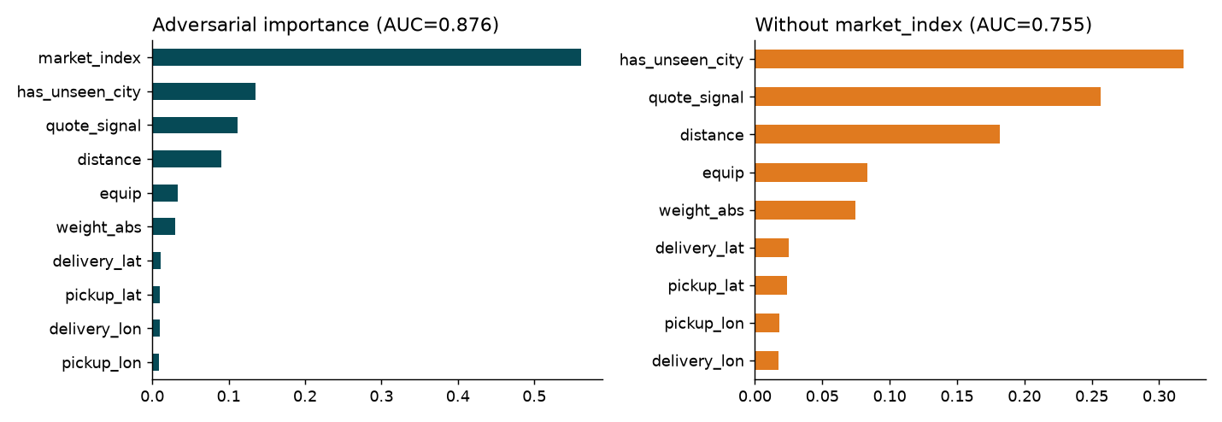
Figure 2. Adversarial validation: what separates train from validation.

3. Fixed December prediction chart (produced by score.py)
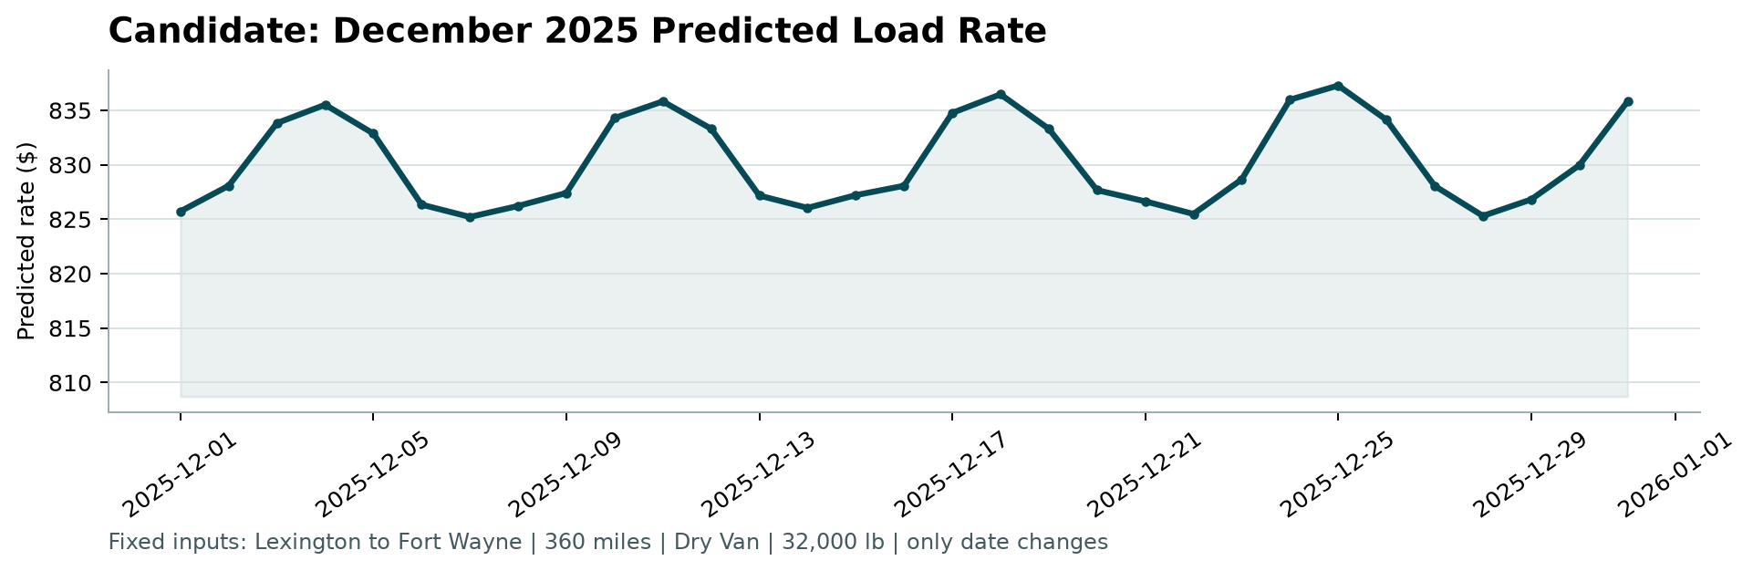
Figure 3. scorer_results/candidate_december.png, created by the unmodified score.py.
- Inputs fixed by the task: Lexington to Fort Wayne, 360 mi, Dry Van, 32,000 lb. Coordinates are the train city medians; market_index and quote_signal for each December date come from the December rows of validation.csv (daily mean over all rows; only 3 December rows share the lane and equipment, too few to use).
- Option A (chosen, daily means of December validation rows): 825.2 to 837.3, mean 830.3. Option B (frozen at the last available day, 2025-11-30): mean 826.2. Mean absolute difference 4.33, maximum 11.10 dollars.
- The curve has a 7-day cycle (peaks Wednesday/Thursday, troughs Saturday to Monday) and no unexplained spikes (largest day-to-day move 7.3 dollars). The cycle is inherited from market_index, which has a strong weekly cycle in both train and validation; the model has no weekday feature.
- Caveats: training ends in October, so December seasonality (holiday demand) is not learned; tree models do not extrapolate beyond the training range; the model's response to market_index in December (log-slope about 0.07) is weaker than the empirical slope (about 0.12-0.13), so the amplitude of the weekly cycle is probably understated.

4. Data exploration and data-quality issues
issue | rows affected | fix
Negative weights (sign errors) | 292 train, 145 validation | abs(weight)
Weight censored at 47,500 lb | 1204 train, 301 validation | keep (legal max load); optional is_capped flag
Null weight | 300 train (0.62%), 165 validation | median impute (by equipment) + was_missing flag, or native NaN for GBMs
Null market_index | 374 train (0.78%), 249 validation | fill with same-date median of the other loads (every date has observed values)
Corrupted posted_rate labels (x0.17-0.47 or x2.1-5.3) | 677 train (1.41%): 340 high, 337 low | drop from training and from CV/holdout scoring (also report holdout on all rows); never 'predict' them
Coordinates: per-row deviation from city median | 0 | use row coordinates (== city medians); Lexington/Fort Wayne taken from train city medians
Coordinates are synthetic / clipped | all rows | treat lat/lon as city identifiers in a synthetic plane; do not use external geography
distance vs haversine mismatch | 111 train ratio>1.6 (median distance 84 mi) | keep; explained by 70-mile floor on distance + noise on very short lanes
Row-level distance noise within a lane | most lanes | use row distance plus lane-mean distance as separate features
Cold-start cities in validation | 1447 validation rows (12.1%): Allentown, Charlotte, Chicago, Jackson, Knoxville, Laredo, Norfolk, San Diego | no city-ID/target-encoding as sole signal; rely on distance, equipment, coordinates, market_index; evaluate with the cold-start holdout
quote_signal is NOT a near-proxy of the target but is unstable | all | use with caution: test in CV with/without; do not rely on it for Nov/Dec
Market regime shift (validation market_index) | 12000 validation rows | model market_index monotonically/log-linearly; rely on the Jan/Aug-Oct (low-index) months for fit quality; Dec market_index filled from validation features per date
Train-vs-validation covariate shift (adversarial validation) | all validation rows | keep features that are stable (distance, equipment, weight); handle market_index via regime-robust modelling; use time-based CV that mimics the shift

Before/after effect of cleaning, measured on the CV folds (Mar-Aug) with a plain log-linear baseline (not the final model):
baseline variant | MAE | RMSE | MAPE %
A) train on ALL rows, eval ALL rows (naive) | 120.343 | 602.401 | 5.433
B) train CLEAN, eval ALL rows | 118.223 | 601.422 | 5.379
C) train CLEAN, eval CLEAN | 68.955 | 96.070 | 3.069
C-noMI) as C but without market_index | 101.879 | 141.202 | 4.256
D) as C, weight RAW (negatives kept) | 70.982 | 101.140 | 3.156
E) as C, weight ABS | 68.955 | 96.070 | 3.069
F) as C, no weight feature | 82.340 | 114.802 | 3.599

- Corrupted labels (677 rows, x0.17-0.45 or x2.2-5.4): removing them from training barely changes a log-linear fit, but they dominate every error metric (RMSE 601 on all rows vs 96 on clean rows). If validation labels contain the same corruption, that error is irreducible. We therefore report metrics on clean rows and, for the holdout, on all rows.
- market_index is the main non-geometric driver; quote_signal is not a near-proxy of the target, but its relationship flips sign by month (outputs/quote_signal_by_month.csv).
- Coordinates are constant per city (no row-level deviations) and synthetic; distance is about 1.18 x haversine with row-level noise and a 70-mile floor.
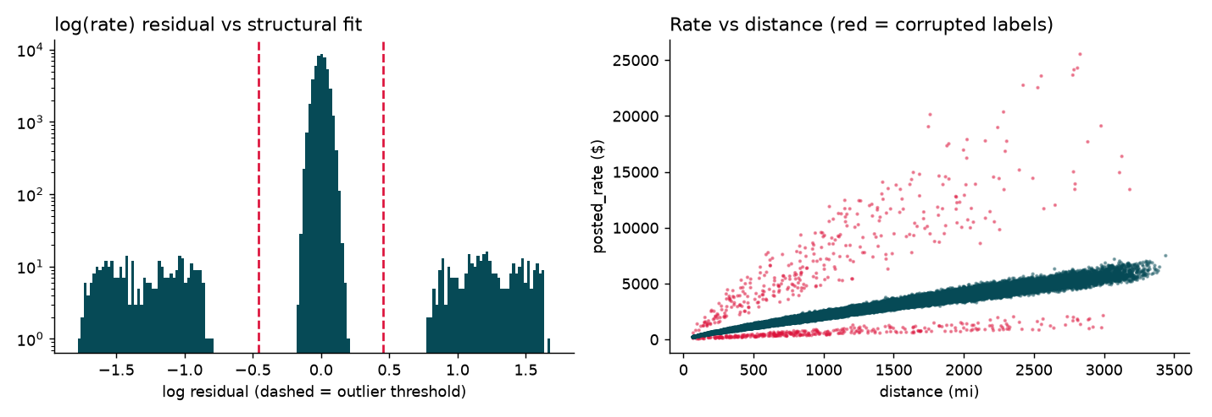
Figure 4. Corrupted labels: residual histogram (log scale) and rate vs distance.
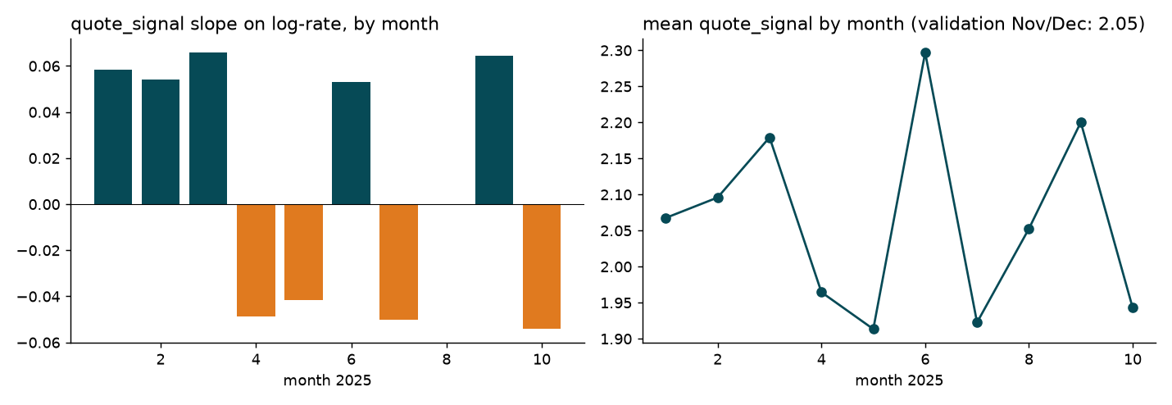
Figure 5. quote_signal: sign of its effect changes from month to month.

5. Features and ablations (CV folds Mar-Aug only)
- Target: log(rate) beat rate-per-mile and log(rate-per-mile) (LightGBM fold-mean MAPE 4.01 vs 4.50 vs 4.58).
- Signals (LightGBM, same base features): no market variables 4.19; market_index 3.14; quote_signal only 4.39; both 3.97. market_index is used (stable, inside the train range for validation and December). quote_signal is excluded: it is also inside the train range, but it makes the model less accurate and much less stable (fold MAPE up to 11.9%).
feature set | MAPE % | fold std | last fold | cold-start CV MAPE %
C1 base+mi (no dow) | 3.040 | 0.514 | 3.153 | 3.306
C2 C1+lane_target | 2.569 | 0.642 | 2.034 | 3.449
C3 C1+geo | 2.415 | 0.669 | 2.622 | 2.747
C4 C1+lane_target+geo | 2.280 | 0.690 | 1.757 | 3.129
C5 C4+dow | 2.384 | 0.689 | 1.878 | 3.057
C6 C4+quote_signal | 3.361 | 3.479 | 2.794 | 3.920

Lane statistics improve seen lanes but hurt rows with new cities; geography helps both. The final system therefore routes rows without lane history to a fallback model without lane statistics.

6. Models, results and choice
model | CV MAPE mean | CV std | CV worst | CV last fold | Sep-Oct MAPE | Sep-Oct MAE | Sep-Oct RMSE | Sep-Oct MAPE all rows | cold-start MAPE
ridge | 3.083 | 0.481 | 3.713 | 3.120 | 4.635 | 109.750 | 146.199 | 7.030 | 4.566
lightgbm | 2.300 | 0.663 | 3.131 | 1.764 | 2.724 | 65.458 | 94.477 | 5.190 | 4.667
catboost | 2.272 | 0.660 | 3.109 | 1.763 | 2.770 | 66.678 | 95.512 | 5.235 | 4.695
hybrid | 2.178 | 0.705 | 3.050 | 1.608 | 2.696 | 65.412 | 93.941 | 5.162 | 4.580
blend | 2.160 | 0.684 | 3.054 | 1.653 | 2.762 | 67.052 | 95.633 | 5.225 | 4.592

MAPE is stable (minimum clean target in any fold is 185). Metrics are on clean rows unless stated; 'all rows' includes the corrupted labels. The tuning objective was the mean fold MAPE.
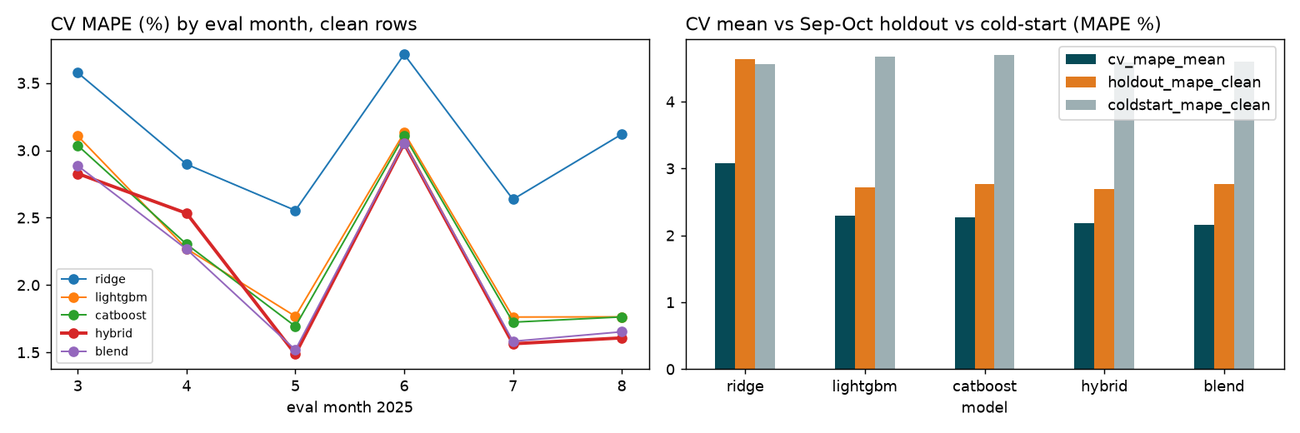
Figure 6. Per-fold CV MAPE and CV / holdout / cold-start comparison.
- Models: Ridge on log(rate); LightGBM; CatBoost; hybrid; non-negative blend of the four (weights ridge 0.05, lightgbm 0.20, catboost 0.24, hybrid 0.51, fitted on the CV predictions).
- Choice by temporal stability, not only the lowest mean: hybrid has the best latest-month CV error (1.61) and the best Sep-Oct holdout (2.70). The blend has a slightly lower CV mean (2.16 vs 2.18) but its weights are fitted on the same predictions that score it, its advantage (0.02) is far smaller than the fold std (0.7), and it is worse on the holdout (2.76). The original selection rule would have picked the blend; it was revised after seeing the results (disclosed).
- Why a hybrid: trees cannot extrapolate. The linear part carries the global scale in distance, equipment and market_index (which can move beyond what trees saw); the trees model bounded residual structure (weight, geography, lane effects).
- A toy-grid test confirms the final model's rate increases strictly with distance for every equipment type, with and without lane history.

7. Importance and residuals
- Permutation importance on the Sep-Oct holdout (increase in MAPE, percentage points): log_distance 92.33, equip 3.82, weight 0.90, pickup_lat 0.27, delivery_lat 0.23, pickup_lon 0.19; market_index 0.15, lane_stat 0.10.
- SHAP (LightGBM, mean |value| on log-rate): distance 0.314, log_distance 0.136, haversine 0.075, equip 0.049, market_index 0.029, weight 0.018, lane_stat 0.011.
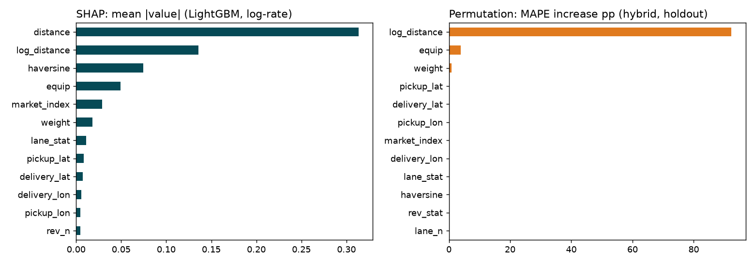
Figure 7. SHAP and permutation importance.
Holdout residuals (clean rows): Dry Van MAPE 2.43% / bias -2.22%; Flatbed MAPE 3.40% / bias -3.19%; Reefer MAPE 2.77% / bias -2.57%. All distance bands and both months are under-predicted by 2.4-2.7%, so the largest remaining error is a systematic level offset, not noise in one segment. The daily mean residual is smooth and highly autocorrelated (lag-1 0.96); none of the available features explains it, and it cannot be learned for November and December.
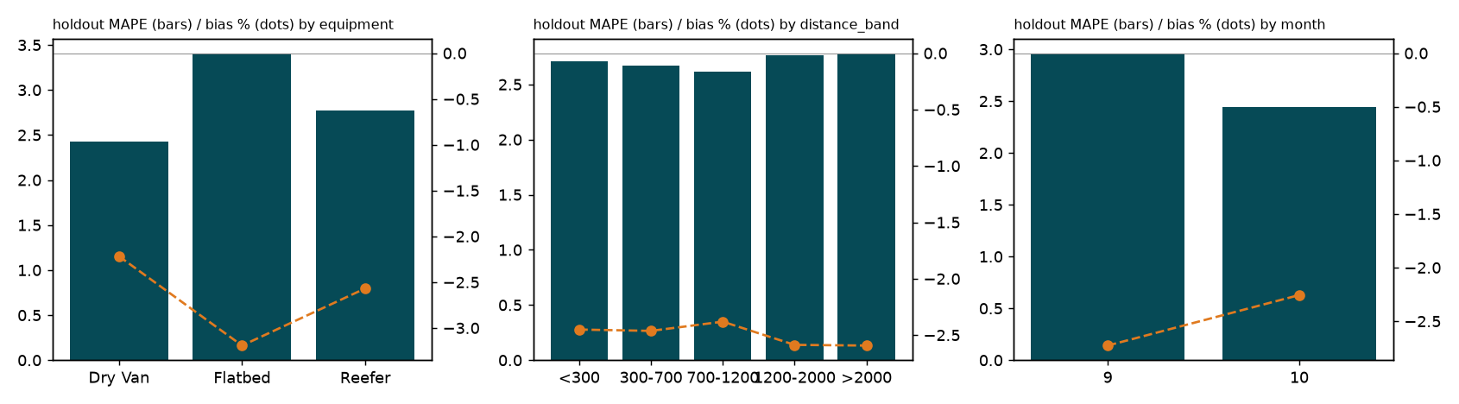
Figure 8. Holdout MAPE (bars) and bias (dots) by equipment, distance band and month.

8. Limitations
- Systematic under-prediction of about 2.2-3.2% on the Sep-Oct holdout; it may carry over to Nov/Dec.
- December seasonality is not learned (training ends 31 Oct); trees do not extrapolate; the model's market_index response in December is about half the empirical slope.
- 8 cities appear only in validation (12.1% of rows); they are served by the fallback model. In the cold-start diagnostic MAPE is about 4.6% versus 2.7% on seen lanes.
- Corrupted labels (about 1.4%) are excluded from training; if validation labels contain them, the final error is dominated by them.
- Spotter's metric is undisclosed; MAE, RMSE, MAPE, sMAPE, RMSLE, R2 and median APE are all computed (outputs/cv_fold_metrics.csv).
- The holdout was used to choose among five tuned candidates and the selection rule was changed after seeing results; the holdout number is therefore mildly optimistic.
- Validation null market_index (249 rows) is filled with a constant (0.944) to respect the rule on validation features; this may cost accuracy on about 2% of rows and cannot be measured without labels.

9. What was not done / not run
- No accuracy is claimed on validation.csv; no labels exist for it.
- Blend weights were not nested-cross-validated; no second Optuna seed; more than 20 trials per model not tried.
- No quantile or interval predictions; no explicit day-level latent-level model; no external data (calendar/holiday features were not used).
- No TabPFN or pretrained weights; no network access beyond installing the pinned packages.
- Not verified on other operating systems or library versions (versions are pinned in requirements.txt; tested on Python 3.12, Linux).
- The 2-3 minute Loom video is a deliverable of the candidate and is not part of this document (script in loom_script.md).

