OOP-Task
Lab-08

Name: Abdullah Aamir Farooqui
Rollno: 25K-0868

Class Exercises
Q1)Ex1:
#include<iostream>
using namespace std;
class student{
string name;
int marks[3];
int count=0;
public:
student(string n=""):name(n),count(0){
}
void addmarks(int M){
if(count<=2){
marks[count++]=M;
}
else{
cout<<"Error!All marks uploaded!"<<endl;
}
}
friend double calculateAvg(student S);
};
double calculateAvg(student S){
int Total=0;
for(int i=0;i<=S.count;i++){
Total+=S.marks[i];
}
return Total/S.count;
}
int main(){
student s1("abdullah");
s1.addmarks(100);
s1.addmarks(80);
s1.addmarks(90);
s1.addmarks(120);
cout<<"Avg of Student 1 is "<<calculateAvg(s1)<<"."<<endl;
}

Output:
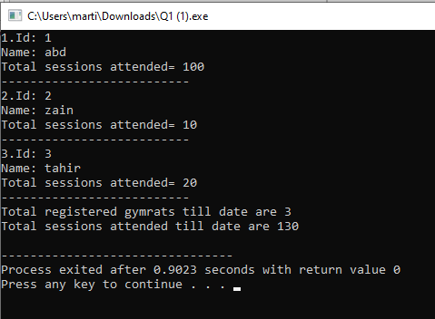
Ex-2:
#include<iostream>
using namespace std;
class LibraryBook{
string title;
bool issued=false;
public:
LibraryBook(string n=""):title(n){}
friend class Librarian;
};
class Librarian{
string name;
public:
Librarian(string n=""):name(n){
}
void issueBook(LibraryBook B){
if(B.issued==false){
B.issued=true;
cout<<"The Book \""<<B.title<<"\" has been issued to you!"<<endl;
}
else{
cout<<"Sorry!The book is already issued to someone else."<<endl;
}
}
void returnBook(LibraryBook B){
B.issued=false;
cout<<"Book returned Sucessfully!"<<endl;
}
};
int main(){
LibraryBook B1("The jungle Book");
Librarian L1("Javed Iqbal");
L1.issueBook(B1);
L1.returnBook(B1);
}
Output:
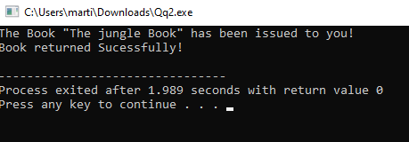
Ex-3:
#include <iostream>
#include <string>
using namespace std;
class Person{
protected:
string name;
public:
Person(string name = "Unknown"):name(name){}
void showperson(){
cout << "Person Name: " << name << endl;
}
};
class Student: virtual public Person{
protected:
float GPA;
public:
Student(string name = "Unknown", float gpa = 0):Person(name),GPA(gpa){}
void showStudent(){
cout << "Student GPA: " << GPA << endl;
}
};
class Employee:virtual public Person{
protected:
int ID;
public:
Employee(string name = "Unknown", int id = 0):Person(name),ID(id){}
void showEmployee(){
cout << "Employee ID: " << ID << endl;
}
};
class TeachingAssistant : public Employee, public Student{
private:
float salary;
public:
TeachingAssistant(string name, float gpa, int id, float salary)
: Person(name), Employee(name, id), Student(name, gpa), salary(salary){}
void showAssistant(){
Person::showperson();
Student::showStudent();
Employee::showEmployee();
cout << "Salary: " << salary << endl;
}
};

int main(){
TeachingAssistant TA("Shivam", 3.9, 1, 30000.0f);
TA.showAssistant();
return 0;
}
Output:
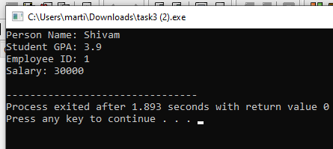

LAB TASKS
Task-1:
#include <iostream>
using namespace std;
class Rectangle{
private:
int length;
int width;
public:
void setlength(int len){
if(len > 0){
length = len;
}
else{
cout << "Length must be positive (> 0)\n";
}
}
void setwidth(int w){
if(w > 0){
width = w;
}
else{
cout << "Width must be positive (> 0)\n";
}
}
int getlength(){
return length;
}
int getwidth(){
return width;
}
friend void calculation(Rectangle &rec);
};
void calculation(Rectangle &rec){
cout << "Area of Rectangle: " << rec.length * rec.width << endl;
cout << "Perimeter of Rectangle: " << 2*rec.length + 2*rec.width << endl;
}
int main(){
Rectangle r1;
int len, wid;

cout << "Enter length of rectangle: ";
cin >> len;
r1.setlength(len);

cout << "Enter width of rectangle: ";
cin >> wid;
r1.setwidth(wid);

cout << "\nRectangle :" << endl;
cout << "Length: " << r1.getlength() << endl;
cout << "Width: " << r1.getwidth() << endl << endl;

calculation(r1);
return 0;
}
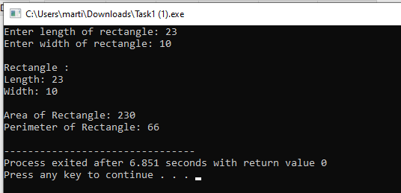
Task-2:
#include <iostream>
#include <string>
using namespace std;
class Mechanic;
class CarEngine{
private:
int horsePower;
public:
CarEngine(int power = 0):horsePower(power){}
friend class Mechanic;
};
class Mechanic{
public:
void display(CarEngine &car) const {
cout << "Engine Horse power is: " << car.horsePower << " HP" << endl;
}
void Upgradepower(CarEngine &car, int amount){
int upgraded = car.horsePower + amount;
if(upgraded >= 100 && upgraded <= 1000){
car.horsePower += amount;
cout << "Engine upgraded! New horse power: " << car.horsePower << " HP" << endl;
}
else{
cout << "Upgrade failed! Horsepower must be between 100-1000 HP." << endl;
cout << "Attempted value: " << upgraded << " HP" << endl;
}
}
};
class Car{
private:
CarEngine engine;
string name;
public:
Car(int power, string name):engine(power), name(name){}
void displayCar(){
cout << "Car Name: " << name << endl;
}
CarEngine& getEngine(){
return engine;
}
};
int main(){
cout << "===== Mechanic Friend Class Demo =====\n" << endl;

CarEngine engine1(150);
Mechanic mechanic;

cout << "--- Engine 1 ---" << endl;
mechanic.display(engine1);

cout << "\nAttempting to upgrade by 200 HP:" << endl;
mechanic.Upgradepower(engine1, 200);

cout << "\nCurrent status:" << endl;
mechanic.display(engine1);

cout << "\nAttempting to upgrade by 900 HP:" << endl;
mechanic.Upgradepower(engine1, 900);

cout << "\nAttempting to downgrade by 100 HP:" << endl;
mechanic.Upgradepower(engine1, -100);

cout << "\n--- Using Car Class ---" << endl;
Car myCar(200, "Tesla Model S");
myCar.displayCar();

cout << "\nEngine details:" << endl;
mechanic.display(myCar.getEngine());

cout << "\nUpgrading car engine:" << endl;
mechanic.Upgradepower(myCar.getEngine(), 300);

cout << "\nFinal engine status:" << endl;
mechanic.display(myCar.getEngine());

return 0;
}
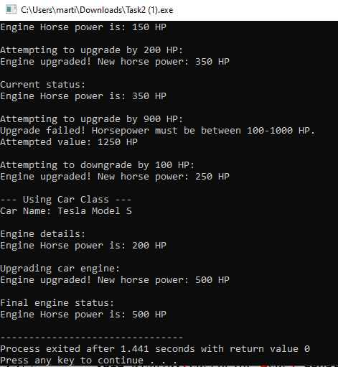
Task-3:
#include <iostream>
#include <string>
using namespace std;

class Person {
private:
int ID;
string name;
public:
Person(int id = 0, string n = "Unknown") : ID(id), name(n) {}

int getID() const {
return ID;
}

string getName() const {
return name;
}

void setPerson(int id, string n) {
ID = id;
name = n;
}

void showPerson() const {
cout << "ID: " << ID << ", Name: " << name << endl;
}
};

class Student : virtual public Person {
protected:
float GPA;
public:
Student(int id = 0, string n = "Unknown", float g = 0.0)
: Person(id, n), GPA(g) {}

float getGPA() const {
return GPA;
}

void setGPA(float g) {
if(g >= 0.0 && g <= 4.0) {
GPA = g;
} else {
cout << "Invalid GPA. Must be between 0.0 and 4.0" << endl;
}
}

void showStudent() const {
cout << "Student - ";
showPerson();
cout << "GPA: " << GPA << endl;
}
};

class Employee : virtual public Person {
protected:
float salary;
public:
Employee(int id = 0, string n = "Unknown", float s = 0.0)
: Person(id, n), salary(s) {}

float getSalary() const {
return salary;
}

void setSalary(float s) {
if(s >= 0) {
salary = s;
} else {
cout << "Invalid salary. Must be non-negative." << endl;
}
}

void showEmployee() const {
cout << "Employee - ";
showPerson();
cout << "Salary: $" << salary << endl;
}
};

class TeachingAssistant : public Student, public Employee {
private:
float bonus;
public:
TeachingAssistant(int id = 0, string n = "Unknown", float g = 0.0,
float s = 0.0, float b = 0.0)
: Person(id, n), Student(id, n, g), Employee(id, n, s), bonus(b) {}

float getBonus() const {
return bonus;
}

void setBonus(float b) {
if(b >= 0) {
bonus = b;
} else {
cout << "Invalid bonus. Must be non-negative." << endl;
}
}

void showTeachingAssistant() const {
cout << "\n===== Teaching Assistant Profile =====" << endl;
cout << "Person Information - ";
showPerson();
cout << "\nStudent Information:" << endl;
cout << " GPA: " << GPA << endl;
cout << "\nEmployee Information:" << endl;
cout << " Salary: $" << salary << endl;
cout << " Bonus: $" << bonus << endl;
cout << " Total Compensation: $" << (salary + bonus) << endl;
cout << "======================================\n" << endl;
}
};

int main() {
cout << "===== Virtual Inheritance & Diamond Problem Solution =====" << endl;

cout << "\nCreating a Teaching Assistant:" << endl;
TeachingAssistant ta(101, "Ahmed Hassan", 3.8, 50000.0, 5000.0);

ta.showTeachingAssistant();

cout << "Accessing Person data (resolved through virtual inheritance):" << endl;
cout << "ID: " << ta.getID() << endl;
cout << "Name: " << ta.getName() << endl;
cout << "GPA: " << ta.getGPA() << endl;
cout << "Salary: $" << ta.getSalary() << endl;
cout << "Bonus: $" << ta.getBonus() << endl;

cout << "\n--- Modifying Attributes ---" << endl;
ta.setGPA(3.9);
ta.setSalary(55000.0);
ta.setBonus(7000.0);

cout << "After modifications:" << endl;
ta.showTeachingAssistant();

cout << "\nCreating another Teaching Assistant:" << endl;
TeachingAssistant ta2(102, "Fatima Khan", 3.5, 45000.0, 4500.0);
ta2.showTeachingAssistant();

cout << "\n===== End of Virtual Inheritance Demo =====" << endl;

return 0;
}
