K250868 Abdullah Aamir Farooqui

Car Marketplace System (Like pakwheels)
Subject: Object oriented programming
instructor: Sir Ubaidullah

Table of Contents
1. Introduction 1
2. System Features & Implementation 1
Feature 1: Centralized Marketplace Feed (Aggregation & Arrays) 1
Feature 2: Communication System 3
Feature 3: Vehicle Details (Composition) 7
Feature 4: User Roles (Inheritance) 9
3. OOP Concepts Used 12
13
5. Final Output & Execution 14
How to Compile: 14
Expected Output: 14

GitHub Repository: muhammadanas20/oop-a1-pak_wheel_system

1. Introduction
“Abdullah's Garage" is a C++ console-based car marketplace simulation inspired by PakWheels. It utilizes 10 interconnected classes to demonstrate core OOP principles—including inheritance, composition, and aggregation—to effectively model real-world interactions between buyers, sellers, and system administrators.

2. System Features & Implementation

Feature 1: Centralized Marketplace Feed (Aggregation & Arrays)
- Observed Functionality: The system features a main feed where all active car advertisements are shown, allowing buyers to search by brand and filter by price.
- Design Reasoning: This relies on Aggregation. The Marketplace and Listing classes use array of pointers (Listing* activeListings[100], Vehicle* vehiclePtr) because the actual vehicles and user accounts exist independently of the marketplace feed. If an ad expires, the car and the owner still exist in the database.
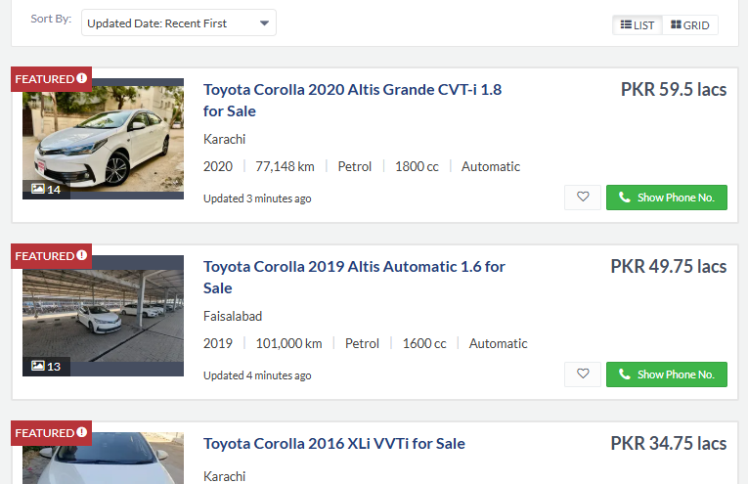
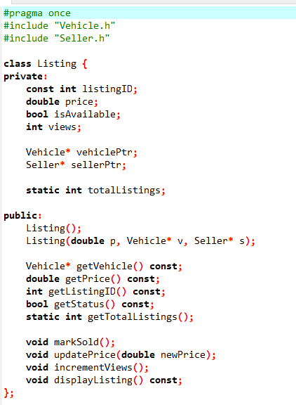

Feature 2: Communication System
- Observed Functionality: Users can initiate direct contact regarding specific vehicles, negotiating prices or asking for details securely.

- Design Reasoning: Implemented utilizing an Array of Objects. The Buyer class contains a dedicated inbox (Message inbox[50]). The Message class itself enforces data integrity by using a const std::string timestamp, ensuring that the exact time a message was sent cannot be altered after creation.

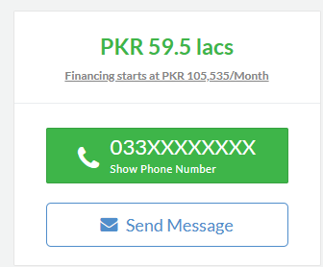
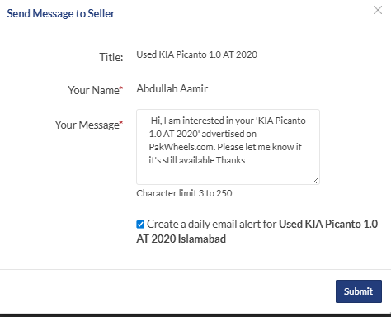
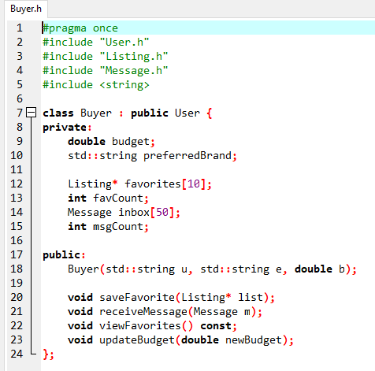

Feature 3: Vehicle Details (Composition)
- Observed Functionality: Every car has specific engine details and registration info
- Design Reasoning: I used Composition (Death relationship). The Vehicle completely owns its Engine and Registration. If the car is deleted from the system, its engine and registration are deleted too.
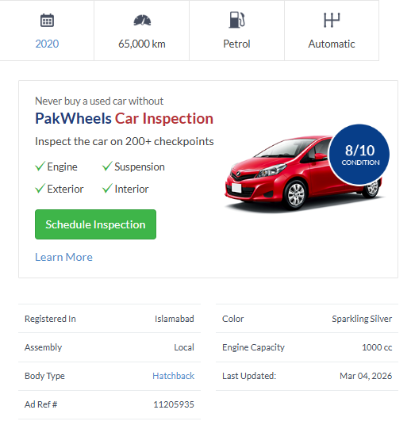
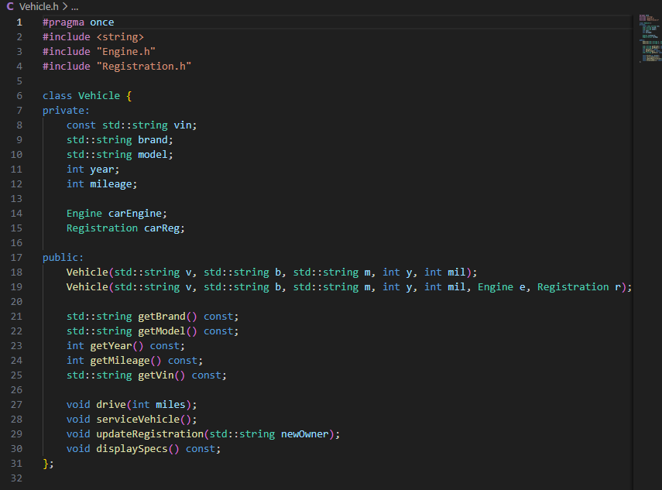

Feature 4: User Roles (Inheritance)
- Observed Functionality: The system has different types of users: Buyers, Sellers, and Admins.
- Design Reasoning: I used Inheritance. There is a main User class that holds basic info (name, email). The Admin, Buyer, and Seller classes inherit from it so we don't repeat code.
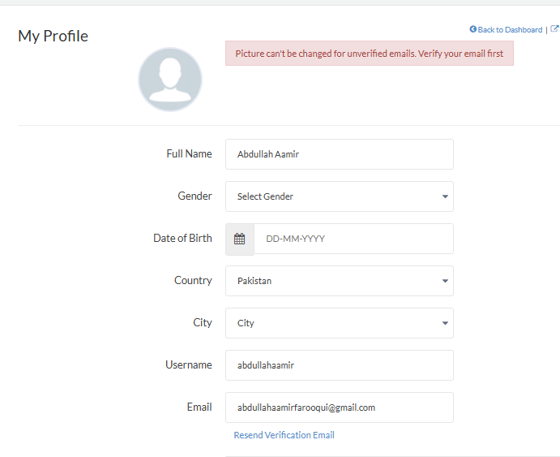
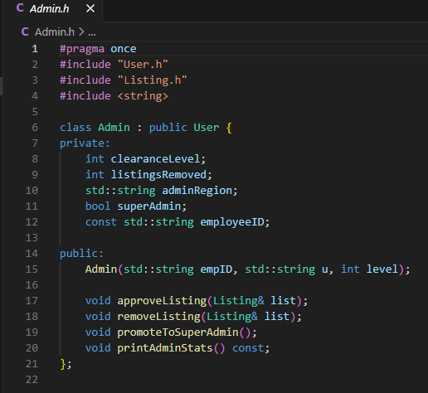

3. OOP Concepts Used
Technical Requirement | Implementation Details in "Abdullah's Garage"
10 Distinct Classes | Engine, Registration, Vehicle, Listing, Message, User, Seller, Buyer, Admin, Marketplace.
Constructors Overview | Extensive use of Parameterized Constructors (e.g., in Vehicle and Engine) to prevent null-state instantiation. A Copy Constructor is safely implemented in the User base class.
Constant Data Members | Exceeds requirement with 6 constants: vin (Vehicle), timestamp (Message), sellerID (Seller), listingID (Listing), employeeID (Admin), and platformName (Marketplace).
Static State Tracking | Global tracking utilized via totalUsers in the User class and totalListings in the Listing class to generate unique, auto-incrementing IDs.
Array of Objects | Successfully deployed in Buyer (Message inbox[50]) and Marketplace (Listing* activeListings[100]).
Composition | Vehicle strictly owns its Engine and Registration components.

Class diagram:


5. Final Output & Execution

How to Compile:
g++ -o marketplace main.cpp Admin.cpp Buyer.cpp Engine.cpp Listing.cpp Marketplace.cpp Message.cpp Registration.cpp Seller.cpp User.cpp Vehicle.cpp
./marketplace

Expected Output:
Upon execution, the system dynamically generates "Abdullah's Garage", instantiates specific vehicles using composition, creates listings using aggregation, and pushes them to the live feed. The simulation then demonstrates automated filtering, a buyer saving a favorite, cross-user messaging, and an Admin utilizing elevated privileges to remove a listing.
