OOP-Task
Lab-10

Name: Abdullah Aamir Farooqui
Rollno: 25K-0868

Class Exercises
Q1)Ex1:
#include <iostream>
using namespace std;

template <typename T>

T getMin(T a,T b){
return (a > b ? b : a);
}

int main(){
cout << "Integer:" << getMin(10,20) << endl;
cout << "Float:" << getMin(3.5f,4.5f) << endl;
cout << "Character:" << getMin('A','X') << endl;
return 0;

}

Output:
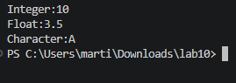

Ex-2:
#include <iostream>
using namespace std;
// Create a class template Calculator that performs:

// Addition
// Subtraction
// Multiplication
// Division
template<typename T>
class Calculator{
private:
T a;
T b;
public:
Calculator(T a, T b) : a(a), b(b) {}

T Sum(){
return a + b;
}

T Division(){
if(b != 0){
return a / b;
}
cout << "Error: Division by zero!" << endl;
return 0;
}

T Difference(){
return a - b;
}

T Multiply(){
return a * b;
}
};

int main(){
cout << "=== Integer Calculator ===" << endl;
Calculator<int> calc1(20, 5);
cout << "Sum: " << calc1.Sum() << endl;
cout << "Difference: " << calc1.Difference() << endl;
cout << "Multiply: " << calc1.Multiply() << endl;
cout << "Division: " << calc1.Division() << endl;

cout << "\n=== Float Calculator ===" << endl;
Calculator<float> calc2(10.5f, 2.5f);
cout << "Sum: " << calc2.Sum() << endl;
cout << "Difference: " << calc2.Difference() << endl;
cout << "Multiply: " << calc2.Multiply() << endl;
cout << "Division: " << calc2.Division() << endl;

return 0;
}
Output:
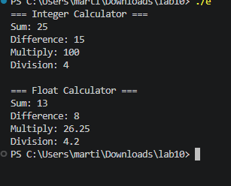
Ex-3:
#include <iostream>
using namespace std;
// Write a program that:

// Takes user age
// Throws exception if age < 18
int main(){
int age;
try{
int buffer;
cout << "Enter Age:";
cin >> buffer;
if(buffer < 18){
throw "Error: UnderAge!!";
}
age = buffer;
}
catch(const char* msg){
cout << msg << endl;
}
return 0;
}

Output:
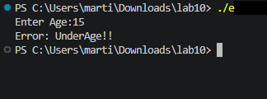

LAB TASKS:
Task1:
#include<iostream>
using namespace std;

template <typename T>
T sum (T a, T b) {
return (a+b);
}

template <typename T>
T difference (T a, T b) {
return (a-b);
}

template <typename T>
T product (T a, T b) {
return (a*b);
}

int main () {
cout << "Adding two integers: " << sum(4, 5) << endl;
cout << "Taking difference of two integers: " << difference(4, 5) << endl;
cout << "Multiplying two integers: " << product(4, 5) << endl;

cout << "Adding two floats: " << sum (5.2, 2.5) << endl;
cout << "Taking difference of two floats: " << difference(5.2, 2.5) << endl;
cout << "Multiplying two floats: " << product(5.2, 2.5) << endl;
}

OUTPUT:
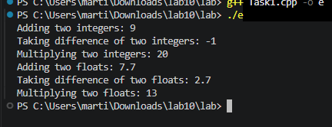

Task2:
#include <iostream>
using namespace std;
// Design a generic array class that:

// Stores elements of any type
// Displays all elements
// Finds maximum value
template <typename T>
class Array{
private:
T* array;
int size;
public:
Array(T* array, int size) : array(array), size(size) {}

void display(){
cout << "Elements of array: ";
for(int i = 0; i < size; i++){
cout << array[i] << " ";
}
cout << endl << "-----------" << endl;
}

T maximum(){
T temp = array[0];
for(int i = 1; i < size; i++){
if(temp < array[i]){
temp = array[i];
}
}
return temp;
}
};

int main(){
cout << "----Integer Array-----" << endl;
int intArray[] = {15, 42, 8, 99, 5};
Array<int> a(intArray, 5);
a.display();
cout << "Maximum value: " << a.maximum() << endl;

cout << "\n----Float Array-----" << endl;
float floatArray[] = {3.5f, 7.2f, 1.1f, 9.8f, 4.3f};
Array<float> b(floatArray, 5);
b.display();
cout << "Maximum value: " << b.maximum() << endl;

return 0;
}

OUTPUT:
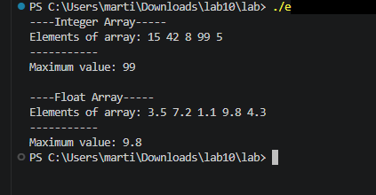

Task3:
// Create a student grading system:

// Input marks
// Throw exception if:

// marks < 0
// marks > 100
// Display appropriate message
#include <iostream>
using namespace std;

class Student
{
private:
string name;
int *marks;
int NoOfSub;

public:
Student(string name, int no)
{
this->name = name;
NoOfSub = no;
marks = new int[no];
}
void UploadingGrade()
{
int buffer;
for (int i = 0; i < NoOfSub; i++)
{
try
{
cout << "Enter a marks of " << i + 1 << " Subject:";
cin >> buffer;
if(buffer < 0){
throw "Error: Marks Cannot be negative!!";
}else if( buffer > 100){
throw "Error: Marks Cannot be exceed 100!!";
}

marks[i] = buffer;
}
catch(const char* msg){
i--;
cout << msg << endl;
}
}
}
void Display() {
cout << "Name:" << name << endl;
cout << "No of Course:" << NoOfSub << endl;
cout << "Marks Details" << endl;
for(int i=0;i<NoOfSub;i++){
cout << "Subject " << i+1 << ":" << marks[i] << endl;
}
}
~Student(){
delete [] marks;
}
};

int main()
{
Student s1("Anas",3);
s1.UploadingGrade();
s1.Display();
return 0;
}

OUTPUT:
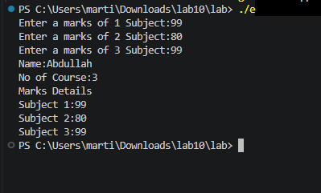

Combine Task

Task:
// COMBINED TASK (TEMPLATES + EXCEPTION HANDLING)
// Task Description:
// Develop a Generic Calculator System using templates and exception handling.

#include <iostream>
#include <limits>

using namespace std;

template <typename T>
class Calculator {
private:
T a;
T b;

public:
Calculator(T first, T second) : a(first), b(second) {}

T add() const {
return a + b;
}

T subtract() const {
return a - b;
}

T multiply() const {
return a * b;
}

T divide() const {
if (b == 0) {
throw "Division by zero exception.";
}
return a / b;
}
};

template <typename T>
T readNumber(const string& prompt) {
T value;
cout << prompt;
cin >> value;

if (cin.fail()) {
cin.clear();
cin.ignore(numeric_limits<streamsize>::max(), '\n');
throw "Invalid input. Please enter a numeric value.";
}

return value;
}

int main() {
try {
cout << "Generic Calculator System" << endl;
cout << "Select data type:" << endl;
cout << "1. Integer" << endl;
cout << "2. Double" << endl;
cout << "Enter your choice (1 or 2): ";

int choice;
cin >> choice;

if (cin.fail() || (choice != 1 && choice != 2)) {
throw "Invalid input. Choice must be 1 or 2.";
}

if (choice == 1) {
int x = readNumber<int>("Enter first integer: ");
int y = readNumber<int>("Enter second integer: ");

Calculator<int> calc(x, y);
cout << "Addition: " << calc.add() << endl;
cout << "Subtraction: " << calc.subtract() << endl;
cout << "Multiplication: " << calc.multiply() << endl;
cout << "Division: " << calc.divide() << endl;
} else {
double x = readNumber<double>("Enter first number: ");
double y = readNumber<double>("Enter second number: ");

Calculator<double> calc(x, y);
cout << "Addition: " << calc.add() << endl;
cout << "Subtraction: " << calc.subtract() << endl;
cout << "Multiplication: " << calc.multiply() << endl;
cout << "Division: " << calc.divide() << endl;
}
} catch (const char* msg) {
cout << "Error: " << msg << endl;
}

return 0;
}

OUTPUT:
