OOP-Task
Lab-11

Name: Abdullah Aamir Farooqui
Rollno: 25K-0868

Class Exercises
Q1)Ex1:
// Write a program to:

// Take user name and age
// Store it in a file
#include <iostream>
#include <fstream>
using namespace std;

int main(){
string name;
cout << "Enter a Name: ";
getline(cin, name);

int age;
cout << "Enter an Age: ";
cin >> age;

ofstream file("task1.txt");
if (!file) {
cout << "Error: could not open file for writing." << endl;
return 1;
}

file << "Name: " << name << '\n';
file << "Age: " << age << '\n';
file.close();

cout << "Data stored in task1.txt" << endl;
return 0;
}
Output:
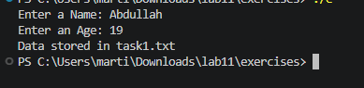

Ex-2:
#include <iostream>
#include <fstream>
#include <cctype>
using namespace std;
// Exercise
// Read a file containing 10 numbers
// Display only even numbers
int main(){
ifstream file("task2.txt", ios::in);

if (!file) {
cout << "Error: could not open task2.txt" << endl;
return 1;
}

char ch;
while (file >> ch) {
if (isdigit(static_cast<unsigned char>(ch)) && ((ch - '0') % 2 == 0)) {
cout << ch << endl;
}
}

file.close();
return 0;
}

Output:
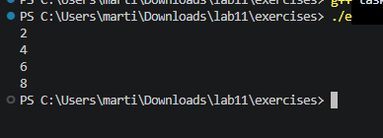
Ex-3:
// Store 5 student records in file
#include <iostream>
#include <fstream>
using namespace std;

class Student {
private:
int id;
string name;
float gpa;
public:
void input() {
cout << "Enter ID: ";
cin >> id;
cin.ignore();
cout << "Enter Name: ";
getline(cin,name);
cout << "Enter GPA: ";
cin >> gpa;
}
void display() {
cout << "ID: " << id << endl;
cout << "Name: " << name << endl;
cout << "GPA: " << gpa << endl;
}
// Function to write object data to file
void writeToFile() {
ofstream file("task3.txt", ios::app);
file << id << " " << name << " " << gpa << endl;
file.close();
}
};
int main() {
Student s;
s.input(); // Take input
s.writeToFile(); // Save to file
cout << "Student record saved!" << endl;
return 0;
}
Output:
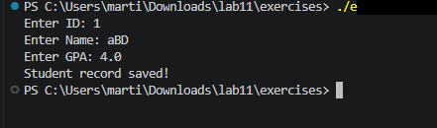
Ex4:
#include <iostream>
#include <fstream>
#include <cstring>

using namespace std;

class Student {
public:
int id;
char name[20];

Student(int i, const char* n) {
id = i;
strcpy(name, n);
}
};

int main() {
Student s[] = {
Student(34, "Anas"),
Student(46, "Ali"),
Student(67, "Abdullah")
};

int n = sizeof(s) / sizeof(s[0]);

ofstream file("student.dat", ios::binary);

if (!file) {
cout << "File error!" << endl;
return 1;
}

for (int i = 0; i < n; i++) {
file.write((char*)&s[i], sizeof(s[i]));
}

file.close();

cout << "Binary data written successfully." << endl;
return 0;
}

Output:
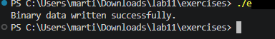

Ex5:
#include <iostream>
#include <fstream>
using namespace std;

int main() {
try {
ifstream file("task5.txt");

if (!file) {
throw "Error: Unable to open file!";
}

cout << "File opened successfully." << endl;

file.close();
}
catch (const char* error) {
cout << error << endl;
}

return 0;
}

Output:
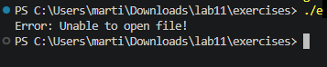
LAB TASKS
Task-1:
#include <iostream>// Modify the program to:

// Append data instead of overwriting
// Use ios::app
#include <iostream>
#include <fstream>
using namespace std;

int main(){
string name;
cout << "Enter a Name: ";
getline(cin, name);

int age;
cout << "Enter an Age: ";
cin >> age;

fstream file("task1.txt",ios::app);
if (!file) {
cout << "Error: could not open file for writing." << endl;
return 1;
}

file << "Name: " << name << '\n';
file << "Age: " << age << '\n';
file.close();

cout << "Data stored in task1.txt by appending" << endl;
return 0;
}

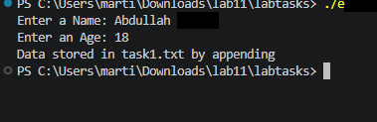

Task-2:
#include <iostream>
#include <fstream>
using namespace std;

// Count number of lines in a file
int main(){
ifstream file("task2.txt", ios::in);

if (!file) {
cout << "Error: could not open task2.txt" << endl;
return 1;
}

int lineCount = 0;
string line;
while (getline(file, line)) {
++lineCount;
}

file.close();
cout << "Number of lines: " << lineCount << endl;
return 0;
}

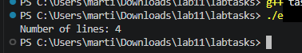
Task-3:
#include<iostream>
#include<fstream>
#include<string>
using namespace std;

class Student {
private:
int id;
string name;
float gpa;
public:
void input () {
cout << "Enter ID: ";
cin >> id;
cin.ignore();
cout << "Enter Name: ";
getline(cin, name);
cout << "Enter GPA: ";
cin >> gpa;
}

void writeToFile() {
ofstream file("task3.txt", ios::app);
if (!file) {
cout << "Could not open file for writing." << endl;
return;
}
file << "ID: " << id << " | Name: " << name << " | GPA: " << gpa << endl;
file.close();
}

void displayFromProgramMemory() {
cout << "ID: " << id << endl;
cout << "Name: " << name << endl;
cout << "GPA: " << gpa << endl;
}

void displayFromFile() {
fstream file;
file.open("task3.txt", ios::in);
if (!file) {
cout << "Could not open file for reading." << endl;
return;
}
cout << "Reading from file: " << endl;
string line;
while(getline(file, line)) {
cout << line << endl;
}
file.close();
}

};
int main () {
ofstream clearFile("task3.txt", ios::trunc);
if (!clearFile) {
cout << "Could not initialize task3.txt." << endl;
return 1;
}
clearFile.close();

Student s[5];
for (int i=0; i<5; i++) {
cout << "Adding records for student " << i+1 << endl;
s[i].input();
s[i].writeToFile();
}
cout << "Student record saved!" << endl;

s[0].displayFromFile();
return 0;
}

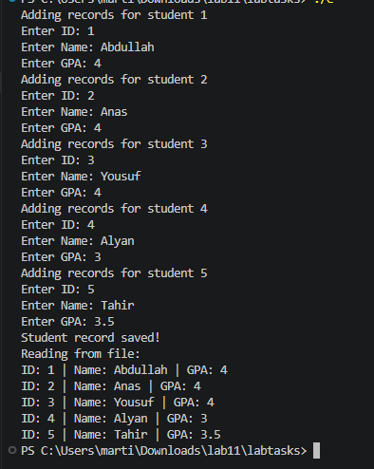
Task4:
#include <iostream>
#include <fstream>
#include <cstring>
// Read and display all objects
using namespace std;

class Student {
public:
int id;
char name[20];

Student() {
id = 0;
name[0] = '\0';
}

Student(int i, const char* n) {
id = i;
strcpy(name, n);
}
};

int main() {
Student s[] = {
Student(34, "Anas"),
Student(46, "Ali"),
Student(67, "Abdullah")
};

int n = sizeof(s) / sizeof(s[0]);

ofstream file("student.dat", ios::binary);

if (!file) {
cout << "File error!" << endl;
return 1;
}

for (int i = 0; i < n; i++) {
file.write((char*)&s[i], sizeof(s[i]));
}

file.close();

ifstream inFile("student.dat", ios::binary);
if (!inFile) {
cout << "File error while reading!" << endl;
return 1;
}

cout << "Students read from file:" << endl;
Student temp;
while (inFile.read((char*)&temp, sizeof(temp))) {
cout << "ID: " << temp.id << " | Name: " << temp.name << endl;
}

inFile.close();

cout << "Binary data written and read successfully." << endl;
return 0;
}

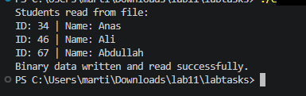
Task5:
// Task
// Combine file handling + exception handling
#include <iostream>
#include <fstream>
#include <stdexcept>
#include <string>
using namespace std;

int main() {
try {
string message;
cout << "Enter a message to store in file: ";
getline(cin, message);

ofstream outFile("task5.txt");
if (!outFile) {
throw runtime_error("Error: Unable to create task5.txt");
}
outFile << message << endl;
outFile.close();

ifstream inFile("task5.txt");
if (!inFile) {
throw runtime_error("Error: Unable to open task5.txt for reading");
}

string line;
cout << "Data read from file:" << endl;
while (getline(inFile, line)) {
cout << line << endl;
}

inFile.close();
}
catch (const exception& error) {
cout << error.what() << endl;
}

return 0;
}

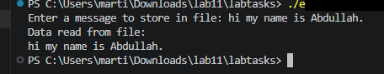

FINAL LAB TASK:

#include <fstream>
#include <string>
#include <iostream>
#include <cstdlib>
using namespace std;

class Student{
private:
int ID;
string name;
double GPA;
public:
void input(){
cout << "Enter a ID:";
cin >> ID;
cin.ignore();
cout << "Enter a Name:";
getline(cin,name);
cout << "Enter GPA:";
cin >> GPA;
}
void WriteToFile(){
ofstream file("final.txt",ios::app);
if(!file){
cout << "Error! File not Opening..."<< endl;
return;
}
file << ID <<"|"<<name << "|" << GPA << endl;
file.close();
cout << "Record Added Successfully!" << endl;
}
static void viewStudent(){
ifstream file("final.txt");
if(!file){
cout << "Error! File not Opening..."<< endl;
return;
}
string line;
cout <<"--------Student Records--------"<< endl;
cout << "ID | Name | GPA" << endl;
while(getline(file,line)){
cout << line << endl;
}
file.close();
}
static void Search(){
ifstream file("final.txt");
if(!file){
cout << "Error! File not Opening..."<< endl;
return;
}
string searchName,line;
cin.ignore();
cout << "Enter a Name to Search:";
getline(cin,searchName);
int found = 0;
while(getline(file,line)){
if(line.find(searchName) != string::npos){
cout << "--------Record Found--------" << endl;
cout << line << endl;
found = 1;
}
}
if(!found){
cout << "Student Record not Found..." << endl;
}
file.close();
}
};
void pressEnter(){
cin.ignore();
cout << "press enter to continue...";
cin.ignore(10000,'\n');
system("cls");
}
int main(){
Student s;
int choice;
cout << "\n-------Student Managment System-------\n" << endl;
int running= 1;
while(running){
cout << "=======Menu=======" << endl;
cout << "1.Add Students"<< endl;
cout << "2.View Students" << endl;
cout << "3.Search Students" << endl;
cout << "4.Exit" << endl;
cout << "Enter a Choice:" ;
cin >> choice;
switch(choice){
case 1:

s.input();
s.WriteToFile();
break;

case 2:
Student::viewStudent();
break;
case 3:
Student::Search();
break;
case 4:
cout << "Program is terminating..." << endl;
running = 0;
break;
default:
cout << "Invalid Choice" << endl;

}
pressEnter();
}
return 0;
}

