**Deployment to kubernetes**

* In your source code files, remove all underscores from paths and use hyphens.

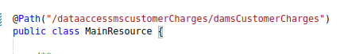

* In pom file, set your artifact id to api/microservice name without underscores.

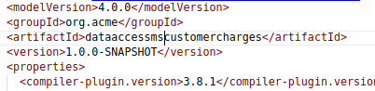

* Open pom.xml file and add the following dependencies

<dependency>

<groupId>io.quarkus</groupId>

<artifactId>quarkus-kubernetes</artifactId>

</dependency>

<dependency>

<groupId>io.quarkus</groupId>

<artifactId>quarkus-container-image-jib</artifactId>

</dependency>

Run following set of commands after changing the paths and adding dependencies to pom.xml file.

* **mvn clean**
* **mvn package**

it will generate kubernetes.yml and kubernetes.json file in target folder

* Rename kubernetes.yml to <projectname>.yaml
* In Yaml file add environment variables
* 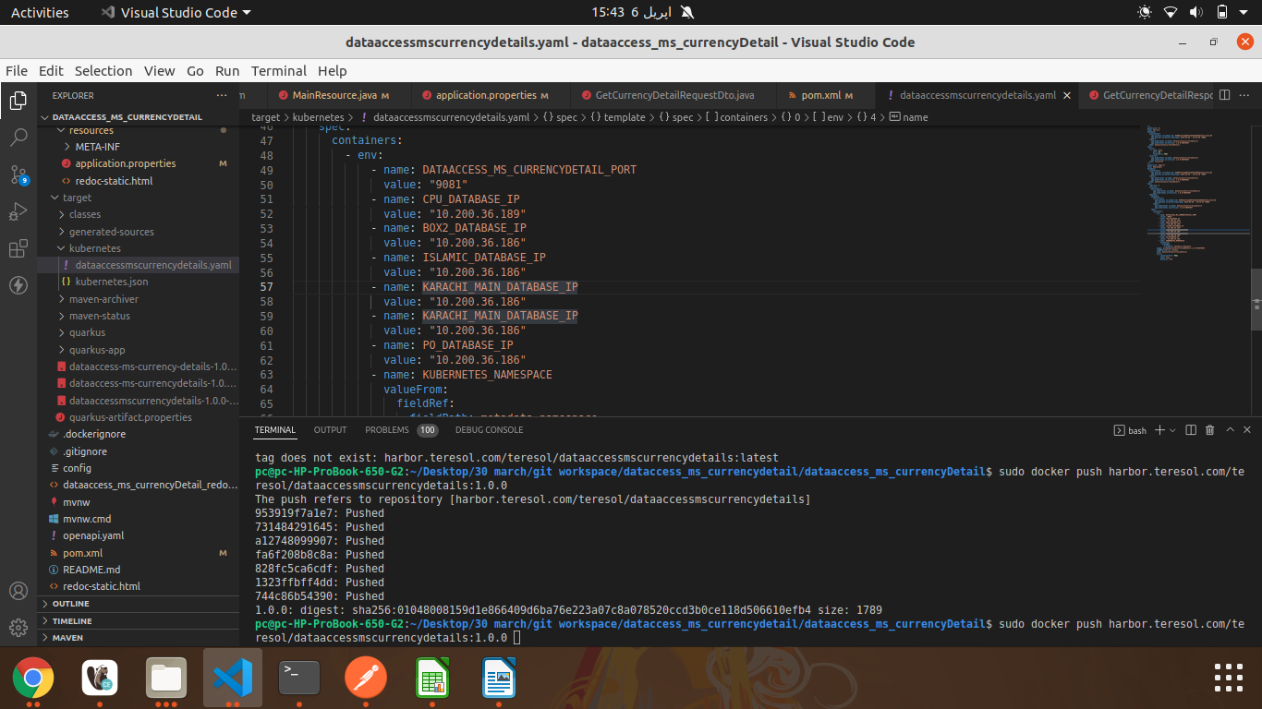
* Open docker file from the following directory path.(Dockerfile.jvm)
* Line **number 10** you find the following command

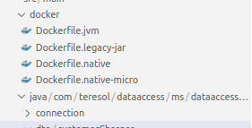

* Now generate docker image of your project and name it after -t.

sudo docker build -f src/main/docker/Dockerfile.jvm -t harbor.teresol.com/teresol/<imagename>:1.0.0 .

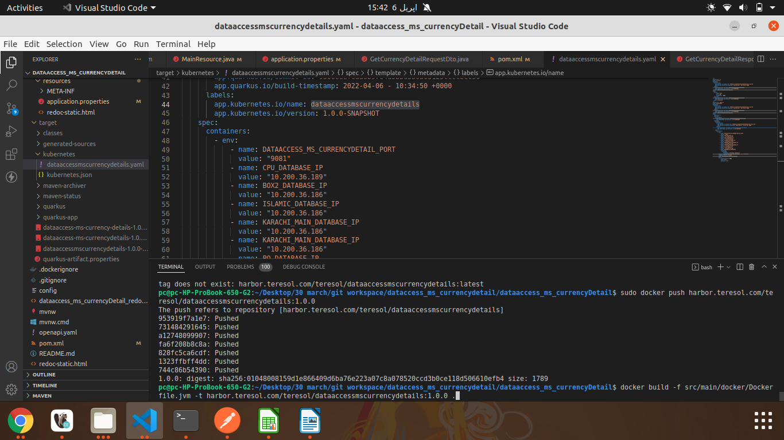

**Local setup on pc before push the image to harbor**

Copy following file to your local system

**harbor.teresol.com.crt**

Open terminal in same folder

verify the file by command

**sudo ls**

After verification copy this file to following path

**sudo cp harbor.teresol.com.crt /usr/local/share/ca-certificates/**

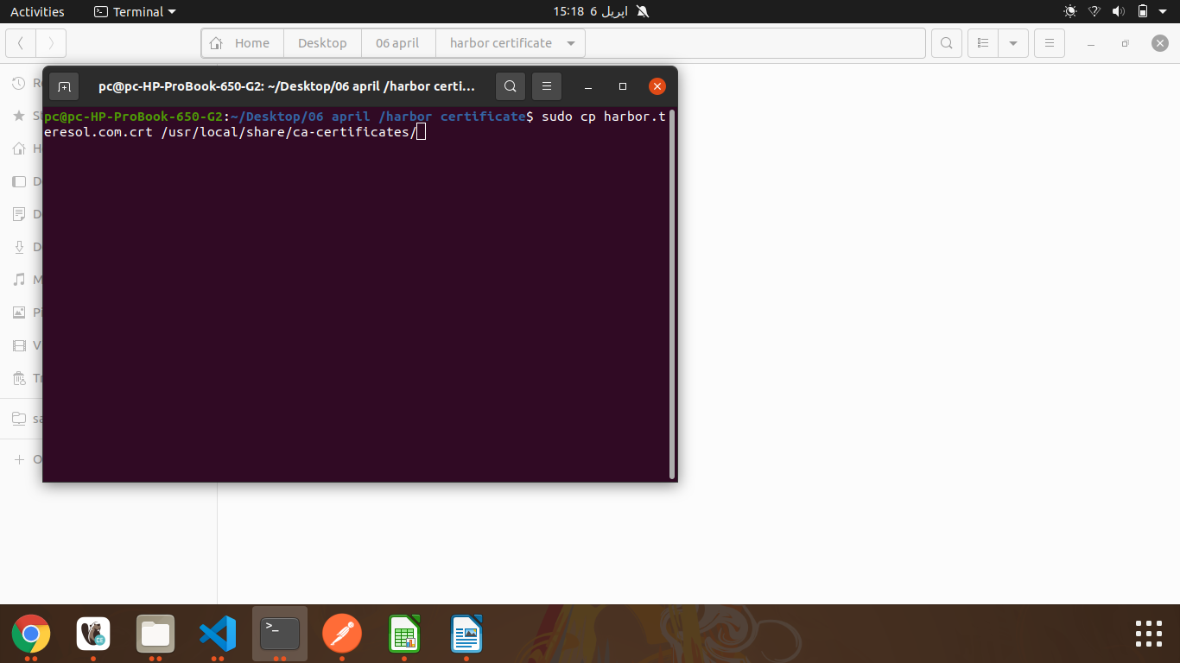

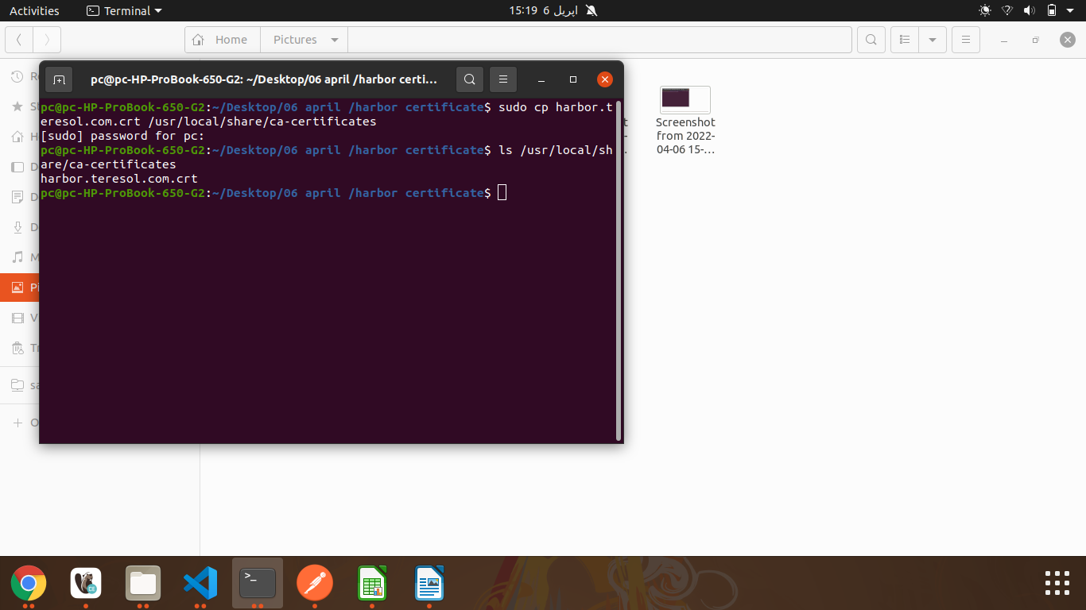

**sudo update-ca-certificates**

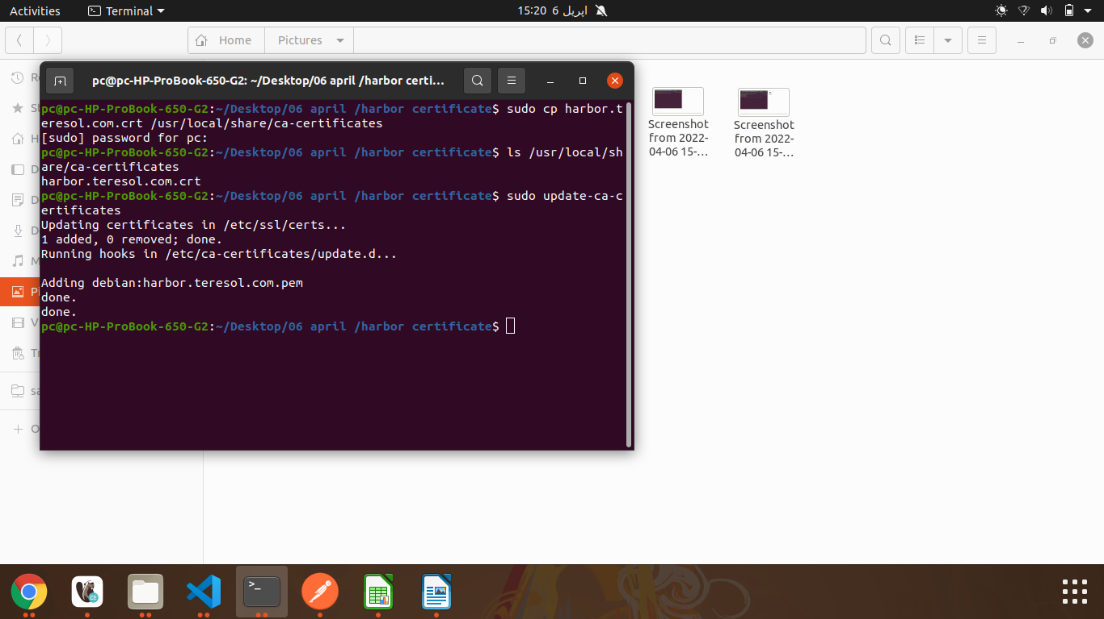

**sudo nano /*etc/*hosts/**

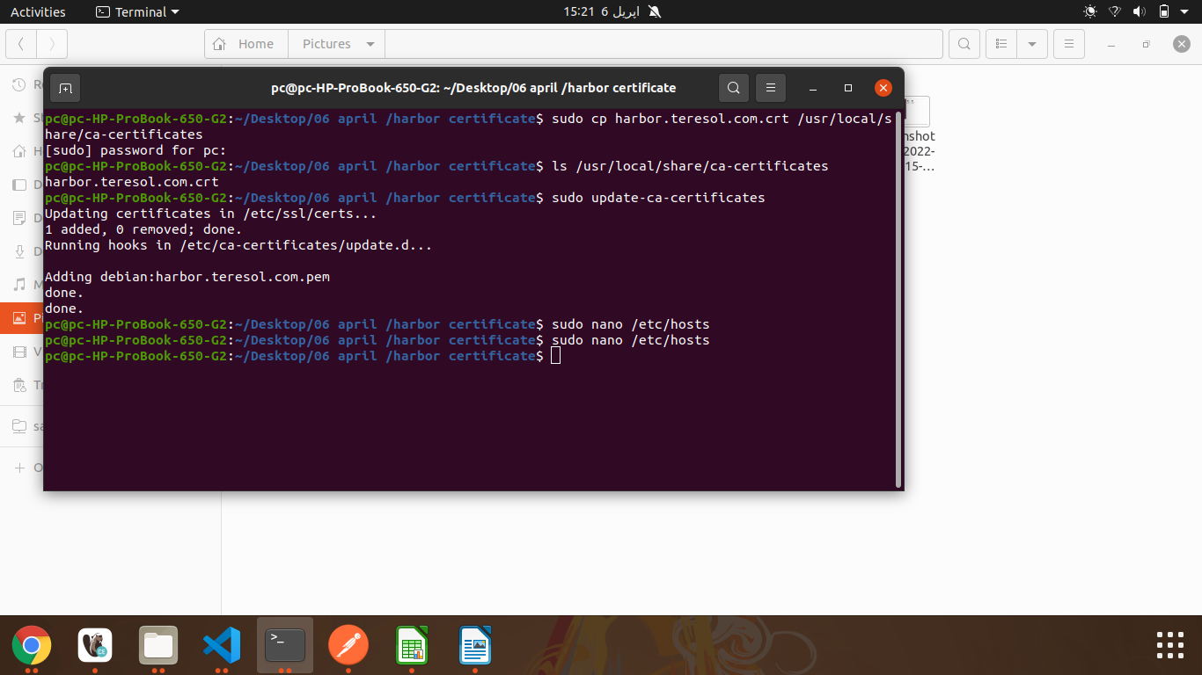

**Add the following line in the end**

10.10.1.170 harbor.teresol.com

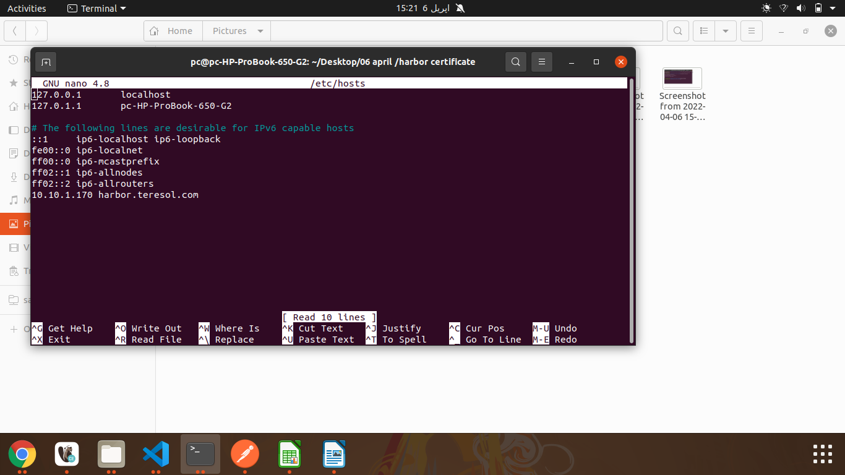

Now login to Docker by following command

**sudo docker login harbor.teresol.com**

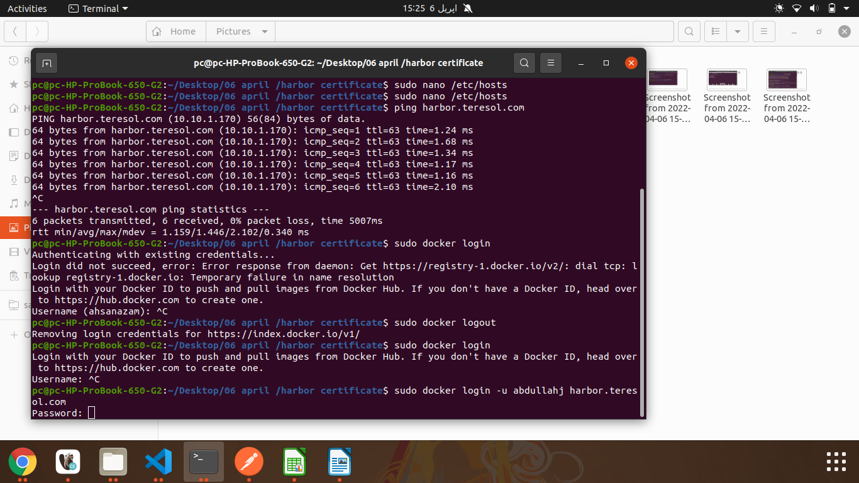

Now push your docker image by following command

**sudo docker push harbor.teresol.com/teresol/<imagename>:1.0.0**

