OLIST E-COMMERCE ANALYTICS
Final Project Report
SQL & Power BI Business Analytics Project

1. Executive Summary
This project analyzes historical e-commerce transaction data to understand what is driving revenue, how customers behave, which products and categories perform best, how customers pay, and where business activity is geographically concentrated.
The analysis uses five selected Olist datasets and combines SQL Server analysis with Power BI dashboards. The workflow covers data validation, exploratory analysis, business analysis, advanced SQL, and interactive reporting.

2. Business Problem
The business has transaction data, but lacks a clear view of its sales and customer performance. Management needs to determine what is driving e-commerce revenue, where the business is performing strongly or weakly, and what customer, product, payment, and geographic patterns can be identified from historical sales data.
The goal is to move from raw transaction records to measurable performance indicators and actionable business insights.

3. Objectives
- Measure revenue, orders, average order value, and monthly sales trends.
- Understand one-time versus repeat customer behavior and customer spending.
- Evaluate product and category performance.
- Analyze payment methods, payment value, revenue contribution, and installments.
- Identify geographic concentration through customer and revenue distribution by state.
- Evaluate order-status performance and delivered-order revenue.
- Apply advanced SQL techniques including CTEs, ranking, window functions, LAG, NTILE, and cumulative analysis.
- Present the results through an interactive Power BI dashboard.

4. Dataset Overview
Dataset | Rows | Purpose
Customers | 99,441 | Customer & geographic analysis
Orders | 99,441 | Sales, status & lifecycle
Order Items | 112,650 | Revenue & product sales
Order Payments | 103,886 | Payment behavior
Products | 32,951 | Product & category analysis

5. Data Quality & Validation
A dedicated SQL data-quality module checks row counts, missing values, duplicates, and key relationships.
- Orders: 160 missing approval timestamps, 1,783 missing carrier-delivery dates, and 2,965 missing customer-delivery dates.
- Products: 610 records have missing category/name-description-photo attributes; two records have missing physical measurements.
- Duplicate checks were performed across customer, order, order-item, payment, and product identifiers.
- The selected product dataset contains 73 distinct non-null product categories.

6. Sales Analysis
- Total payment value analyzed: $16.01M.
- Average payment transaction: $154.10.
- Average order value: $160.99.
- November 2017 recorded the highest monthly revenue at approximately $1.19M.
- Delivered orders account for approximately 96.34% of analyzed order-item revenue.

7. Sales Analysis Dashboard
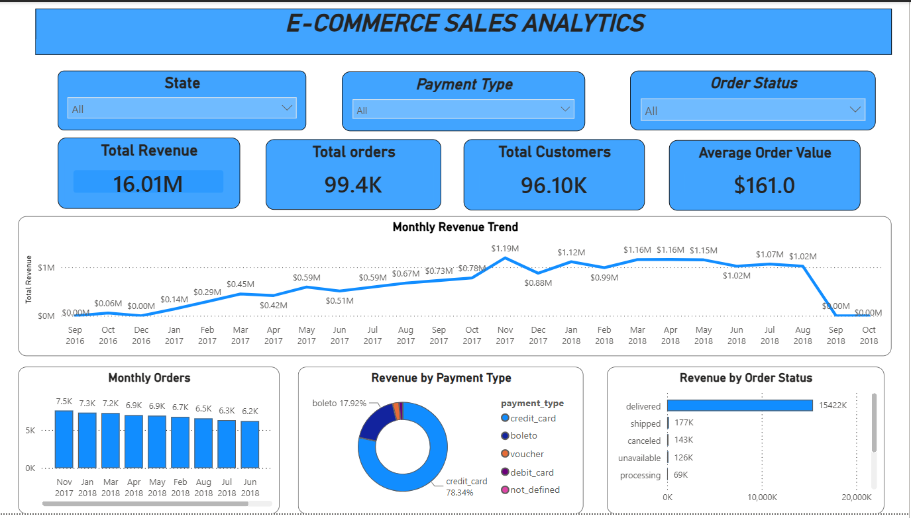
The Sales Analysis dashboard combines KPIs, monthly revenue trends, order status, payment contribution, and other sales-level views.

8. Sales Visuals
The dashboard's monthly revenue visual highlights changes in sales performance over time.
The payment visual shows the dominance of credit-card transactions, which contribute approximately 78.34% of total payment value.

9. Customer Analysis
- 96,096 unique customers are represented in the selected transaction data.
- 93,099 customers are one-time purchasers and 2,997 are repeat customers.
- One-time customers represent approximately 96.88% of customers.
- Average customer spend is approximately $166.59.
- São Paulo has 41,746 customer records and approximately 41.98% of the customer base.

10. Customer Analysis Dashboard
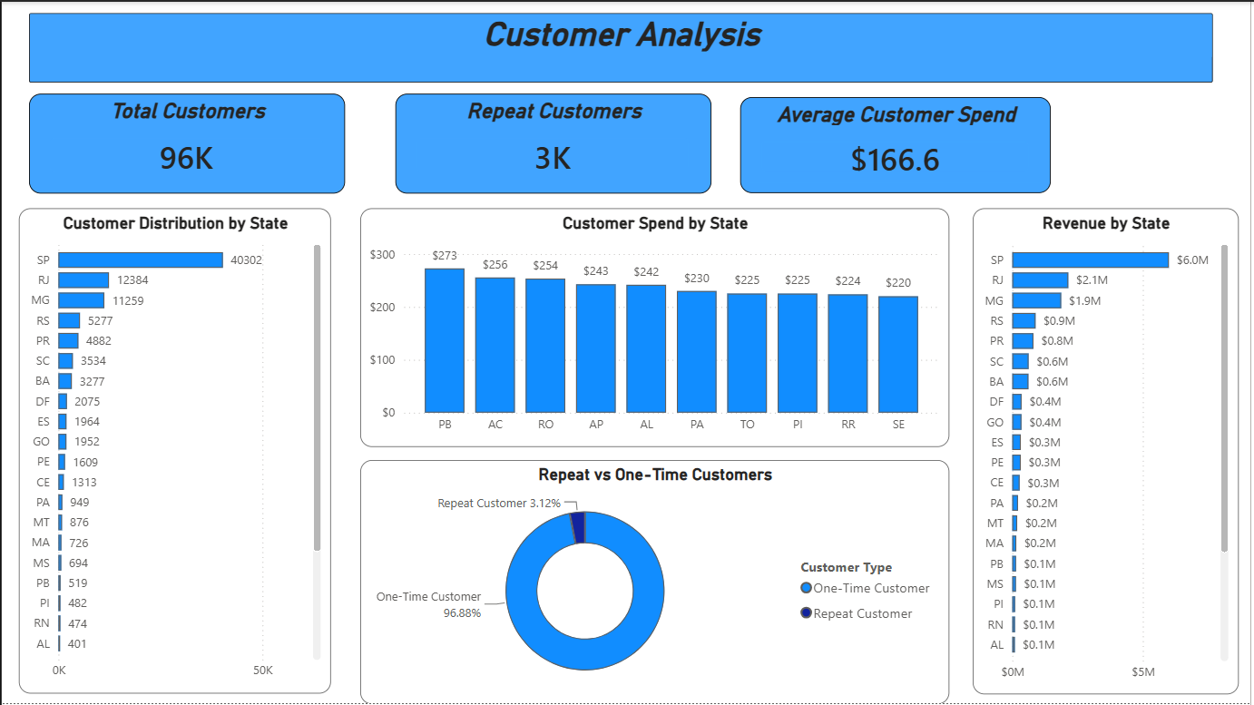
The Customer Analysis page combines customer KPIs, repeat behavior, state distribution, and customer spending views.

11. Geographic Analysis
Geographic analysis evaluates customer concentration and spending across Brazilian states.
- São Paulo: 41,746 customer records.
- Rio de Janeiro: 12,852.
- Minas Gerais: 11,635.
- Rio Grande do Sul: 5,466.
- Paraná: 5,045.
This concentration provides a basis for regional performance evaluation and future market-expansion decisions.

12. Product & Category Analysis
- beleza_saude generated approximately $1.26M.
- relogios_presentes generated approximately $1.21M.
- cama_mesa_banho generated approximately $1.04M.
- esporte_lazer generated approximately $988K.
- informatica_acessorios generated approximately $912K.

13. Product & Category Dashboard
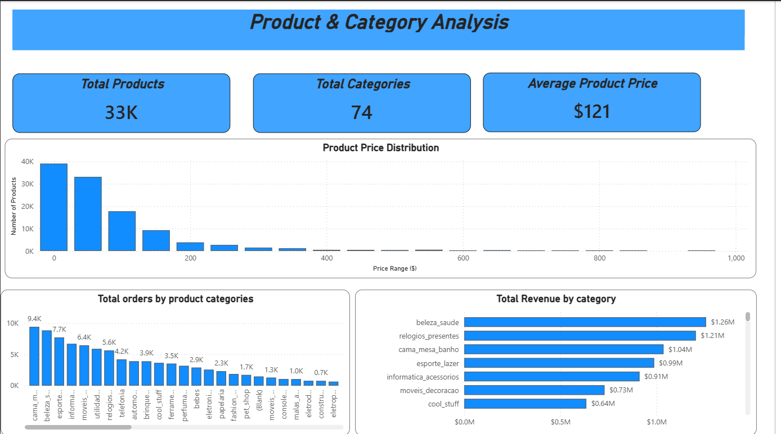
The Product & Category Analysis page supports category revenue, product counts, price-related analysis, and product performance comparisons.

14. Payment Analysis
- Credit card is the dominant payment method with 76,795 payment records.
- Credit-card payment value is approximately $12.54M.
- Credit cards contribute approximately 78.34% of total payment value.
- Boleto is the second-largest payment method by record count.

15. Advanced SQL Analysis
- CTEs for structured multi-step analysis.
- RANK() for customer revenue ranking.
- DENSE_RANK() for category ranking.
- SUM() OVER() for cumulative monthly revenue.
- LAG() for month-over-month revenue comparison.
- ROW_NUMBER() for the top five customers within each state.
- CASE-based High, Medium, and Low Value customer segments.
- NTILE(4) for customer revenue quartiles.
- Window-function-based Pareto-style category revenue concentration.

16. Key Business Insights
Customer retention is the biggest opportunity. Approximately 96.88% of customers are one-time purchasers.
Revenue is geographically concentrated. São Paulo is the largest customer market.
Credit cards dominate payment value. Approximately 78.34% of payment value comes from credit cards.
A small group of categories drives substantial revenue. The leading categories include beleza_saude, relogios_presentes, cama_mesa_banho, esporte_lazer, and informatica_acessorios.
Delivered orders dominate analyzed revenue. Approximately 96.34% of analyzed order-item revenue is associated with delivered orders.
Sales vary over time. November 2017 was the strongest month in the analyzed period.

17. Business Recommendations
- Develop retention initiatives for first-time customers through post-purchase communication, personalized offers, and repeat-purchase incentives.
- Use state-level performance to identify strong markets and investigate lower-contributing regions.
- Prioritize inventory and promotional attention around high-revenue product categories.
- Maintain strong credit-card payment support while evaluating other payment methods.
- Monitor canceled, unavailable, and other non-delivered orders separately to identify operational issues.
- Track monthly revenue and customer segments as recurring management KPIs.

18. Technology Stack
- Microsoft SQL Server / SSMS
- SQL for validation, EDA, business analysis, and advanced analytics
- Microsoft Power BI for interactive dashboards
- CSV datasets for source data

19. Limitations & Future Improvements
- The project does not include actual profit or margin data.
- The analysis is historical rather than real-time.
- Customer retention is measured through observed repeat orders rather than predictive churn modeling.
- Future extensions could include profitability, customer lifetime value, churn prediction, demand forecasting, and marketing attribution.

20. Conclusion
This project demonstrates an end-to-end business analytics workflow using SQL and Power BI. Starting from five transactional datasets, the analysis validates data quality, measures sales performance, evaluates customer behavior, compares product categories, examines payment preferences, and identifies geographic concentration.
The strongest opportunity identified is customer retention: most customers purchase only once. Combined with category, payment, geographic, and monthly sales insights, the analysis provides a practical foundation for data-driven decisions around revenue growth and customer engagement.

21. Project Assets
- Business_Problem.md
- Data_Dictionary.md
- SQL scripts for data quality, EDA, sales, customer, product, and advanced analysis
- Power BI dashboard with Sales, Customer, and Product & Category pages
- Dashboard screenshots and selected chart visuals

22. Dataset Source
Olist Brazilian E-Commerce Public Dataset — anonymized Brazilian e-commerce transaction data covering 2016–2018.

