FINAL PROJECT REPORT
RFM Customer Segmentation & E-commerce Analytics
Final findings based on the Power BI dashboard and project analysis
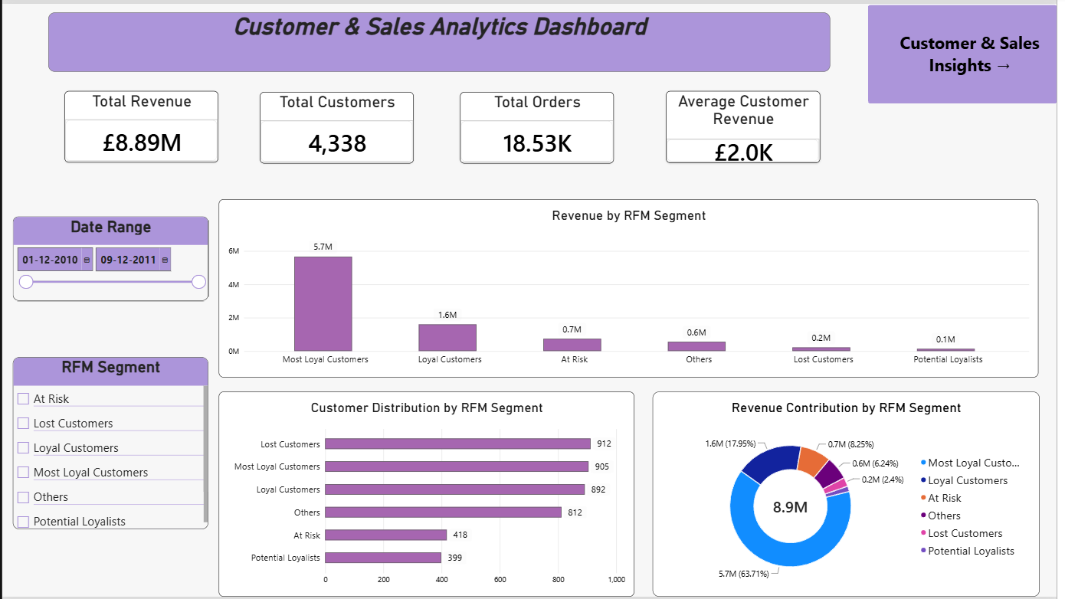
Figure 1. Executive Overview dashboard — actual Power BI screenshot supplied for the final report.

1. Executive Summary
This project analyzes historical Online Retail transaction data to understand overall sales performance, customer purchasing behavior, and customer value. The solution combines data preparation and exploratory analysis, SQL business analysis, RFM customer segmentation, and an interactive Power BI dashboard.
The dashboard reports £8.89M in total revenue from 4,338 customers and approximately 18.53K orders. The customer base is highly concentrated: Most Loyal Customers generate about £5.7M, representing 63.71% of revenue, while Loyal Customers contribute another £1.6M (17.95%). At the same time, 912 customers are classified as Lost and 418 as At Risk, creating a significant retention opportunity.

2. Executive KPIs
Metric | Dashboard Value
Total Revenue | £8.89M
Total Customers | 4,338
Total Orders | 18.53K
Average Customer Revenue | £2.0K
Analysis Date Range | 01-12-2010 to 09-12-2011

3. Dashboard Structure
The Power BI report contains two connected views. The Executive Overview provides the portfolio-level picture, while Customer & Sales Insights provides deeper analysis of customers, products, monthly revenue, countries, and RFM segment performance.
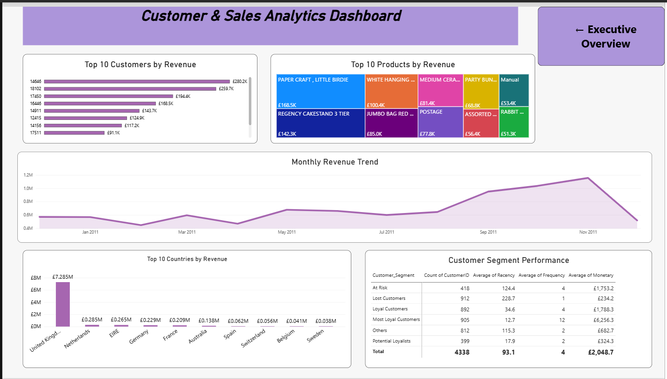
Figure 2. Customer & Sales Insights dashboard — actual Power BI screenshot.

4. RFM Customer Segmentation Findings
RFM analysis groups customers according to Recency, Frequency, and Monetary value. The dashboard shows six customer segments: Most Loyal Customers, Loyal Customers, At Risk, Others, Lost Customers, and Potential Loyalists.
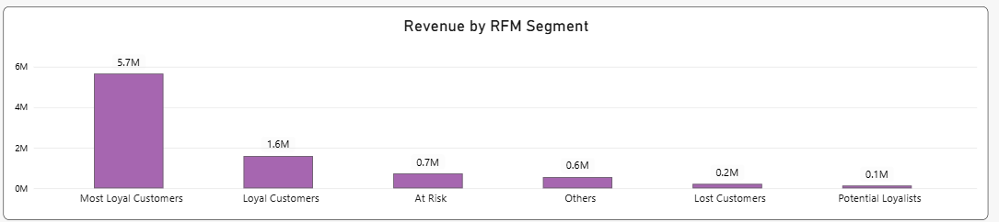
Figure 3. Revenue by RFM Segment — actual Power BI visual.
Segment | Customers | Avg. Recency | Avg. Frequency | Avg. Monetary
Most Loyal Customers | 905 | 12.7 | 12 | £6,256.3
Loyal Customers | 892 | 34.6 | 4 | £1,788.3
At Risk | 418 | 124.4 | 4 | £1,753.2
Others | 812 | 115.3 | 2 | £682.7
Lost Customers | 912 | 228.7 | 1 | £234.2
Potential Loyalists | 399 | 17.9 | 2 | £324.3
Most Loyal Customers are the strongest segment on all three RFM dimensions: they have the lowest average recency (12.7 days), the highest average frequency (12 orders), and the highest average monetary value (£6,256.3).
Lost Customers show the opposite pattern: average recency of 228.7 days, frequency of only 1 order, and average monetary value of £234.2. This provides a clear behavioral distinction between highly engaged customers and customers who have effectively become inactive.

5. Revenue Concentration
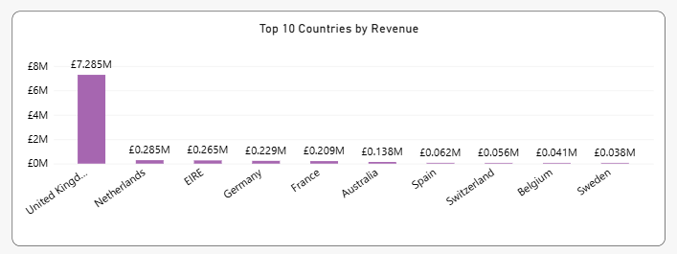
Figure 4. Revenue contribution by RFM segment — actual Power BI visual.
Most Loyal Customers contribute 63.71% of total revenue. Loyal Customers contribute 17.95%, followed by At Risk at 8.25%, Others at 6.24%, Lost Customers at approximately 2.4%, and Potential Loyalists at roughly 1.4%.
The key implication is that revenue is highly concentrated in customers who already demonstrate strong purchasing behavior. Protecting these customers is therefore critical, but the business should also create pathways for promising customers to move into higher-value segments.

6. Customer Distribution & Retention Risk
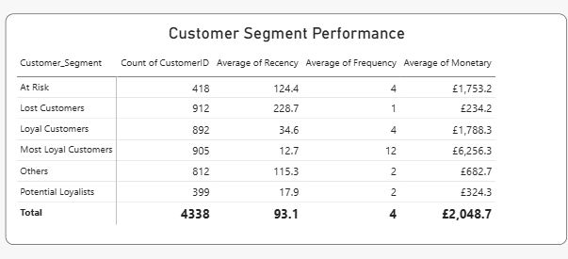
Figure 5. Customer Segment Performance — actual Power BI visual.
Lost Customers are the largest segment by customer count with 912 customers, followed closely by Most Loyal Customers (905), Loyal Customers (892), and Others (812). At Risk contains 418 customers, while Potential Loyalists contains 399.
This creates a major retention challenge: the Lost and At Risk groups together contain 1,330 customers, approximately 30.66% of the customer base. The average recency of these groups is also substantially higher than the loyal segments, indicating prolonged inactivity.

7. Customer-Level Findings
The Customer & Sales Insights page identifies the highest-value customers individually. Customer 14646 is the top customer by revenue at approximately £280.2K, followed by Customer 18102 at approximately £259.7K and Customer 17450 at approximately £194.4K.
The project analysis also shows that customer value is not determined by revenue alone. Frequency and recency provide additional context for identifying customers who are both valuable and actively engaged.

8. Product Performance Findings
The Top 10 Products by Revenue visual highlights the products generating the largest revenue contribution. PAPER CRAFT, LITTLE BIRDIE leads at approximately £168.5K, followed by REGENCY CAKESTAND 3 TIER at approximately £142.3K and WHITE HANGING HEART T-LIGHT HOLDER at approximately £100.4K.
These products can be considered priority products for merchandising, cross-selling, and campaign analysis because they already demonstrate strong revenue performance.

9. Geographic Findings
The United Kingdom dominates geographic performance with approximately £7.285M in revenue. The next largest markets are the Netherlands (£0.285M), EIRE (£0.265M), Germany (£0.229M), and France (£0.209M).
The large gap between the UK and other countries indicates that the business is heavily concentrated in its core UK market, while other European and international markets represent smaller but potentially scalable revenue opportunities.

10. Monthly Revenue Findings
Revenue fluctuates across the analysis period, with a clear increase during the second half of 2011. The dashboard shows the strongest monthly performance around November 2011, reaching approximately £1.16M.
This pattern suggests that seasonal effects, promotional activity, or changes in customer purchasing behavior may influence revenue. Future analysis could investigate the exact drivers behind these monthly peaks.

11. Key Business Insights
- Revenue is highly concentrated: Most Loyal Customers alone contribute 63.71% of total revenue.
- Most Loyal Customers have the strongest behavioral profile, with 12.7-day average recency, 12-order average frequency, and £6,256.3 average monetary value.
- Lost Customers are the largest customer segment by count (912) and have very weak engagement: 228.7-day average recency and 1-order average frequency.
- At Risk customers represent 418 customers and still have substantial historical value, with £1,753.2 average monetary value.
- Lost and At Risk customers together represent 1,330 customers, creating a significant retention and reactivation opportunity.
- The UK is the dominant market, contributing approximately £7.285M in revenue.
- A small group of products contributes a meaningful share of product revenue, led by PAPER CRAFT, LITTLE BIRDIE.
- Revenue strengthens in the later months of 2011, with November showing the strongest monthly performance.

12. Business Recommendations
Recommendation | Action
Protect Most Loyal Customers | Prioritize loyalty benefits, personalized campaigns, early access, and proactive retention because this segment drives the majority of revenue.
Re-engage At Risk Customers | Build targeted campaigns for the 418 At Risk customers, prioritizing customers with higher historical monetary value and frequency.
Run Win-Back Campaigns | Target Lost Customers with personalized reactivation offers, but prioritize customers who previously generated meaningful revenue.
Develop Potential Loyalists | Use repeat-purchase incentives, bundles, and personalized recommendations to increase frequency and move promising customers toward Loyal segments.
Reduce Revenue Concentration Risk | Continue protecting the high-value base while growing the contribution of other customer segments.
Strengthen International Markets | Use the UK as the core market while evaluating scalable acquisition and retention strategies in the next-highest revenue countries.
Monitor Monthly Performance | Use the dashboard to track revenue trends and investigate seasonal or campaign-related spikes.

13. Final Conclusion
The project demonstrates how transaction-level retail data can be transformed into actionable customer intelligence using Python, SQL, RFM analysis, and Power BI. The most important finding is the contrast between a highly valuable Most Loyal customer base and a large population of Lost and At Risk customers.
The dashboard provides management with a practical way to monitor revenue, customer distribution, RFM segment performance, products, countries, and monthly trends. The recommended strategy is therefore two-sided: protect the customers who already generate most of the revenue while systematically increasing retention and reactivation among weaker segments.

14. Project Scope & Limitations
This project is descriptive and diagnostic. It uses historical transaction behavior to identify patterns and segments. It does not use machine learning to predict churn, future revenue, or customer lifetime value. Segment labels should therefore be interpreted as analytical classifications rather than guaranteed future outcomes.

15. Project Assets
- EDA.ipynb — Python data cleaning and exploratory analysis
- Business_Analysis.sql — SQL business analysis
- RFM_Calculation.sql — RFM scoring and segmentation
- RFM_dashboard.pbix — Power BI dashboard
- Online Retail.xlsx — source transaction dataset
- Business_Problem.md — business problem and project scope
- Data_Dictionary.md — dataset field definitions

