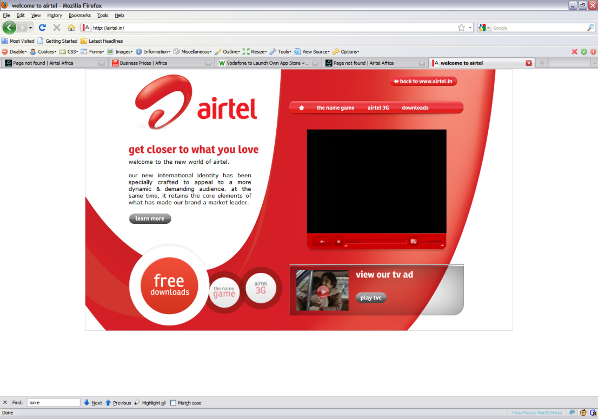**User ID Access Request Form - Airtel Africa**

|  |  |  |  |  |  |  |
| --- | --- | --- | --- | --- | --- | --- |
| **General Information & Instructions** | PLEASE READ THIS SECTION CAREFULLY TO ENSURE YOU FILL THE FORM CORRECTLY INCLUDING OBTAINING ALL REQUIRED APPROVALS. INCOMPLETE FORM WILL LEAD TO REJECTION OF YOUR REQUEST.  **For all types of User ID requests**  1. FOR EACH REQUESTED USER ID YOU MUST INCLUDE THE AUUID OF THE PERSON THAT WILL USE THE USER ID BEING REQUESTED  For information Airtel employee, **AA**UID format is 13XXXX and for vendors it is s 23XXXX (X=running sequence number).  2. By default, **AA**UID will be the employee’s user ID for system whose access is being requested.  3. Enter the name of the Owner of the user ID, and the Owner’s Manager, and the Requester.  If this is a request for a new User ID, complete sections A & B  4. If this is a request to change or disable a user ID or revoke access, complete sections A,B & C   1. **Non-Privilege Access (PARTNER) –** If you are requesting for a UNIX / Windows/Application ID and/or email access, user/requester should fill the form and obtain ID Owner’s Blue Page Manager approval. If you are a vendor / partner, you need to obtain approval from PARTNER / Airtel Line Manager 2. **Non-Privilege Access (Airtel) –** If you are requesting for a UNIX / Windows/Application ID and/or email access, user/requester should fill the form and obtain Line Manager Approval. If you are a vendor / partner, you need to obtain approval from Line Manager. For Bulk request of vendors / partners HR Manager / ITD approval is accepted too. 3. **Privileged Access (PARTNER) –** If you are requesting for a UNIX / Windows/UNIX ID with admin/higher level privileges, user/requester should fill the form and obtain an email approval from ID owner’s Blue page Manager / (Privilege /Group / Application/ Database owner) / SSO and ITD.   **User/Requester** – Fill the form completely as per your access requirement. Detailed business justification should be mentioned under business reason section of page # 2  **Manager / Line Manager / HR Manager** – Review the access request form submitted by employee/requester to ensure user is requesting for relevant access to perform his/her job role  **Privilege / Group / Application / Database Owner** – Review the access request form and ensure user is requesting for relevant access to perform his/her job role. Approve or reject the access request  **ITD** – Review the access request form and ensure user is requesting for relevant access to perform his/her job role. Approve or reject the access request   1. **Intermediate codes –** Intermediate code can be used in the URT string instead of a serial number to identify ID ownership. These codes are held centrally in the URT application, and allow for functional/system accounts to be easily assigned to a user without having to modify them on the servers. 2. **Individual ID -** Give human access to information / computing system based on the business need. 3. **System ID -** Created during the installation of the base operating system or subsystem. 4. **Application ID -** Created during the installation of the application. 5. **Shared ID -** Gives access to functions that need to be used by a group of people for system operations, multiple users with a single ID and is used as a mechanism to identify multiple users with a single ID. 6. **Functional ID -** Generic accounts (for example, Root, Administrator) that are required by the operating system, system level software or utilized by automated processes and are associated with a group, function or role   For approvers information, please refer**, Approval Matrix on Page #5** | | | | | |
| **SECTION A – Complete for all requests** | | | | | | |
| **Request Type**  ***(MANDATORY)*** | New User ID **(**complete section A & B)  Ownership Transfer - Application / Functional / System / Shared ID (complete section A & B)  Add / Remove - Privilege / Group Access (specify ID): (complete section A,B & C)  Disable Existing User ID (specify ID): (complete section A & B)  Enable Existing User ID (specify ID): (complete section A & B)  Email Migration – Existing OPCO Name       Moving OPCO Name       **(**complete section A & B) | | | | | |
| **Type of ID**  ***(MANDATORY)*** | Individual ID  Application / Functional / System / Shared ID Name | | | | | |
| **Type of Access**  ***(MANDATORY)*** | Standard Access  Privilege Access (complete section C) | | | | | |
| **Employee Organization *(MANDATORY)\*\*\**** | PARTNER  AIRTEL  Vendor. Specify Vendor Organization Name | | | | | |
| **Owner of ID**  **(Who will use the ID)**  ***(MANDATORY)\*\*\**** | First name :        Last name : | | | | | |
| Employee Serial # : | Employee **AUUID** #: xxxx | | EmployeePhone#: xxx | | |
| Employee Type : Perm /Temp       Start Date:       End Date : | | | | | |
| Employee Location (Country):  KHQ     Department (IT /Sales/Mktg etc.):  xxxxxx   Employee Email Address:  xxx      Application Name:       Application Role:        Application Sub Role (As per requirement): | | | | | |
| **Owner’s Manager Details**  **(Line Manager)**  ***(MANDATORY)*)** | Full Name :        Manager’s Job title : | | | | | |
| Manager’s Email Address (internet format)  xxxxx  Line Manager **AUUID** #:  xxxxx | | | | | Phone:  xxxxx |
| **Requester Details (Complete only if different than Owner)** | Employee Serial # : | | Employee **AUUID** #: | | Employee Phone #: | |
| Employee Type : Perm /Temp       Start Date:       End Date :        Employee Location (Country):       Department (IT /Sales/Mktg etc.):        Employee Email Address : | | | | | |
| **OPCO Details**  ***(MANDATORY)\*\*\**** | Chad  DRC  Gabon  Kenya  Madagascar  Uganda  Zambia  Malawi  Niger  Nigeria  Congo B  Rwanda  Seychelles  Tanzania  HQ  Pune | | | | | |
| **SECTION B - Complete for all New / Existing User ID requests** | | | | | | |
| **Platform** | **General Information on System and Servers the access is being requested for.** | | | | | |
| **System / Application**  ***(MANDATORY)*** | Global AD ID :  EMAIL :  VPN :  Distribution List :  Shared Mailbox :  WINDOW Standalone Server ID :  UNIX Server ID :  DB ID :  Application ID : Specify Application name:       Wireless Access :   |  |  |  |  | | --- | --- | --- | --- | | **OS PLATFORM** | **IP DDRESS** | **SUSBSYSTEM PLATFORM** | **IP Address** | | 1. AIX |  | 1. ORACLE BILLING |  | | 1. LINUX |  | 1. ORACLE NON_BILLING |  | | 1. HP-LINUX |  | 1. DB2 |  | | 1. SUN |  | 1. SYBASE |  | | 1. WINDOWS |  | 1. SQL |  | | 1. VPN |  | 1. TERADATA |  | | 1. DOMAIN IP |  | 1. CRM/ORACLE |  | | 1. OTHERS   (Please Specify) |  | 1. OTHERS  (Please Specify) |  | | | | | | |
| **VPN DETAILS** | |  |  |  |  | | --- | --- | --- | --- | | **SR #** | **VAS Server IP Address to be accessed (e.g. 172.23.94.7:8083)** | **Source Protocol/Port (e.g. 105.230.0.0/15 and 154.76.0.0/14)** | **Description (e.g. Access to Real Analytics War room application)** | | 1 |  |  |  | | | | | | |
| **Choose VPN Group Name/s** | **East-Wipro-support-Team - Wipro employee**  **East-Wipro-Partners - Wipro sub-vendor (e.g Mara ison, csgi)**  **East-Airtel-Africa-Employee - Airtel Employee**  **East-Business-Associates - Airtel partner Vendor (e.g. Comviva)**  **West-Wipro-support-Team -  Wipro employee**  **West-Wipro-Partners - Wipro sub-vendor (e.g Mara ison, csgi)**  **West-Airtel-Africa-Employee - Airtel Employee**  **West-Business-Associates - Airtel partner Vendor (e.g. Comviva)**  **VPN-NSD-AFRICA (For Network team only)** | | | | | |
| **Provide DB Access details (Table / Schema etc.)** |  | | | | | |
| **Business Reason** **(*Only for Privilege Access requests)*** |  | | | | | |
| **DL Name**  **(*Attach DL member email in Excel)*** |  | | | | | |
| **Shared Mailbox Name**  ***(Attach member email in Excel)*** |  | | | | | |
| **SECTION C – Complete for Add / Delete (Privileges / Access)** | | | | | | |
| **Modification or Disable** | **Appropriate Approvals Listed in General information must be provided** | | | | | |
| **Add / Remove Specific Access**  **OR User ID** | User ID:        If Application, please add Application Name here:        Add Privilege / Group Access (Specify)        Remove Privilege / Group Access (Specify) | | | | | |

## Approval Section

_______________ _______________ _______________

Manager Name Signature Date

_______________ _______________ _______________

ITD Name Signature Date

_______________ _______________ _______________

Business Apps owner

(AM, USDM, Pretups.) Signature Date

_______________ _______________ _______________

Partner Apps Owner

(DB privilege access) Signature Date

_______________ _______________ _______________

Head of IT Operations

(DB privilege access) Signature Date

Manager details should always be same in approval section and owner’s manager section

*ID Managers to take care that access is maintained at current job requirements, i.e. unnecessary access is removed

**For Standard Access in Window / UNIX please share below approvals.**

1. Line Manager (**For Airtel**) 2. Privilege / DB / Group / Application Owner

**For Standard / Privilege Access in Window / UNIX please share below approvals.**

1. Line Manager 2. Privilege / DB / Group / Application Owner 3. SSO 4. ITD

**For VPN Access please share below approvals.**

1. Blue Page Manager / Line Manager (For Airtel Employees only) 2. ITD

**For Standard Access in Application please share below approvals**

1. Line Manager

**For Privilege Access in Application please share below approvals**

1. Line Manager 2) Application Owner 3) ITD

# Note: For NEP (Non-expiring Password) approved SOD is a mandatory requirement

**ITD Details (IF ITD IS OUT OF OFFICE APPEND DELEGATE APPROVAL INSTEAD):-**

|  |  |  |  |
| --- | --- | --- | --- |
| **OPCO** | **NAME** | **MOBILE** | **EMAIL** |
| **Nigeria** | Kola Sonola | +254 732200009 | [Kola.Sonola@ng.airtel.com](mailto:Kola.Sonola@ng.airtel.com) |
| **Congo B** | Arnauld W. Bondamba | +242055009709 | [Arnauld.BONDAMBA@cg.airtel.com](mailto:Arnauld.BONDAMBA@cg.airtel.com) |
| **DRC** | Georges Kasongo | +243 999964802 | [georges.kasongo@cd.airtel.com](mailto:georges.kasongo@cd.airtel.com) |
| **Uganda** | James Museba | +256752670011 | [james.museba@ug.airtel.com](mailto:james.museba@ug.airtel.com) |
| **Seychelles** | Siva Varadarajan | +2482810063 | [Sivarajan.Varadarajan@sc.airtel.com](mailto:Sivarajan.Varadarajan@sc.airtel.com) |
| **Zambia** | Sanjoy Ghosh | +260-978981570 | [sanjoy.ghosh@zm.airtel.com](mailto:sanjoy.ghosh@zm.airtel.com) |
| **Malawi** | Allan Banda | +265999989202 | [allan.banda@mw.airtel.com](mailto:allan.banda@mw.airtel.com) |
| **Kenya** | Albert Nduatih Mungai | +254733678477 | [albert.mungai@ke.airtel.com](mailto:albert.mungai@ke.airtel.com) |
| **Rwanda** | Innocent Nsabumuhire | +250736000055 | [Innocent.Nsabumuhire@rw.airtel.com](mailto:%20Innocent.Nsabumuhire@rw.airtel.com) |
| **Tanzania** | Franky Filman | +255784670258 | [Franky.Filman@tz.airtel.com](mailto:Franky.Filman@tz.airtel.com) |
| **Gabon** | Rodrigue Koublanou | +24107170462 | [Rodrigue.Koublanou@ga.airtel.com](mailto:Rodrigue.Koublanou@ga.airtel.com) |
| **Madagascar** | Jedidia Heri | +261331100511 | [Herimanjato.R@mg.airtel.com](mailto:Herimanjato.R@mg.airtel.com) |
| **Chad** | Dassoukhi Badaoui | +23566200090 | [dassoukhi.badaoui@td.airtel.com](mailto:dassoukhi.badaoui@td.airtel.com) |
| **Niger** | Souley Yahaya | +22797777732 | [Souley.Yahaya@cg.airtel.com](mailto:Souley.Yahaya@cg.airtel.com) |
| **Pune** | David Mwiti | +254736050226 | david.mwiti@africa.airtel.com |