To connect the LEDs and push buttons to the right Pins, please check the following explanations:

* Buttons :
  + -----------Floors buttons-----------
  + PE10 : Button to call the elevator from the floor 3
  + PE8 : Button to call the elevator from the floor 2 to go UP
  + PE12 : Button to call the elevator from the floor 2 to go down
  + PB0 : Button to call the elevator from the floor 1
  + ----------Elevators buttons---------
  + PA2 : Command the elevator to go to the floor 3
  + PA0 : Command the elevator to go to the floor 2
  + PC2 : Command the elevator to go to the floor 1

Please pay attention to connect all buttons with external pull-down circuit as illustrated in the following design :

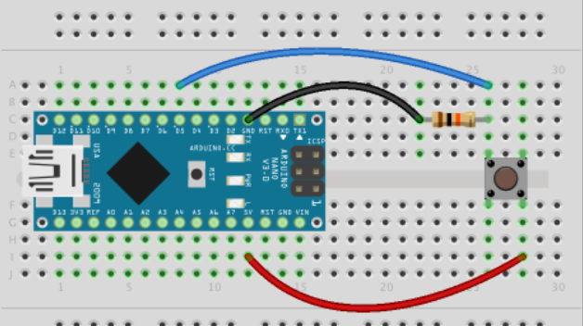

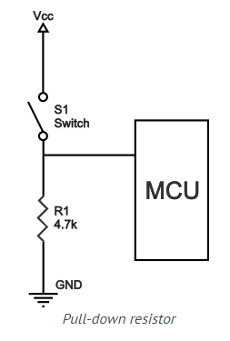

* LEDS:
  + ---------RED LEDS : Indicating the place and state of the elevator------------
  + PA6 : the elevator is in the floor 1 or state 1
  + PA4 : the elevator is in the floor 3 or state 3
  + PC4 : the elevator is in the floor 2 or state 2
* Busser:
  + PC0 : The buzzer should be connected to the PIN PC0
* State machine of elevator :
  + The program that I right to made this virtual elevator is based in the following state machine:

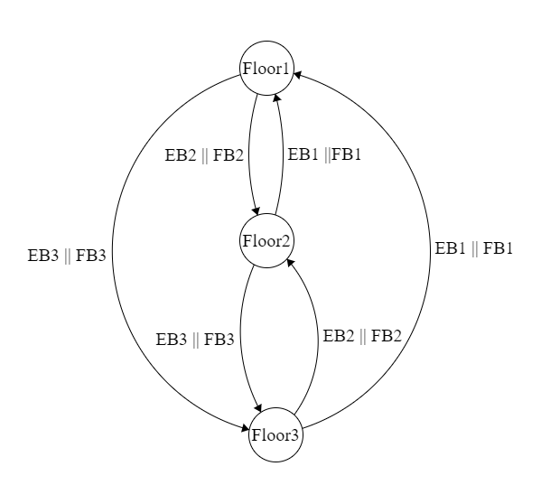

|  |  |
| --- | --- |
| EB1 | Elevator button to go to floor1 |
| FB1 | Floor button to request elevator from floor1 |
| EB2 | Elevator button to go to floor2 |
| FB2 | Floor button to request elevator from floor2 |
| EB3 | Elevator button to go to floor3 |
| FB3 | Floor button to request elevator from floor3 |