
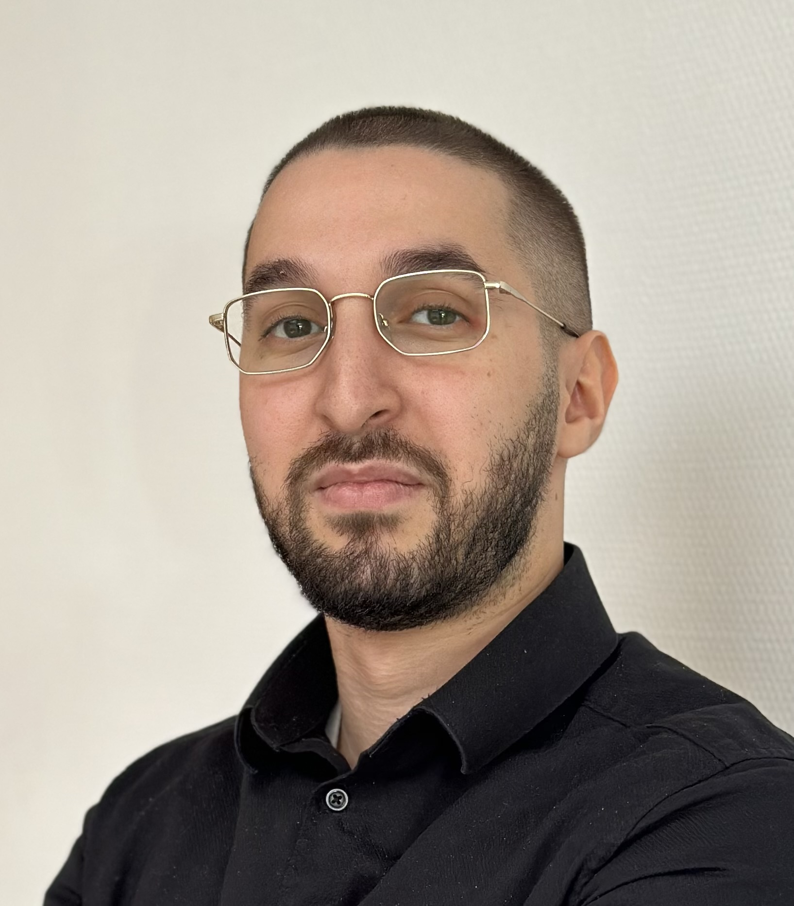
ABDELKADER ARBAOUI
Customer Success Manager
abdelarbb@gmail.com | +33 6 51 26 39 76 | LinkedIn: Abdelkader Arbaoui | Open to relocate
PROFILE
Trilingual professional with 3 years of experience in customer-facing and commercial roles, focused on Customer Success. Passionate about AI, data, and emerging technologies, I use data and automation to support product adoption and customer experience.
SKILLS
Customer Success: Portfolio/account health · QBR/SLA · NPS/CSAT · Retention/renewals · ARR · Upsell · Onboarding/adoption · C-level/CISO · Billing/collections · Margin
Service Delivery: Technical setup · Training/workshops/webinars · Adoption campaigns · Project management · Team leadership · Documentation · Voice of the customer · Roadmap/testing · RFP
CRM & Tools: Salesforce · HubSpot · Jira · Confluence · Notion · SharePoint
Data & Reporting: Python · SQL · CS Analytics · Power BI · Excel/VBA · SAP · PowerPoint · OpenSearch · Power Automate
Dev & Automation: AI tools · GitHub/GitLab · API integration · Open Banking
Soft Skills: Emotional intelligence · Stakeholder management · Active listening · Adaptability · Leadership
WORK EXPERIENCE
Thales — Customer Success Manager — Cybersecurity & Secure Communications Aug 2025 – Sep 2026
Citadel/Cryptobox — encrypted messaging platform and cloud security
- Managed ~40 accounts, from CAC 40 groups to smaller organisations: usage/account-health segmentation, NPS/CSAT, adoption, renewals (93% retention; €500K ARR) and upsell up to €100K.
- Delivered monthly SLA reports and quarterly QBRs to C-level/CISO stakeholders, covering milestones, risks and corrective actions.
- Coordinated 5–10 security incidents with Sales, Product, Support and R&D: root-cause analysis and service continuity within SLAs.
- Led Customer Success Plans: objectives, governance, client setup/onboarding, 1:1 and 1:many adoption, training, webinars, email campaigns and GTM alignment.
- Built CS Analytics in Python/SQL across CRM and usage data, automating PPTX/Power BI reporting; adopted by 4 people, saving 2h/report and ~€20K on CRM.
- Owned client billing/collections, service pricing and margin management.
- Ongoing project: single documentation portal with product guides, coordinated with Product teams; brought customer needs into roadmap/user testing and supported releases, client setup and platform launches.
Inetum — Business Development Representative Sep 2022 – Nov 2024
- Generated €500K+ in revenue (5+ meetings/week) and €200K+ in additional revenue through strategic RFPs.
- Interviewed consultants on assignments, skills and availability, then matched them to client opportunities.
- Built an AI tool for internal profile search and drove adoption through task allocation, user coaching and internal training documentation.
- Analysed client needs and proposed cybersecurity, cloud and infrastructure solutions.
- Led five consultants/developers: follow-up, assignments, training, mentoring, corrective feedback and conflict resolution.
EDUCATION
INSEEC Paris Sep 2025 – Sep 2026
MSc Business Development
Euridis Business School Sep 2022 – Nov 2024
Master in Sales Engineering
PERSONAL PROJECTS
MONEY TRACKER — Personal Finance Application (Local)
- Designed a local app for bank/investment accounts, subscriptions, forecasts and consolidated net worth.
- GoCardless Open Banking, Trade Republic API; Python/FastAPI, SQLAlchemy, SQLite, Pydantic, React/Vite, Tailwind, Recharts, Fernet, keyring, X-API-Key.
SAP DASHBOARDS — Financial Consolidation (Excel/VBA)
- Automated SAP trial-balance consolidation into Magnitude statements using Excel/VBA, account mapping, debit/credit controls and PDF export.
BTP COPILOT — AI Tendering Product Framing
- Framed an AI copilot for construction SMEs: BOAMP/TED/DECP monitoring, go/no-go and tender analysis with traceable evidence/unknowns; Supabase/Hermes architecture, human review, no automatic submission.
ADDITIONAL INFORMATION
Languages: French (C2), English (C1), Arabic (C2) · Microsoft AZ-900 (Azure Fundamentals)

