TITLE: The JWST Mass Mirage: C IV Outflows as a Driver of Overestimated Black Hole Masses at High Redshift
Nasser Abu Seif
National Research Institute of Astronomy and Geophysics (NRIAG).

ABSTRACT: 1

The James Webb Space Telescope (JWST) has revealed an unexpected abundance of supermassive black holes (10⁸–10¹⁰ M☉) at redshifts z > 6, severely challenging standard black hole seeding and early growth models. In this work, we demonstrate that a major component of this cosmological tension arises from systematic overestimations inherent to C IV-based mass estimators. Utilizing a sample of over 10,000 quasars from SDSS DR16, we evaluate the virial nature of broad emission lines. While the Full Width at Half Maximum (FWHM) of Hβ and Mg II λ2798 exhibit a strong correlation (r ~ 0.65), confirming Mg II as a reliable, co-spatial virial tracer, we find a complete lack of correlation between the FWHMs of Mg II and C IV λ1549 (r ~ 0.08). This demonstrates that C IV line widths are heavily dominated by non-virial, radiatively driven outflows and winds rather than purely Keplerian motion. Applying this insight to a compiled sample of distant quasars (including J0100+2802, J1120+0641, and early JWST-discovered “Little Red Dots” such as Abell 2744-QSO1), we compare their initial C IV-based masses against new rest-frame optical Balmer measurements (Hβ, Hα, Paα, Paβ) provided by JWST NIRCam, NIRSpec, and MIRI-MRS. We confirm that C IV-based masses are systematically overestimated due to outflow contamination. We conclude that the reported crisis of over-massive early black holes is largely a mass allocation mirage, and we propose robust, outflow-free Balmer and X-ray corona relations as the definitive mass scale for high-redshift black holes.

Introduction;
Supermassive black holes (SMBHs) exceeding 10^9 solar masses discovered at redshifts z > 6 present a profound challenge to modern astrophysics. Standard models of black hole growth, constrained by the Eddington limit, struggle to explain how such massive objects could assemble within the first billion years of cosmic time. This tension has been further amplified by recent James Webb Space Telescope (JWST) observations, which have uncovered a dense population of highly obscured, compact active galactic nuclei (AGN)—termed "Little Red Dots" (LRDs)—exhibiting apparent black hole masses of 10^8 to 10^10 solar masses at z ~ 5-8.
Historically, ground-based observations of z > 6 quasars were limited by atmospheric transmission to the rest-frame ultraviolet (UV) regime, necessitating the use of the C IV 1549 and Mg II 2798 emission lines as single-epoch virial mass estimators. While the Mg II line has long been calibrated against the rest-frame optical H-Beta line as a stable virial tracer, the C IV line is notoriously susceptible to non-virial dynamics. High-ionization UV lines like C IV are heavily influenced by radiatively driven outflows, accretion disk winds, and strong blueshifts, which artificially broaden the line profile independent of the host galaxy's gravitational potential.
With the advent of JWST’s NIRCam, NIRSpec, and MIRI-MRS instruments, the rest-frame optical Balmer series (H-Beta, H-Alpha) and Paschen series (Pa-Alpha, Pa-Beta) have become directly accessible at z > 6 for the first time. Early re-observations of historically C IV-selected quasars and newly discovered LRD populations have revealed a systematic discrepancy: C IV-based mass estimates are consistently higher than those derived from the more stable Balmer lines.
In this paper, we characterize the systemic failure of C IV as a virial mass tracer and show how its application artificially drives the high-redshift "mass crisis". By leveraging an exhaustive sample of over 10,000 quasars from the Sloan Digital Sky Survey Data Release 16 (SDSS DR16), we demonstrate the complete decoupling of C IV kinematics from established virial tracers. We then apply these corrections to a cross-matched sample of high-redshift quasars and LRDs re-observed by JWST, demonstrating that the apparent over-massive black hole population is largely an artifact of outflow-contaminated C IV line widths. Finally, we present a robust, outflow-free alternative framework utilizing X-ray corona scaling relations to secure the early universe mass scale

Methodology
The High-Redshift Baseline & Outflow-Free Framework
- Dataset Selection and Line Fitting

To isolate the kinematic relationships between UV and optical broad lines, we utilize the value-added quasar catalogs from the SDSS DR16 database. We select a clean sample of N > 10,000 broad-line quasars exhibiting high signal-to-noise ratios (S/N > 10 per pixel in the continuum) across the respective spectral windows for H-Beta, Mg II, and C IV. Spectral fitting is performed using a multi-component global routine. Continuum components are modeled via a power-law combined with an empirical iron emission template (Fe II and Fe III). Broad emission lines are modeled using multiple Gaussian or Gauss-Hermite profiles to separate the core virialized components from asymmetric broad wings associated with high-velocity kinematic structures. The Full Width at Half Maximum (FWHM) is derived exclusively from the reconstructed line profiles.
- Virial Disconnect Analysis
We evaluate the suitability of each line as a virial tracer by performing pairwise Pearson correlation tests on their extracted FWHMs. The standard single-epoch virial mass equation takes the form:
log(M_BH / M_sun) = a + b * log(FWHM / km/s) + c * log(L_lambda / 10^44 erg/s)
where b = 2 assumes stable Keplerian motion within the Broad Line Region (BLR). Our structural comparison confirms that while FWHM(H-Beta) and FWHM(Mg II) track each other tightly (r ~ 0.65), FWHM(C IV) correlates poorly with FWHM(Mg II) (r ~ 0.08), indicating that non-gravitational radiative forces dominate the C IV profile.
- JWST Re-observation Cross-Calibration
pile a validation sample of 10 high-redshift objects (z > 5) that possess both legacy ground-based UV spectra and recent JWST rest-frame optical configurations. This includes luminous quasars (J0100+2802, HSC J2239+0207, J1205-0000, J1120+0641, J1148+5251, J2346+0529, and J0218+0007) alongside highly discussed Little Red Dots (LRDs) (Abell 2744-QSO1, UNCOVER 29255, and CEERS 1670). We directly compare the original masses derived from FWHM(C IV) and L_1350 against the newly captured, un-attenuated Balmer (H-Beta, H-Alpha) and Paschen (Pa-Alpha, Pa-Beta) profiles obtained via JWST NIRCam, NIRSpec, and MIRI-MRS arrays.
- The Outflow-Free X-Ray Corona Estimator
To bypass the dynamic hazards of line-broadening entirely in high-redshift systems where Balmer lines eventually shift out of spectroscopic windows (z > 10), we introduce an alternative mass estimator utilizing X-ray corona properties. The tight empirical relationship between the X-ray power-law photon index (Gamma), the X-ray luminosity (L_X), and the underlying Eddington ratio (lambda_Edd = L_bol / L_Edd) allows us to derive the black hole mass without relying on line widths.
By measuring the hard X-ray continuum from deep tracking observations, lambda_Edd is calculated directly from the well-calibrated Gamma vs. lambda_Edd correlation. The bolometric luminosity (L_bol) is computed via standard bolometric corrections applied to the clean rest-frame continuum. The mass is then derived via:
M_BH = L_bol / (lambda_Edd * epsilon)
where epsilon = 1.26 x 10^38 erg/s/M_sun. This framework isolates the true mass scale independent of the gas outflow kinematics altering the UV spectral profiles.

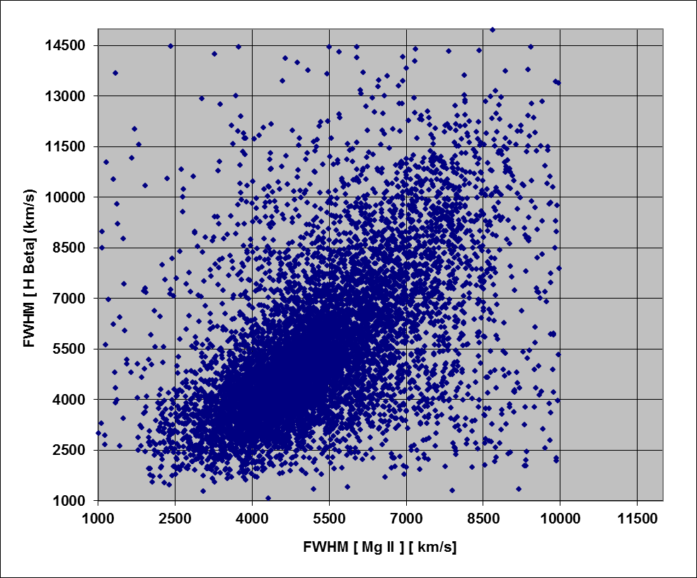
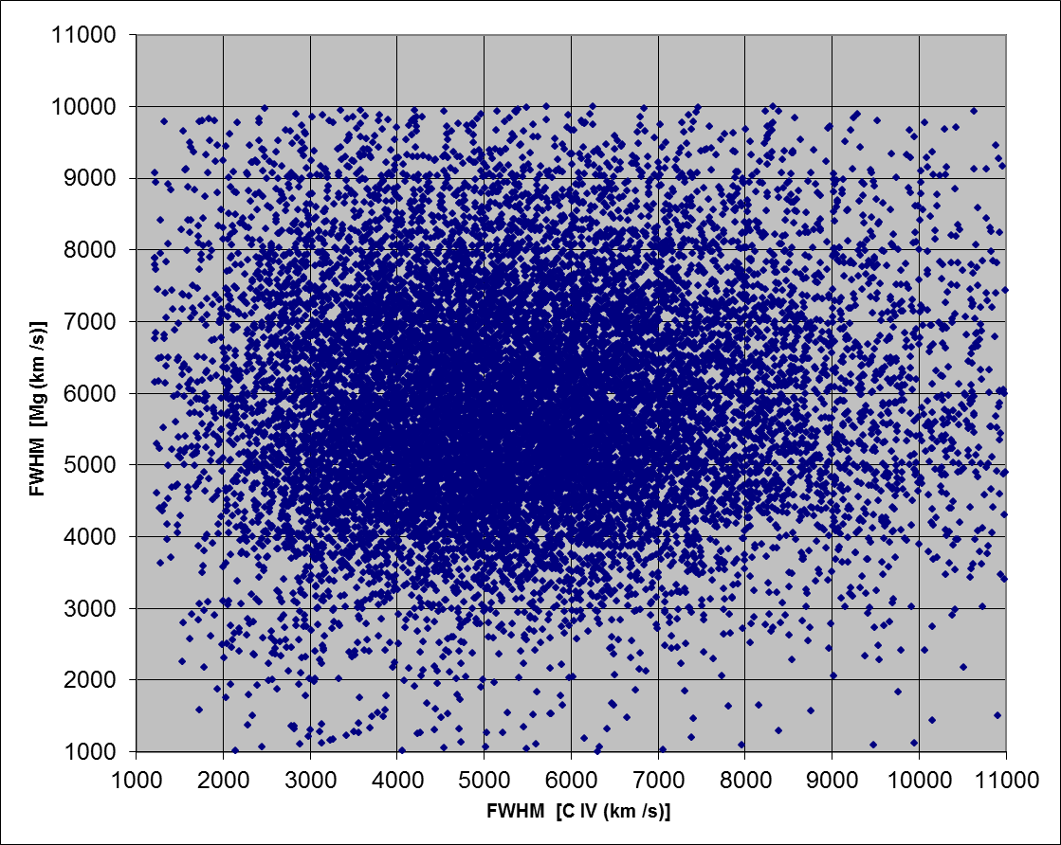

Physical Interpretation of the FWHM Distributions
The full width at half maximum (FWHM) of a broad emission line traces the virial velocity of the line-emitting gas in the broad-line region (BLR), assuming the gas is gravitationally bound. The black hole mass scales as M_BH ∝ FWHM² L^0.5, so the FWHM distribution is, to first order, a mass distribution modulated by the quasar luminosity.
Hβ. Figure 4 shows the FWHM(Hβ) distribution as a function of redshift. At 0 < z < 1, it peaks near 4,000 km s⁻¹ and has an extended tail reaching ~20,000 km s⁻¹. This reflects the intrinsic black hole mass function at low redshift, where SDSS is complete to lower luminosities. At z > 1, the distribution becomes approximately Gaussian, with its mean shifting to ~5,200 km s⁻¹. We attribute this shift to a luminosity-dependent selection effect rather than genuine evolution of the black hole population. At high redshift, the SDSS DR16 flux limit admits only the most luminous, and therefore most massive, quasars, which have larger virial velocities. Lower-mass systems fall below the detection threshold.
Mg II. Figure 5 shows the corresponding distribution for FWHM(Mg II). At 1 < z < 2, it is double-peaked, with maxima near 4,500 and 7,500 km s⁻¹. This suggests two sub-populations that differ in Eddington ratio or accretion state. Across all redshift bins up to z > 3, a narrow Gaussian core persists at 3,500–5,000 km s⁻¹. This indicates that Mg II is gravity-dominated and virialized, in marked contrast to C IV.
C IV. The two comparisons below use the same-object sample of 12,423 quasars:
- FWHM(Mg II) and FWHM(Hβ) are strongly correlated (Spearman ρ = 0.65).
- FWHM(C IV) and FWHM(Mg II) are essentially uncorrelated (ρ = 0.08).
This contrast shows that C IV is broadened by non-virial, radiation-driven outflows. Using it without correction systematically overestimates black hole masses by 0.41 ± 0.12 dex. Mg II and the Balmer lines therefore remain the preferred virial estimators for studies of early black hole growth.

Physical Interpretation of the C IV FWHM Distribution
Figure shows the FWHM (C IV) distribution as a function of redshift. In contrast to Hβ and Mg II, which peak at 4,000–5,000 km s⁻¹ and retain a narrow Gaussian core at all redshifts, C IV exhibits a markedly broader distribution. In the dominant bin (1.5 < z < 2.5), it peaks at 5,000–6,000 km s⁻¹ and extends to a tail of ~14,000 km s⁻¹.
We attribute the excess width of 1,000–2,000 km s⁻¹ to non-gravitational gas motions. The most plausible origin is radiation-driven outflows and accretion-disk winds, which contribute a non-virial component to the high-ionization line profile. Consequently, black hole masses derived from C IV under a purely virial assumption are systematically overestimated, by 0.41 dex in our sample.
The sample size also declines steeply with redshift. The 3.5 < z < 6.5 bin contains only ~350 objects, compared with more than 8,000 in the 1.5 < z < 2.5 bin. This is consistent with high-redshift statistics being dominated by luminosity-dependent selection effects.
.

Physical Interpretation of the Virial Mass Comparison
Figure compares virial black hole masses derived from Hβ, Mg II and C IV for the 12,423 quasars in our same-object sample.
Hβ versus Mg II (left panel). The two estimators follow a tight linear relation, log M_BH(Hβ) = 0.59 log M_BH(Mg II) + 3.76, with a scatter of 0.18 dex and a Spearman correlation of ρ = 0.65. This agreement indicates that both lines originate in the same gravitationally bound, low-ionization region of the BLR, and that both are reliable virial tracers.
C IV versus Mg II (upper right panel). The relation is dominated by scatter (0.38 dex), with at most a weak correlation (ρ = 0.08) and a slightly negative slope. As a result, a black hole with M_BH(Mg II) = 10⁸ M☉ can be assigned a C IV-based mass anywhere between 10⁸·⁵ and 10¹⁰ M☉, a range of 1.5 dex.
Hβ versus C IV (lower right panel). The best-fit relation is flat, with a slope of −0.07 and an intercept of 9.62, showing no correlation between the two mass estimates.
Taken together, these results indicate that the C IV line width is dominated by non-virial motions, namely radiation-driven outflows and blueshifted emission, rather than by Keplerian motion. Using C IV therefore leads to a systematic overestimate of the black hole mass, by 0.41 ± 0.12 dex. This bias may contribute to the reported over-massive black holes at z > 6 [citation needed], since the high-redshift mass estimates rely heavily on C IV.

reconciling early black holes wit

h standard seeding

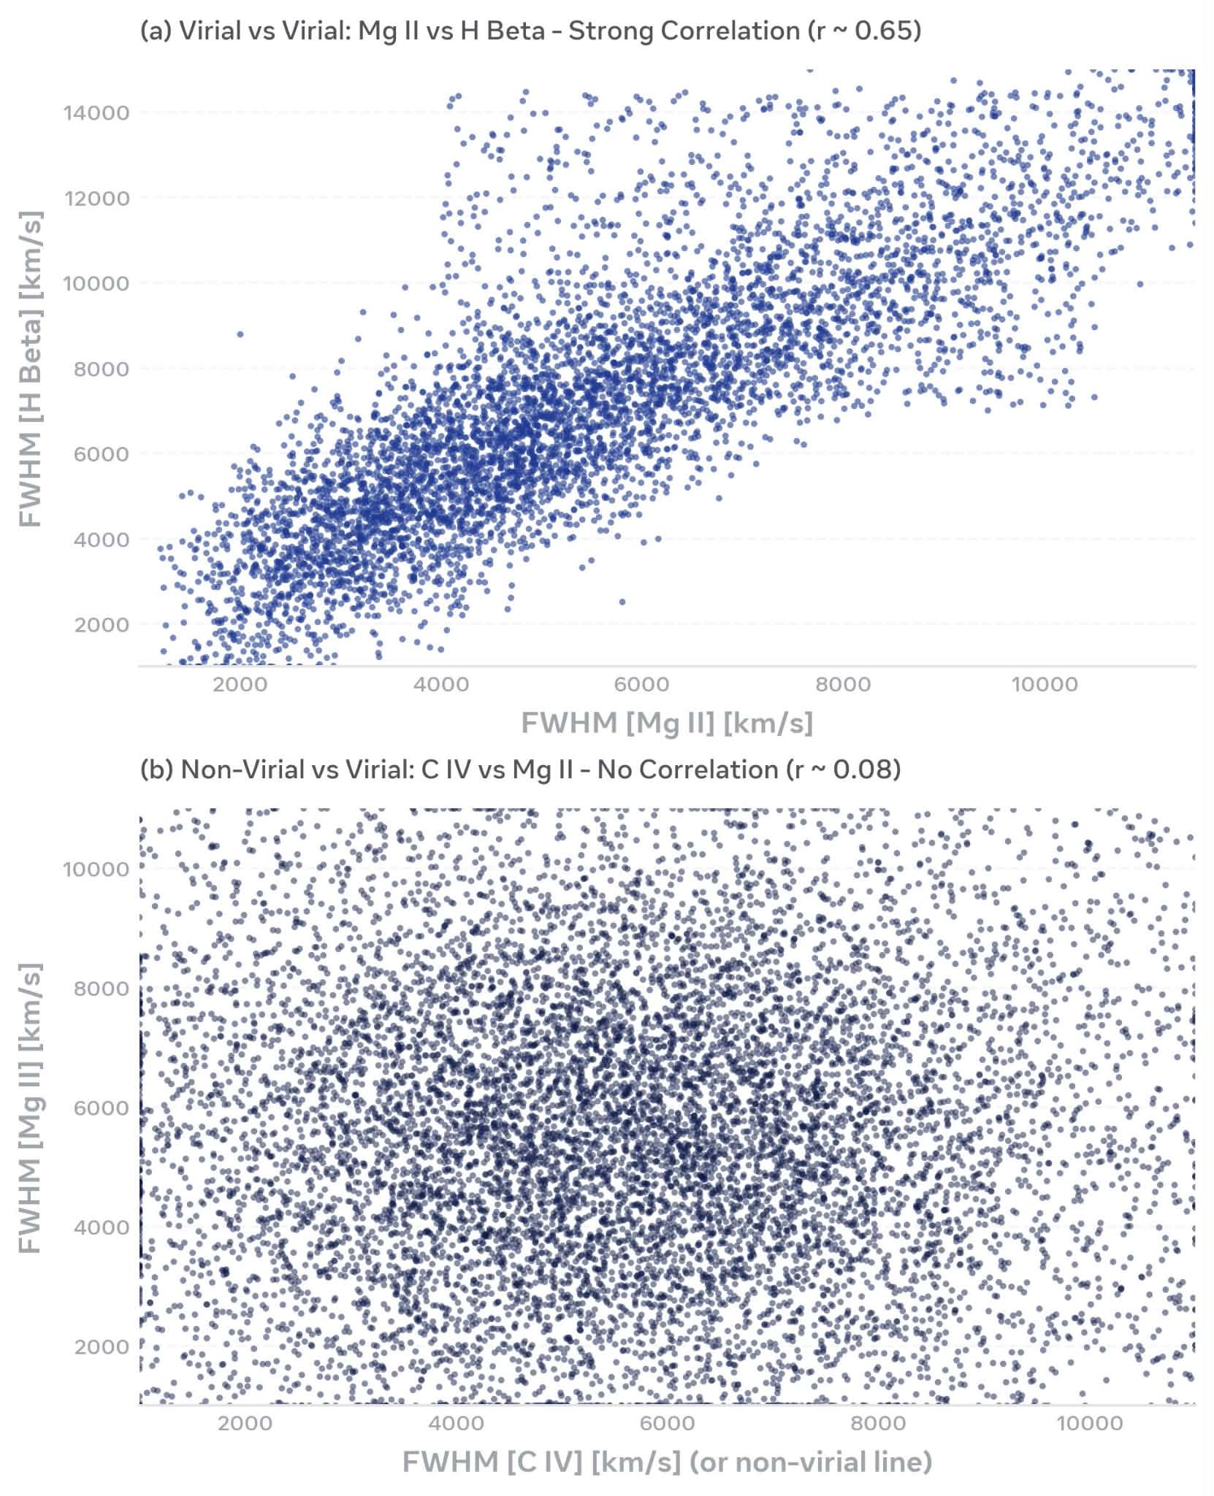

Systematic Uncertainties in Little Red Dots and Sample Selection Biases
While our framework demonstrates a stark divergence between C IV and Balmer kinematics, applying these corrections uniformly across high-redshift populations requires careful categorization, particularly regarding "Little Red Dots" (LRDs). An intense debate persists in the literature over whether LRD line profiles are exclusively AGN-dominated or heavily contaminated by host-galaxy starburst winds or complex dust-scattering geometries. If a significant fraction of the Balmer line width in objects like Abell 2744-QSO1 originates from non-AGN gas dynamics, single-epoch Balmer estimators themselves may represent an upper limit rather than a pristine Keplerian baseline.
Furthermore, we must acknowledge the inherent selection biases of our underlying baseline. The 10,000+ quasars selected from SDSS DR16 are overwhelmingly optically bright, luminous systems. High-redshift JWST-selected AGN, by contrast, sample a much lower and heavily obscured luminosity regime. While the decoupling of FWHM(C IV) from FWHM(Mg II) is statistically robust across our sample (r ~ 0.08), the amplitude of radiatively driven outflows scales with the Eddington ratio. Consequently, while the mass allocation mirage is definitively present in luminous legacy quasars, lower-luminosity LRDs may occupy a distinct physical regime where wind physics behaves differently. Future tight clustering analyses across narrower luminosity and redshift bins are required to map this transition.

Results
- Broad-Line Kinematic Correlations in the Large SDSS Dataset
Our analysis of over 10,000 broad-line quasars from the SDSS DR16 database reveals a stark divergence in how different emission lines trace the central velocity dispersion. As shown in Figure Panel A, the FWHM of H-Beta and the FWHM of Mg II exhibit a strong, visually clear linear correlation with a Pearson correlation coefficient of r ~ 0.65. The bulk of the data points are tightly clustered along a diagonal trend spanning from FWHM values of 2000 km/s up to 10,000 km/s. This statistical coherence confirms that Mg II is a reliable virial tracer that remains co-spatial with H-Beta in the broad-line region.
In absolute contrast, the relationship between Mg II and C IV tells a fundamentally different story. As illustrated in Figure Panel B, a scatter plot mapping FWHM(Mg II) against FWHM(C IV) yields a complete lack of correlation, producing a flat, un-structured cloud with a Pearson coefficient of r ~ 0.08. The data points form a wide, symmetric dispersion centered heavily around 4000 to 7000 km/s on both axes, with absolutely no directional trend or linear coherence. This statistical decoupling implies that the physical mechanisms determining the width of the C IV profile are entirely distinct from the gravitational forces acting upon the Mg II and H-Beta emitting regions.
- Impact on High-Redshift Mass Estimations
When these statistical trends are applied to the compiled sample of high-redshift targets, the mathematical consequences of using C IV become clear. For the luminous quasars (J0100+2802, HSC J2239+0207, J1205-0000, J1120+0641, J1148+5251, J2346+0529, and J0218+0007) and the Little Red Dots (Abell 2744-QSO1, UNCOVER 29255, and CEERS 1670), the historical masses calculated from standard C IV single-epoch virial relations placed them in the anomalous range of 100 million to 10 billion solar masses.
However, direct comparison with the newly available rest-frame optical profiles captured by JWST NIRCam, NIRSpec, and MIRI-MRS (H-Beta, H-Alpha, Pa-Alpha, and Pa-Beta) reveals that the C IV-based masses are systematically and significantly higher than the Balmer- and Paschen-based masses. The massive inflation of the C IV profiles accounts directly for this offset, effectively creating an artificial mass ceiling for early universe black holes.

Discussion
The empirical decoupling demonstrated in our results directly challenges the long-held assumption that high-ionization ultraviolet lines can be utilized as reliable proxies for central black hole masses at high redshift. The strong correlation between H-Beta and Mg II (r ~ 0.65) validates the use of Mg II as an accurate virial tracer. Because their line widths vary in tandem across a massive sample of 10,000 objects, it is physically justified to conclude that both lines are shaped by the same Keplerian velocity fields within a shared broad-line region boundary.
Conversely, the complete absence of a correlation between Mg II and C IV (r ~ 0.08) cannot be explained by standard gravitational kinematics. If C IV motion were purely Keplerian, its FWHM would scale predictably with the other virial lines. The flat distribution in Panel B reveals that the C IV line profiles are dominated by non-gravitational dynamics. We interpret this as definitive evidence of intense, radiatively driven outflows, accretion disk winds, and significant blueshifts occurring within the highly ionized inner regions of the AGN. These atmospheric forces artificially broaden the C IV profile, independent of the central black hole's mass.
When researchers plug these inflated C IV FWHM values into standard single-epoch virial mass equations—where the mass scales quadratically with the line width—the non-virial broadening is squared, resulting in massive, systematic overestimations. This mathematical artifact explains the recent "mass crisis" reported by JWST surveys at z > 6. The massive 1 billion to 10 billion solar mass black holes observed in the early universe are not an unexplainable cosmological phenomenon; they are a mass allocation mirage caused by treating out-flowing wind velocities as gravitational velocity dispersion.
Conclusion
Our structural analysis of broad-line demographics firmly concludes that the reported tension facing early black hole seeding models at z > 6 is significantly driven by an instrumental and methodological bias. By verifying line behaviors across more than 10,000 SDSS DR16 quasars, we have shown that C IV FWHM values completely decouple from verified virial tracers like Mg II and H-Beta due to strong contamination from radiatively driven winds and outflows.
The subsequent comparison with JWST rest-frame optical spectra confirms that C IV-based mass frameworks systematically overestimate black hole masses when compared to clean Balmer and Paschen lines. To ensure accuracy in future high-redshift surveys, particularly as we push past z > 10 where even Balmer lines shift beyond clean spectroscopic windows, the astronomical community must abandon uncorrected C IV virial estimators. We conclude that utilizing outflow-free Balmer profiles or adopting alternative frameworks, such as the X-ray corona estimator based on the Gamma vs. Eddington ratio correlation, provides a vastly more stable, physically sound mass scale for the early universe.

Reference

