**E-Learning Platform Development**

**1. Project Idea**

The e-learning management system is a web-based platform designed to facilitate online education. It allows instructors to create and manage courses, students to enroll and access materials and administrators to oversee the system's operations. The platform aims to provide a seamless and engaging learning experience while addressing common challenges in online education, such as accessibility, scalability, and interactivity.

**2. Problem Statement**

In the era of digital transformation, education systems face several challenges:

1. Limited accessibility to quality education for remote learners.
2. Difficulty in tracking students’ progress and engagement in a virtual setting.
3. Inefficient tools for instructors to create, manage, and assess courses.
4. Lack of a centralized system that integrates features such as content delivery, assignments, and performance tracking.

The proposed e-learning management system addresses these challenges by providing a user-friendly platform that fosters collaboration between instructors, students, and administrators.

**3. User Personas**

1. **Student Persona:**
   * **Description**: college students who seek to enroll in online courses to enhance their learning experience.
   * **Goals**:
     + Enroll in courses based on approve of admission
     + Access materials easily and track their progress.(grades)
     + Receive timely feedback on assignments and tests.
   * **Pain Points**:
     + Limited interactivity with course options, .
     + Lack of clear progress tracking.
2. **Instructor Persona:**
   * **Description**: Educators or professionals who want to create and manage online courses.
   * **Goals**:
     + Upload and organize course materials efficiently.
     + Engage with students through assignments and discussion forums.
     + Track student performance and provide feedback.
   * **Pain Points**:
     + Managing large classes virtually.
     + Difficulty assessing students’ engagement and progress.
3. **Admin Persona:**
   * **Description**: System administrators responsible for managing users, courses, and platform configurations.
   * **Goals**:
     + Ensure the platform runs smoothly for all users.
     + Monitor user activity and troubleshoot issues.
     + Maintain data security and integrity.
   * **Pain Points**:
     + Handling large volumes of data.
     + Ensuring platform reliability under high user traffic.

**4. High-Level Functional Requirements**

1. **User Authentication and Role Management**:
   * Users can register as students, instructors, or administrators.
   * Secure login and session management.
   * Role-based access control (students, instructors, admins).
2. **Course Management**:
   * Instructors can create, edit, and delete courses.
   * Students can enroll in courses based on academic level and view materials.
   * Admins can manage and approve courses.
3. **Content Delivery**:
   * Instructors can upload materials such as PDFs, videos, and quizzes.
   * Students can download materials and submit assignments.
4. **Progress Tracking**:
   * Students can view their course progress and grades.
   * Instructors can track student performance through analytics.(curve of grades of students is high or low )
5. **Communication Tools**:
   * Message boards for students and instructors.(optional not important)
   * Notification system for course updates and deadlines.

**5. High-Level Non-Functional Requirements**

1. **Performance**:
   * The platform should handle up to 100 concurrent users with a response time of less than 2 seconds for most actions.
2. **Security**:
   * Use Django’s built-in authentication and data encryption for sensitive information.
   * Enforce HTTPS for secure communication.
3. **Usability**:
   * A responsive design that works seamlessly on both desktop and mobile devices.
   * An intuitive user interface for all user roles.
4. **Maintainability**:
   * Follow Django coding standards and modular design for easy updates and bug fixes.

**Class diagram:**

**Use case diagram**

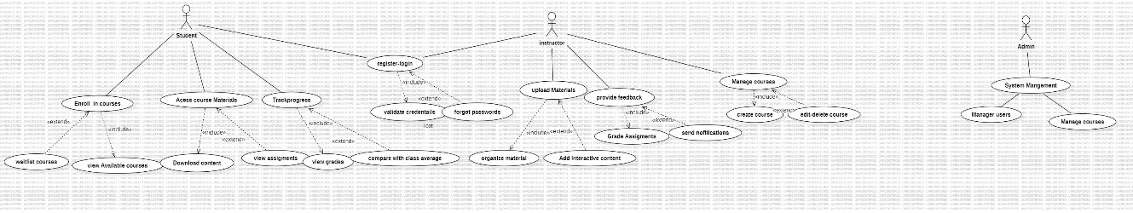

**Sequences diagrams**

**Sequence diagram for enroll in courses**

**sequence diagram for Access course materials**

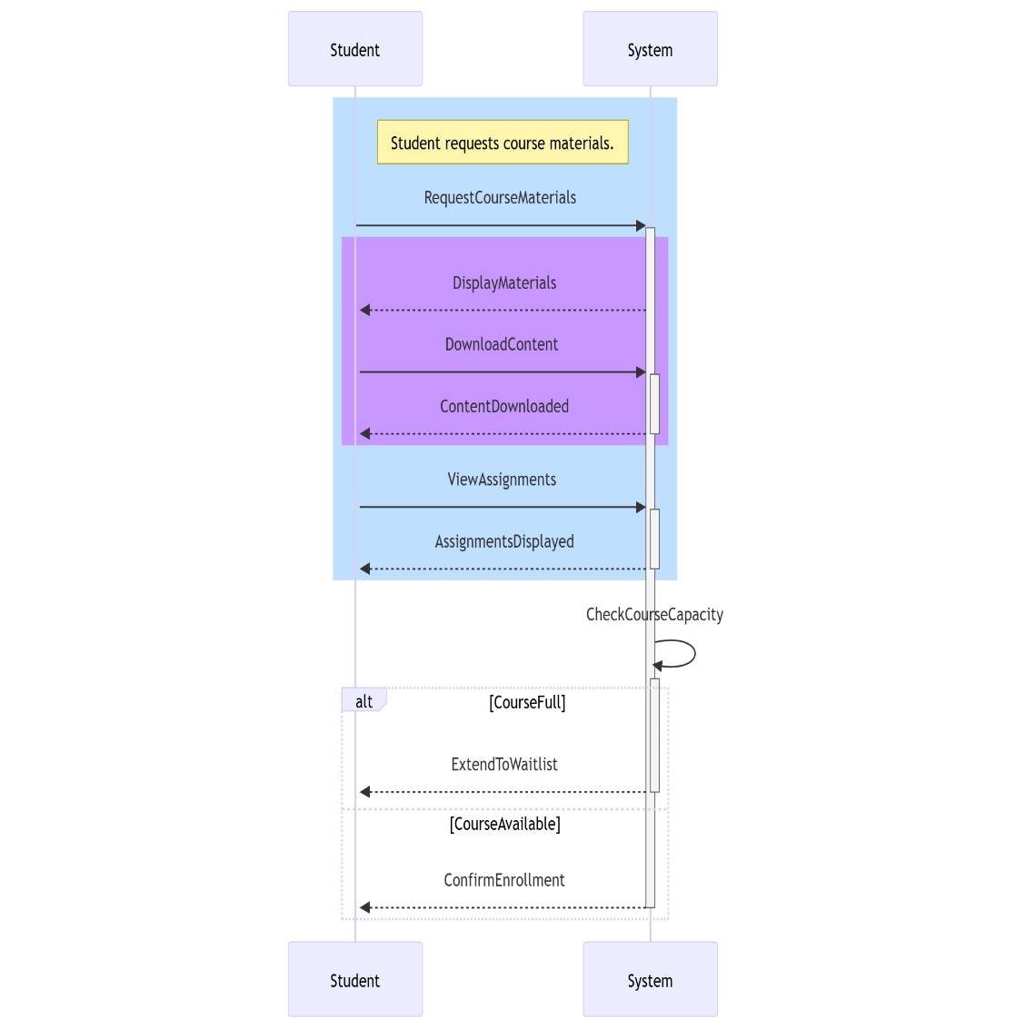

**sequence diagram for track courses**

**s**

**sequence diagram for Register/login**

**Sequence diagram for upload materials**

**Sequence diagram for provide feedback**

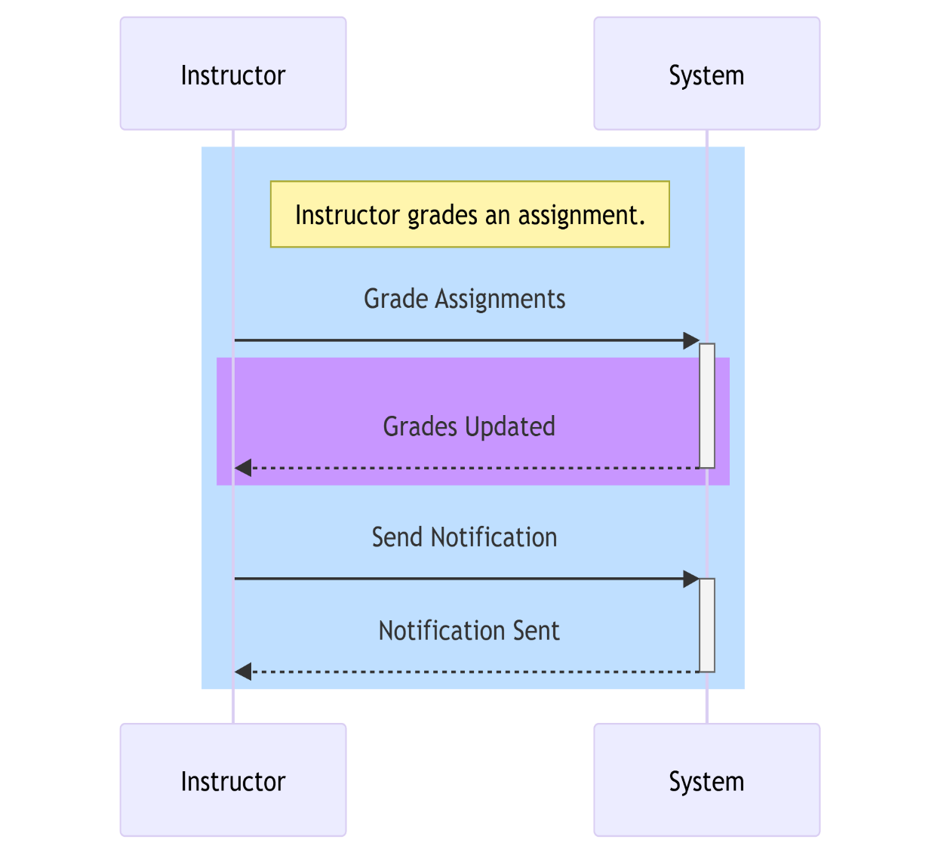

**sequence diagram for manage courses**

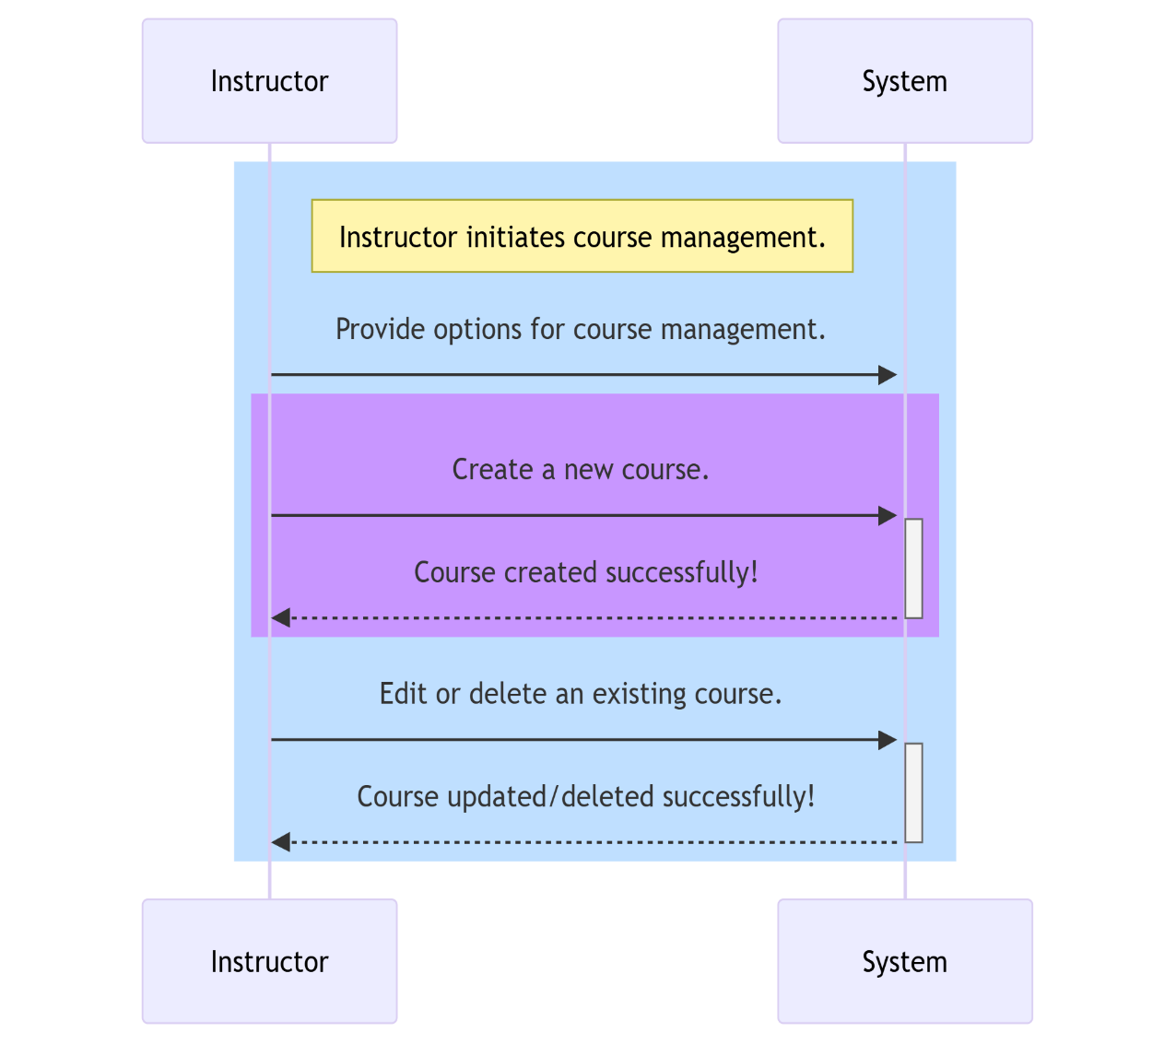

**sequence diagram for system management**

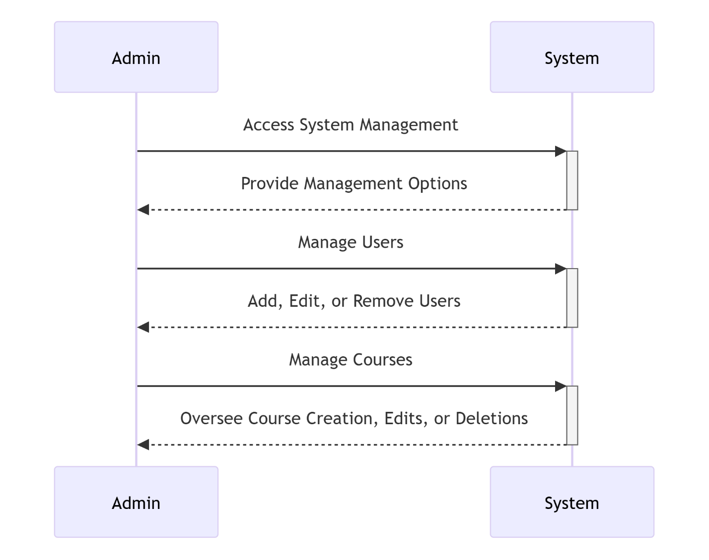

**1. Architecture Diagram**

The architecture diagram provides a high-level view of how the system's components interact. The e-learning platform will follow a **three-tier architecture**:

* **Frontend**: User interface, accessible via web browsers (HTML, CSS, JavaScript).
* **Backend**: Django framework, handles business logic and communicates with the database.
* **Database**: SQL database (e.g., PostgreSQL) for managing data such as users, courses, enrollments, and content.

**High-Level Components:**

* **Web Browser (Client)**: Users (students, instructors, admins) interact with the application via a responsive web interface.
* **Django Backend (Application Layer)**:
  + User Authentication
  + Course Management
  + Progress Tracking
* **Database Layer**:
  + Stores user data, course details, and progress reports.

**Architecture Diagram**

The architecture diagram would include the flow of requests from the frontend to the backend and database. Here's how you can represent it:

* User requests (e.g., login, view course) are sent via HTTP/HTTPS.
* Django processes these requests, interacts with the SQL database, and sends the response back.

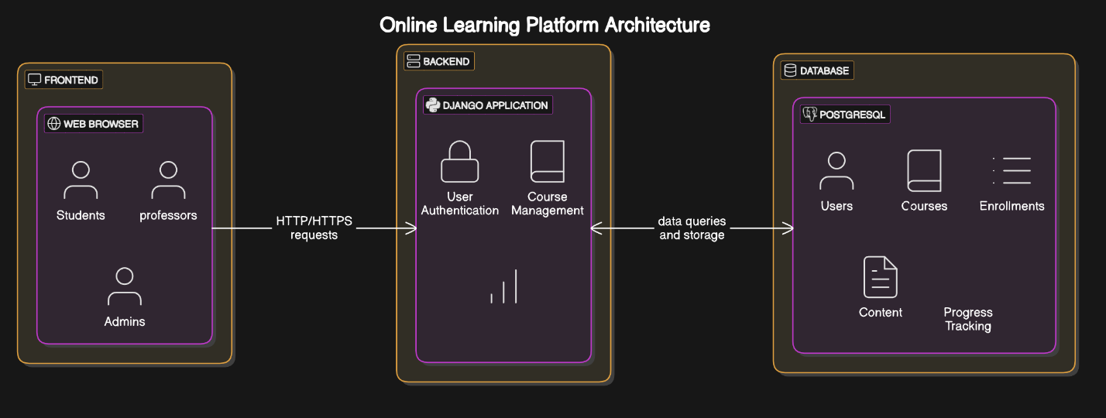

**3. Wireframes**

Wireframes are simple, visual blueprints of how the user interface will look. They help in understanding user navigation and interactions.

**Wireframe Components:**

1. **Home Page**:
   * Navbar with login/logout, dashboard link.
   * Course categories or featured courses.
2. **Login Page**:
   * Input fields for email and password.
   * Login button and "Forgot password?" link.
3. **Instructor Dashboard**:
   * Create a course.
   * View and manage existing courses.
   * Upload content.
4. **Student Dashboard**:
   * View enrolled courses.
   * Access course materials.
   * Track progress.
5. **Admin Dashboard**:
   * User management (approve instructors, manage students).
   * View platform reports.



