

Multi-Client Chat Application

Abdelrahman Ehab Rahal - 221001443
Mahmoud Mohamed Abdgelil – 221001313
Nour Mohamed sharkawy – 221001458
Alhussein Abdulaziz Nagdy- 221002149

Csci463 introduction to networks

December ,2025

Project Idea

The Multi-Client Chat Application is a real-time communication system that allows multiple users to connect to a central server and exchange messages secure local network.
The system supports group chat, private one-to-one chat, online user tracking, typing indicators, and file sharing, all through a modern graphical user interface

Objectives
- Build a real-time chat system using socket programming
- Support multiple clients simultaneously
- Provide a user-friendly GUI
- Implement private and group communication
- Ensure secure data transfer
Technologies Used
- Programming Language: Python
- GUI Framework: PyQt5
- Networking: Socket Programming
- Security: SSL/TLS Encryption
- Operating System: linux / Windows/Mac

The application follows a Client–Server architecture:
Server
- Handles multiple client connections
- Manages online users
- Broadcasts group messages
- Routes private messages
- Sends typing notifications
client
- Connects securely to the server
- Displays online users
- Sends and receives messages
- Opens a separate window for private chat
- Shows typing indicators
Main Features
1. Group Chat
- All connected users can send and receive messages in the main chat room.
- Messages are displayed with:
  - Sender name
  - Timestamp
  - Clear alignment (sender vs receiver)
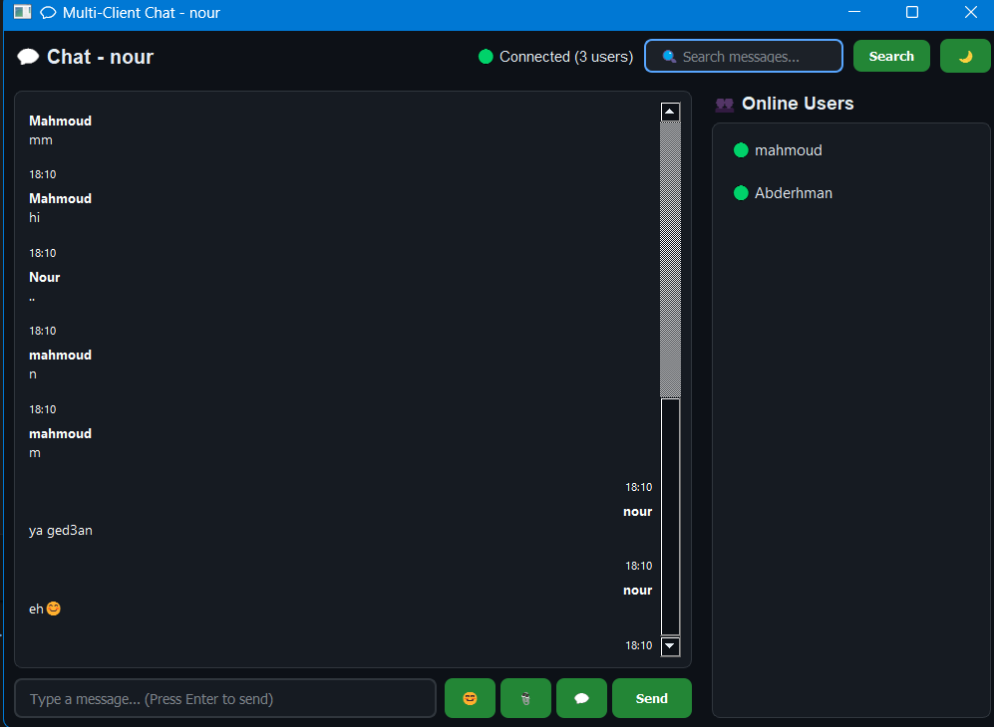

2. Private Chat
- Users can select another user from the online list.
- A separate private chat window opens.
- Messages are visible only between the two users.
Ex: between Mahmoud and abdelrahman
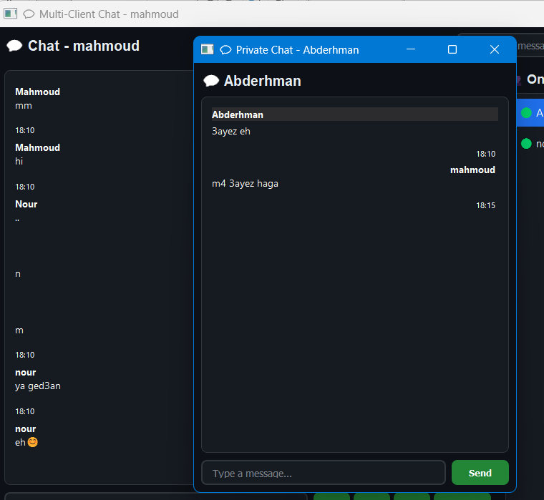
3. Online Users List
- Displays all currently connected users.
- Updates automatically when users join or leave.
- Shows connection status.
Ex : When Nour and Mahmoud connect to the system, each user can see the other listed in the Online Users panel.
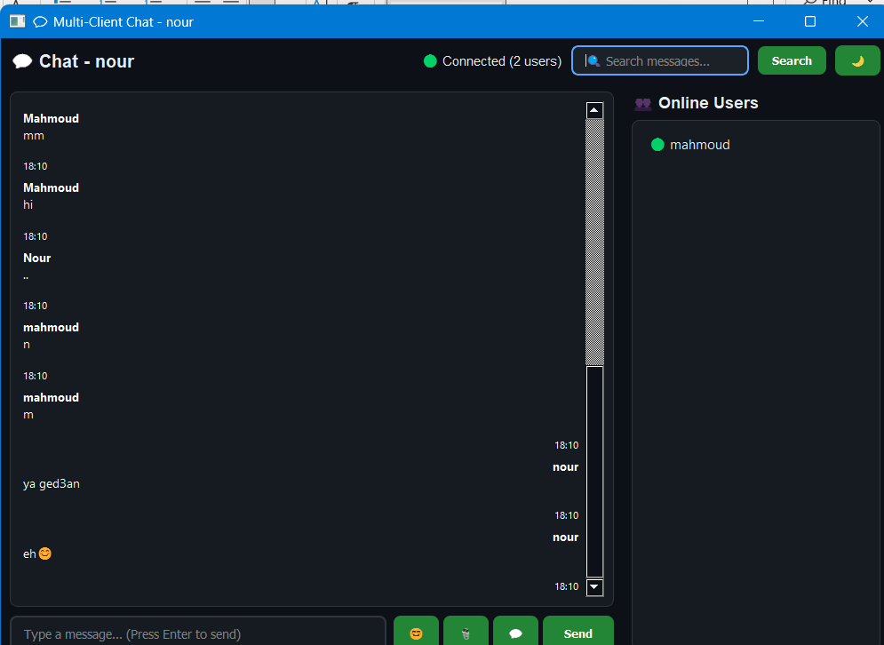

4. Typing Indicator
- Shows “User is typing…” when someone is typing.
- Indicator disappears automatically after a short time.
- Prevents duplicate typing messages.

5. File Sharing
- Users can send files to others.
- Files are encoded and transmitted securely.

6. Search Messages
- Users can search for keywords inside chat messages.

7. Dark Mode & UI Design
- Modern dark theme interface.
- Clean layout with:
  - Chat area
  - Online users panel
  - Message input bar
- Responsive and user-friendly design

How to Run the Project

1. Start the Server
python server.py

2. Run Clients
Open multiple terminals and run:
python client.py username1
python client.py username2
python client.py username3
Each client opens in a separate window.

Conclusion
This project demonstrates the practical use of socket programming, multi-threading, and GUI development to build a real-time multi-client communication system.
It successfully meets all required objectives and provides a strong foundation for future enhancements such as message persistence, voice chat, or cloud deployment

