Description and features

*The game play

-The goal of the game is to connect dots and take as much boxes as you can and mark them with your color. The board may be of any size. When short on time, a 2x2 board (a square of 9 dots) is good for beginners. A 5x5 is good for experts.

*menu

-there’s a menu at the start of the game which allows you to start the game or show leader board then exit or to load saved games , another menu is open from inside the game that allows you to exit ,show leader board ,save the game ,or \***continue the game**bonus maybe ? :,D\***

*colors

-First when any player connect to grids the line is colored with the player color *red or blue*.

-Then when a player wins a box all the borders of this box are colored with the player color.

-When a player wins a box the box it self is colored with the player color *p1 or p2 is written in the box depending on who won the box*

**-Finally when a box is won by the 1st player and the successive box is won by the 2nd player the intersection line is colored with different color *bonus maybe ? :,D\***

**\*wining**

-After wining a box the player who won that box will have an extra turn .

-After wining a box the score of the player who won that box increases by 1

-when the game ends the player with the higher score wins *logic :,DD*

**-after wining a box a sound of victory is released :,,D**

**\*Undo/redo**

-You can undo your move or redo it again ,but when you play you can’t redo again the prev (undo)s ,you can undo the whole game back and redo it again *thus an extra move is added at the end of the game as a question whether you want to undo or just finish the game*

**\*save/load**

-you can save up to 3 games and load them to replay the game *+ the game that you can continue*

**\*leader board**

- aleader board one for each mode that shows the first 10 players with highest scores in this mode

**\*time**

-calculates time taken by both players .

Design Overview+user manual

1-At the beginning the user enters his name .and remember to press enter after any input .

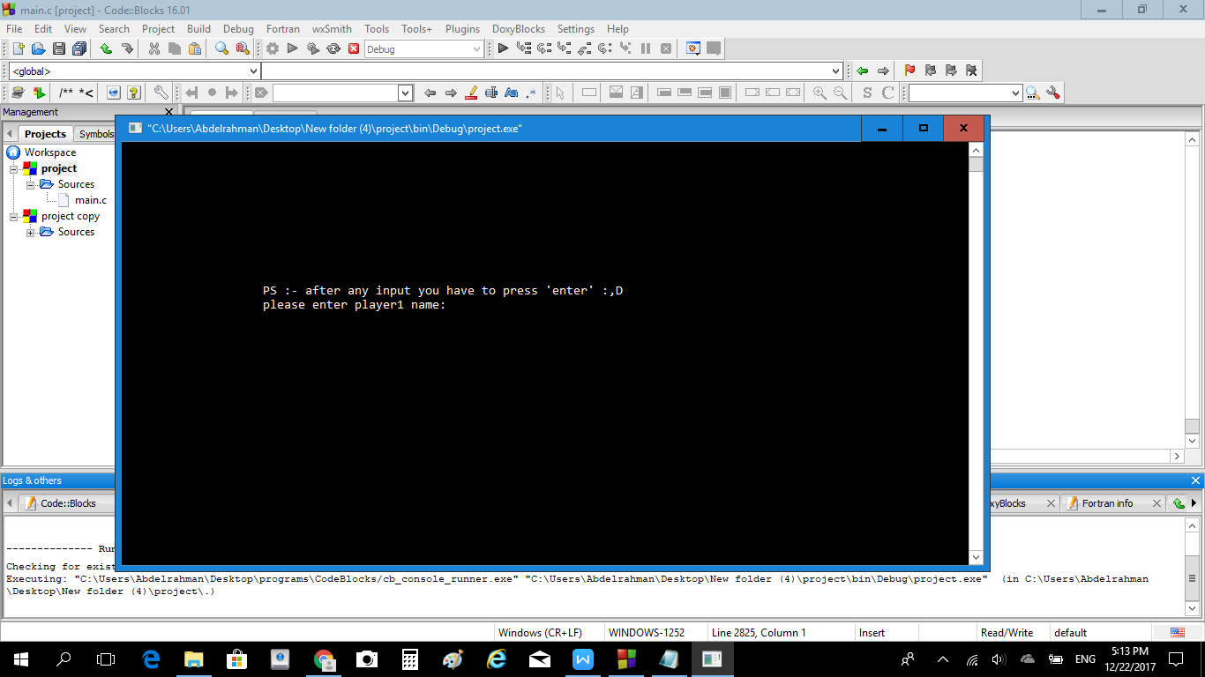

2-Then selects from the menu to **continue last game** press 1, load saved games press 4 , start new game press 2 ,show leader board press 3 or exit press 5 :(.

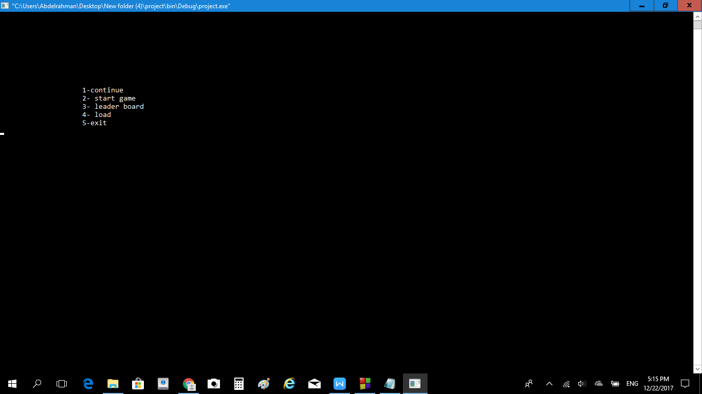

3-if you choose exit the game will end

If you choose load it will load one of the 3 saved games

Press 1 or 2 or 3 ,,but take care it will over write the saved game in this file

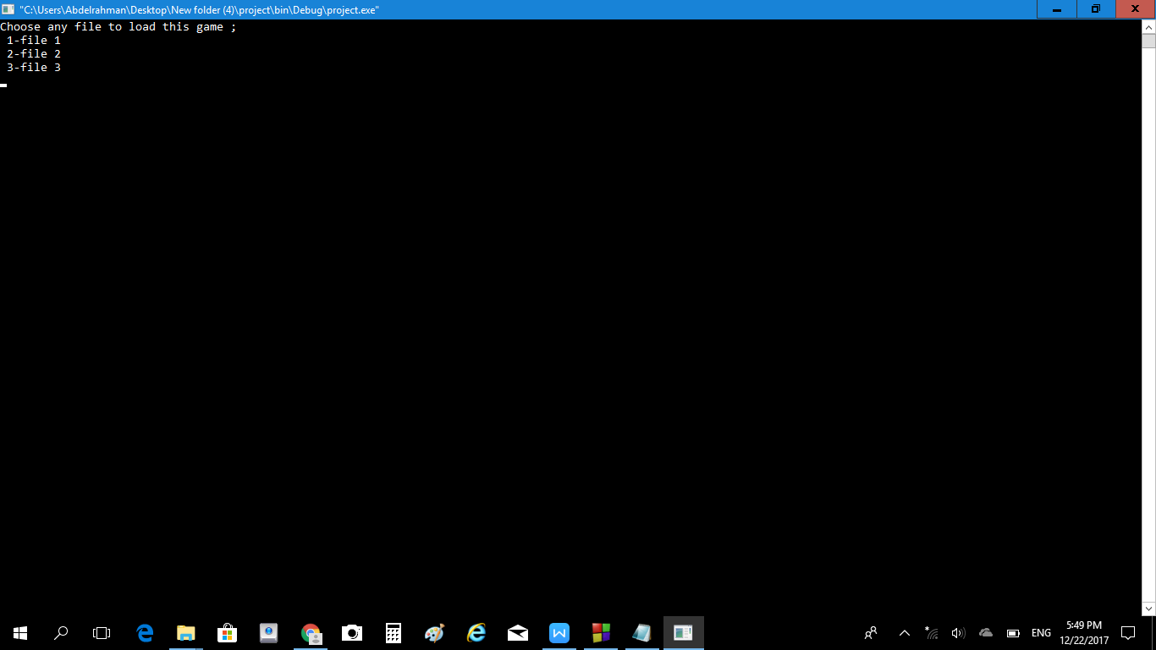

If you choose leader board it will show the 2*2 game leader board or 5*5 game leader board ,it’s your choice press 2 or 5

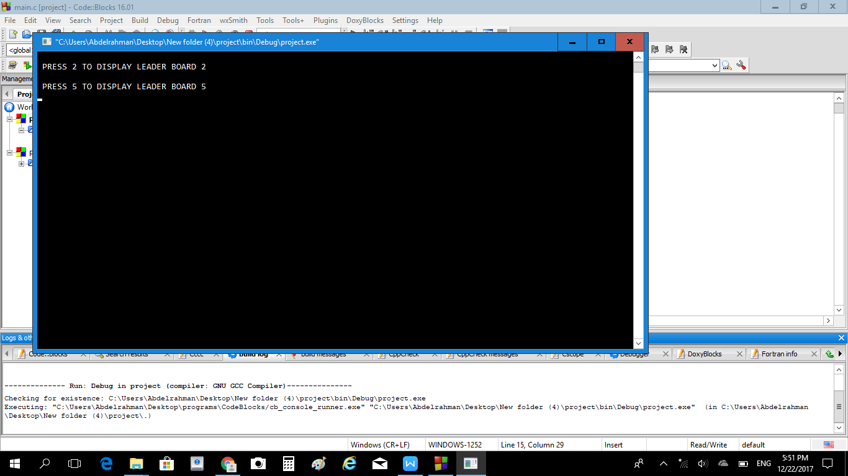

Example

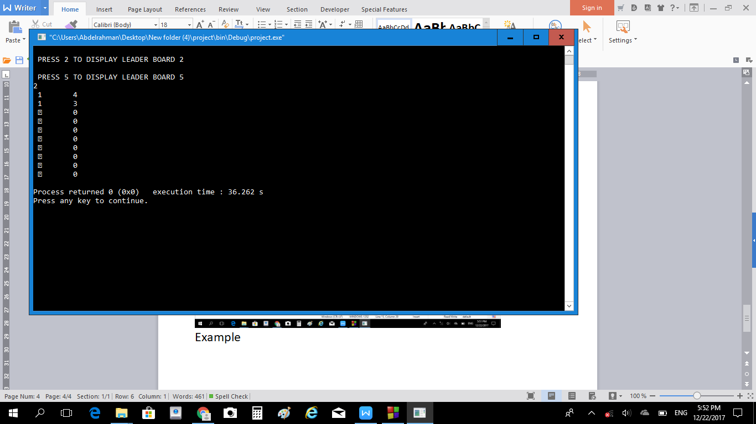

If you choose start game you will choose the size of the game 2*2 ( beginner) or 5*5 (expert)

The beginner mode 2*2 press 1

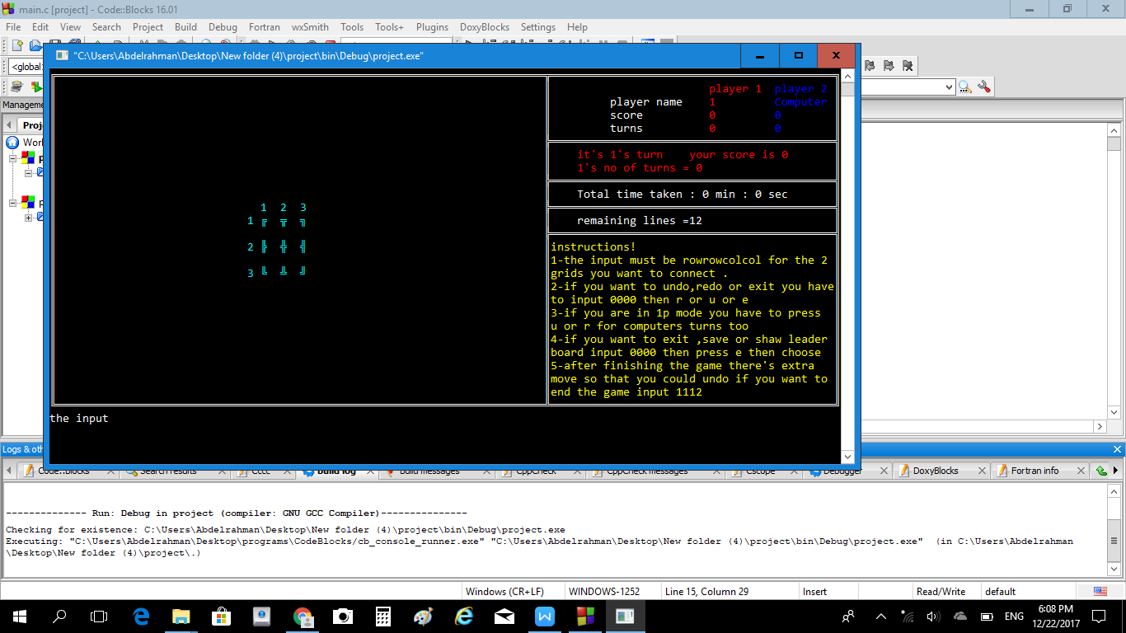

The expert mode 5*5 press 2

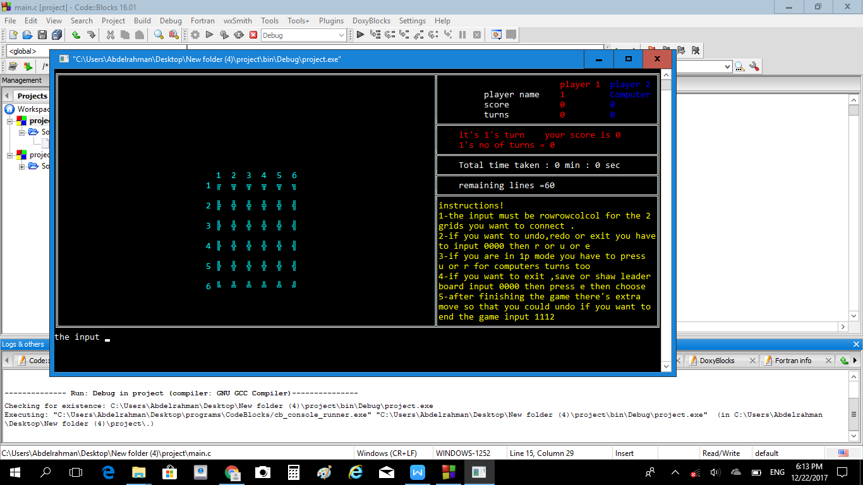

After that you will choose the game mood , 2 players or only one player vs the computer

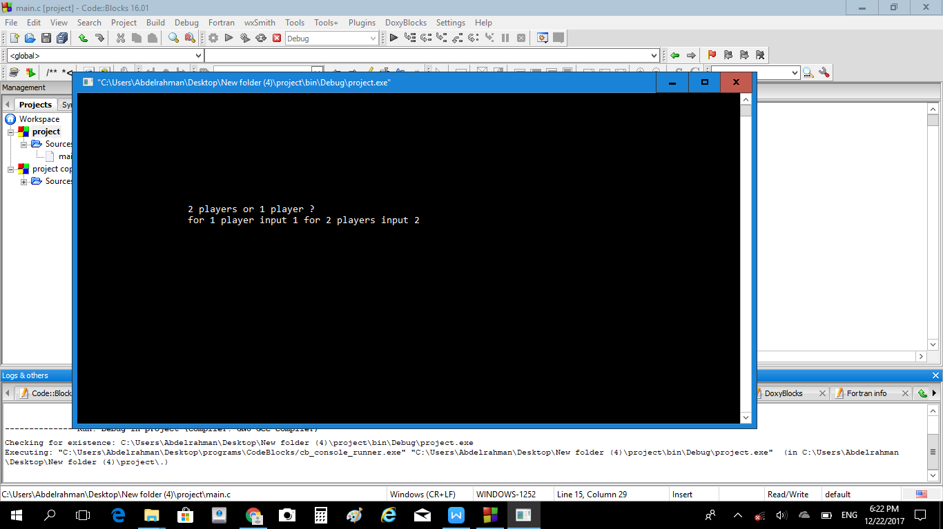

Press 1 for 1player mode

Press 2 for 2players mode

**Then comes the input ,**

**The input must be row row col col for the 2 grids you want to connect**

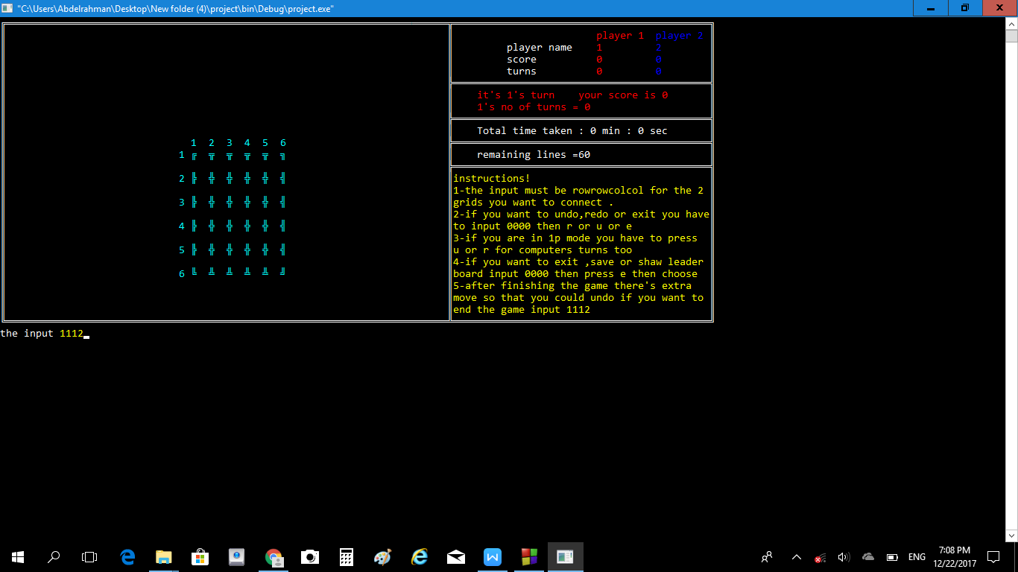

The 1112 mens

1st row =1 2nd row=1 1st col =1 2nd col=2

Then it will connect the grids with the index (1,1)&(1,2)

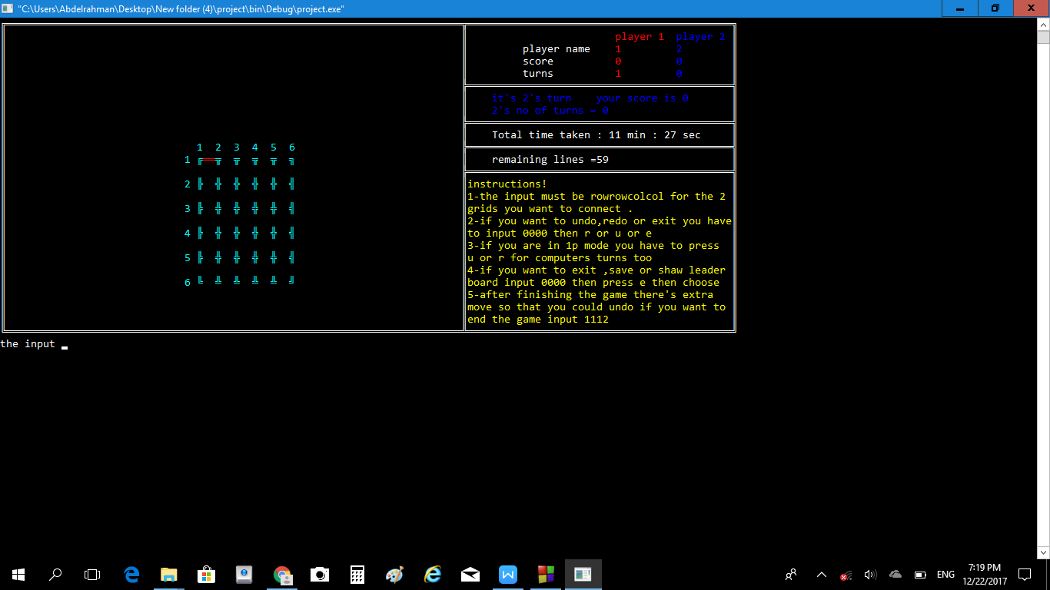

The line is red as it’s p1 turn the 2nd turn will be in blue

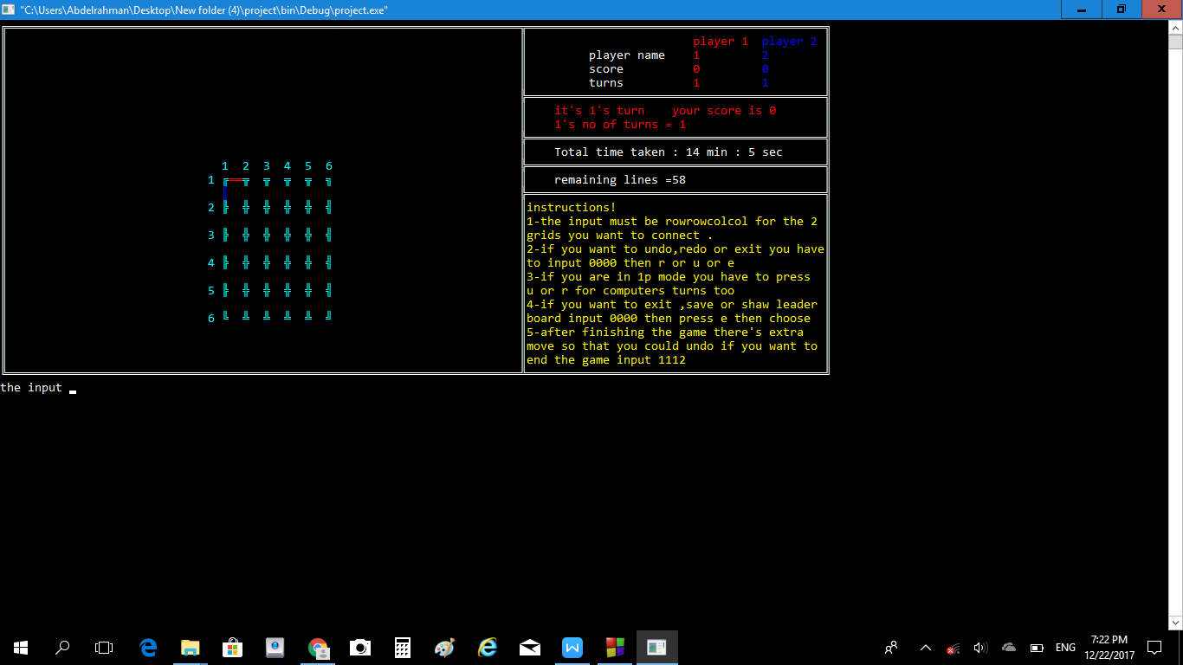

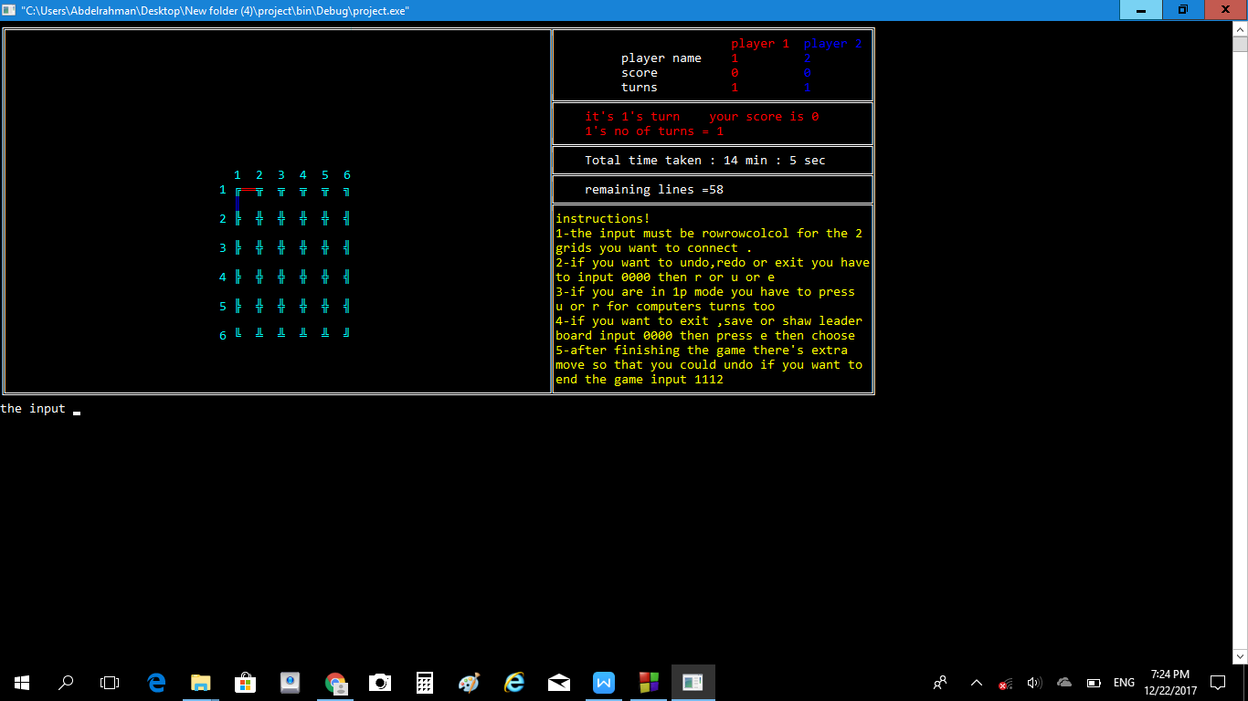

This is the instruction section ,includes each player name , his score &number of turns ,, decides whose turn is this ,total time taken and the remaining lines in the game.

wining

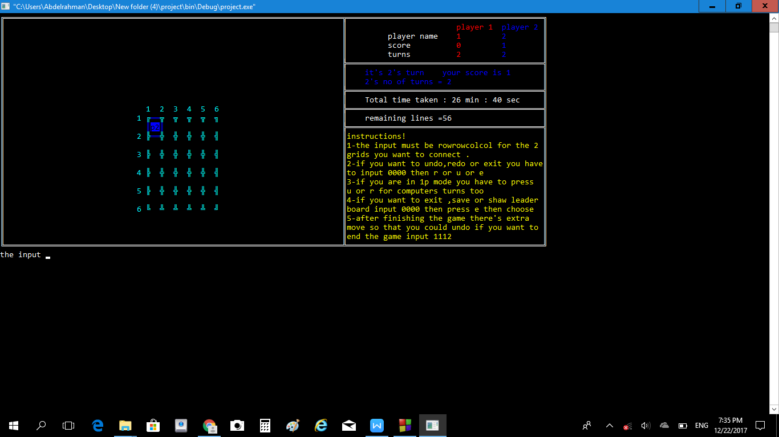

After player 2 won this box all the borders of this box are colored with the player color , his score increased by one

The cell itself is colored with the color and p1 or p2 is written in the box

The player who won takes an extra turn as a reward :,D

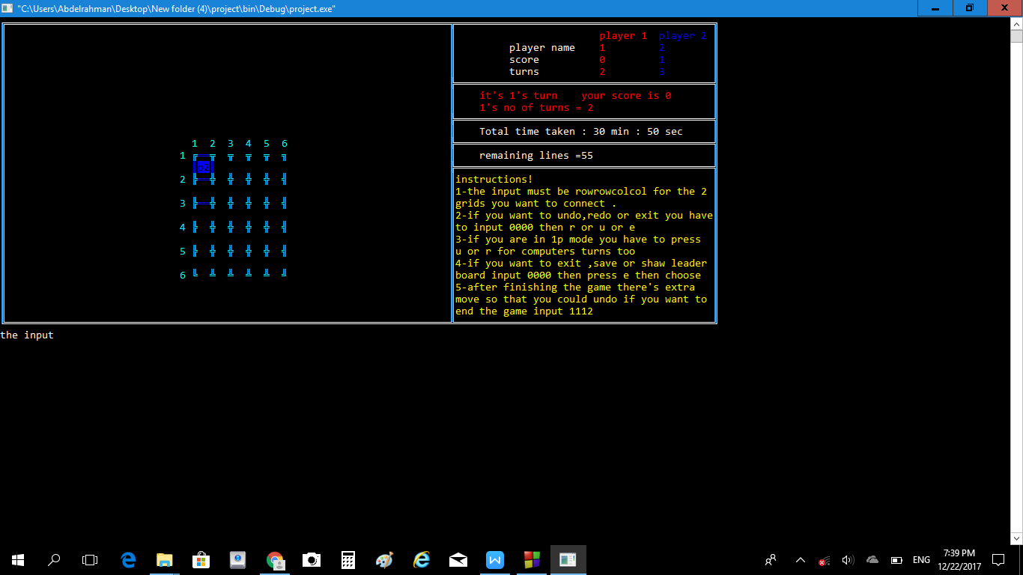

Another box won by player 1

The same things happen

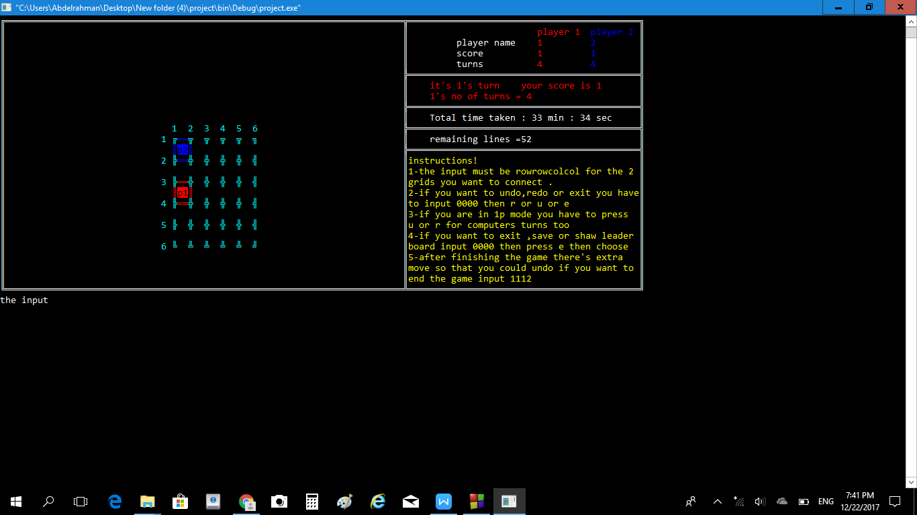

When 2 successive boxes are in different colors the intersection border is colored in a different color

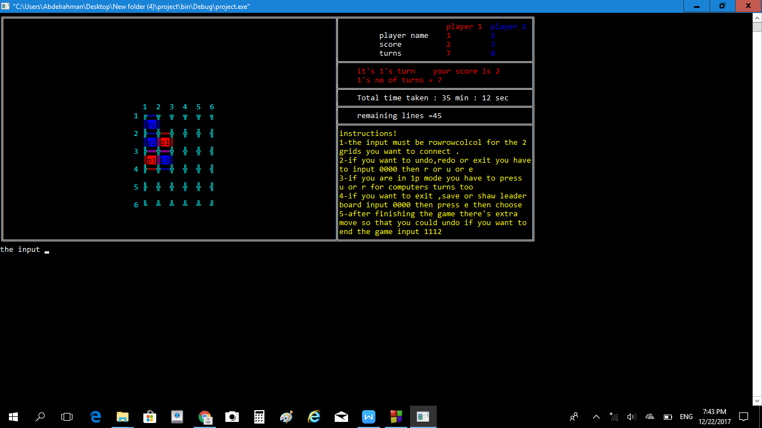

When you finish the game there is an extra move whether you want to undo again or finish the game

If you want to finish the game choose any inout like 1112

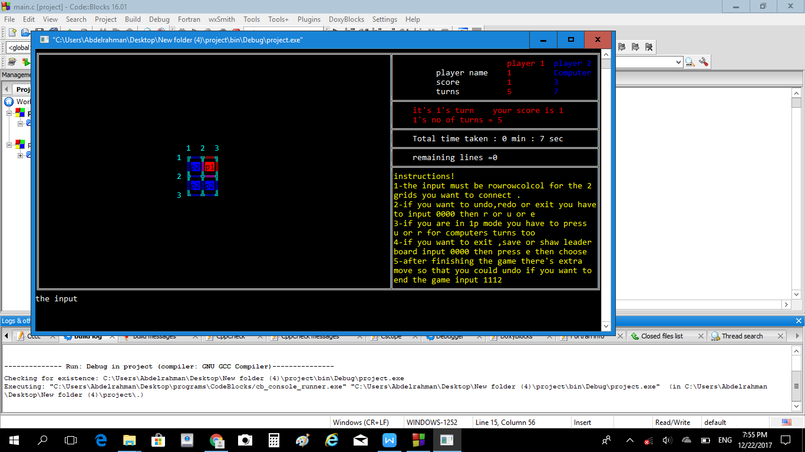

If you want to undo /redo or exit to the main menu you have to enter 0000 (the pass word :,D)

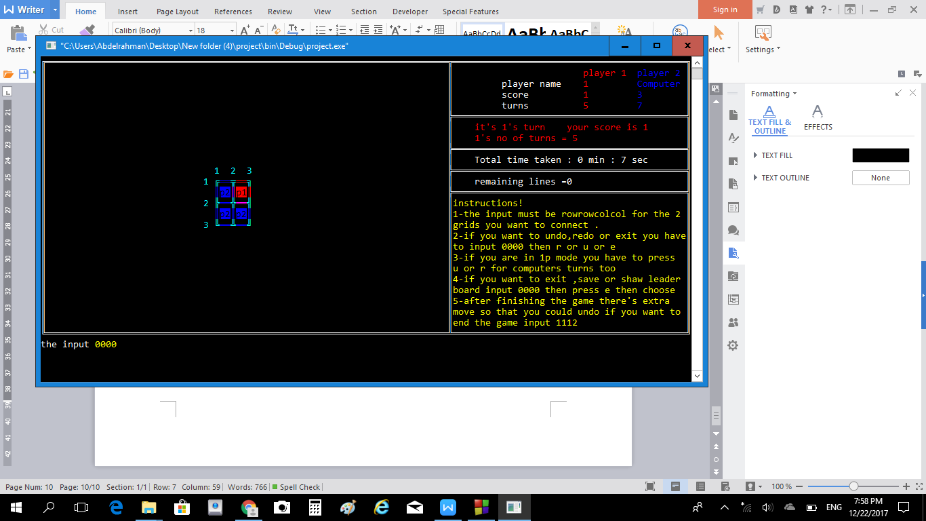

The press u for undo or r for redo or e for exit

Ps:- in the computer mode you have to press the u and the r to undo or redo the computer turns

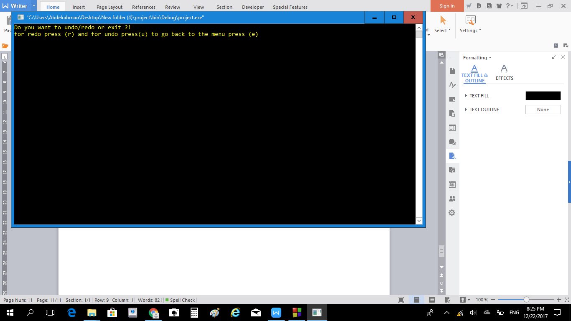

Note that you can undo the whole game and redo it again as long as you didn’t play , but once you input a new play all the undoes are cleared and you can’t do any more redoes .

The instructions and warnings are written in the game ,

When the input is wrong a warning message appears and tells you what’s wrong with your input .

Finally if you press e and exit

You can choose to save the game press 3

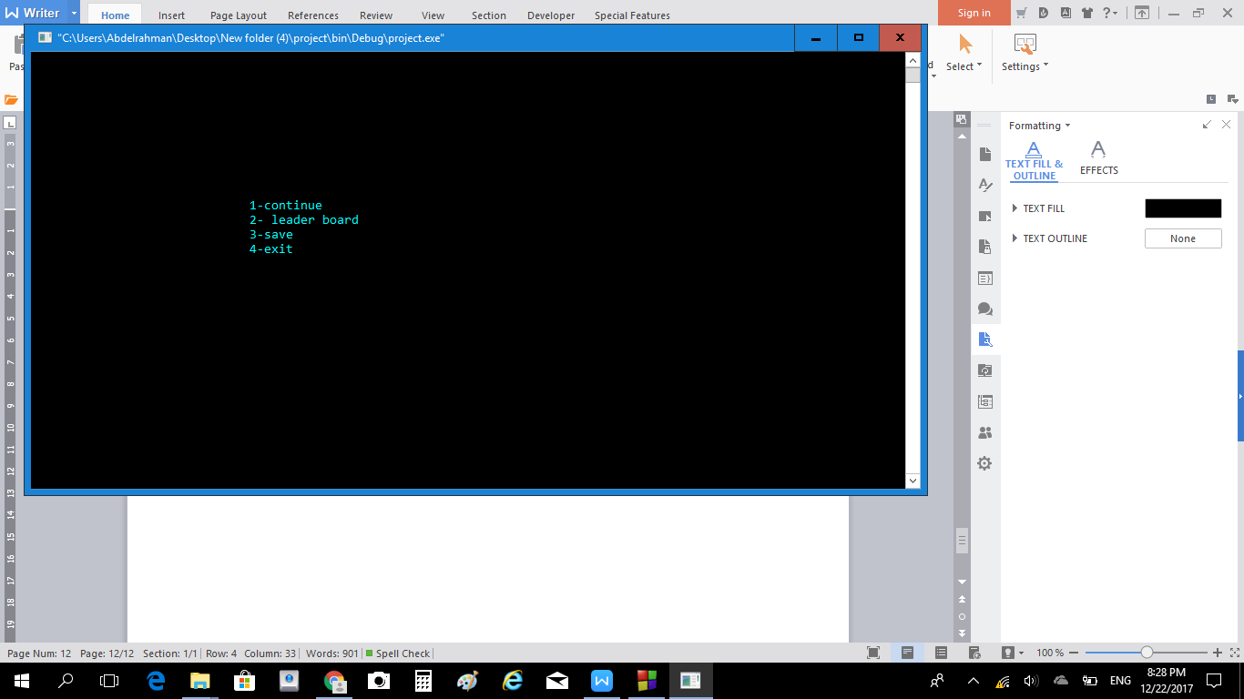

And then choose the file to save your game in

Press 1 ,2 or 3

