**ARDUINO**

**Task_3 (part 2)**

**Autonomous wall follower robot**

**Name: Abdelfattah Mohamed**

**ID: 59**

**Content:**

1. **Overview.**
2. **Connect the robot with Arduino:**
3. **Ultrasonic sensor.**
4. **DC motor.**
5. **Servo motor.**
6. **LED.**
7. **Functions explanation:**
8. **check_front();**
9. **check_sides();**
10. **blink_led();**
11. **servo_motor();**
12. **stop_motor();**
13. **turn_right();**
14. **turn_left();**
15. **flowchart:**
16. **Overview:**

That’s robot drive in a path of walls and sweep boxes from it way to reach end.

It detects all of this thing by ultrasonic sensor, move by DC motor and sweep boxes by servo motor.

1. **Connect**ion:
2. Ultrasonic sensor:

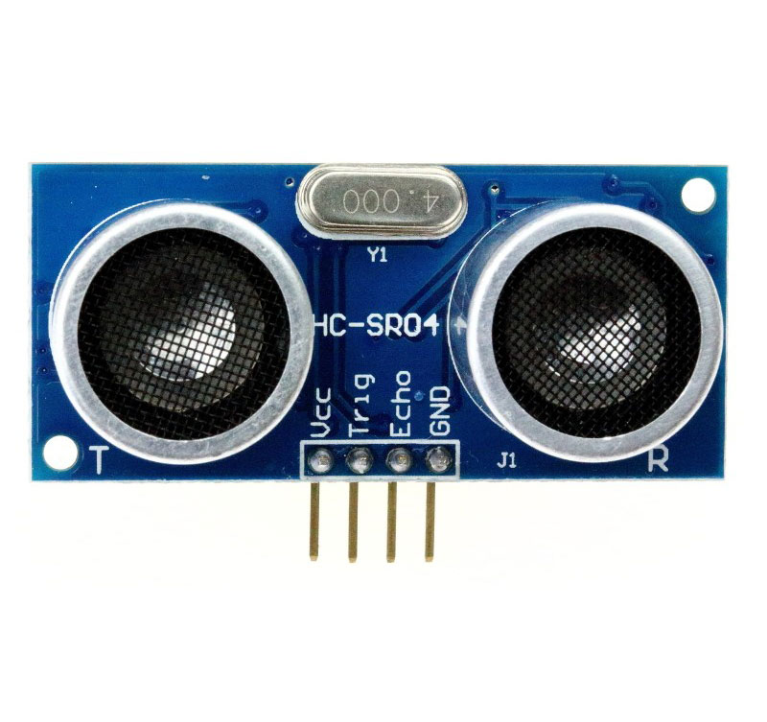

VCC: connected to VCC(5V).

GND: connected to GND(0V).

TRIG: connected to Arduino's pin (0, 1, 2, 12).

This pin to transfer the emission.

ECHO: connected to Arduino's pin (6, 7, 8, 9).

This pin to receive the emission.

I used 4 Ultrasonic sensors 2 in front and the other each one on two sides.

To measure distance at three sides and detect boxes or wall at front of robot.

1. DC motor:

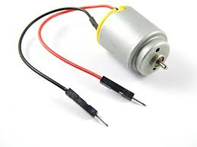

Pin_1: to direction.

connected to Arduino's pin (4, 5).

Pin_2: to speed.

connected to Arduino's pin (10, 11).

I used 2 DC motor each one on two sides.

To control stop, move and turn.

1. Servo motor:

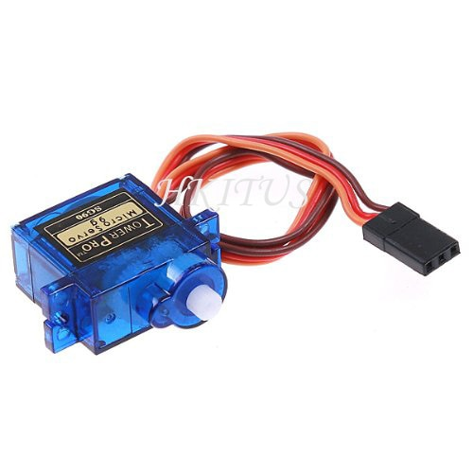

VCC: connected to VCC(5V).

GND: connected to GND(0V).

CONTROL: connected to Arduino's pin (3).

I use 1 servo motor to sweep boxes from robot's way.

It turns 180 degree to sweep in (1.35 sec) boxes and return in (0.27sec).

1. LED:

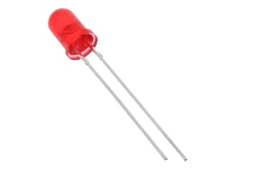

VCC: connected to Arduino's pin (13).

GND: connected to GND.

I used 1 LED to blink with the number of the encountered boxes.

1. **Function:**
2. Check_front ();

This function take measurement from two fronted Ultrasonic sensor and compare each other to detect body in front of robot.

Check if distant_1 equal distant_2 (wall).

Go to check_sides();

Else (box)

Go to blink_led() then servo_motor();

1. check_sides();

This function take measurement from two-sided Ultrasonic sensor and compare each other to detect robot need turn or the end.

Check if distant_1 equal distant_2 (end).

Return to loop function and return from it to end program.

Else (turn)

If (distant_1 equal distant_2) (turn left)

Go to turn_left ();

Else (turn right)

Go to turn right ();

1. **blink_led ();**

this function blinks the led with the number of encountered boxes

1. **servo_motor();**

**this function to generate servo motor to sweep boxes from the robot's way.**

It turns 180 degree to sweep in (1.35 sec) boxes and return in (0.27sec).

1. **stop_motor();**

**this function to stop the robot.**

**By give speed of two motor zero velocity.**

1. **turn_right();**

**this function to turn the robot right 90 degree**

**by stop right motor and give velocity to left motor.**

1. **turn_left();**

**this function to turn the robot left 90 degree**

**by stop left motor and give velocity to right motor.**

1. Flowchart:

