1- Created instance with a public IP
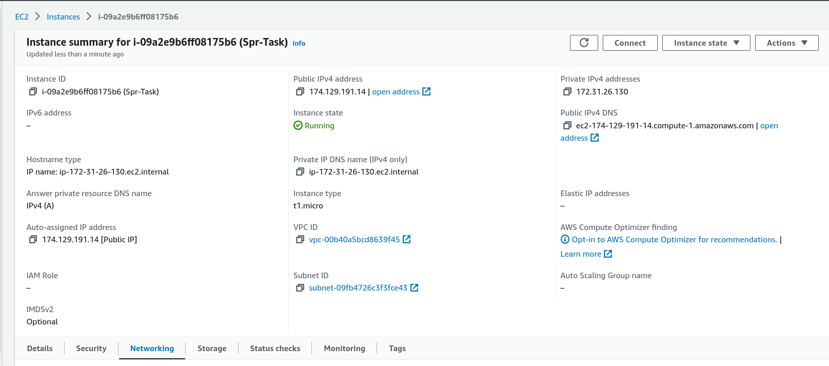

2- Installing apt and Ngnix
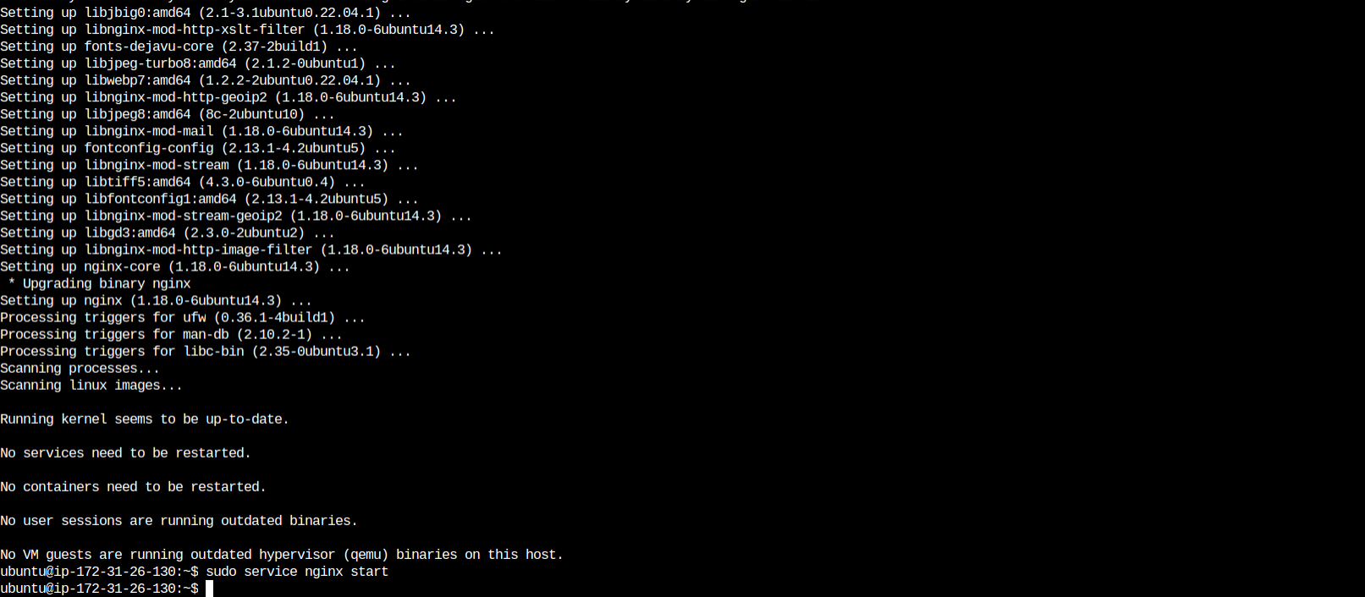

3- Acess to the Ngnix from a public IP
