**- Project Resources –**

**- Product owner:**

Our product owner is a **“healthy food company”** that want to provide a healthy life style to everyone by making them use “healthy life app” which provide healthy diet and workout videos.

**- Process description (include plan schedule):**

- Our application provides healthy diet and sports instructions to any kind of users (normal people, diabetic and high or low blood pressure patient).

- So at the beginning as a one team we started to divide the roles between us.

- Started to analysis and understand what our customer want from us to provide at the application, also making interviews with different people in different ages with different health conditions.

- we analysis all those interviews which we have from our product owner and people into requirements, then show it to the product owner to see if it matches his needs.

- In each iteration we work we involve our product owner so he gives us his vision so we can complete our task perfectly.

- We make different version of design showing it to our customer, also asking him to interact and give us his opinion and vision.

- The next step is to implement the requirements.

- Finally in each step we have a tester which test if the iteration works well or not.

**- Note: We work with the agile methodology, so all these iterations parallel work.**

**- Tools and Technology -**

- For collecting information we did interviews, then we turn it into observation and divide the requirements into functional and non-functional requirements.

- For designing we started to put our thoughts in papers by sketching them, then turning those sketches into real designs by using tools like “**PS**” and “**AI**”.

- For the implementation we used “android studio” because it’s an android application.

- For the backend we used “Firebase” to store and retrieve the user’s data.

**- Product/Study Diary:**

**- Roles and Responsibilities:**

**- Sprint x (every sprint as a sub-section) -**

-both of these two points are included in our excel sheet, but here some screen shots of it:

**Sprint1: (not all the sprint included in this screenshot)**

**Scrum master:** Khalid Mahmoud

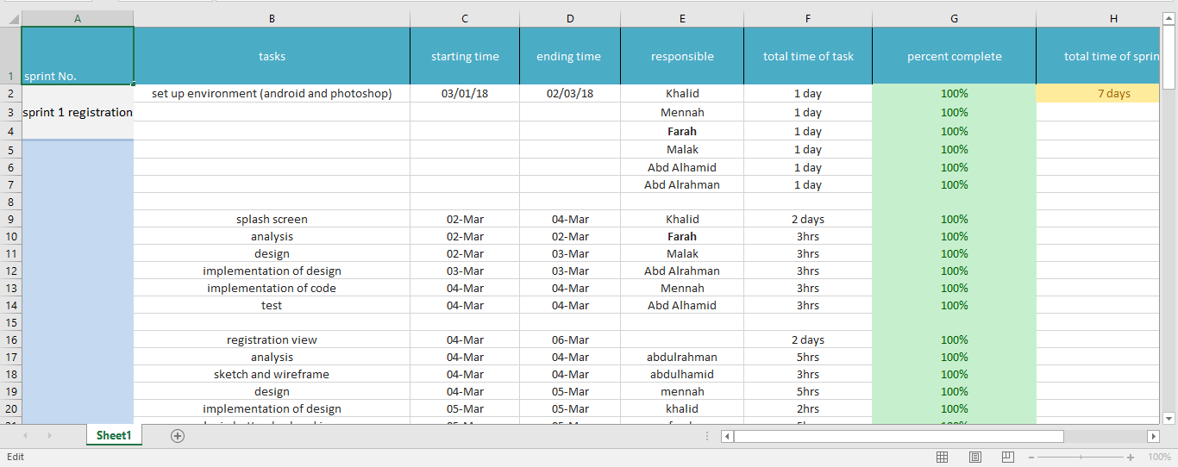

**Sprint2:**

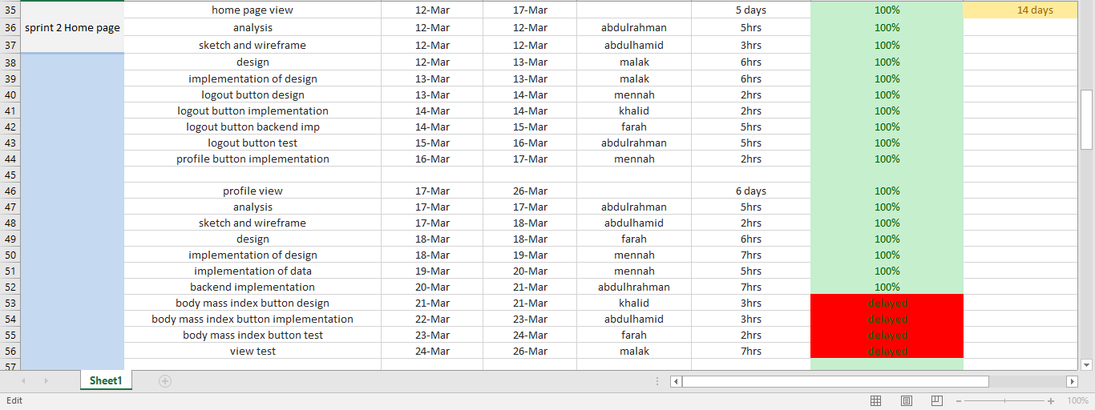

**Sprint3: (not all the sprint included in this screenshot)**

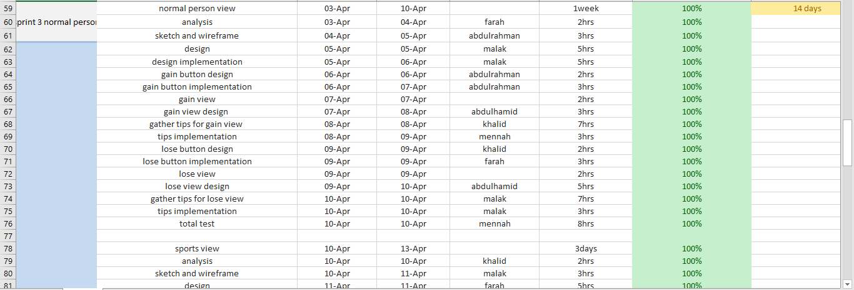

**Sprint4: (not all the sprint included in this screenshot)**

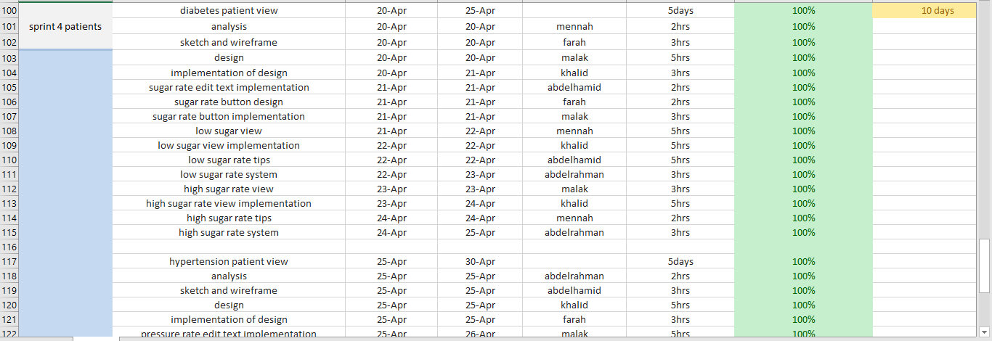

**-Risk Management Plan:**

- The product owner doesn’t like one of the iterations or doesn’t have a clear vision of what he wants.

- Anyone of the project team may get sick or has an emergency situation and this going to cause delay in work.

- Lack in fund.

- New Technology comes up to ruin the used Technology.

**-Project Schedule (estimate):**

|  |  |
| --- | --- |
| **Schedule** | **Events** |
| By Wed28.2.2018.  By Thu1.3. – Thu 8.3.  By Tue 6.3.2018. | -Set up and Role assigned.  **-1st Sprint (registration).**  -In 1st sprint we’ll manage to make a splash screen, registration view and login view. |
| By Sat 10.3. 2018.  By Mon 12.3. – Mon 26.3.  By Wed 24.3.2018 | -Sprint review meeting for Sprint1.  **-2nd Sprint (home page and profile view).**  -In 2nd sprint our main goal is to do the home page and the user profile view. |
| By Sun 1.4.2018.  By Tue 3.4. – Wed 18.4.  By Mon 16.4.2018. | -Sprint review meeting for Sprint2.  **-3rd Sprint (normal person).**  - In 3rd sprint our main goal is to do “two of the empty views in the 2nd sprint ‘home page’”, notifications that the user will reserve and Feedback view that would be found in the drawer.  -The two empty views are: Normal person, Sports. |
| By Thu 19.4.2018    By Fri 20.4. – Mon 30.4.  By Sat 28.4.2018 | Sprint review meeting for Sprint3  **- 4th Sprint (patients).**  -In the 4th sprint our main goal was to done Hypertension patient view and Diabetes patient view. |

**-Team member’s roles and responsibilities:**

-Included in Product/Study Diary above and in the sprint excel sheet.