**Narrative/Story**

We could have the game start with a black screen and a loud rumble. Like and earthquake or building collapsing.

- next the girl wakes up beside the pond “where am I”   
and gets up: player can control from this point on? – Music Starts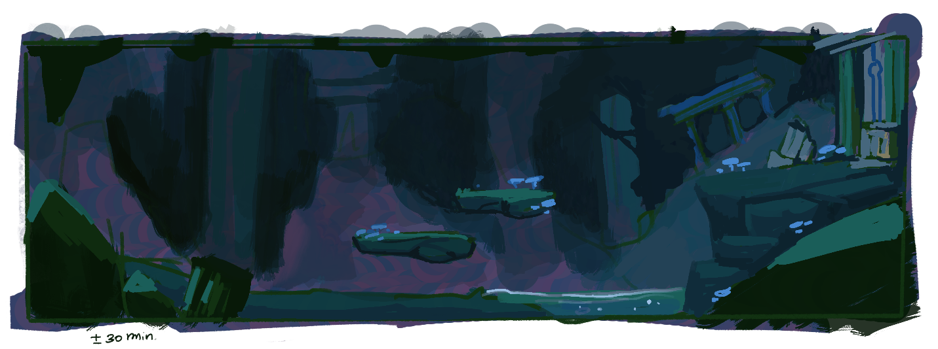

1st area has a small puzzle as a warm up that opens the door. Could be something super simple like lighting a candle if we start with fire element. Or retrieving the key from a little underwater cavern below if she’s water.

- door opens; it opens up into a 2nd area (can be the same general background with some minor changes.) a bigger puzzle here, golem is found near the door.

**Ideas for meeting the Golem:**

1. They either fight a bit, fight ends with sad robot noises and girl realises the robot is just as scared as she is. or they get along immediately.
2. make it like she found it dormant and maybe a piece is missing, and create a puzzle based on finding that missing piece to make it wake up.

After waking up the golem, the golem says her name and she then affirms her name.

They open the door together.

(2nd area; based on the blue image with doors) Combined-powers puzzle with an underwater area.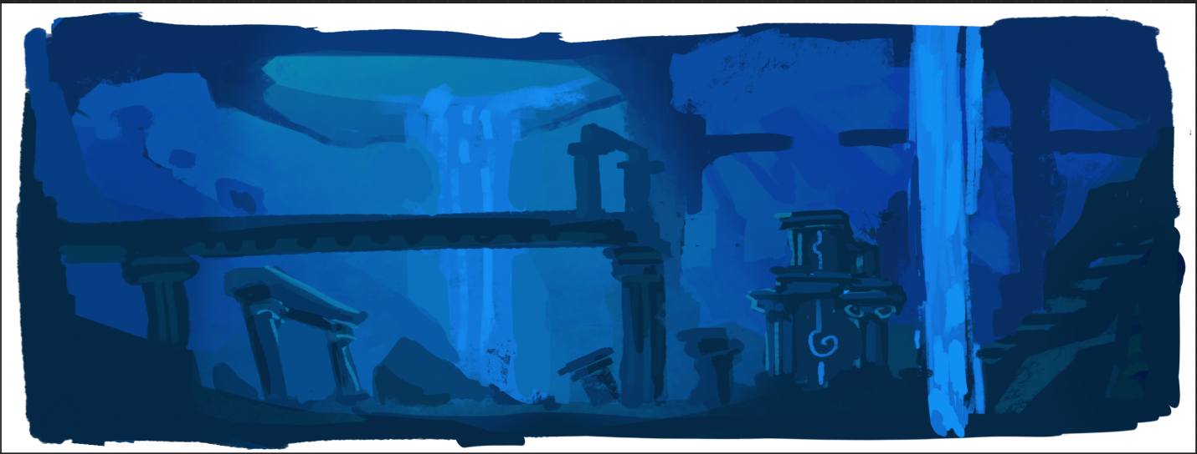

In the underwater area the girl discovers certain artifacts and buildings belonging to her home (Atlantis). The realization of what happened sets in. Girl does whatever she needs to do to complete the underwater part of the puzzle and swims back up. Opening the door with the golem again.

- could have a few more puzzle areas after this or just some basic platforming while the protagonist ponders about things. (Moment of rest gameplay-wise)

- last area; either fight the cyclops using the abilities from earlier or one last puzzle.

**Ending Ideas:**

1. last door; either the screen fades to white after entering that last door - meaning they got out of the tunnel system or
2. we get to a final area with underground trees and lakes. Something they could make habitable, a new home.
3. Open ending of wanting to find home. and have her looking in the horizon.

**The End**