|  |  |
| --- | --- |
| **Name** | Abdelli Nasr eddine |
| **Promotion** | 2MSIR |
| **GitHub Profile** | <https://github.com/AbdelliNasredine> |
| **GitHub Repo** | <https://github.com/AbdelliNasredine/INF_SEC_WORK> |

As we have seen in the previous lab session, Git is a vcs (version control system) used to keep track of our project evolution, also, Github is a service that lets us save our git projects in a remote location and allows us to collaborate. The processes of using Git & GitHub is as follows:

1. Git Setup
   1. Installing Git
   2. Configuration Git
   3. Initializing a Local Git Repository
   4. Adding and Committing Changes to Local Repository
2. GitHub Setup
   1. Generating & Adding a SSH Key to GitHub
   2. Creating a new GitHub Repository
   3. Pushing Changes to Github

# **Git Setup**

**Note: I am using WSL2 (Windows Subsystem Linux 2) with Ubuntu 20.04**

### Git Installation:

Git is already installed in my WSL system.

### 

### Git Configuration:

To configure Git, I use “git config --global –e” command that open the configuration file in default file editor (nano in my case) instead of typing each config command individually.



### Initializing a Local Git Repository:

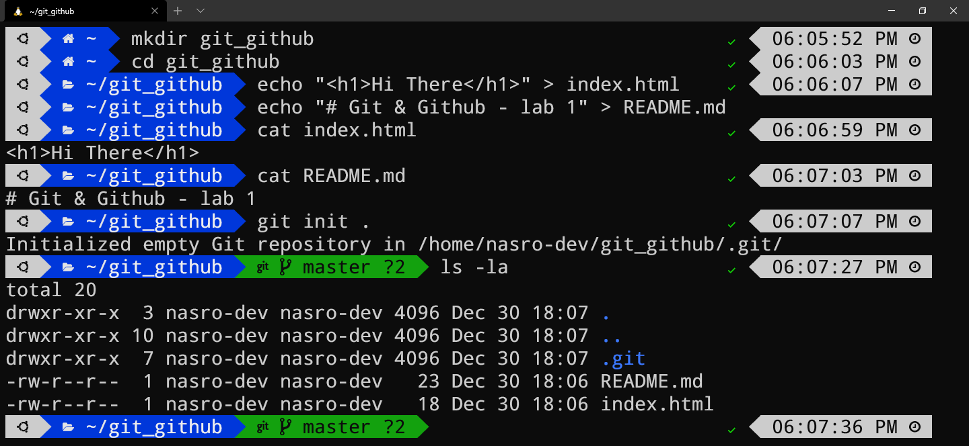

I created a directory named “git_github/” and add two files “index.html” & “README.md” and initialized a Git repo using “git init .” we noticed the presence of a hidden folder named “.git”.

### Adding and Committing Changes to Local Repository:

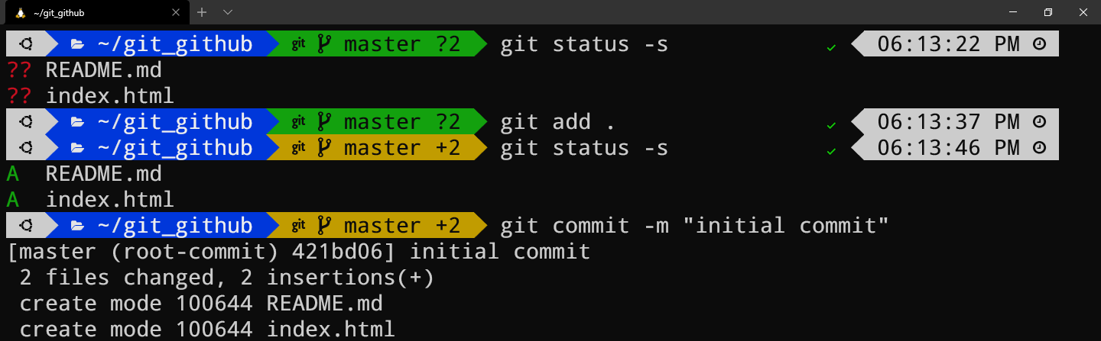

I used “git status –s” to check the status of the files (staged, unstaged, untracked), both files are untracked, so to add them to staging area, I used “git add .”. Committing to local repository using “git commit –m ‘initial commit’ ”, finally, “git log” is used to see the commit history.

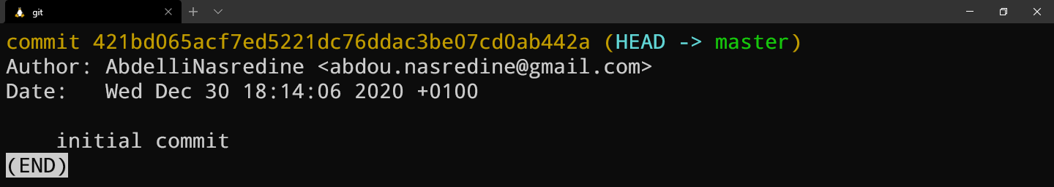

# **GitHub Setup**

### Generating and Adding an SSH Key to GitHub:

Key generating is done using “ssh-keygen” tool, ssh-keygen support multiple cryptographic algorithms (DSA, RSA, ECDSA, Ed25519), but Github official recommends using Ed25519 if its supported or RSA with 4096 bit length otherwise.

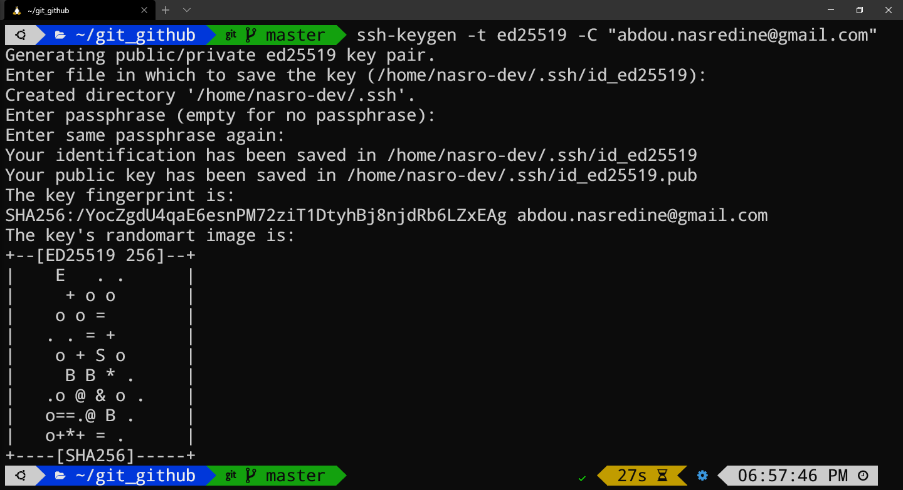

Then copy the ssh key to clipboard



Then I pasted it to my github accounts SSH Keys

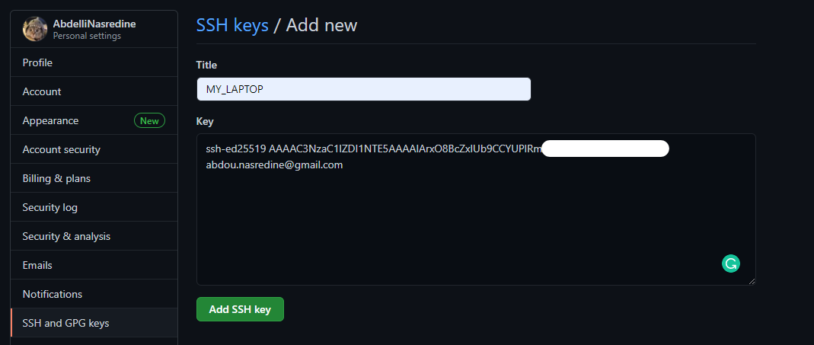

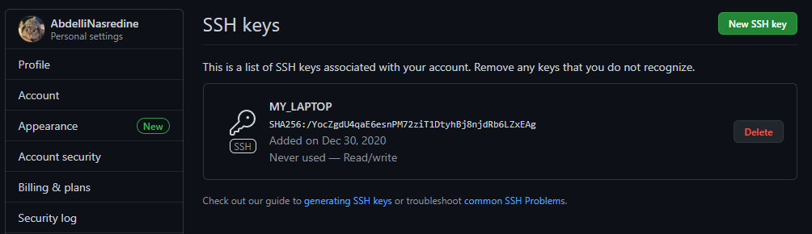

Now, SSH Key is added.

### Creating a New GitHub Repository:

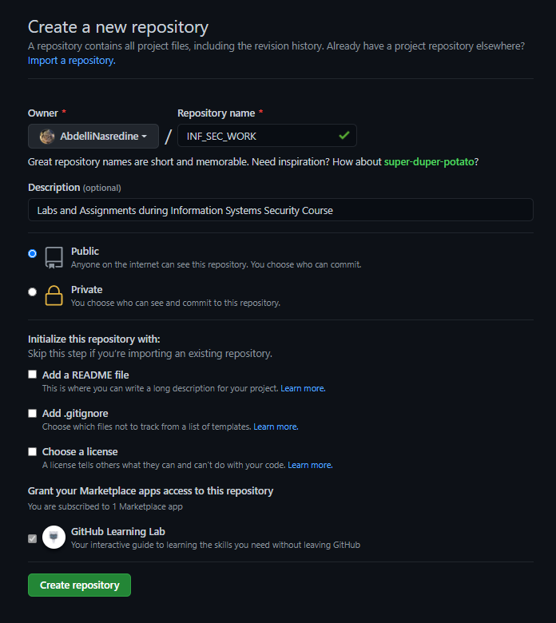

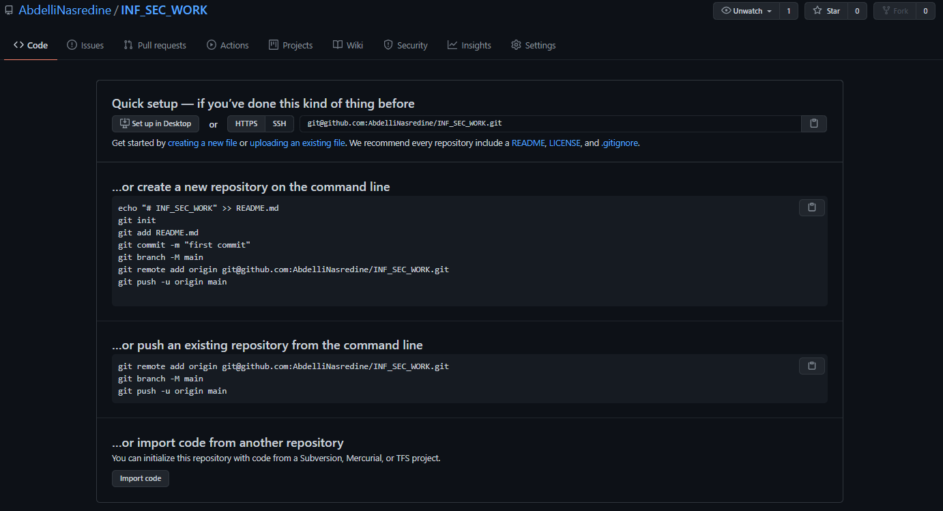

### Pushing Changes to Github:

Until now, I have an empty Github repository; the last thing to do is syncing local repo with remote

**Note: Github changed the name of main branch to “main”, it was “master”. So we need to change the local repo with that.**

