|  |  |
| --- | --- |
| **Full Name** | Abdelli Nasredine |

## **Brief Summary**

The combination of *Java* and *JavaFx* (*GUI* Library) were used to implement Cesar Cipher. The *GUI* allows the user to do the following tasks:

1. Read the content of a text file
2. Provide simple options concerning :
   1. Algorithm choice (Cesar at the moment)
   2. Operation mode (Encryption or Decryption)
   3. Key
3. Encryption / Decryption
4. Save the output to a file

## **How to run**

I provided a *Jar* file in the release section of my github repo[1], to run the app simply run *java –jar <name-of-jar-file>.jar* where *name-of-jar-file* is the name if the jar file.

## **Screenshots**

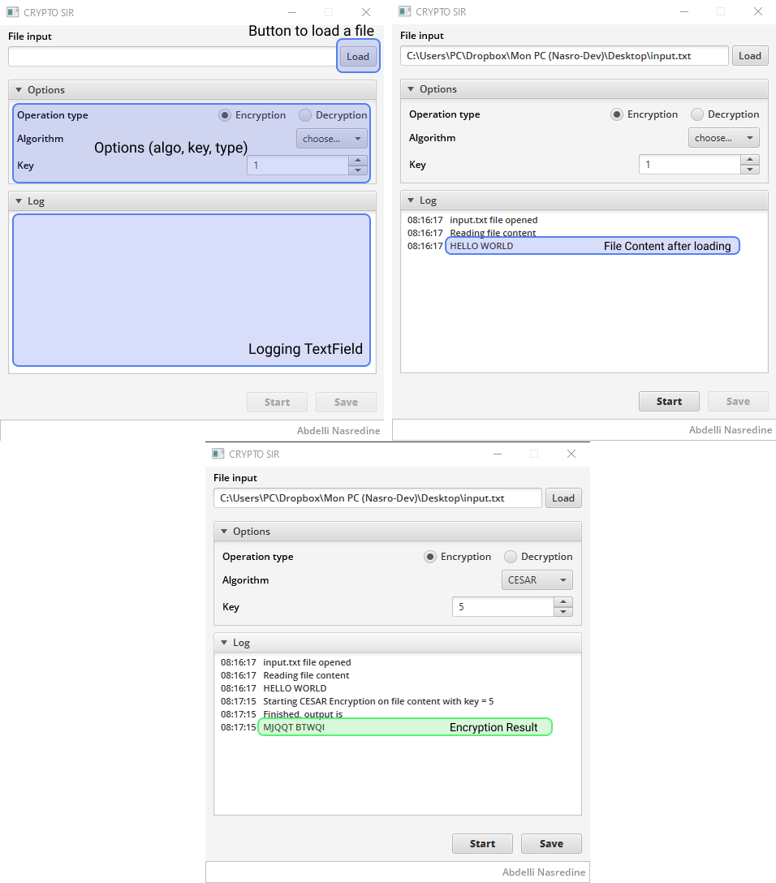

1. <https://github.com/AbdelliNasredine/INF_SEC_WORK>