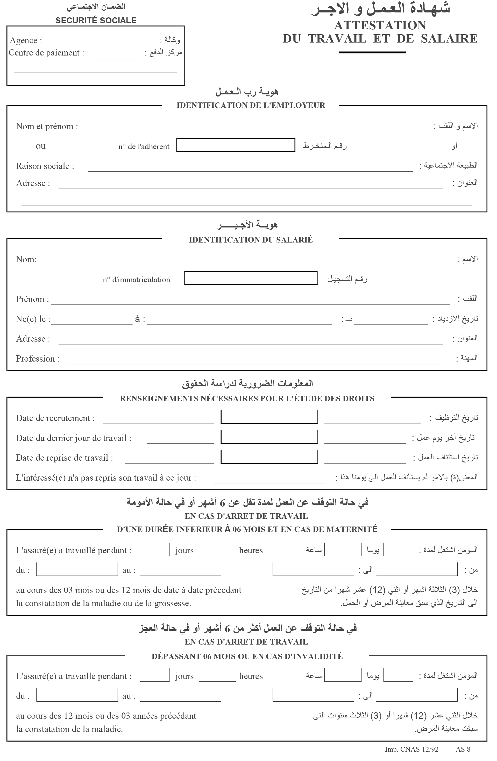

#CentrePaiment

#Agence

#DRT

#DJT

#DATEREC

#NSS

#WILLYA

IAP/SONATRACH

#NbrAdh

#ADDEMPLOYEUR

#NOM

#PRENOM

#DATNAIS

#ADDEMP

#FONCTION

|  |  |  |  |  |
| --- | --- | --- | --- | --- |
|  |  |  |  |  |
|  |  |  |  |  |
|  |  |  |  |  |
|  |  |  |  |  |
|  |  |  |  |  |
|  |  |  |  |  |
|  |  |  |  |  |
|  |  |  |  |  |
|  |  |  |  |  |
|  |  |  |  |  |
|  |  |  |  |  |
|  |  |  |  |  |

Directeur #DIR

#DIRECTEUR

#Date

#Agence