**Documentation**

**Pharmacy Management System**

**Under supervision**  
Dr. Mohamed Abdelfattah  
Eng. Shereen Adel.

**Prepared by:**

* Rana Farid Shawky.
* Rola Hossam El-Din.
* Rawan Hossam Ibrahim.
* Rana Mustafa Mohamed.
* Safa Anwar Arafa.
* Abdel Moniem Elsayed Abdel Moniem.

**Abstract**

* Nowadays, Pharmacy management system is one of the most essential tools that are mostly used in medical store. it is mostly used to manage pharmacy related activities such as medical inventory, record keeping, sales management as well as managing the drug stock and information of the expired medicines.
* Many pharmacies are still operating manually; they don’t have adequate software to manage their daily activities. It needs the pharmacist assistant to check the expired date of the medicine twice a week, and it can take a lot of time to find out whether certain medicine are out of stock. In this project we tried to develop a computerised and web based Pharmacy management system.
* Pharmacy management system has its own significance to the retail pharmacy shops. Using this system, it will help us to records all transaction made at the daily sales, recognize all debtors, customers, employees, balance stock, etc. It will manage all activities around the shop that increases productivity and maximize profit, it will also minimizing the risk of getting loss because all transactions are recorded to the system.

**Introduction**

* In this project we tried to develop a computerized and web based Pharmacy management system. Our main intention is to allow this application to be used in most retailing pharmacies , where a small point of customization will be required to each pharmacy in the implementation period.
* This system is designed to overcome all challenges related to the management of medicine that were used to be handled locally and manually.
* So, we designed this system to improve the accuracy, enhance safety , efficiency and help the Pharmacist to improve inventory management, cost and medical safety in the pharmaceutical store.
* Pharmacy management system was developed to ensure the security of information and reliability of Pharmacy records when accessing and providing services to the customers. The information gathered during the data collection was properly analyzed and the results provided the basis for the new system. The system was tested and found to be functional and the outputs produced by this system were encouraging. The application will hence reduce the loss of information unlike the existing system and also information will be processed fast.

**Definitions**

**User- Friendly:**

The System is clear for using the created software interface for manipulating actions or tasks. In the other way the proposed system is designed for human likeable components in colour, font and other related things.

**Manual based System:**

The system that uses was paper based and arranged on the shelf through functionality documents. Everything that is arranged, searched, updated and deleted is through human only. In general manual based system is un-computerized system which is tedious in its data arrangement for efficient work.

**Pharmacist:**

The profession who have knowledge on the medicine usage, instruction for use those medicines for the particular diseases and other related things.

**Management System:**

A system in which manage, organize, formulate data’s through a technical data structure arrangement.

**Billing:**

The way in which generating paper which store information about some specific data containing details explanation.

**SDLC**

System Development life cycle (SDLC) is a traditional methodology for developing maintaining and replacing information system. This methodology consists of different phases that describe the procedures for successful system development.

1. Planning
2. Analysis
3. Design
4. Implementation and Maintenance

* **Planning**

It is the process of identifying problems, opportunities, and objectives. This phase required the analysts to look honestly at what is occurring in a business. Then, together with other organizational members, the analyst pinpoints problems. Identifying objectives is also an important component of the first phase. The analyst first discovered what the business is trying to do. Then the analyst was able able to see whether some aspect of information systems applications can help the business reach its objectives by addressing specific problems or opportunities.

**Activities in this phase consist of:**

* interviewing user management
* Summarizing the knowledge obtained
* Estimating the scope of the project
* Documenting the results

The output of this phase is a feasibility report containing a problem definition and summarizing the objectives. Management must then make a decision on whether to proceed with the proposed project.

* **System Analysis**

It is a process of collecting factual data, understand the processes involved, identifying problems and recommending feasible suggestions for improving the system functioning. This involves studying the business processes, gathering operational data, understand the information flow, finding out bottlenecks and evolving solutions for overcoming the weaknesses of the system so as to achieve the organizational goals. System Analysis also includes subdividing of complex process involving the entire system, identification of data store and manual processes.

* **System Design**

It is the most crucial phase in the developments of a system. The logical system design arrived at as a result of systems analysis is converted into physical system design. Normally, the design proceeds in two stages:

1. *Preliminary or General Design:*

In the preliminary or general design, the features of the new system are specified. The costs of implementing these features and the benefits to be derived are estimated. If the project is still considered to be feasible, we move to the detailed design stage.

1. *Structured or Detailed Design:*

In the detailed design stage, computer oriented work begins in earliest. At this stage, the design of the system becomes more structured. Structure design is a blue print of a computer system solution to a given problem having the same components and inter-relationships among the same components as the original problem.

* **Implementation**

After having the user acceptance of the new system which has developed, the implementation phase began. Implementation is the stage of a project during which theory is turned into practice. The major steps involved in this phase are:

1. *Coding*

The system design needed to be implemented to make it a workable system. This demands the coding of design into computer understandable language example programming language. This is also called the programming phase in which the programmer converts the program specifications into computer instructions, which we refer to as programs. It is an important stage where the defined procedures are transformed into control specifications by the help of a computer language.

1. *Testing*

Before actually implementing the new system into operation, a test run of the system has done for removing the bugs, if any. It is an important phase of a successful system. After codifying the whole programs of the system, a test plan should be developed and run on a given set of test data. The output of the test run should match the expected results. Sometimes, system testing is using the test data following test run are carried out.

1. *Program test*

When the programs coded, compiled and brought to working conditions, it was individually tested with the prepared test data. Any undesirable happening has been noted and debugged (error corrections).

1. *System Test*

After carrying out the program test for each of the programs of the system and errors removed, then system test has done. At this stage the test has been done on actual data. The completed system has been executed on the actual data. At each stage of the execution, the results or output of the system was analysed. During the result analysis, was found that the outputs are not matching the expected output of the system. In such case, the errors in the particular programs has identified and fixed and further tested for the expected output.

* **Maintenance**

It is necessary to eliminate errors in the system during its working life and to tune the system to any variations in its working environments. It has been seen that there are always some errors found in the systems that has noted and corrected.

**Diagrams**

**1.Use Case Diagram**

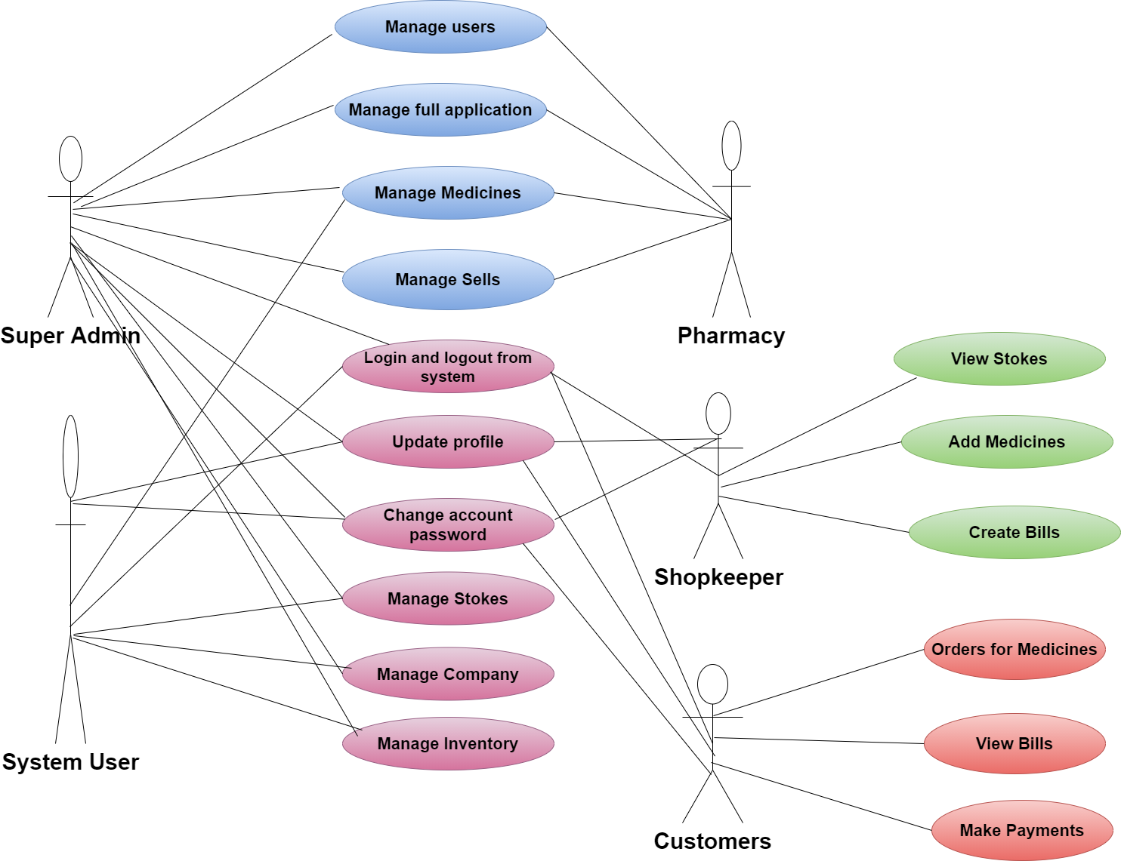

**2. Activity Diagram**

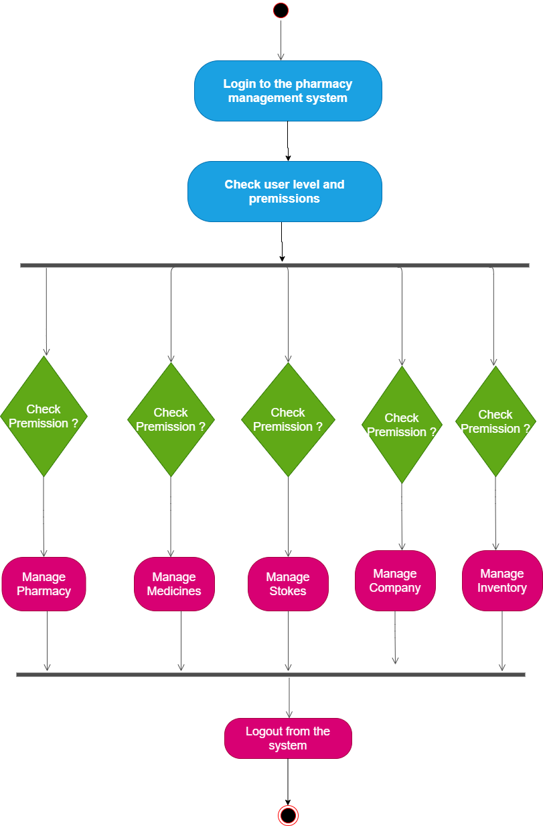

**3.Class Diagram**

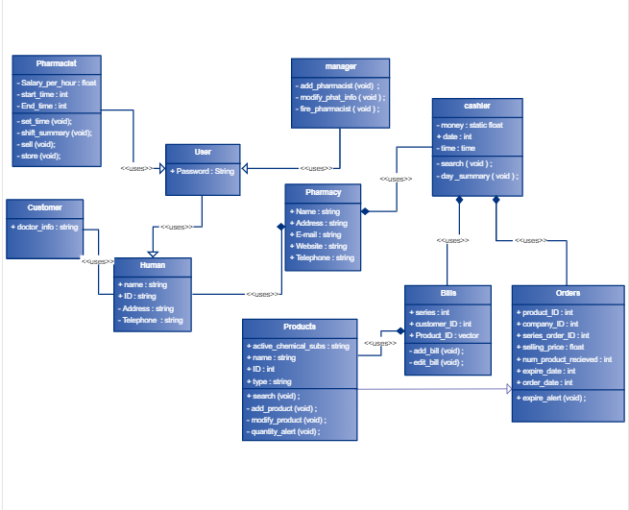

**4.Sequence Diagram**

**5.DFD Diagram**

**6.ERD**

**Forms**

1. **Sign In**

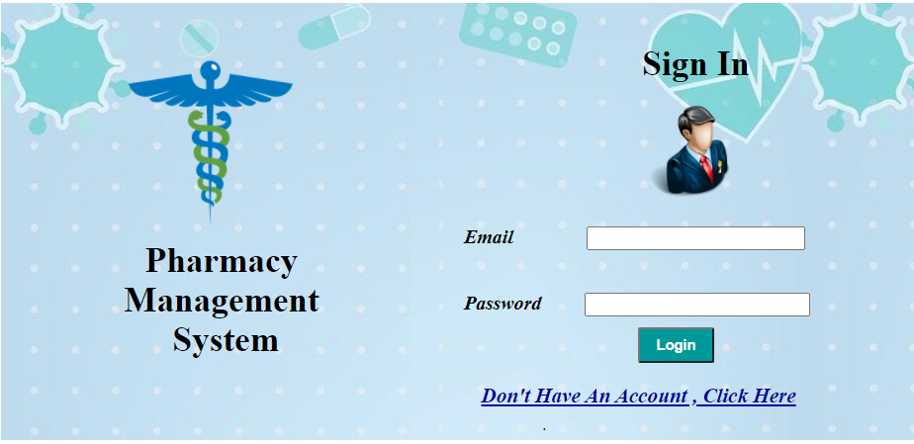

**2.Sign UP**

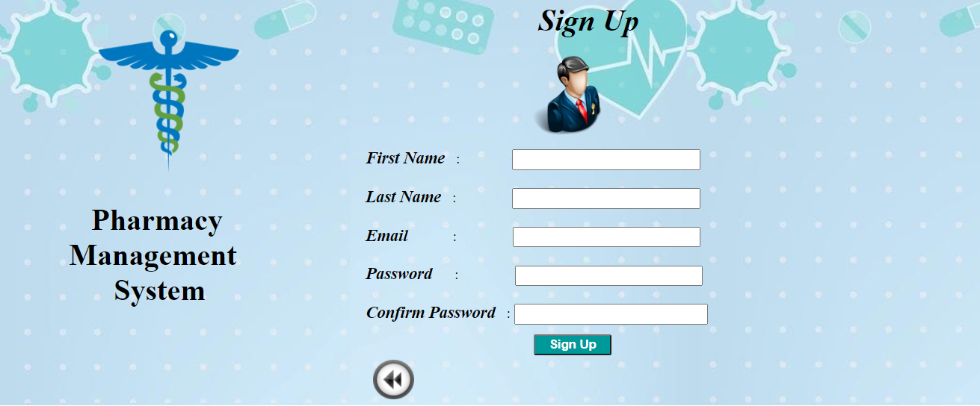

* **Description**

- The first page in our system is login page.

If the Administrator has already account he will enter his email and his password in the text boxes and press login to submit his inputs and move him to home page

if the user enter wrong email or password message will appear indicating that His email or password is invalid .

If the user doesn’t have account, he should press the hyperlink "Don't Have An Account , Click Here " A sign up page appears that contains

The Administrator will enter his name, email, password, confirm password then enter register button

Now he can login to the system and entering his email and password.

There are validators on the Text boxes

First name and last name text boxes administrator can't login with out fillng them

Email text box if that administrator enter invalid email error message will appear " Email Not Valid " And compare validator in confirm password to compare the data entered in password box and confirm password box if the data match error message will appear indicating that " password don't match " .

**Database:-**

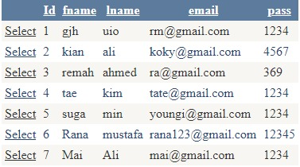

1. **Home**

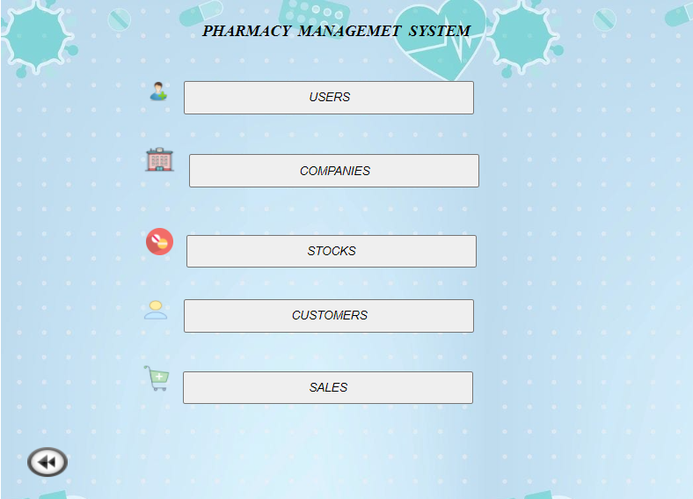

* **Description**

- After logging in by the system administrator, he will enter the home page, which includes a group of system branches that are dealt with by the supervisor and the first branch we have is the user through which the supervisor allows users to enter the system and the second branch, which is the shrimp through which it is done Registration of the companies that will deal with the system and the third branch, which is the stocks branch, through which the user can enter the data for the required medicines and their information, and the fourth branch through which the user can enter customers into the system and the last branch is sales, which are determined through sales for the system by The way of history .

1. **User Registration**

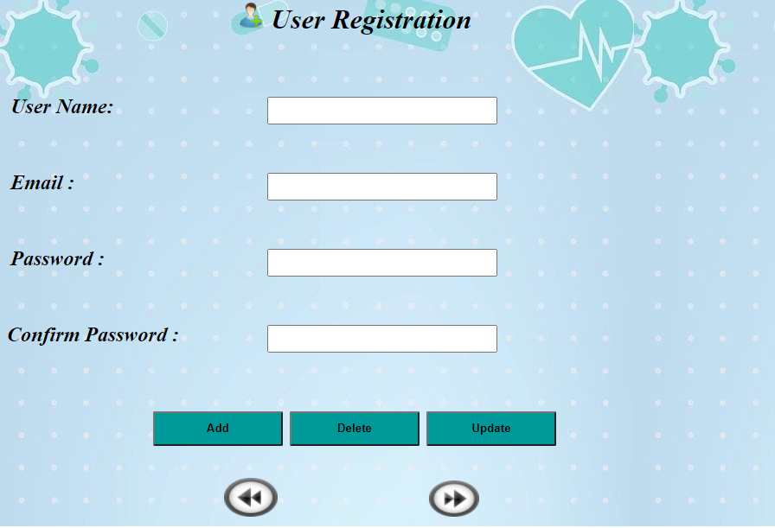

* **Description**

- This form shows how the administrator enters the user data for registration in the system to have the probability to access the next specific screens in the system .

-The admin enters the username, e-mail, password and confirm password in text boxes, It contains validation on username, e-mail and confirm password.

-It has the ‘ADD’button that contains ‘INSERT Function’to enter the new data in database so when clicked secondly ,the message(Sorry,user already exist!) shown .

-It has the ‘UPDATE’ button that allows updating in email, password as soon as entering the username .

-It has the ‘DELETE’button that removes the all row in the database when entering the e-mail and pressing the button .

**Database:-**

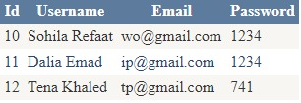

1. **Company**

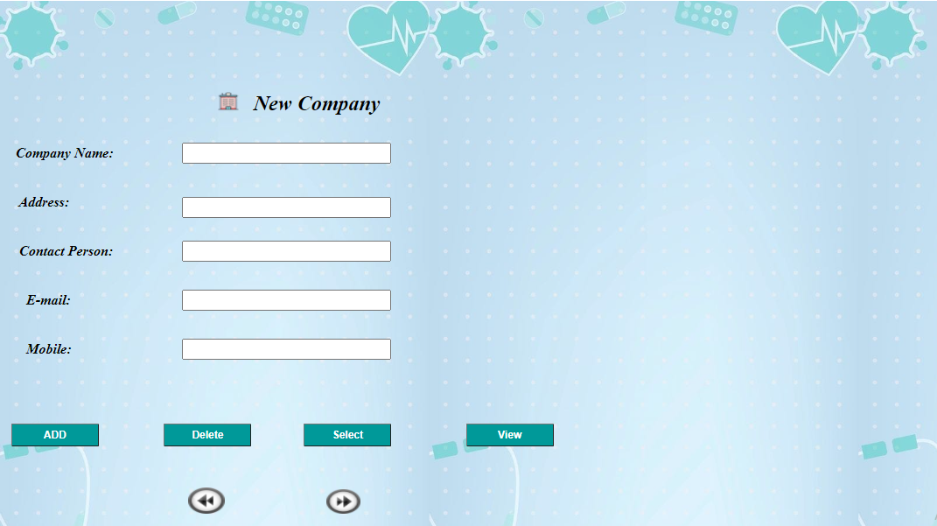

* **Description**
* On this screen, the administrator adds a group of companies or more that we deal with in importing medicines and some other supplies.
* In this screen, the names of the companies are added to all of the data for each company.
* in this screen, including the name of the company, its address, and the name of the person responsible for dealing with him within the company, as well as the company's e-mail address for quick communication.
* There are four Buttons in this screen:
* The First Button is ADD, and through it, all screen data is added.
* The Second Button is Delete, through it, the data of the company that has been stored it is deleted from the data base.
* The Third Button is Select, through it, the data for each company is determined and presented.
* The Fourth Button is View, through it, all the companies' data added in the system are shown.
* The Fifth Button is Next, and through it, the administrator moves to the screen of registering the drugs to be Import them.

**Database:-**

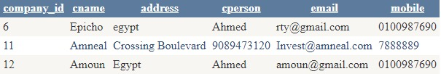

1. **New Stock**

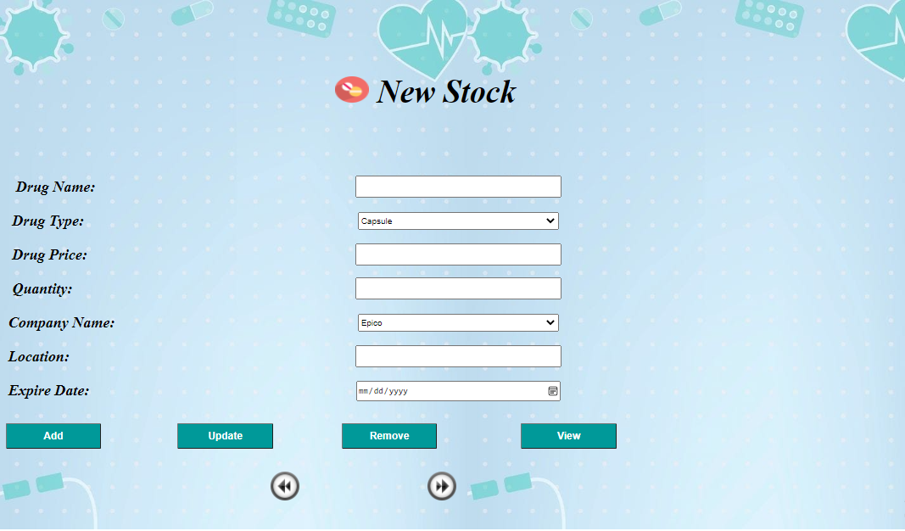

* **Description**

- This is the stock screen which is talking about the drugs which come from companies to the pharmacy. We can add the drug name, type (capsule, liquid or tablets), price, quantity of the requested drug, exporting company name, location and drug expire date which we can choose from the calendar. The button add which can add all these information to the database, the button update which updates drug price on data base depending on drug name, the button remove which removes the row depending on drug name from data base and finally the button view which show us a grid view of data base attributes and values and modifications on them.

**Database:-**

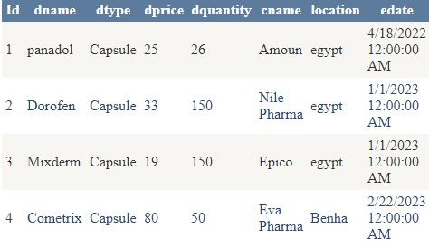

AS you can see this a grid view of data base attributes and some values inserted.

1. **Customer**

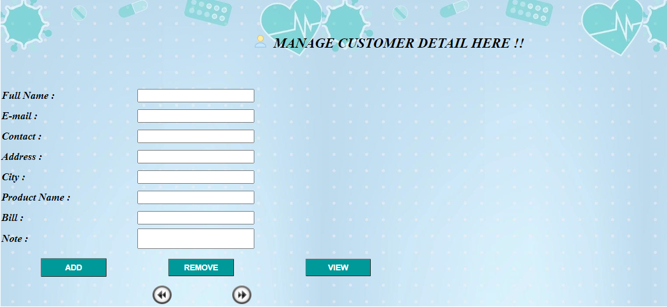

* **Description**

- This form called “ Manage Customer Details Here! ” which indicates that the user is the one who has the control to enter all the basic details related to the customer.

Before entering data there are two validators on two textboxes

The first one called required field validator that appears as (*) , It applies if the user does not enter any data in Full Name Textbox.

The second one called regular expression validator that appears as (E-mail Not Valid) , It applies if the user enter invalid email in E-mail Textbox.

The user begins to enter all the customer-related details such as Full Name , E-mail , Contact Number , Address , City , Product Name , Bill and Note .

There are 3 buttons :

Button ( ADD ) that insert customer in database If the customer is new, a message will appear “ The customer inserted successfully ” But if the customer is there before, a message will appear “ The customer already exist ” .

Button (REMOVE) which delete data depends on full name.

Button (VIEW) which shows all data in Grid View.

There are 2 image buttons:

Button (BACK) which moves to the previous page.

Button (NEXT) which moves to the next page.

**Database:-**

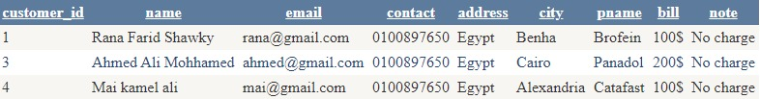

1. **Sales**

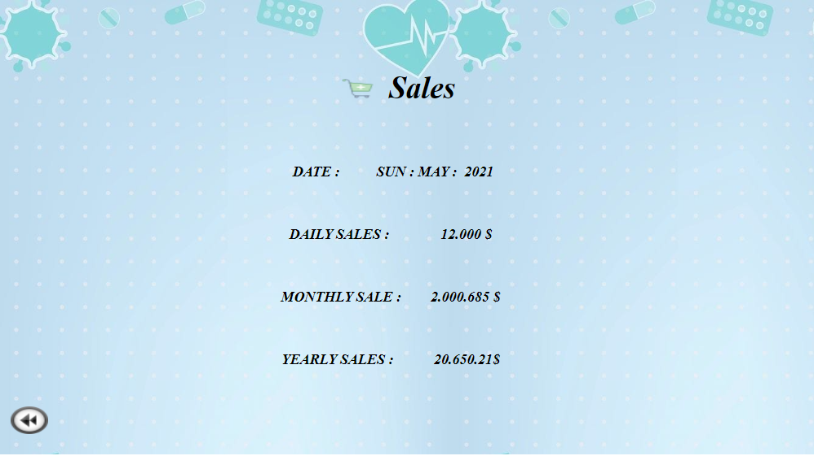

* **Description**

- In the sales page, the system compensates its sales according to the date, whether daily, monthly, or secondary. The percentage of sales will vary on the date, and we display on this page those sales that will take place in here the system .

**Reports**

1)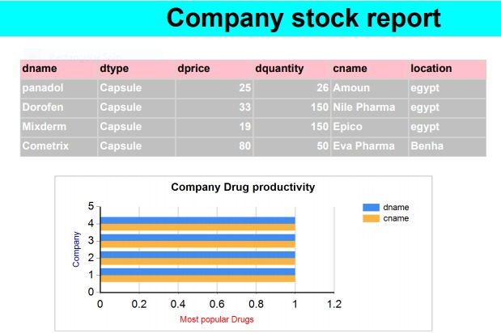

* **Description**

- This is a report which shows the relationship between company and stocks tables. As you can see there is a table which shows the drug name attribute, the drug type, the drug quantity , the exporting company name and location and with some different values inserted. There is also a chart which shows most popular drugs in different companies with different percentage.

2)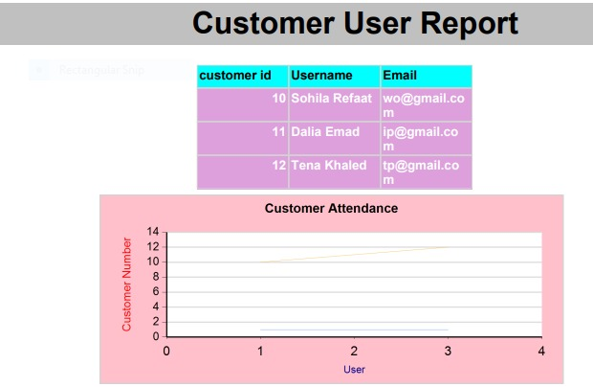

* **Description**

- This is a report which shows the relationship between user and customer tables in data base , As you can see there is a table which shows the customer id ,username and customer email. There is also a chart which shows the percentage of customers that users receive a day.

**Conclusion**

* Pharmacy management system is actually a software which handle the essential data and save the data  and actually about the database of a pharmacy and it's management.
* This software help in effectively management of the pharmaceutical store or shop. It provide the statistics about medicine or drugs which are in stocks which data can also be updated and edited.
* It works as per the requirement of the user and have options accordingly. It allow user to enter manufacturing as well as the expiry date of medicine placing in stock and for sales transaction.
* This software also have ability to print the bill and invoices etc. The record of suppliers supplies can also be saved in it. There are other function available too . The main purpose is effectively and easily handling of pharmacy data and it's management.