Simple Shell Assignment.

Name: Abdelmonem Badr Elsawy

ID:28

code:
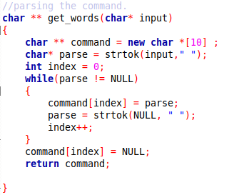
get_words function: takes line and return array of words

signalHandler: print in log file when the child terminated.

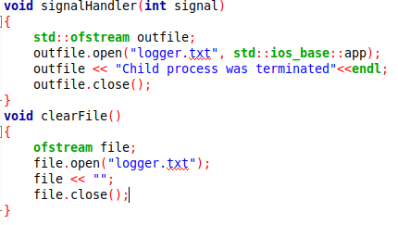

Creating child process using fork() and execute command in this child process.

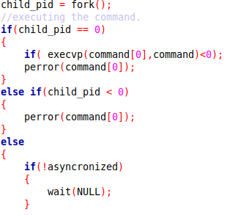

Simple runs:

firefox open using the shell.
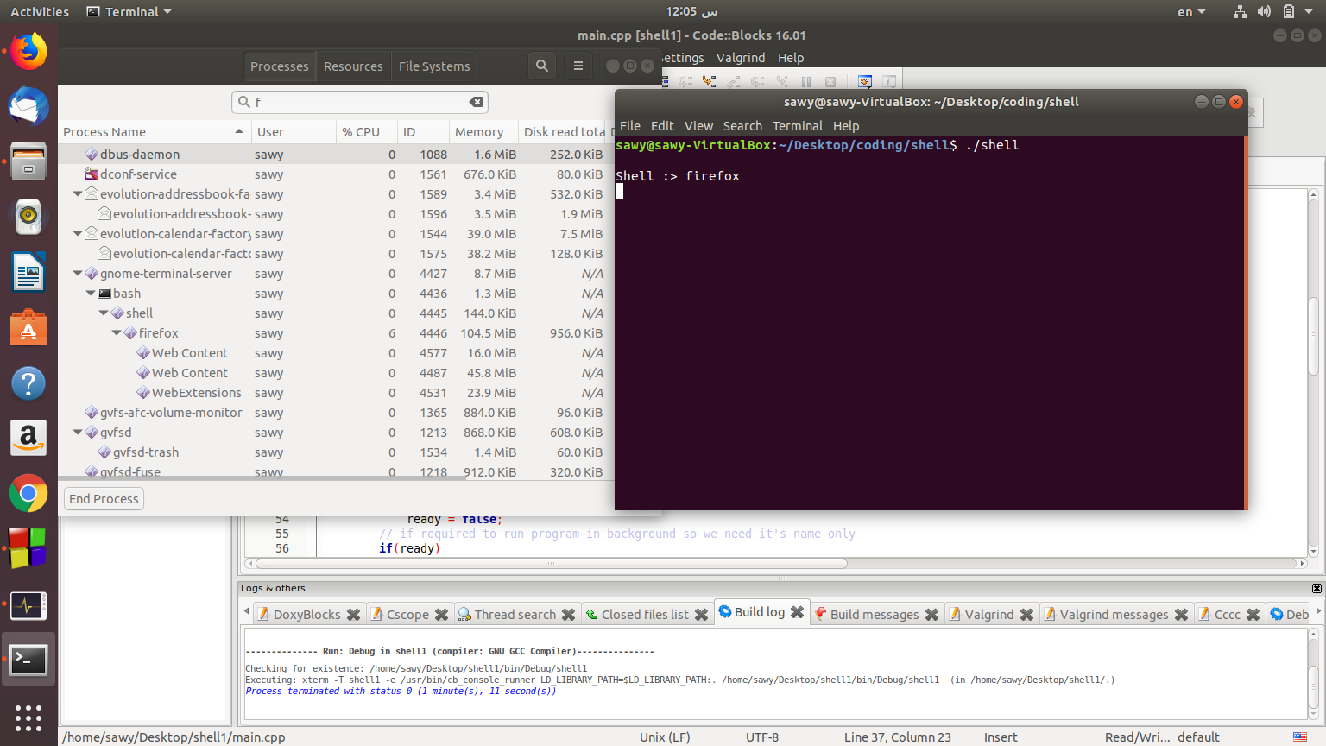

Using commands with parameters and without parameters.
