BRAND + PRODUCT ARCHITECTURE / INTERN HANDOFF
SPORTMETRYX™ FOOTBALL
Human Performance Intelligence for Football
Measure the athlete. Understand the workload. Predict performance degradation. Protect availability.
Powered by Healthmetryx™
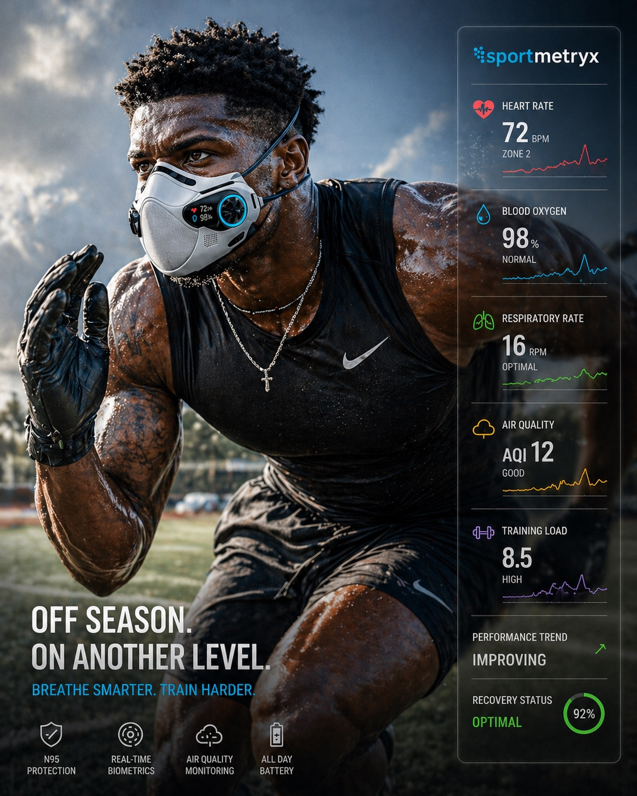
CANONICAL VISUAL REFERENCE • “OFF SEASON. ON ANOTHER LEVEL.” • “BREATHE SMARTER. TRAIN HARDER.”
Internal working package for brand, product, engineering, design, sports science, and commercialization interns

01 / EXECUTIVE DIRECTIVE

What the interns are building
Sportmetryx Football is the football-specific commercialization layer of Healthmetryx human-performance intelligence. It should not be designed as a generic wearable dashboard. It is a validity-gated performance operating environment that connects respiratory, physiological, workload, recovery, environmental, and contextual football data to athlete and team decision support.
Category: Human Performance Intelligence for Football.
Brand promise: Breathe smarter. Train harder. Perform with context.
Operating principle: Sensors originate data. Sportmetryx converts validated signals into performance intelligence.
BUILD RULE Every screen, metric, model, and marketing claim must identify whether it is (1) established HMX platform capability, (2) football-specific derived model, (3) research/prototype capability, or (4) future/regulated capability.

Source-of-truth hierarchy
Layer | Directive
Established HMX platform logic | RCM; validity gating; respiratory/physiological/environmental fusion; longitudinal baselines; readiness/recovery; WPI-derived functional readiness architecture.
Established sports use cases | Athlete readiness/recovery; overtraining risk; environmental performance effects; travel recovery; injury-risk research.
Football verticalization to build | Player/position models; football performance index; snap/drive/practice/game context; Team Command; football workflows and reporting.
Visual brand anchor | Attached Sportmetryx football creative: athlete-first composition, cyan/black palette, transparent telemetry rail, respiratory device emphasis, elite-performance tone.

Non-negotiable positioning
- Decision support, not diagnosis.
- Athlete development and availability, not punitive surveillance.
- Validity-gated outputs: withhold or flag low-confidence results.
- Individual baselines before population assumptions.
- Explainable scores with component drivers and confidence.
- Football context matters: position, drill, snap, drive, quarter, game, travel, climate, recovery window.
02 / BRAND SYSTEM

Brand hierarchy
Brand layer | Role
Healthmetryx™ | Core science, respiratory intelligence, data infrastructure, validity architecture, enterprise credibility.
Sportmetryx™ | Sports-performance commercialization brand and cross-sport intelligence layer.
Sportmetryx™ Football | Football vertical: player, position, unit, roster, training, game, recovery, and performance intelligence.
SMX product modules | Named applications and models within Sportmetryx Football; always subordinate to Sportmetryx master brand.

Voice and message architecture
Primary line: Breathe Smarter. Train Harder.
Category line: Human Performance Intelligence for Football.
Executive proposition: Measure the athlete. Understand the workload. Predict performance degradation. Protect availability.
Coach proposition: Know who is ready, why, and what changed.
Athlete proposition: Understand your baseline, workload, recovery, and trend.
Performance-science proposition: Unify respiratory, physiological, environmental, and football-context data in one validity-gated model.

Visual identity system
Core palette — Graphite/near-black, deep navy, white, Sportmetryx cyan. Use red/green/gold/purple only as semantic telemetry accents.
Imagery — Elite football athletes in motion; training, recovery, sideline, tunnel, field, film-room and performance-lab environments. Avoid generic stock-wellness imagery.
Interface — Transparent/dark telemetry panels; crisp numerics; trend lines; confidence/validity indicators; position and workload context.
Composition — Athlete remains the hero. Intelligence is a precise overlay, not visual clutter.
Typography — Condensed/strong display typography for campaign lines; clean sans-serif for product UI and technical content.
Brand signature — sportmetryx wordmark in cyan/white; “Powered by Healthmetryx” in enterprise/technical contexts.
VISUAL CANON Use the attached football creative as the visual reference, but do not copy unvalidated device geometry or imply that the pictured respirator is a shipping Sportmetryx product.

03 / PRODUCT ARCHITECTURE

Sportmetryx Football product family
Module | Purpose | Primary user | Core output
SMX Player Readiness™ | Daily athlete readiness and recovery state | Athlete / performance staff | Readiness score, recovery score, fatigue state, confidence, explanation codes
SMX Performance Index™ | 0–100 football-specific functional performance/readiness index | Performance / coaching | Composite score plus component drivers; prototype until validated
SMX Load Intelligence™ | External + internal workload response | Strength & conditioning | Practice/game load, exertion response, trend, acute/chronic context
SMX Recovery Intelligence™ | Post-training, post-game and travel recovery | Athlete / performance / medical | Sleep-recovery, autonomic context, respiratory recovery, retest guidance
SMX Injury Risk Intelligence™ | Research-grade risk signal from fatigue/workload/baseline change | Performance / medical research | Risk signal, drivers, confidence; never injury diagnosis
SMX Team Command™ | Roster-level operational command environment | HC/GM/performance leadership | Position-group readiness, exceptions, trends, availability intelligence
SMX Environment™ | Human response to heat, air quality, altitude and venue conditions | Performance / operations | Exposure context, venue/travel modifiers, performance degradation research
SMX Digital Athlete Twin™ | Longitudinal individual baseline and context model | Performance science / athlete | Personal baseline, response curves, scenario comparisons, trajectory

Experience hierarchy
PLAYER → POSITION → UNIT → PRACTICE → SNAP → DRIVE → QUARTER → GAME → SEASON
The same athlete signal should be interpretable at multiple football time scales. The system should preserve provenance so a season trend can be traced back to games, practices, drills, and underlying validated measurements.
04 / FOOTBALL PERFORMANCE INDEX

SMX Performance Index™ — proposed model
The football index should inherit the discipline of HMX-WPI while being redesigned for sport. It is a prototype composite, not a clinically validated or injury-prediction score. Interns should implement it transparently, with configurable weights and no black-box “magic number.”
Component | Example signal domain | Prototype weight
Respiratory Efficiency | Respiratory rate deviation, breath/CO₂ proxy where available, exertion-normalized recovery | 20%
Oxygen Function | SpO₂ trend and deviation where reliable/available | 10%
Recovery & Autonomic State | Sleep, HRV/IBI, resting HR, recovery trajectory | 20%
Workload Response | External load + cardiovascular/respiratory response to drill/practice/game | 20%
Movement / Explosive Capacity | Acceleration/deceleration, sprint/repetition context, position-specific movement | 15%
Environment & Travel | Heat, air quality, altitude, travel/sleep disruption | 5%
Individual Baseline Deviation | Longitudinal departure from athlete-normal state | 10%
VALIDITY GATE No composite score should be released when required signal quality, calibration freshness, sample integrity, or minimum-data thresholds fail. Display “WITHHELD / RETEST” with explanation codes rather than manufacturing certainty.

Score output contract
- SMX Performance Index (0–100) and band
- Readiness / recovery state
- Respiratory efficiency state
- Workload response state
- Movement/explosive state where instrumented
- Environment/travel modifier
- Baseline deviation
- Confidence score and validity status
- Top positive and negative drivers
- Recommended operational action / retest window
- Audit/provenance record
05 / POSITION INTELLIGENCE

Position-specific models
Model | Positions | Primary intelligence | Guardrail
SMX-QB™ | Quarterback | Cognitive/workload context, throwing workload, respiratory recovery, movement efficiency, stress/recovery, decision-performance research | Do not claim direct cognition measurement without validated inputs.
SMX-SKILL™ | WR / RB / DB | Sprint exposure, acceleration/deceleration, explosive repetition, respiratory recovery, fatigue-related movement change | Separate external load from physiological response.
SMX-TRENCH™ | OL / DL | Collision/load accumulation where data available, repeated explosive exertion, respiratory burden, heat stress, recovery | Contact-load inputs require instrumented source or team data.
SMX-LB/TE™ | LB / TE / hybrid | Mixed sprint/contact workload, change of direction, repeated effort, recovery, heat/environment context | Hybrid position model; configurable by role.
SMX-ST™ | K/P/return/coverage | Sprint/recovery cycles, explosive readiness, workload, travel/environment context | Role-specific modules; avoid one-size-fits-all special teams score.

Football context object
Every analytic event should be able to carry the following context when available:
- athlete ID / consent state / roster role
- position and position group
- session type: recovery, lift, conditioning, practice, walkthrough, game
- drill and rep identifier
- snap/play identifier and personnel context where integrated
- drive, quarter, game and opponent
- surface / venue / indoor-outdoor
- weather, heat, air quality and altitude
- travel leg / time-zone shift / days since travel
- equipment/sensor configuration
- injury/return-to-play status only when governed and authorized
06 / DATA + SYSTEM ARCHITECTURE

From signal to football decision support
ATHLETE + DEVICE SIGNALS
↓
CONTEXT + TEAM DATA
↓
VALIDITY / QUALITY GATE
↓
RCM / SMX ANALYTICS
↓
INDIVIDUAL BASELINE + DIGITAL ATHLETE TWIN
↓
FOOTBALL-SPECIFIC MODELS
↓
PLAYER / POSITION / TEAM COMMAND
↓
REPORTS • API • RESEARCH DATA PRODUCTS

Data domains
Domain | Examples / design requirement
Respiratory | Respiratory rate; exhaled CO₂ proxy where instrumented; breath-phase consistency; sample quality; baseline deviation.
Cardiovascular / recovery | Heart rate; IBI/HRV; SpO₂; sleep; skin temperature; activity/exertion context where available.
Movement / workload | Accelerometry; sprint/accel/decel; distance; drill reps; team workload feeds; contact load only if sourced.
Environmental | Heat/temperature; humidity; air quality/PM/VOC/CO₂; altitude; indoor/outdoor/venue context.
Football context | Position, drill, snap, drive, quarter, game, opponent, travel, surface, practice type.
Governance | Consent, athlete identity mapping, device calibration, data provenance, confidence, retention, access role, audit trail.
07 / TEAM COMMAND EXPERIENCE

SMX Team Command™ dashboard suite
View | Minimum capability
Roster Mission Control | Roster readiness distribution, exceptions, trend, confidence, position-group state.
Player 360 | Individual baseline, today vs baseline, workload, recovery, respiratory state, trend, explanation codes.
Position Room | QB / skill / trench / hybrid / ST comparison within role-specific model.
Practice Command | Drill-level workload and physiological response; exceptions; recovery between periods.
Game Readiness | Pre-game state, travel/environment modifiers, availability intelligence; no autonomous lineup decisions.
Recovery Command | Post-practice/game recovery, sleep, HRV, respiratory recovery, retest queue.
Environment & Venue | Heat, AQ, altitude, venue modifiers and human-response research.
Travel Intelligence | Time-zone, sleep disruption, physiological change, recovery trajectory.
Intervention Queue | Human-reviewed alerts, reason codes, confidence, recommended follow-up/retest.
Data Quality & Validity | Sensor status, missingness, calibration, artifact, withheld outputs.
Research / Export | Governed cohort analytics, de-identified exports, model validation workspace.

UI rules
- Show confidence/validity adjacent to every consequential score.
- Show “why” before “what to do”: top drivers and baseline comparison precede recommendation.
- Use exception-based roster views; do not overwhelm coaches with raw sensor streams.
- Preserve athlete access to their own longitudinal information where governance permits.
- Use role-based views: athlete, performance staff, medical/research, coach/football ops, executive.
- Never use red/green alone; pair status color with text/icon for accessibility.
08 / FOOTBALL USE CASES

Priority workflows
Off-season development: Establish baseline; track conditioning adaptation; respiratory/recovery response; training-load tolerance; longitudinal improvement.
Training camp: High-frequency readiness; heat/environment burden; cumulative load; position-group comparisons; recovery queue.
In-season practice: Daily readiness, drill response, load management, recovery between high-load days, individualized baseline deviation.
Game week: Travel/sleep/environment modifiers; readiness trend; position-group exceptions; confidence-gated pre-game report.
Post-game recovery: Respiratory/cardiovascular recovery trajectory; sleep debt; workload residual; retest timing.
Return-to-performance research: Governed longitudinal comparison to athlete baseline and workload tolerance; medical decisions remain with qualified staff.
Venue / climate preparation: Air quality, heat, humidity, altitude and observed athlete response; venue suitability/performance degradation research.
Roster / season analytics: Availability trends, position-group workload, recovery burden, travel effects, longitudinal performance research.

Target buyers and users
- NFL, CFL, UFL and professional football organizations
- NCAA / university football performance programs
- Elite academies and training facilities
- Strength & conditioning and sports-science departments
- Team medical/research groups under appropriate governance
- Equipment and wearable OEM partners
- Insurance / athlete availability research partners
- Leagues, venues and performance-data partners
09 / COMMERCIAL ARCHITECTURE

How Sportmetryx Football becomes a product business
Revenue layer | Offer
Team Platform License | Annual enterprise software license for Team Command, player/position analytics, reports and APIs.
Athlete / Seat License | Per-athlete annual license for Player 360, longitudinal baseline and recovery/readiness intelligence.
Device / Sensor Integration | Approved device bundle, integration, leasing or partner hardware; hardware must not define the platform.
Performance Science Services | Baseline design, model configuration, validation studies, implementation and staff training.
Data / Research Programs | Governed, consented and appropriately de-identified research cohorts and analytics products.
OEM / League Integration | Embedded SMX intelligence/API for equipment, wearable, venue or league partners.

Packaging concept
SMX Football Core — Player Readiness + Recovery + Team Command + validity layer.
SMX Football Pro — Core + Load Intelligence + position models + travel/environment + API.
SMX Football Research — Pro + governed research workspace + model validation + cohort/export tooling.
SMX Football Enterprise — Multi-team / league / academy deployment, custom integrations, advanced governance, data products.
PRICING Interns should build pricing architecture and unit economics as a separate workstream. Do not publish invented pricing in external materials until executive approval.

10 / IP + CLAIM BOUNDARIES

Protect the platform; do not overclaim the sensors
Existing HMX foundation: Respiratory intelligence architecture, validity gating, multimodal fusion, longitudinal baselines, functional readiness logic, data provenance and platform workflows.
Football continuation opportunities: Football context engine; position-specific multimodal performance models; snap/drive temporal alignment; athlete digital twin; context-adaptive readiness; explainable team command; performance-degradation forecasting.
Potential hardware integration IP: Sensor placement, device orchestration, football equipment integration, multi-device calibration and quality gating—subject to prior-art and freedom-to-operate review.
Data asset: Longitudinal, consented football respiratory + physiological + workload + environment + context dataset and derived models.
Trade secrets: Feature engineering, model weights, validity thresholds, baseline adaptation, explanation logic, integration mappings, deployment playbooks.

Claim language guardrails
Use | Avoid unless validated / authorized
readiness signal; recovery trend; risk signal; performance degradation research; workload response; decision support | diagnoses injury; prevents concussion; predicts injury with certainty; medical clearance; cognitive diagnosis; guaranteed performance improvement
validity-gated; confidence score; baseline deviation; research/prototype model | clinically validated unless evidence exists; FDA-cleared unless actually cleared; autonomous coaching/medical decision
environmental modifier; human-response correlation | causal environmental harm without validated study design
11 / INTERN EXECUTION PLAN

12-week build sequence
Timing | Workstream | Exit deliverables
Weeks 1–2 | Brand + requirements | Brand kit; terminology glossary; source-of-truth register; user roles; product requirements; data dictionary v0.1.
Weeks 3–4 | UX + data model | Team Command wireframes; Player 360; position room; event/context schema; validity states; synthetic football dataset.
Weeks 5–6 | Scoring prototype | Transparent SMX Performance Index; baseline logic; confidence/withhold rules; explanation codes; unit tests.
Weeks 7–8 | Position models | QB, Skill, Trench, Hybrid, ST model configurations; drill/practice/game context; environment/travel modifiers.
Weeks 9–10 | Integrated demo | End-to-end demo: capture/import → validity → scoring → Player 360 → Team Command → report/export.
Weeks 11–12 | Validation + commercialization | QA; model cards; claims review; demo script; buyer one-pager; pilot protocol; backlog and next-phase SRS.

Workstream ownership
Brand/Design intern: Visual system, UI components, campaign templates, iconography, Team Command prototypes.
Product intern: PRD, user stories, workflow maps, acceptance criteria, backlog, demo narrative.
Data/AI intern: Synthetic dataset, feature dictionary, scoring prototype, baseline models, confidence/validity tests.
Sports-science intern: Football constructs, position logic, workload/recovery definitions, study design, literature evidence register.
Engineering intern: Ingestion adapters, schemas, APIs, dashboard prototype, provenance/audit, integration tests.
Commercial intern: Buyer map, pilot packages, competitive matrix, partner/OEM targets, pricing hypotheses, ROI model.

Definition of done
- Every feature traces to a requirement and data source.
- Every score exposes drivers, confidence and validity.
- Every external claim has evidence status and owner.
- Every prototype screen uses the canonical Sportmetryx visual system.
- No athlete data is used without appropriate governance/consent controls.
- A synthetic-data demo can execute one complete football decision loop end to end.
- The package can be handed to a team, university or OEM without internal notes or unsupported claims.
12 / REQUIRED INTERN DELIVERABLES

Artifact checklist
Area | Required output
Brand | Sportmetryx Football mini brand guide; logo lockups; palette; typography; icon system; imagery rules; campaign templates.
Product | Master PRD; module PRDs; user-role matrix; navigation architecture; acceptance criteria.
Design | Figma-quality Team Command, Player 360, Position Room, Practice Command, Recovery, Validity, Environment/Travel screens.
Data | Canonical football data dictionary; event/context schema; synthetic dataset; provenance fields; consent/access fields.
Models | SMX Performance Index prototype; model cards; position configurations; baseline logic; confidence/withhold logic.
Engineering | API spec; ingestion adapters; database schema; demo implementation; test suite; audit log.
Science | Evidence register; validation protocol; pilot study design; claims matrix; measurement limitations.
Commercial | Pilot one-pager; team pitch deck; OEM pitch; pricing hypotheses; competitive landscape; ROI framework.
Legal/Governance | Privacy/data-rights checklist; athlete consent model; role-based access; claim review; IP invention disclosure queue.

Demo acceptance test
GOLDEN PATH Synthetic athlete → validated signal ingestion → individual baseline comparison → football context assignment → SMX score + explanation → position-room view → Team Command exception → human-reviewed action → recovery follow-up → auditable report/export.

13 / SOURCE BASIS + STATUS

What this package is grounded in
The package consolidates the Sportmetryx football visual supplied for this handoff and existing Healthmetryx project materials. The following are the principal internal source bases used to define the architecture:
Healthmetryx Business FAQ: Sports performance use cases: athlete readiness/recovery, air-quality effects, travel effects, injury-risk research.
Healthmetryx WPI PPT / Worker Productivity Index: 0–100 functional readiness architecture; oxygen, CO₂, respiratory efficiency, fatigue/recovery, exposure and validity/confidence; command dashboards and explanation-driven decision support.
Healthmetryx Infographic Design: Capture → Validate → Analyze → Act architecture; RCM as the analytic layer; readiness, fatigue, recovery, benchmarking and operational workflows.
WPI Respiratory Telemetry Protocol: Respiratory + Samsung/wearable physiological context; validity fields; baseline deviation; metabolic-context framing; explanation codes.
RCM Health Data Demo: Wellness/recovery analytics; sleep debt, fatigue, VO₂ context, activity, HR, respiratory rate, SpO₂, recovery readiness and trend stability.
Mission-Adaptive Human Performance Intelligence materials: Multimodal human-performance engine; mission/context engine; adaptive guidance; fleet/team readiness; digital human twin; privacy/validity layer.
Attached Sportmetryx football creative: Canonical visual reference and campaign language for the football vertical.

Status legend for future work
Status | Meaning
ESTABLISHED | Supported by existing HMX architecture/materials.
DERIVED | Football-specific application logically derived from HMX architecture; requires product validation.
PROTOTYPE | Implementable concept/model for demo and research; not yet validated for external performance claims.
FUTURE / REGULATED | Requires additional validation, approvals, rights, hardware or clinical/regulatory pathway.
SPORTMETRYX™ FOOTBALL
BREATHE SMARTER. TRAIN HARDER.
Powered by Healthmetryx™

