Project: Car Proximity Alarm

Course: Embedded Systems

Dr. Khalid Elshafey

Participance:

1. Sherif Gamal Abdellatif (45)
2. Abdelrahman Farouk Sayed (52)
3. Elsayed Khalid Elsayed Elrefaey (32)
4. Attia Sayed Attia (60)
5. Fayad Mohamed Fayad (65)
6. Ammar Mohamed Sayed (62)

*Objective*:

Design and build a system that finds out the distance between your car and the nearest object, then indicates to the driver via LEDs and Buzzer, if the distance is in the (safe, caution or danger) range.

*Tools*:

* Proteus simulator.
* Arduino IDE.

*Components*:

* Arduino uno
* Ultra-sonic sensor
* Buzzer
* Three LED’s
* Three resistors
* NPN transistor
* Voltmeter (for testing the sensor)
* Serial Virtual Monitor (for debugging)

*Design*:

This system is a Discrete system (has both discrete I/O).

Following is the FSM of the system: -

Input: D: Real

Outputs: SafeLED, DangerLED, CautionLED, Buzzer: Pure

The “**D**” variable represents the distance between the car and the nearest object in cm (comes from the readings of the Ultra-sonic sensor), we defined (***UpperLimit,***  ***LowerLimit*** ) constants to be (300, 100) cm respectively, both can be customized based on the requirements of the system.

*Steps*:

* Connect pins (6, 7) to (Trigger, Echo) pins of the Ultra-sonic sensor, respectively.
* Connect pins (8, 9, 10, 11) to (Safe-LED, Caution-LED, Danger-LED, base of NPN transistor) respectively.
* Connect the collector of the NPN transistor to the negative pin of the Buzzer, and the emitter to GND.

HW connection: -

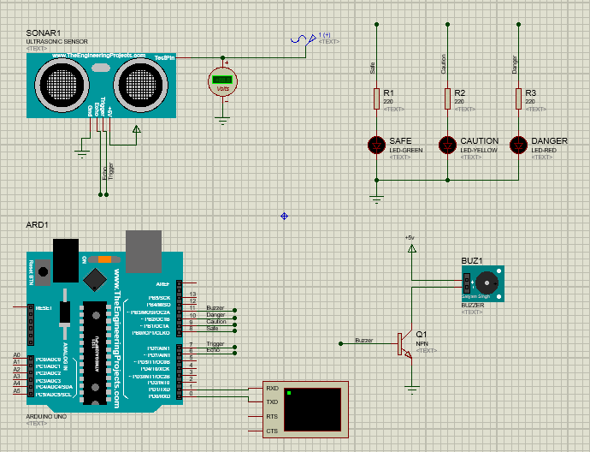

*Code*:

<https://github.com/Abdelrahman-Abdelgawad/ArduinoProjects/blob/main/CarProximityAlarm/CarProximityAlarm_ArduinoCode/CarProximityAlarm.ino>

*Output:*

