SYSTEM ANALYSIS
& DESIGN
Olist E-Commerce Sales & Customer Experience Analytics
InsightHub | DEPI Data Analytics Project
Prepared from the approved project documents and the nine supplied Olist CSV tables
Document version 1.0 | 4 November 2026 | Target milestone: 6 November 2026
Official project tools: Power BI Desktop • Power Query • DAX • GitHub

Document Control
Item | Definition
Project | Olist E-Commerce Sales & Customer Experience Analytics
Team | InsightHub
Primary tools | Power BI Desktop, Power Query, DAX, GitHub
Dataset | Nine supplied Olist CSV tables
Design milestone | 6 November 2026
Document status | System analysis and design baseline; implementation and final validation remain separate activities.

Contents
- 1. Executive Summary and Design Basis
- 2. Problem Statement, Objectives and Scope
- 3. Actors, Use Cases and Requirements
- 4. Software Architecture
- 5. Dataset Inventory and Profiling
- 6. Database Design: ERD, Logical Schema and Physical Model
- 7. KPI and Measure Specification
- 8. Data Flow and System Behavior
- 9. UI/UX Design and Prototyping
- 10. System Deployment and Integration
- 11. Additional Deliverables: Testing, API Applicability and Deployment Strategy
- 12. Assumptions, Risks, Limitations and Traceability

1. Executive Summary and Design Basis
This document defines the analysis and design baseline for the InsightHub Olist analytics project. The solution is a Power BI analytical report built from nine public Olist CSV tables. The design covers the report users and use cases, functional and non-functional requirements, the analytical architecture, source-data structure, proposed semantic model, data flow, report wireframes, deployment view, and validation plan.
The project is not a new e-commerce storefront or transaction-processing application. It analyzes existing order, item, payment, review, product, seller, customer and location records. The architecture therefore uses an analytics pipeline (CSV sources → Power Query → semantic model → DAX measures → interactive Power BI report), not an invented web backend, microservice stack or API.
Design rule
Design outputs in this document describe the intended system. The four final Power BI report pages, complete transformations, DAX implementation, and executed QA evidence belong to the later Implementation and Final Presentation / Testing milestones.

The official DEPI guideline places System Analysis & Design between 9 October and 6 November 2026, followed by Implementation through 30 November and Final Presentation, Testing & Reports through 4 December. The current document is scoped to the design milestone.

2. Problem Statement, Objectives and Scope

2.1 Problem Statement
Order volume alone does not fully describe e-commerce performance. Product mix, delivery timeliness, customer review outcomes, seller contribution, and payment behavior provide complementary views of the order journey. This project measures patterns supported by the available Olist records and avoids causal claims that the dataset cannot establish.

2.2 Project Objectives
- Measure order activity and item sales trends over the available period.
- Compare products and categories by recorded item sales value, order-item volume, and freight charges.
- Analyze review scores and examine their observed relationship with delivery timing and product/customer groups.
- Measure delivery duration and late-delivery rate using defined rules for eligible delivered orders.
- Compare seller contribution and explore payment types, installment counts, and payment values.
- Deliver four interactive Power BI dashboards with validated metrics, filters, and documented limitations.

2.3 Scope
In scope | Out of scope unless additional valid data is approved
Data profiling, cleaning and transformation with Power Query. | Profit margin, discount impact, marketing attribution, advertising ROI, inventory/stock analysis, or target attainment without the required fields.
A relational model with documented table grain, join keys and validated relationships. | Carrier-level service comparisons without carrier identifiers and route-level records.
Transparent KPI definitions and DAX measures where appropriate. | Causal claims that delivery delays directly cause low ratings.
Four interactive Power BI dashboard pages with slicers and cross-filtering; drill-through where useful. | Forecasting or predictive modeling as a guaranteed deliverable; this requires a separate feasibility decision.
Evidence-based findings and recommendations with limitations clearly stated. | Claims that are not supported by available source fields.

Scope guardrail: item sales value is not profit. The source tables do not contain an approved profit or margin field. Payment value is a separate measure from item sales value. These definitions must remain distinct across all report pages.

3. Actors, Use Cases and Requirements

3.1 Actors
Actor | Need / interaction
Business decision-maker | Review distinct order counts and recorded item sales value over time; use supported filters.
Sales / category analyst | Compare products and categories by item sales value, order-item count, and freight.
Customer experience / operations analyst | Explore review scores, delivery duration and late-delivery indicators.
Seller / payments analyst | Explore seller contribution, seller geography, payment types, installments and payment values.
Report user | Navigate pages and apply supported slicers / cross-filter interactions.
DEPI instructor / reviewer | Review documentation quality, analytical validity, implementation evidence and presentation.

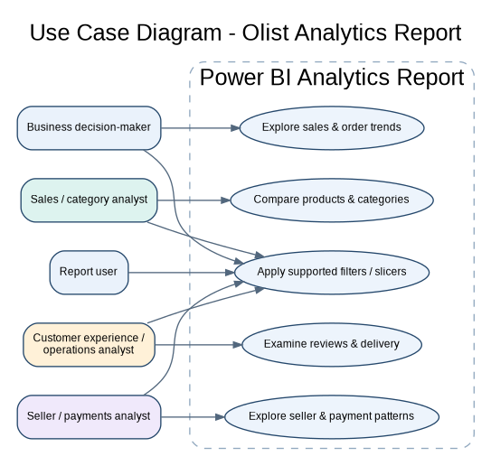
Figure 1. Use Case Diagram - report interactions are analytical only; no checkout or order-editing functions are included.

3.2 Use Case Descriptions
ID / use case | Actor | Main flow | Expected result
UC-01 Explore sales trends | Business decision-maker | Open Executive Sales & Order Trends; choose a period or supported dimension; inspect orders and item sales value. | Relevant visuals update according to the selected filters.
UC-02 Compare categories | Sales/category analyst | Open Product & Category Performance; compare categories/products by item sales and item count; inspect freight where relevant. | Comparisons use documented measure definitions and filter context.
UC-03 Examine delivery and reviews | Customer-experience / operations analyst | Open Customer Experience & Delivery Performance; inspect review scores and delivery indicators for eligible records. | Observed patterns are displayed without claiming causation.
UC-04 Explore seller/payment patterns | Seller/payments analyst | Open Seller & Payment Insights; compare seller contribution and payment attributes. | Totals respect the separate item and payment table grains.
UC-05 Apply filters | Report user | Select a supported date, status, category, state, seller or payment filter as provided on the page. | Applicable visuals respond consistently.

3.3 Functional Requirements
ID | Requirement | Priority
FR-01 | Display distinct order counts and recorded item sales value over the available period. | High
FR-02 | Compare products/categories using item sales value and order-item count. | High
FR-03 | Show customer review-score distributions. | High
FR-04 | Calculate delivery duration and late rate under documented eligibility rules. | High
FR-05 | Analyze seller contribution and geography where fields support it. | Medium
FR-06 | Analyze payment types, installments and payment values without duplicating totals. | Medium
FR-07 | Provide relevant slicers and cross-filter interactions for supported fields. | High
FR-08 | Display clear titles, units and definitions for headline KPIs. | High

3.4 Non-Functional Requirements
ID | Area | Requirement
NFR-01 | Usability | Use consistent layouts, readable labels, clear units and intuitive filters.
NFR-02 | Performance | Test report interactions and record actual response behavior on the agreed environment.
NFR-03 | Reliability | Reconcile headline KPIs against source-level or independent calculations before release.
NFR-04 | Data integrity | Document table grain, keys, relationships and transformations; avoid joins that inflate totals.
NFR-05 | Security | Do not commit credentials, access tokens or unnecessary sensitive data to the repository.
NFR-06 | Maintainability | Document KPI definitions, assumptions, cleaning steps and known limitations.
NFR-07 | Compatibility | Verify the report in the agreed Power BI Desktop environment and document dependencies where relevant.

4. Software Architecture
The suitable architecture for the confirmed project scope is a layered analytical architecture. The DEPI guideline gives MVC and microservices as examples, but the supplied project baseline identifies Power BI Desktop, Power Query, DAX and GitHub; it does not identify a custom frontend, backend, API or microservice deployment. Those patterns are therefore not asserted here.
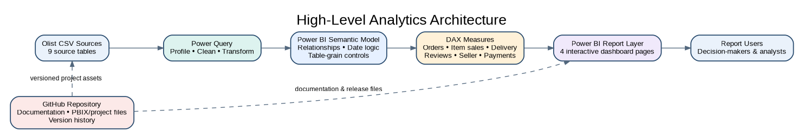
Figure 2. High-level architecture. GitHub is used for documentation and project collaboration, not as a runtime data-processing component.
Layer | Responsibility | Confirmed tool / artifact
Source layer | Provide the nine Olist CSV tables. | CSV files
Preparation layer | Profile columns, handle data-quality issues, standardize types and transform tables. | Power Query
Semantic model layer | Define table grain, relationships, date logic and filter propagation. | Power BI data model
Calculation layer | Define measures for orders, item sales, freight, reviews, delivery, sellers and payments. | DAX
Presentation layer | Deliver four interactive report pages with slicers and cross-filtering. | Power BI Desktop
Collaboration layer | Store documentation, diagrams and approved project files; track revisions. | GitHub

Architecture decisions: (1) keep order-item and payment facts separate; (2) use order header as a shared parent for order-related facts; (3) do not connect raw geolocation directly on ZIP prefix; (4) use a shared KPI dictionary; (5) document any deployment beyond Power BI Desktop only after the team confirms access and method.

5. Dataset Inventory and Initial Profiling
The team supplied all nine Olist CSV tables. The counts below were calculated from the supplied files on 4 November 2026. They are source-profile observations, not a claim that cleaning, model implementation or final QA has been completed.
Source table | Rows | Columns | Observed grain / key
customers | 99,441 | 5 | One record per customer_id; customer_unique_id repeats.
geolocation | 1,000,163 | 5 | ZIP/coordinate observations; no unique ZIP-prefix key.
order_items | 112,650 | 7 | One row per order_id + order_item_id.
order_payments | 103,886 | 5 | One row per order_id + payment_sequential.
order_reviews | 99,224 | 7 | Review rows; neither review_id nor order_id is unique in all rows.
orders | 99,441 | 8 | One row per order_id.
products | 32,951 | 9 | One row per product_id.
sellers | 3,095 | 4 | One row per seller_id.
product_category_translation | 71 | 2 | One row per Portuguese category translation key.

5.1 Source Data Quality Findings
Area | Observed result in supplied files | Design / handling decision
Orders and dates | 99,441 unique order_id rows. Purchase timestamps range from 2016-09-04 to 2018-10-17. Missing: 160 approval dates, 1,783 carrier dates, 2,965 delivered-customer timestamps; 8 records marked delivered lack the delivered-customer timestamp. | Use delivered orders with valid purchase, actual-delivery and estimated-delivery dates for duration / late-rate denominators. Preserve other statuses; do not call missing delivery dates on-time.
Order items | 112,650 rows across 98,666 orders. Composite (order_id, order_item_id) is unique; order_id repeats by design. | Treat the row grain as one order item. Count order items by rows; count orders distinctly.
Payments | 103,886 rows across 99,440 orders. Composite (order_id, payment_sequential) is unique; up to 29 payment records appear for one order. | Keep payments as a separate fact table. Never join payments directly to order items at raw row level for summing both amounts.
Reviews | 99,224 rows; 98,410 distinct review_id values; 814 rows beyond first occurrences share an existing review_id. 547 order_ids have multiple review rows. 87,656 titles and 58,247 comment messages are null. | Create a generated ReviewRowKey in Power Query. Use review_score and review dates; do not treat review_id as a primary key or discard valid scores because comments are blank.
Products / categories | 610 product rows have null category names. Product rows contain 73 distinct non-null category names; the translation table covers 71. Two names are not translated. Weight and dimensions have 2 missing values each. | Use a left join to translation; retain original Portuguese names when translation is absent and label null categories as Unknown / Unclassified. Do not infer missing product attributes.
Geolocation | 1,000,163 rows; 261,831 exact duplicate rows; 19,015 unique ZIP prefixes. ZIP prefix repeats in 981,148 rows. 8,556 ZIP prefixes have more than one city value; 8 have more than one state value. | Keep raw geolocation as staging. If coordinates are needed, create a one-row-per-ZIP aggregate with documented aggregation; do not use raw geolocation as the one-side of a relationship.
Customers | 99,441 rows and unique customer_id; 96,096 distinct customer_unique_id values. | Use customer_id for the source order/customer-record link. Use DISTINCTCOUNT(customer_unique_id) for distinct buyer counts. Do not treat customer_unique_id as a unique row key.

Initial referential-integrity check: the tested non-null customer/order/item/product/seller/payment/review foreign-key values had zero orphan rows against their supplied parent tables. Repeat the check after Power Query transformations and model changes.

5.2 Order Status Profile
Order status | Rows
delivered | 96,478
shipped | 1,107
canceled | 625
unavailable | 609
invoiced | 314
processing | 301
created | 5
approved | 2

The source contains 96,478 orders marked delivered, but 8 of these lack an actual delivered-customer timestamp. For a delivery-duration or late-delivery calculation that requires an actual date, 96,470 delivered orders have all three required timestamps non-null in the source profile; chronology and business eligibility rules still require validation before the final denominator is approved.

5.3 Important Source-Model Warnings
- order_item_id is only unique within order_id; it is not a global primary key.
- payment_sequential is only unique within order_id; it is not a global primary key.
- review_id is duplicated across records in the supplied file; add an index-based surrogate key for row identity.
- customer_unique_id represents a buyer identity across order-level customer records and is not unique in the customers file.
- Geolocation ZIP prefixes and city labels are not one-to-one; ZIP-level aggregation and city/state conflict handling must be documented.
- Product category translation is incomplete; retain unmapped source values instead of dropping them.

6. Database Design and Data Modeling

6.1 Entity-Relationship Diagram
The source ERD below records the supplied tables and their major key relationships. It deliberately shows geolocation as a staging source because its ZIP prefix is highly duplicated. The category translation table is a partial lookup, not a complete category universe.
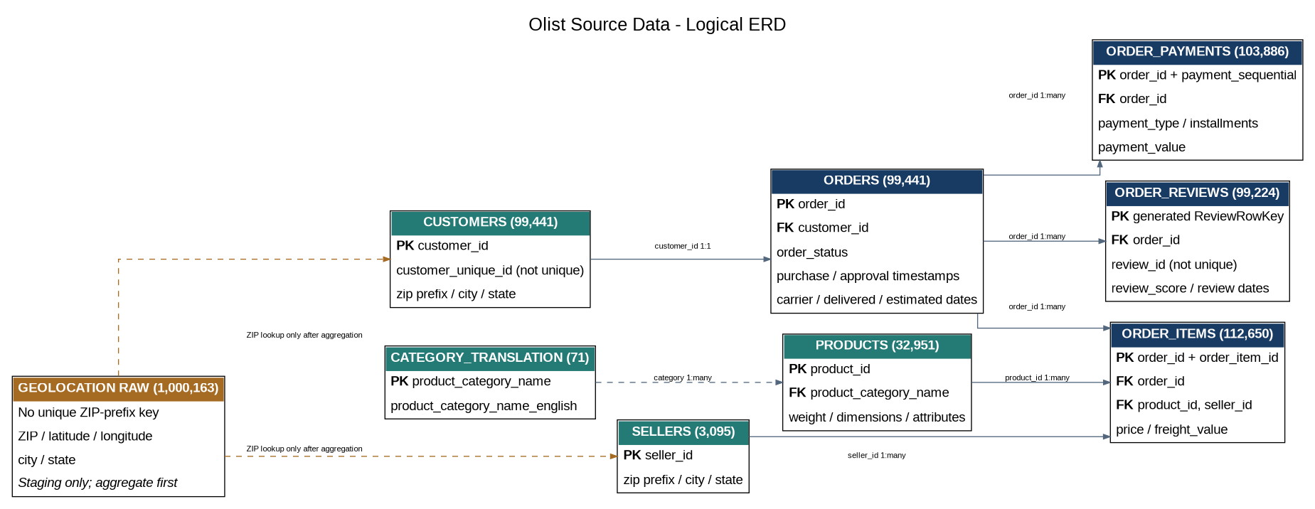
Figure 3. Source ERD for the nine supplied Olist tables. Dashed links denote lookups requiring preprocessing or incomplete mapping.
Source relationship checks: Orders.customer_id matches Customers.customer_id one-to-one in this snapshot; Order Items order_id/product_id/seller_id, Payments.order_id and Reviews.order_id all match existing parent keys with zero unmatched rows in the supplied files. This does not eliminate the need to test filter propagation after model implementation.

6.2 Logical Schema and Data Dictionary
Table | Primary key / key rule | Foreign key / relationships | Grain and important columns
customers | customer_id (unique) | ZIP prefix may map to derived ZIP lookup. | One row per customer_id record. customer_unique_id is repeated buyer identifier; customer_zip_code_prefix, customer_city, customer_state.
geolocation | No source PK; assign staging row key only if required. | ZIP prefix is not unique; never use as a raw one-side key. | One observed ZIP/coordinate row; geolocation_zip_code_prefix, latitude, longitude, city, state.
orders | order_id (unique) | customer_id → customers.customer_id. | One row per order. order_status; purchase, approved, carrier, delivered-customer, estimated-delivery timestamps.
order_items | Composite: order_id + order_item_id. | order_id → orders; product_id → products; seller_id → sellers. | One row per order item. shipping_limit_date, price, freight_value.
order_payments | Composite: order_id + payment_sequential. | order_id → orders. | One row per payment record. payment_type, payment_installments, payment_value.
order_reviews | Generated ReviewRowKey in Power Query; review_id is not unique. | order_id → orders. | One row per review record. review_score, comment fields, review_creation_date, review_answer_timestamp.
products | product_id (unique). | product_category_name → product_category_translation where mapped. | One row per product. category, weight, dimensions, name/description length, photo count.
sellers | seller_id (unique). | ZIP prefix may map to derived ZIP lookup. | One row per seller. seller_zip_code_prefix, seller_city, seller_state.
product_category_translation | product_category_name (unique in supplied lookup). | Referenced by products.product_category_name. | One translation row per mapped Portuguese category; translated English name.

6.3 Source Attribute Dictionary and Proposed Data Types
The field names below reproduce the supplied CSV headers. Data types are recommended Power Query types for modeling. Postal-code prefixes are recommended as Text even though the CSV may import them as numbers, because they are identifiers and may require leading zeros. Nullable fields remain nullable until a documented cleaning rule is applied.
Table | Source attributes and recommended types | Key / nullability notes
customers | customer_id (Text); customer_unique_id (Text); customer_zip_code_prefix (Text); customer_city (Text); customer_state (Text). | customer_id = PK. customer_unique_id is repeated; zip prefix is an identifier.
geolocation | geolocation_zip_code_prefix (Text); geolocation_lat (Decimal); geolocation_lng (Decimal); geolocation_city (Text); geolocation_state (Text). | No unique natural key in supplied raw table; ZIP prefix repeats. Keep as staging or derive aggregated ZIP lookup.
orders | order_id (Text); customer_id (Text); order_status (Text); order_purchase_timestamp (Date/Time); order_approved_at (Date/Time, nullable); order_delivered_carrier_date (Date/Time, nullable); order_delivered_customer_date (Date/Time, nullable); order_estimated_delivery_date (Date/Time). | order_id = PK; customer_id = FK. Three timestamp columns contain nulls in source.
order_items | order_id (Text); order_item_id (Whole Number); product_id (Text); seller_id (Text); shipping_limit_date (Date/Time); price (Decimal); freight_value (Decimal). | Composite PK: order_id + order_item_id. order_id, product_id and seller_id are FKs.
order_payments | order_id (Text); payment_sequential (Whole Number); payment_type (Text); payment_installments (Whole Number); payment_value (Decimal). | Composite PK: order_id + payment_sequential. order_id = FK.
order_reviews | review_id (Text); order_id (Text); review_score (Whole Number); review_comment_title (Text, nullable); review_comment_message (Text, nullable); review_creation_date (Date/Time); review_answer_timestamp (Date/Time). | review_id is not unique. Add generated ReviewRowKey; order_id = FK. Comment fields are nullable.
products | product_id (Text); product_category_name (Text, nullable); product_name_lenght (Whole Number, nullable); product_description_lenght (Whole Number, nullable); product_photos_qty (Whole Number, nullable); product_weight_g (Whole Number, nullable); product_length_cm (Whole Number, nullable); product_height_cm (Whole Number, nullable); product_width_cm (Whole Number, nullable). | product_id = PK. Preserve the source header spelling “lenght” or document a deliberate rename. Category and several attributes contain nulls.
sellers | seller_id (Text); seller_zip_code_prefix (Text); seller_city (Text); seller_state (Text). | seller_id = PK; ZIP prefix is an identifier, not a numeric measure.
product_category_translation | product_category_name (Text); product_category_name_english (Text). | product_category_name = unique key in supplied lookup; only 71 source categories mapped.

Normalization note: preserve the distinct source entities and child-record grains rather than flattening all tables together. The model uses separate order-item, payment and review fact tables with a shared order header. A derived lookup may be created for ZIP geolocation; the raw geolocation table is not a valid one-side dimension at ZIP-prefix grain.

6.4 Recommended Physical Model for Power BI
The recommended model keeps order-level data and the three multi-row order facts separate. It is a Power BI semantic model design, not a claim that the CSV sources have been physically normalized or that the final PBIX has already been built.
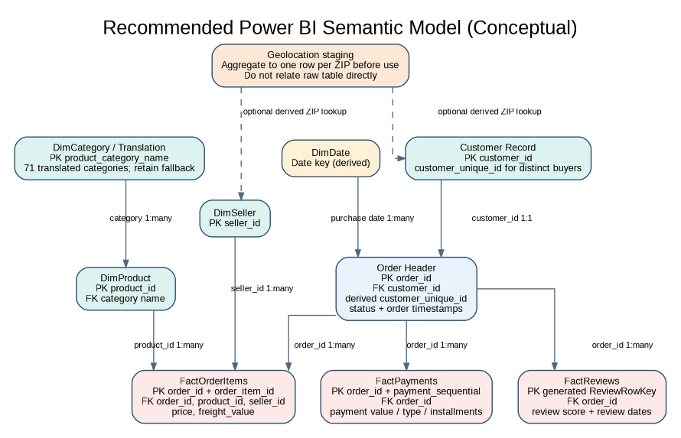
Figure 4. Recommended semantic model. Dashed geolocation edges are optional and require one-row-per-ZIP aggregation or role-playing lookup copies.
Relationship | Cardinality / direction | Implementation note
Customers[customer_id] → Orders[customer_id] | 1:1 in supplied snapshot | Customer_id is unique on both sides. Use customer_unique_id for unique buyer counts, not as the relationship key.
Orders[order_id] → OrderItems[order_id] | 1:* | One order can contain multiple order-item rows.
Orders[order_id] → Payments[order_id] | 1:* | One order can have multiple payment sequence rows.
Orders[order_id] → Reviews[order_id] | 1:* | An order can have multiple review rows; add ReviewRowKey for row identity.
Products[product_id] → OrderItems[product_id] | 1:* | Product_id is unique in Products.
Sellers[seller_id] → OrderItems[seller_id] | 1:* | Seller_id is unique in Sellers.
CategoryTranslation[product_category_name] → Products[product_category_name] | 1:* where mapped | Use left join/fallback; translation does not cover all categories.
Date[Date] → Orders[PurchaseDate] | 1:* | Use purchase date as active relationship; use role-playing/inactive date relationships for other date analyses as needed.

Geolocation is an optional relationship only after aggregation to one row per ZIP prefix. Use role-playing copies or direct state attributes to avoid ambiguous filter paths.

6.5 Normalization and Transformation Considerations
- Preserve raw CSVs; implement documented preparation steps in Power Query rather than overwriting source files.
- Add ReviewRowKey with an index because review_id is not unique in the supplied file.
- Create a ZIP-level geolocation aggregate only if map coordinates are required. Consider average latitude/longitude and a documented representative city/state rule; retain the raw table for audit.
- Use a category lookup with left-join semantics. Keep unmapped Portuguese category names and identify null categories as Unknown rather than losing rows.
- Convert ZIP prefixes to text in Power Query to preserve leading zeros and avoid numeric treatment of postal identifiers.
- Use date-only columns for calendar relationships while retaining source datetime columns for precise delivery-duration calculations.
- Keep Order Items, Payments and Reviews as separate fact tables. Do not flatten them into one order-level table without aggregation to a common grain.

7. KPI and Measure Specification
The earlier Project KPIs document distinguishes project-success KPIs from e-commerce business measures. This section maps the approved dashboard questions to source fields and candidate visuals, then specifies candidate business measures. Final status inclusion, format and filter logic must be approved in the shared KPI dictionary before implementation.

7.1 Dashboard Question-to-Field-to-Measure Mapping
Dashboard / question | Source fields | Measure / analytical rule | Suitable visual
Executive: How do orders and item sales change over time? | orders.order_id; orders.order_purchase_timestamp; order_items.order_id, price. | Distinct order count; sum of order-item price by purchase month. | Line chart / trend.
Executive: Which customer states and categories contribute to item sales? | customers.customer_state; products.product_category_name; category translation; order_items.price. | Item sales value grouped by customer state or translated category. | Bar chart / share chart.
Product: Which categories/products lead by item sales and item count? | products.product_id, product_category_name; order_items.product_id, price, order_id, order_item_id. | Sum item price; count item rows; rank products/categories. | Sorted bar chart / matrix.
Product: How do freight charges compare with item sales? | order_items.freight_value, price; product category. | Freight value; item sales value; ratio only with explicit denominator. | Scatter / clustered bar.
Product: Where product attributes are available, how do they vary? | products.product_weight_g, product_length_cm, product_height_cm, product_width_cm, category. | Descriptive distribution; disclose missing product attributes. | Scatter / box-style distribution.
Customer & Delivery: How are review scores distributed? | order_reviews.review_score, review_id, order_id. | Count valid review rows by score; optionally define order-level aggregation separately. | Column chart.
Customer & Delivery: What share of eligible delivered orders are late? | orders.order_status, order_purchase_timestamp, order_delivered_customer_date, order_estimated_delivery_date. | Late eligible delivered orders divided by all eligible delivered orders. | KPI card / stacked bar.
Customer & Delivery: How does duration vary by customer state? | orders purchase/delivered dates; customers.customer_state; customer_id. | Duration on eligible delivered order records; keep order grain. | Bar chart / map only if geo validated.
Customer & Delivery: Do late/on-time groups show different scores? | orders.order_id and delivery dates; order_reviews.order_id, review_score. | Compare review records by documented delivery group; state that it is association. | Clustered column / box-style chart.
Seller & Payment: Which sellers contribute most? | sellers.seller_id, seller_state; order_items.seller_id, order_id, price, order_item_id. | Seller item sales value and item-row count. | Ranked bar chart.
Seller & Payment: How are payment types and installments distributed? | order_payments.payment_type, payment_installments, payment_value; orders purchase date through order_id. | Payment record count or payment value by type/installment; choose one denominator. | Bar / column chart.
Seller & Payment: How do payment values vary over time? | order_payments.order_id, payment_value; orders.order_purchase_timestamp. | Sum payment_value by purchase month with fact table kept separate. | Line chart.

Grain and overlap caution
An order may contain several items/categories, sellers, payment rows and review rows. Category- or seller-level cuts can therefore repeat order-level measures across groups. Label such views as overlapping analysis and do not sum group-level distinct-order or order-level delivery/review values as if the groups were disjoint.

7.2 KPI and Measure Definitions
Measure | Definition / calculation basis | Important control
Distinct Orders | DISTINCTCOUNT(Orders[order_id]). | Document order-status inclusion; report filters may change denominator.
Item Sales Value | SUM(OrderItems[price]). | This is item price value, not profit and not necessarily the same as payment value.
Order-item Count | COUNTROWS(OrderItems) at the item-row grain. | Do not count order_id rows as distinct orders.
Freight Value | SUM(OrderItems[freight_value]). | Keep freight distinct from item sales value.
Average Item Sales Value per Order | Item Sales Value ÷ Distinct Orders under the same filter/status context. | Guard against divide-by-zero and mismatched denominators.
Distinct Buyers | DISTINCTCOUNT(Orders[customer_unique_id]). | Create customer_unique_id on the order header by merging/relating Customers on customer_id in Power Query; this keeps the measure responsive to purchase-date filters. The source customer_unique_id is not a row key.
Review Score Distribution | Count of review rows for each nonblank review_score (1–5). | Multiple review rows can exist for an order; define whether visualization is review-record or order-level.
Delivery Duration | Actual delivered-customer timestamp minus purchase timestamp for eligible delivered orders. | Eligible: order_status = delivered and purchase, delivered and estimated timestamps valid. Display units explicitly.
Late-delivery Rate | Eligible delivered orders with actual delivery timestamp > estimated delivery date ÷ all eligible delivered orders. | Do not classify canceled, unavailable, shipped or missing-date orders as on-time.
Seller Item Sales Value | SUM(OrderItems[price]) grouped by seller. | Compare only under the same item grain; consider sample size for seller comparisons.
Payment Value | SUM(OrderPayments[payment_value]) from the payment fact. | Do not sum it after a raw join to order items.
Payment Type / Installments | Distribution of payment records or payment value by type/installment count. | State clearly whether chart counts records, orders or payment value.

Critical metric distinction
Item Sales Value = sum of order-item prices. Payment Value = sum of payment records. Neither is profit. Do not combine the two facts at raw row level because both can have multiple rows per order.

8. Data Flow and System Behavior

8.1 Context-Level DFD
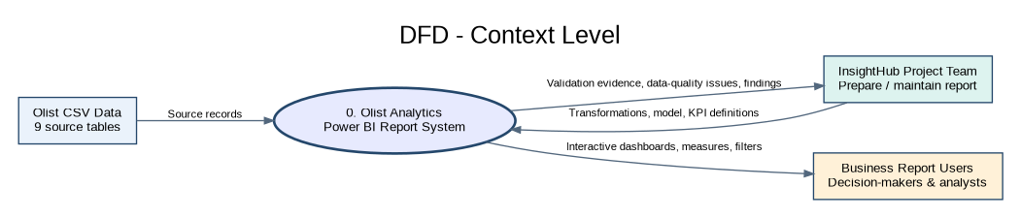
Figure 5. Context-level DFD: source records enter the analytical report system; report outputs go to intended users; the project team receives validation and issue evidence.

8.2 Detailed DFD - Level 1
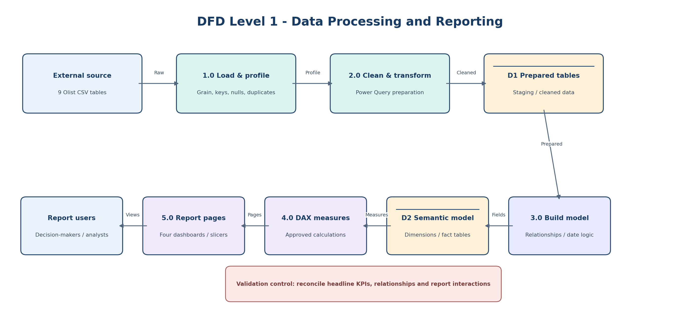
Figure 6. Detailed DFD showing the sequence of source loading, profiling, transformation, semantic modeling, DAX calculation and report consumption.

8.3 Sequence Diagram
Scenario: a report user opens a page and changes a supported slicer. The report applies filter context to the semantic model, DAX measures are evaluated, and affected visuals refresh. The flow describes standard report interaction; it does not imply a custom API or backend service.
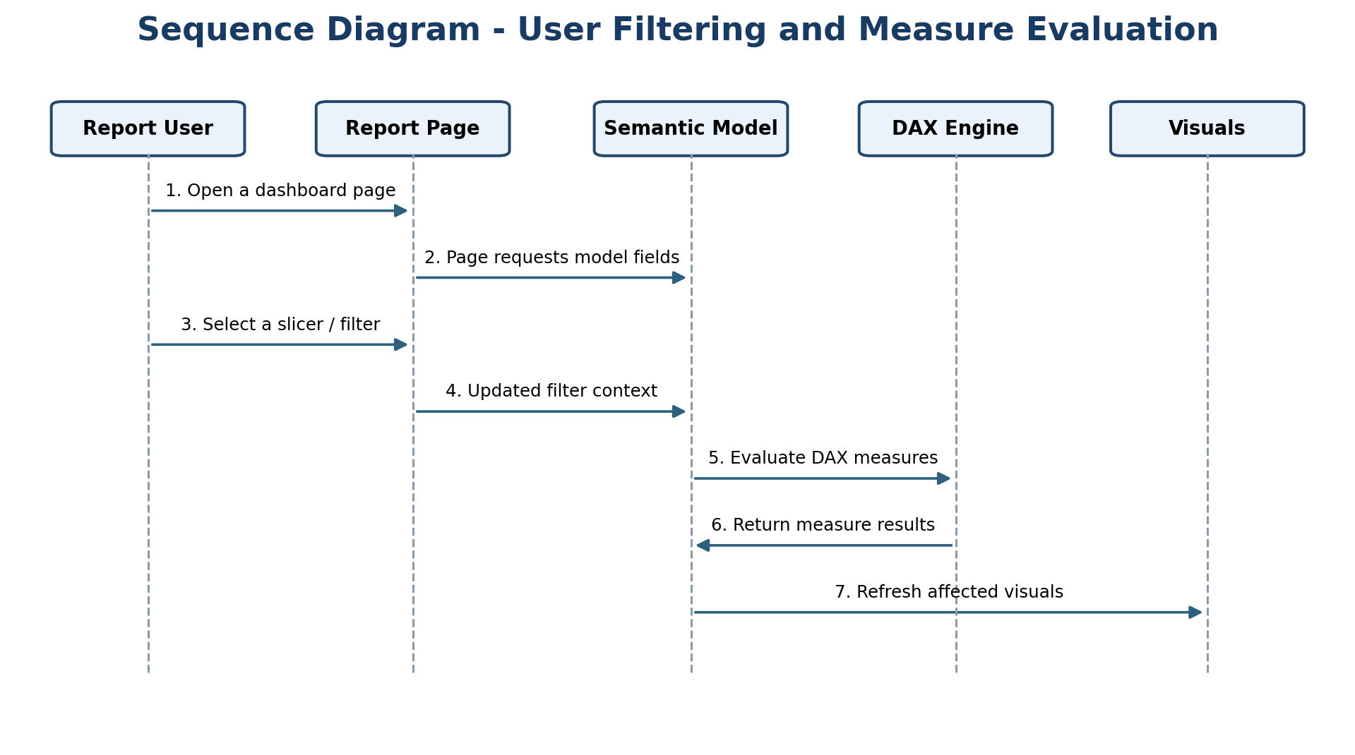
Figure 7. Sequence diagram - slicer selection and measure evaluation.

8.4 Activity Diagram
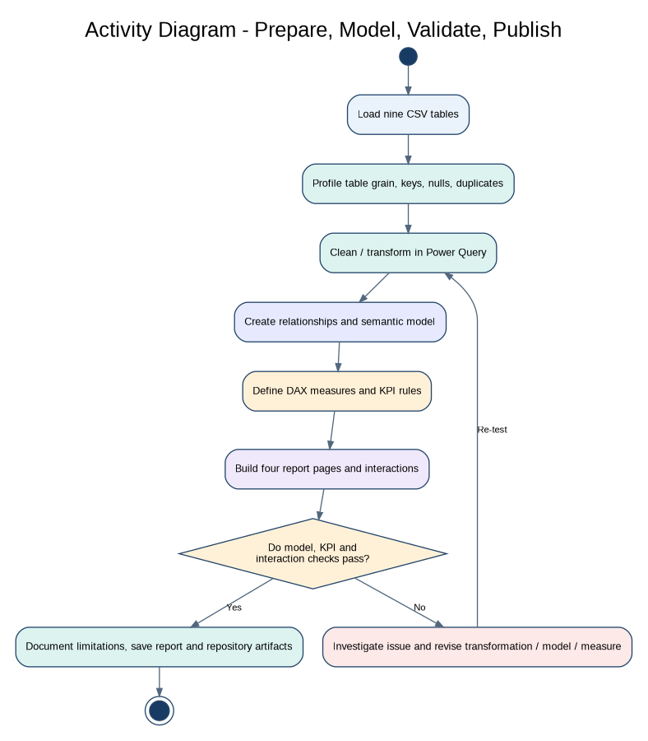
Figure 8. Activity diagram - data preparation through report validation and release. Failed checks return the work to correction and re-testing.

8.5 State Diagram
The supplied CSVs are snapshots; they do not provide a full event log for every order-status transition. To avoid inventing an order lifecycle, the state diagram models the state of the analytical dataset/report deliverable during preparation and validation.
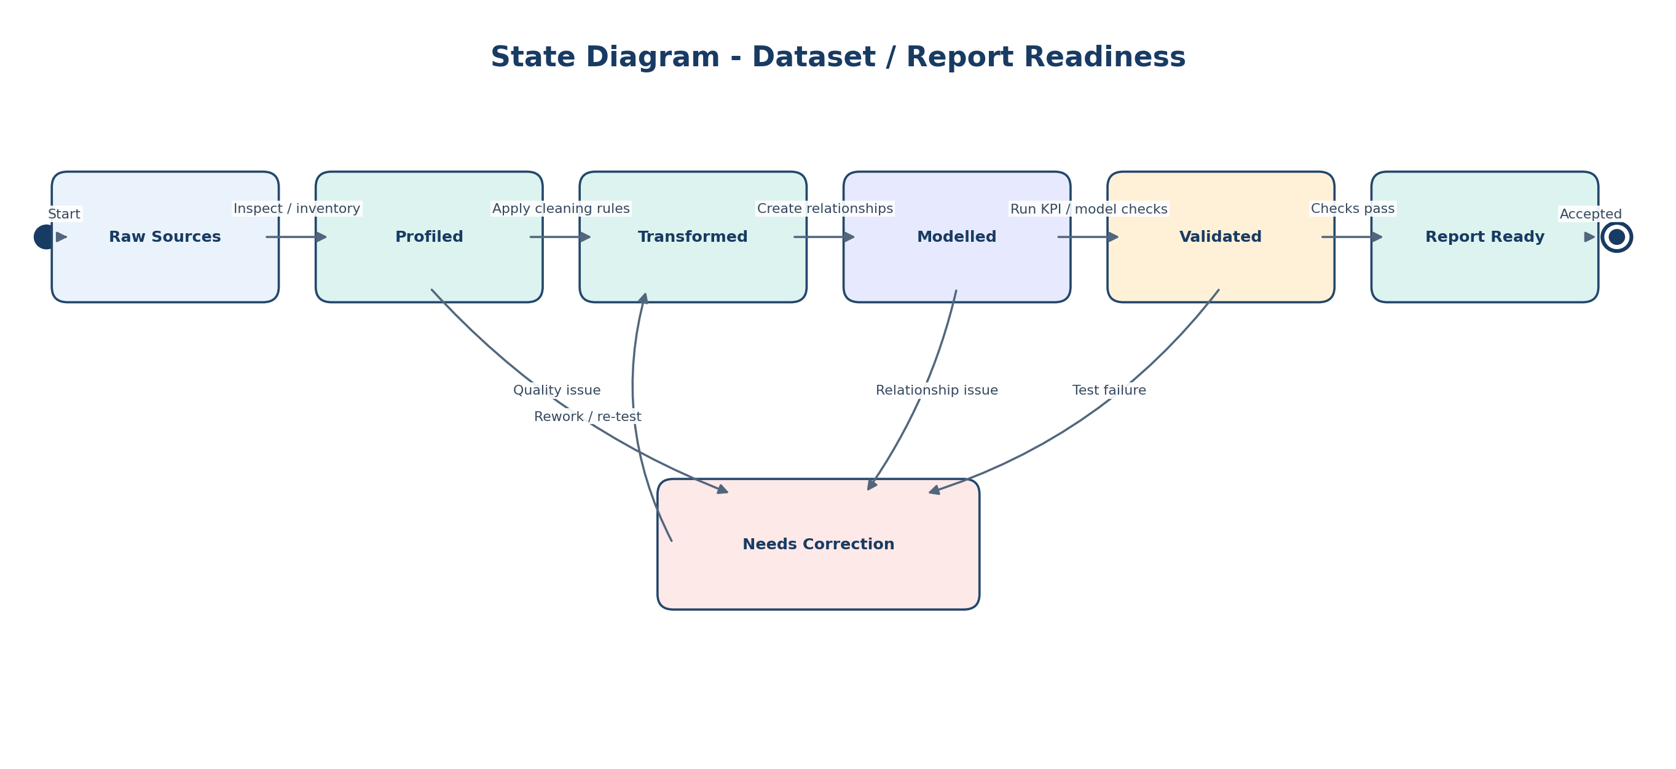
Figure 9. State diagram - conceptual readiness states for the dataset/report deliverable.

8.5.1 State Transition Notes
Current state | Event / condition | Next state
Raw Sources | Nine CSV tables are received and inventoried. | Profiled
Profiled | Table grain, keys, nulls and duplicate patterns are reviewed; agreed cleaning rules are applied. | Transformed
Transformed | Power Query preparation is complete and the proposed relationships are created. | Modelled
Modelled | Relationship, KPI and sample-record checks are executed. | Validated or Needs Correction
Needs Correction | A data-quality, relationship or test issue is corrected and retested. | Transformed / Modelled
Validated | Required design and QA checks pass for the current milestone. | Report Ready

8.6 Class Diagram
Power BI is not an object-oriented application in the supplied project scope. The class diagram is therefore a conceptual domain view, not a claim that these are implemented code classes. The listed operations represent analytical capabilities/measures that can be implemented in DAX.
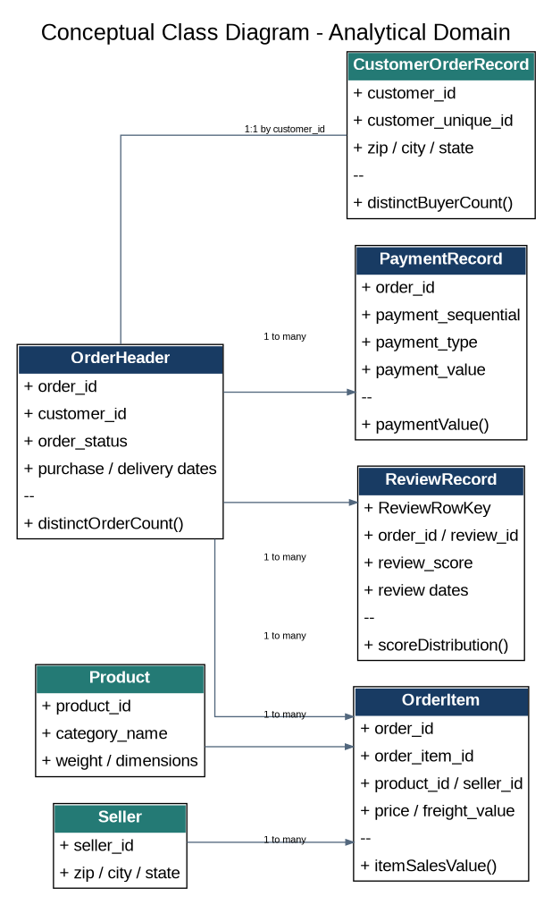
Figure 10. Conceptual analytical-domain classes and associations. Operations are measure concepts, not implemented object methods.

9. UI/UX Design and Prototyping
The following are wireframes, not final Power BI pages. They specify page hierarchy, information zones, likely visuals and slicers. Exact KPI values and final visual choices are confirmed after data profiling, measure approval and implementation.
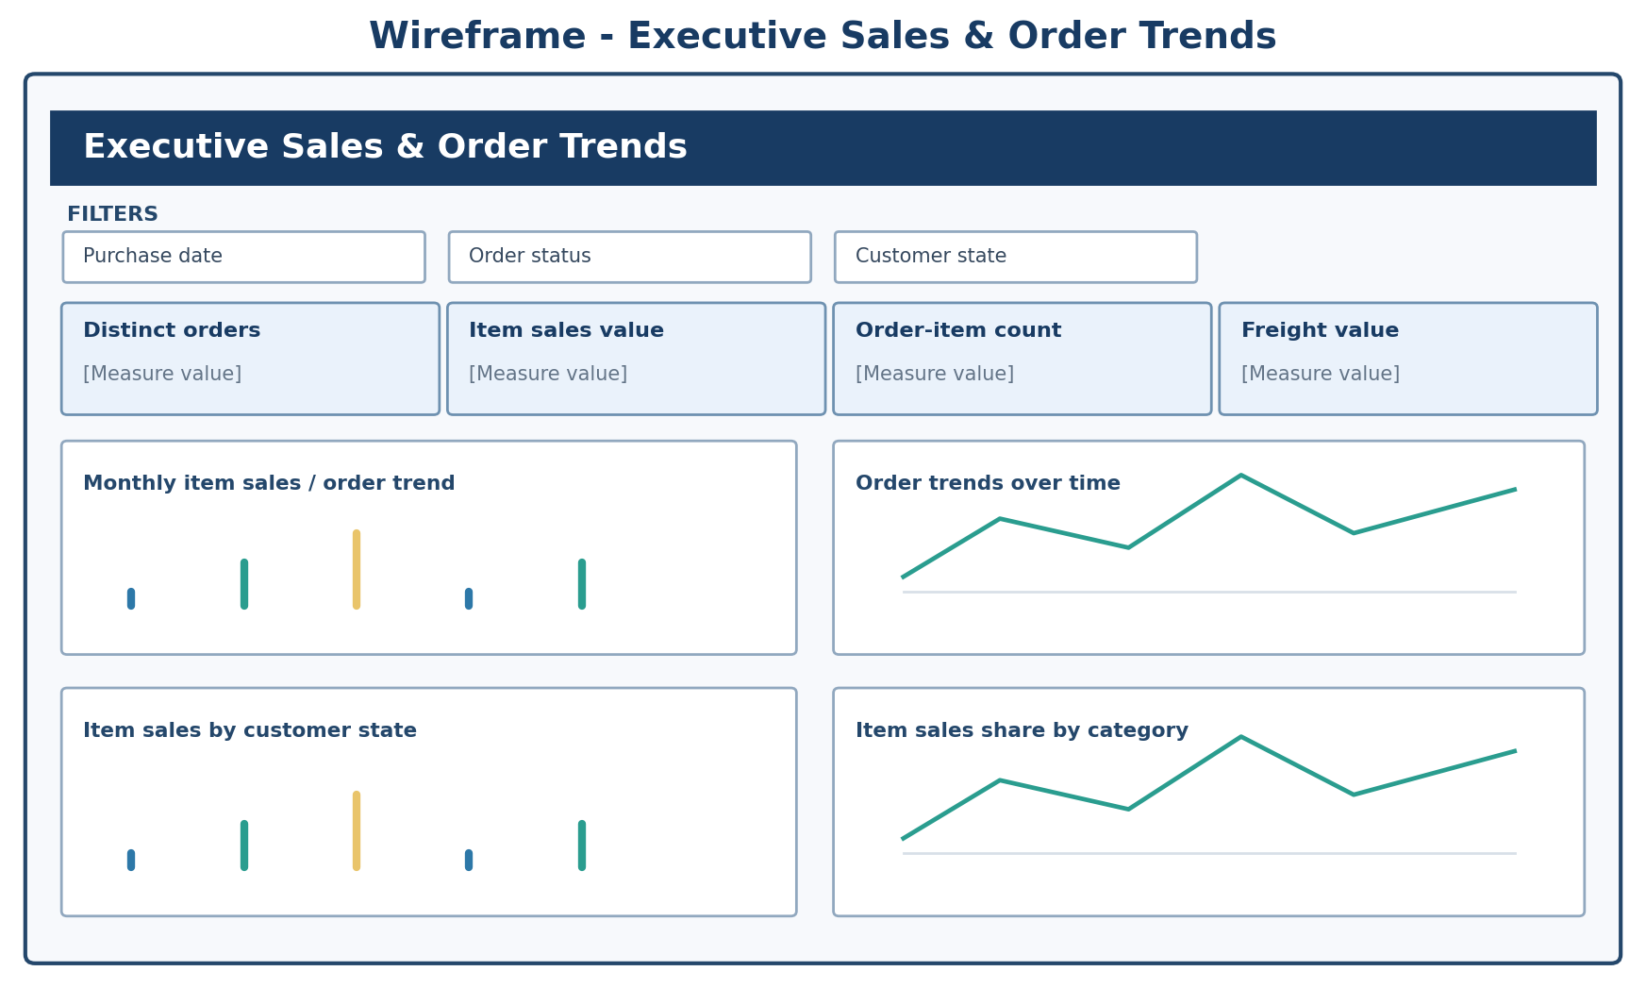
Figure 11. Wireframe 1 - Executive Sales & Order Trends.
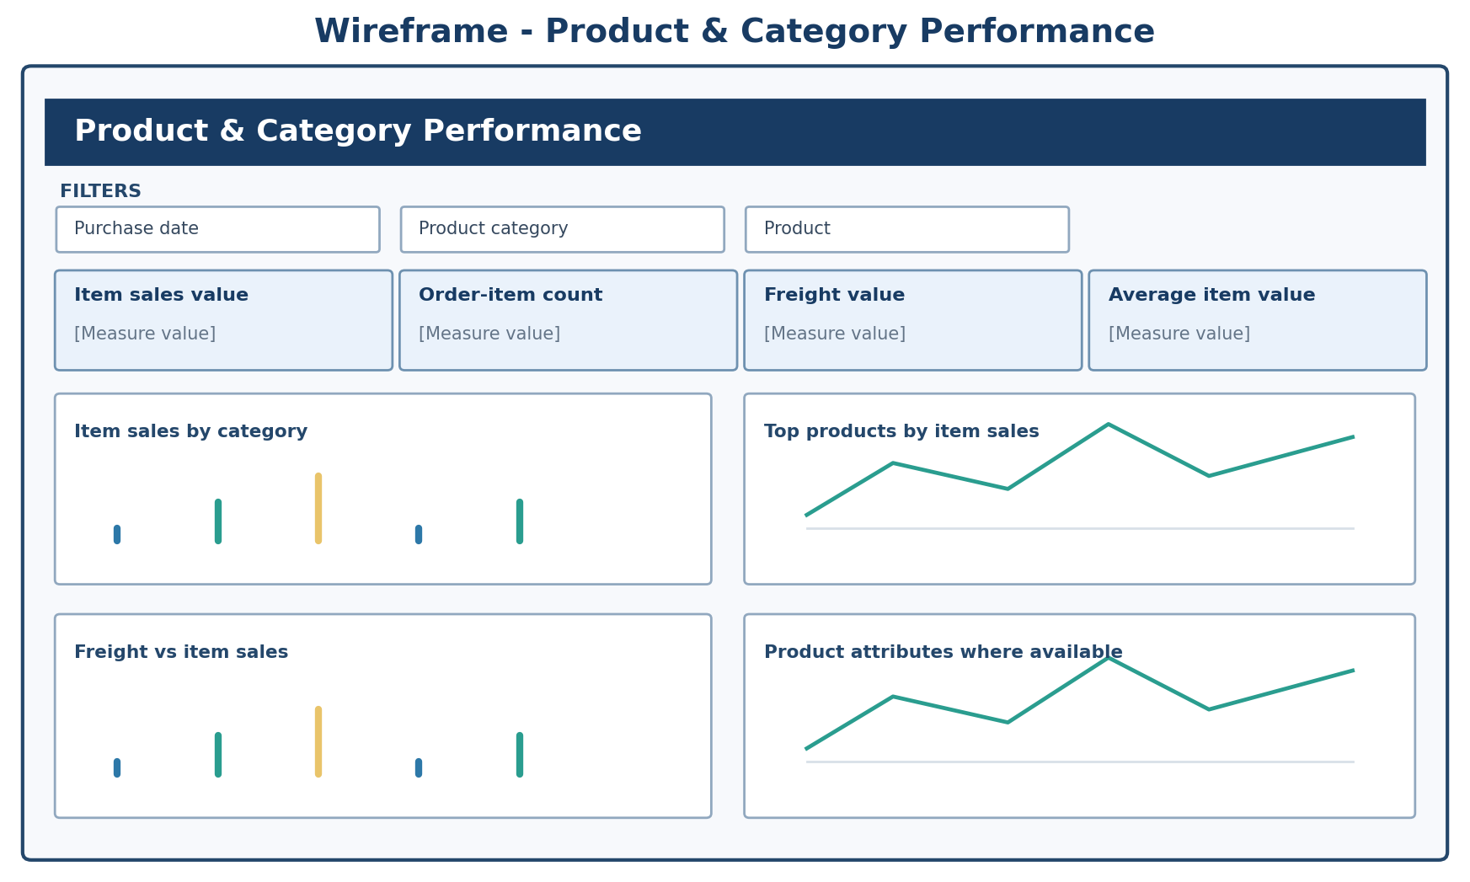
Figure 12. Wireframe 2 - Product & Category Performance.
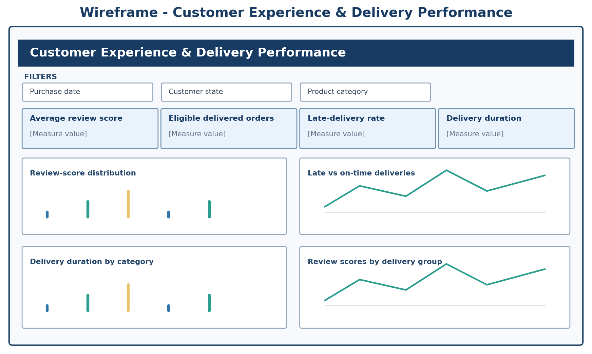
Figure 13. Wireframe 3 - Customer Experience & Delivery Performance.
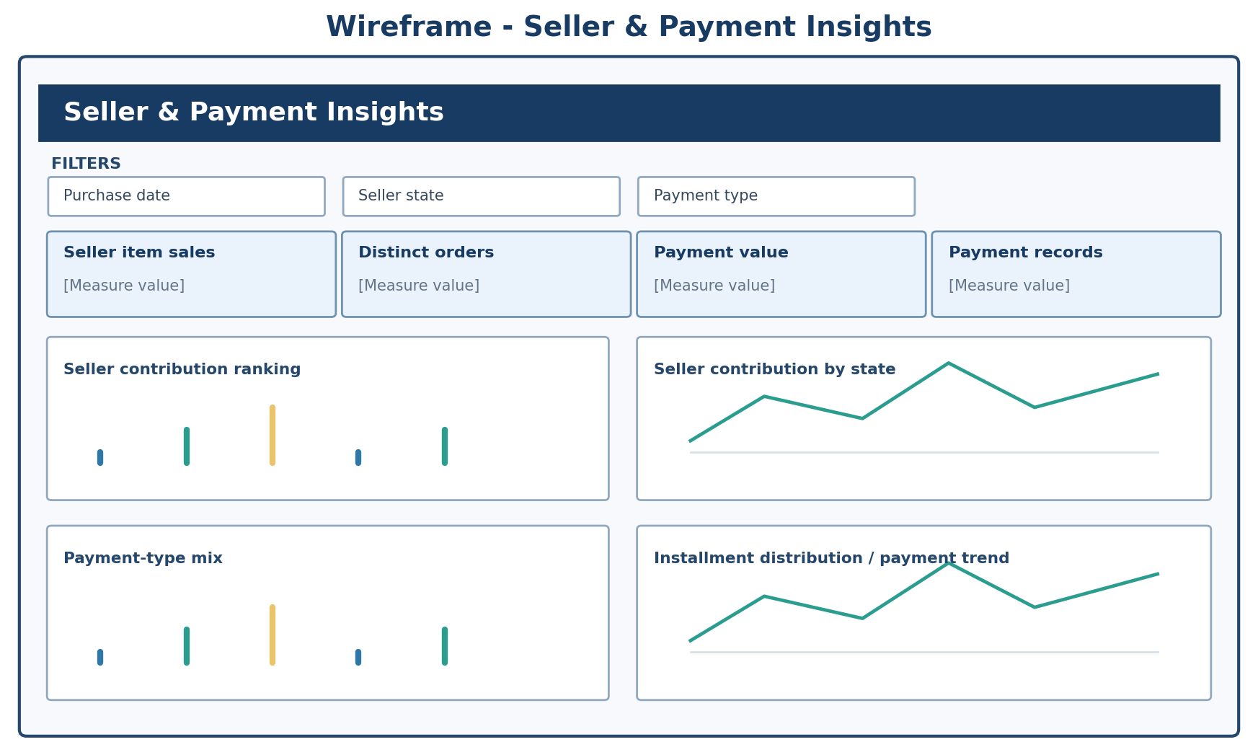
Figure 14. Wireframe 4 - Seller & Payment Insights.

9.1 Proposed UI/UX Guidelines
Design area | Guideline
Page structure | Use a consistent title/header area, a filter row, a KPI row, and a clear visual grid. Keep the most decision-relevant metrics near the top.
Color system | Proposed palette: deep navy for headers, blue for primary series, teal for positive/secondary series, amber for warning/attention, and neutral backgrounds. Do not rely on color alone.
Typography | Use one readable sans-serif family consistently; reserve larger type for page titles and KPI values.
Charts | Choose charts based on the analytical question: line for trends, bar for ranking/comparison, distribution charts for review scores, and carefully labeled maps only when geography coordinates are validated.
Filters | Use consistent slicer placement and labels across pages. Ensure slicers filter only intended fields and test cross-page behavior.
Definitions | Display units and concise definitions for headline measures. Distinguish item sales value from payment value and do not label either as profit.
Accessibility | Maintain strong text/background contrast, readable font size, descriptive chart titles, keyboard-usable controls where supported, and labels/markers in addition to color.
Consistency | Reuse layout patterns, spacing, number formats, date formats and interaction conventions across all four pages.

10. System Deployment and Integration

10.1 Technology Stack
Layer / purpose | Confirmed technology or artifact | Status
Data source | Nine Olist CSV files | Supplied by project team
Data preparation | Power Query | In project baseline
Data model and reporting | Power BI Desktop | In project baseline
Analytical calculations | DAX | In project baseline
Version control / documentation | GitHub repository (olist-ecommerce-analytics) | In project baseline
Custom backend / APIs | None identified in the supplied project documents | Not part of current design
Cloud hosting / Power BI Service | Not confirmed in supplied documents | Optional only after team/instructor approval

10.2 Component Diagram
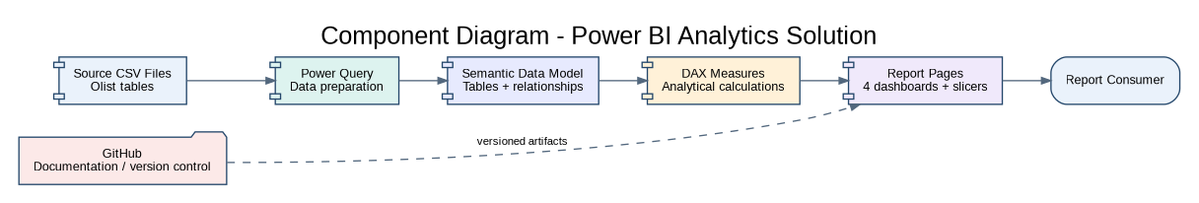
Figure 15. Component view of the analytical report system and the GitHub collaboration boundary.

10.3 Deployment Diagram
The deployment view below describes the current desktop authoring approach and the proposed repository handoff. It does not claim that a cloud report has already been published. If the team later uses Power BI Service, tenant access, sharing permissions, refresh configuration and instructor approval must be confirmed and documented.
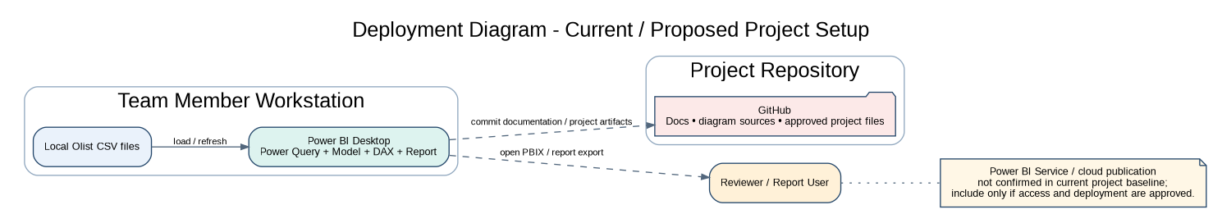
Figure 16. Deployment view - current/local Power BI Desktop authoring with GitHub project repository; cloud publication is unconfirmed.

11. Additional Deliverables

11.1 API Documentation Applicability
The DEPI guideline requests API documentation only if the system includes APIs. The supplied project proposal identifies Power BI Desktop, Power Query, DAX and GitHub, and does not identify API endpoints or a custom API service. Therefore, API documentation is not applicable to the current design baseline. Do not fabricate endpoints. Revisit this decision only if an API is introduced and approved.

11.2 Testing and Validation Plan
Test ID | Test / validation | Expected result / acceptance evidence | Stage
T-01 | Source row-count and primary-key checks for Orders, Customers, Products, Sellers, and translation lookup. | Counts match source profile; key uniqueness retained after transformation. | Source profiling started; repeat after ETL.
T-02 | Composite key validation for Order Items and Payments. | (order_id, order_item_id) and (order_id, payment_sequential) remain unique. | Source profile passed; re-test model.
T-03 | Review row identity check. | Generated ReviewRowKey is unique; duplicate review_id values do not cause row loss. | Required in Power Query.
T-04 | Geolocation ZIP relationship check. | No raw many-duplicate ZIP prefix table is used as the one-side; aggregate lookup has one row per ZIP. | Required if ZIP geospatial model is built.
T-05 | Foreign-key integrity. | No unexpected orphan values between the tested source parent/child keys. | Initial source check: zero orphan rows; repeat after transform.
T-06 | Item sales and freight reconciliation. | Report totals reconcile to direct Order Items calculations under the same row/status/filter rules. | Implementation QA.
T-07 | Payment value reconciliation. | Payment totals reconcile to Order Payments; remain unaffected by item-row multiplication. | Implementation QA.
T-08 | Delivery eligibility and late rule. | Only delivered orders with valid purchase, actual and estimated timestamps enter denominator; late means actual > estimated. | Implementation QA.
T-09 | Review score distribution. | Counts reconcile to nonblank review rows; multiple reviews per order are handled according to documented rule. | Implementation QA.
T-10 | Category mapping completeness. | All mapped categories translate; two unmapped category values and null category values remain visible through fallback/Unknown logic. | Power Query / model QA.
T-11 | Slicer and cross-filter behavior. | All supported slicers affect intended visuals; no unexpected blanking or contradictory totals. | Report QA.
T-12 | Headline KPI reconciliation and peer review. | All headline KPIs have expected value, report value, filter context, test status and reviewer. | Before release.

Testing status must be updated only after the corresponding test is executed. The current document contains a test plan and source-profile checks; it does not claim that the final PBIX tests have passed.

11.3 Deployment Strategy
- Keep the supplied CSVs in a controlled project data location and document their source and refresh path.
- Build and save the report in Power BI Desktop (.pbix). Keep the report file, source transforms and documentation organized in the repository according to the team’s storage policy.
- Use Power Query refresh and validate row counts after each transformation change.
- Commit documentation, diagram sources and approved project artifacts to GitHub using meaningful commit messages. Do not commit credentials or access tokens.
- If raw files exceed the repository/browser upload limits, document the public dataset source and provide a reproducible download/setup instruction rather than silently omitting data.
- If Power BI Service publication is approved and available, document workspace, permissions, refresh ownership, data source credentials handling and sharing scope before publishing.

12. Assumptions, Risks, Limitations and Traceability

12.1 Design Assumptions and Limitations
- The current system is an analytics/reporting solution using the confirmed Power BI toolchain; it is not a new transactional e-commerce application.
- Final KPI formulas and order-status inclusion rules require team approval before implementation.
- All reported insights must be based on the supplied Olist fields; missing or unsupported metrics must be excluded or clearly disclosed.
- Relationships and filter directions must be validated in Power BI after the physical model is implemented.
- Cloud deployment, APIs, automated refresh pipelines and public-facing application access are not established by the supplied project baseline.
- Wireframes are design artifacts; they are not the completed interactive Power BI report.

12.2 Risk Traceability
Risk from prior register | Design response in this document
Incorrect joins / table grain | Separate Order Items, Payments and Reviews; document composite keys and relationship cardinality; run reconciliation tests.
Missing / invalid timestamps | Define delivered-order eligibility and missing timestamp treatment; exclude invalid records from delivery denominators.
Incomplete product attributes / translation | Preserve unmapped category labels and missing values; disclose coverage limitations.
Misleading KPI definitions | Maintain shared KPI dictionary, explicit grains, filters and eligibility rules.
Dashboard scope overlap | Use four distinct page purposes and question-to-visual mapping.
Uneven work / delayed handoffs | Keep a shared review checkpoint and integrated baseline before implementation.
Unsupported conclusions | Use association language, disclose data limits, and do not invent profit/marketing/carrier/forecast metrics.
Visual/filter errors | Use the test plan for slicers, cross-filter behavior and KPI reconciliation.

12.3 Source Document Alignment and Open Consistency Item
This design uses the supplied Project Proposal (four dashboard scopes, objectives, source tables and scope limits), Requirements Gathering (users, use cases and FR/NFR IDs), Project KPIs (project-success targets and candidate business metrics), Literature Review (data-model, data-quality, delivery and validation improvements), Risk Assessment, Task Assignment & Roles, and Project Plan.
Team-size consistency item to resolve before final GitHub upload
The latest Task Assignment & Roles and Requirements Gathering describe a four-member team. The supplied Project Plan and a team paragraph in the Project Proposal still contain an older reference to six members. This document follows the current four-member baseline; update those older references or record the approved team size so the repository does not contradict itself.

The Project Plan also lists the System Analysis & Design deliverable as data model, relationship design, KPI specification, dashboard wireframes and navigation/interactions plan. These are reflected in this report. The four dashboard pages themselves are scheduled for Implementation, not completed here.

12.4 Design-to-Implementation Handoff Checklist
- Approve this design baseline and confirm team-size references in prior documents.
- Confirm the shared KPI dictionary and order-status inclusion rules.
- Build Power Query transformations and preserve a cleaning log.
- Implement the recommended model and test relationships / filter directions.
- Create and validate common DAX measures.
- Implement the four Power BI pages using the approved wireframes.
- Execute the test cases and record actual results, fixes and limitations.
- Prepare final findings, recommendations, presentation and handover instructions.

Appendix A. Supplied CSV Inventory
Logical table | Uploaded CSV reference | Rows
customers | customers CSV | 99,441
geolocation | geolocation CSV | 1,000,163
order_items | order_items CSV | 112,650
order_payments | order_payments CSV | 103,886
order_reviews | order_reviews CSV | 99,224
orders | orders CSV | 99,441
products | products CSV | 32,951
sellers | sellers CSV | 3,095
product_category_translation | product_category_translation CSV | 71

The labels above identify the nine logical CSV tables; the uploaded files were assigned generated local filenames in this workspace. If the team replaces or refreshes a CSV file, rerun the row-count, key, null, category and relationship checks and update this report version.

