Assignment two for kernel module

- Check how many cores .
The number of CPU cores determines how many processes the system can handle simultaneously. Knowing this helps in creating additional processes for observation.
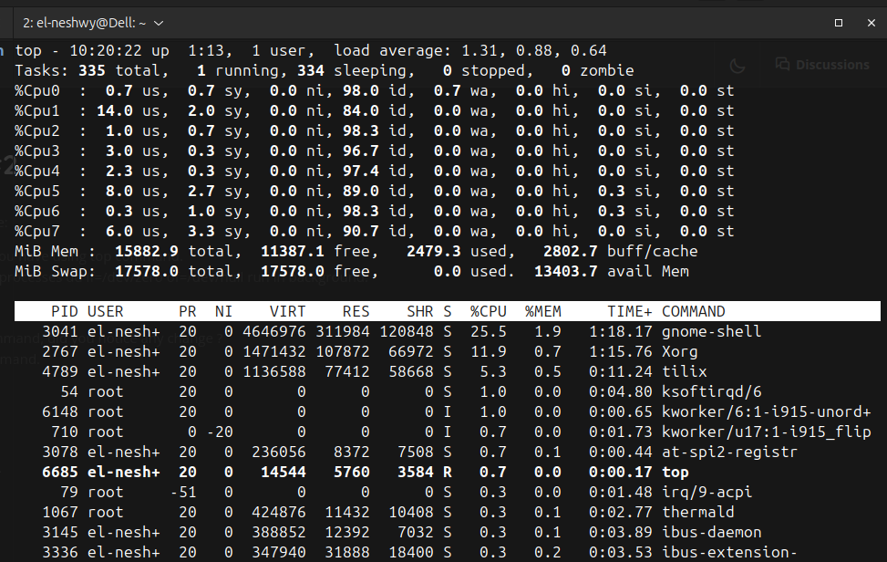
we found that we have 8 cores.
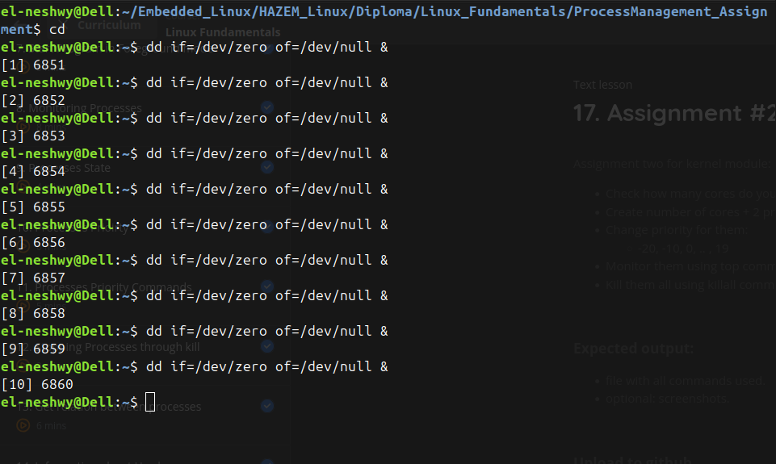
- Create number of cores + 2 processes dd if=/dev/zero of=/dev/null run in background.

We create number_of_cores + 2 processes to simulate a workload. These processes will continuously transfer data between /dev/zero (a null data source) and /dev/null (a null data sink).

- Change priority for them:
Process priorities determine how much CPU time a process gets. A lower nice value (-20) gives higher priority, while a higher nice value (19) gives lower priority.
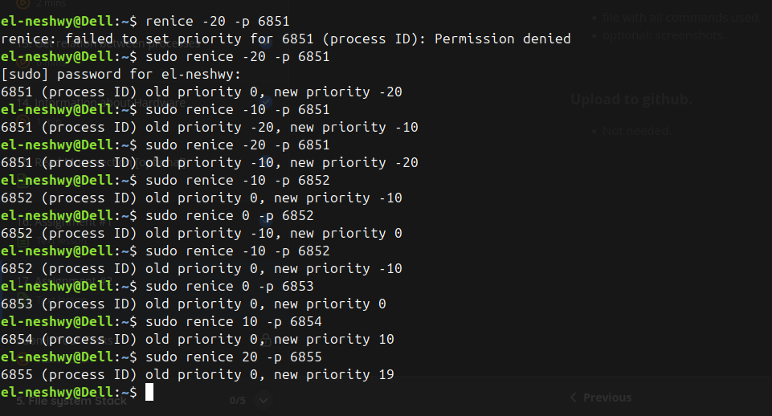
- Monitor them using top command, did you notice any change ?
Observe how the changes in priority affect CPU scheduling and usage.
- Processes with PR = -20 (highest priority) will consume more CPU time.
- Processes with PR = 19 (lowest priority) will consume minimal CPU time.
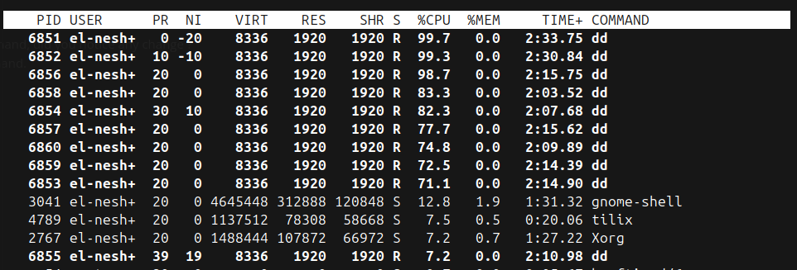
- Kill them all using killall command.
Terminate all the dd processes once observations are complete.
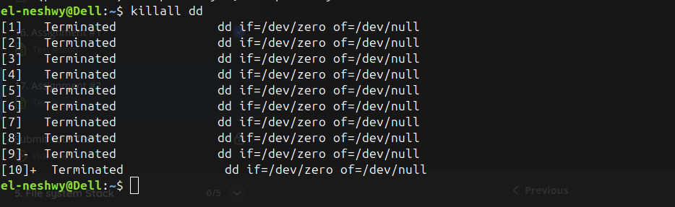

Conclusion
This exercise demonstrated how Linux uses process priorities to manage CPU scheduling. Higher-priority processes (-20) received more CPU time, while lower-priority ones (19) were scheduled less frequently. Adjusting priorities helps optimize system performance, ensuring critical tasks are prioritized without starving others. The experiment provided practical insights into process management and the impact of priorities on system behavior.

