**HKTVmall Scraper – Windows Version 1 User Manual**

1. Add the links that you wish to scrape to the input file “links.csv” as shown below, you can add either single product links or category links.

1. Text

   Description automatically generated Double click on the file “Scrape_HKTVmall_v1.exe” as shown below.
2. Graphical user interface

   Description automatically generatedThe script will automatically trigger a Chrome session and will open the link given as input as shown below
3. A computer screen capture

   Description automatically generated with medium confidence When the above Chrome window closes, and the script window is reporting a scraping   
   completion message as shown below then close the scraper window
4. 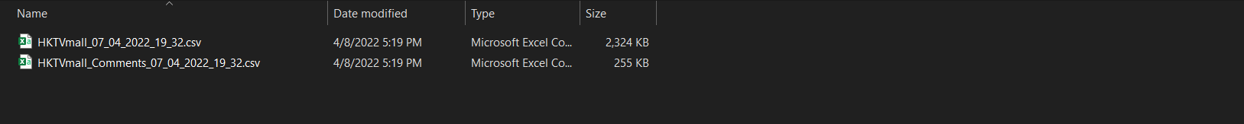 The scraper is saving all the scraped data in a folder named “scraped_data” in the same directory of the scraper and inside this folder the scraper is creating a new sub folder with the timestamp of the scraping session, two csv files for the product info and the other one for the user’s comments will be created for each scraping session as shown below.

Product user’s comments

Product scraped info