IMDB Top 1000 Movies Analysis
Final Report
Introduction
The Internet Movie Database (IMDB) is a renowned online platform that hosts a vast collection of information about movies, TV shows, and entertainment. This dataset includes crucial details such as movie ratings, genres, cast, and reviews, making it an ideal resource for data analysis in the entertainment industry.
Name: IMDB Top 1000 Movies
Project Description
- Problem Statement:
- Analyze the IMDB movie reviews dataset to uncover insights, patterns, and trends in the data by applying data engineering skills.
- Data Cleaning to improve decision making.
- Possible Impact of Your Analysis:
- The analysis can provide insights into how movie trends behave in relation to gross revenue and ratings, offering ideas about the factors that contribute to a movie's financial or critical success.
- Audience Insights: Understanding patterns in audience ratings and critics' scores (Rating and Metascore) can provide insights into the preferences of viewers and critics. This could help production studios and filmmakers align their content with audience expectations.
- Genre Trends: By analyzing genres and their success in terms of ratings and gross revenue, you can identify popular trends and profitable genres. This information could be used by film producers and distributors to target high-demand markets.

- Dataset(s): Data of the top 1000 movies scraped from the IMDB website. Dataset also duplicates a movie in another row if the movie consists of more than one genre. Its has 8 features/variables/fields which are the following:
- Title: Title of Movie
- Director: Director of the movie
- Release year: Year that the movie was released in
- Runtime: Duration of the movie
- Genre: Genre of the movie
- Rating: Audience Rating of the movie
- Metascore: Critics Rating of the movie
- Gross(M): Total grossing of the movie

Source: Kaggle IMDB 1000 Dataset

Business Impact
The entertainment industry faces challenges in identifying the key drivers of a movie's financial and critical success. With limited data-driven insights, production companies, streaming platforms, and marketing teams often make decisions based on intuition rather than evidence. Understanding the factors influencing a movie's success—measured by audience ratings, critics' scores, and gross revenue—is critical to improving decision-making.
Objective:
Leverage the IMDB Top 1000 Movies dataset to:
- Analyze trends and patterns in movie performance across various genres, directors, and release years.
- Identify correlations between audience ratings, critics' metascores, and gross revenue.
- Provide actionable insights to optimize production, marketing, and content strategies for future movies.
Business Impact
Exploring this data could allow production companies and distributors to make better decisions regarding investments in movie projects. It could also enable more accurate predictions of a movie’s potential success through predictive analytics. This can help studios allocate budgets effectively, identify profitable genres or directors, and optimize marketing strategies. Additionally, viewers could benefit from recommendations based on trends in audience ratings, while the industry could better understand market forces that drive fluctuations in movie gross revenue or critical reception.

Dataset(s)
IMDB 1000 top movies

Strengths:
- The dataset contains 1000 movies with 9 comprehensive columns, providing a wealth of information for analysis.
- Includes key features such as audience ratings, critics' scores, and gross revenue, which are essential for understanding movie performance.
- Covers diverse attributes like genre, runtime, and director, allowing for multidimensional insights into the film industry.
Weaknesses:
- The dataset exhibits inconsistent entries, such as duplicated rows for movies with multiple genres, which can complicate straightforward analysis.
- Certain columns may require extensive cleaning or preprocessing to ensure the data is usable for machine learning models or statistical analysis.
- Potential biases due to the focus on top-rated movies, which may not represent trends in lower-rated or less commercially successful films.
Methods
Variables and comparisons
- Title
- Director
- Release_year
- Runtime
- Genre
- Rating
- Metascore,
- Gross

- release_year vs. gross: Correlation = 0.26
This indicates a weak positive correlation, meaning that movies released in more recent years tend to have slightly higher gross revenue.
- runtime vs. gross: Correlation = 0.14
This shows a weak positive correlation, suggesting that movies with longer runtimes may have slightly higher gross revenue, but the relationship is not strong.
- rating vs. gross: Correlation = -0.058
A very weak negative correlation indicates almost no relationship between the movie rating and gross revenue.
- metascore vs. gross: Correlation = 0.18
This is a weak positive correlation, implying that movies with higher metascores may tend to perform slightly better in terms of gross revenue.

- release_year vs. runtime: Correlation = 0.23
This indicates a weak positive correlation, suggesting that movies in recent years tend to have slightly longer runtimes.
- runtime vs. rating: Correlation = 0.22
A weak positive correlation means that movies with longer runtimes may have slightly higher ratings.
- release_year vs. rating: Correlation = -0.13
This weak negative correlation suggests that newer movies may have slightly lower ratings, but the relationship is not strong.
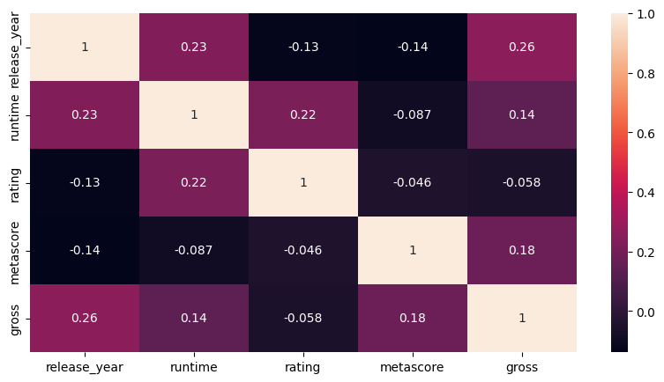

Dashboard

The dashboard will give various metrics, show the overall trends of features, and list the factors involved in the trend.

Milestones
    - Data gathering/acquisition
    - Find additional datasets
    - Identify characteristics of variables
    - Clean data & Feature engineering
    - Create visualizations
    - Show relationships between variables
    - Create dashboard
    - Write final report
Timeline

Week | Tasks
Week 1 | - Explore the initial dataset, and find additional datasets (if needed)  - Identify characteristics of variables
Week 2 | - Clean data  - Feature Engineering  - Envision final product
Week 3 | - Show relationships between variables  - Create visualizations  - Tabulation and Pivot Tables
Week 4 | - Create dashboard  - Write final report

Data
IMDB top 1000 Movies

Data of the top 1000 movies scraped from the IMDB website, which has the following details:
Dataset Details: 1000 rows(samples), with 9 columns(features)
Size: around (159.76 kB)
Access: By searching for any relevant data sources that can be useful in our project
Source: Kaggle IMDB 1000 Dataset

Data Analysis & Computation

Data Profiling
IMDB top 1000 Movies (raw data)
- Understand The Data.
- Assess Missing Data.
- Evaluate Data Types.
- Check for Duplicates.
- And other data understanding techniques…

Data Wrangling
IMDB top 1000 Movies (raw data)
- Remove missing data.
- Validate the data types.
- Handle duplicates.

Data Table Schema:
Field | Type | Description
title | object | The field contains the title of movies
director | object | The field contains the director of the movie
release_year | number | The field contains the year that the movie was released in
runtime | Integer | The field contains the duration of the movie
genre | object | The field contains the genre of the movie
rating | float | The field contains the audience Rating of the movie
meta_score | Integer | The field contains the critics Rating of the movie
gross | float | The field contains the total grossing of the movie

Inconsistent Values Handling:
- Release Year: Strings such as () were removed to clean the feature.
- Runtime: Strings like min were identified and removed for consistency.
- Gross: Unnecessary characters such as $ and M were removed to ensure numerical consistency.
Data Type Adjustments:
- Data types for all features were checked and corrected as necessary to align with their intended purpose (e.g., numeric, categorical, or datetime).
Features Verified as Clean:
- Title, Director, Genre, and Metascore:
These features were found to be free from duplicates or missing values.
- No further cleaning was required, highlighting a good-quality subset of the data.
Outlier Detection and Handling:
- Outliers in the dataset were effectively detected and managed to ensure data reliability.

Project Title
Project Title
Exploratory Data Analysis
Name: IMDB

1. Introduction
The dataset contains information about the top 100 movies on IMDB, with columns such as release_year, runtime, genre, rating, metascore, and gross. The goal of this analysis is to understand the factors that influence a movie's revenue (gross) and uncover trends and patterns in the data.

2. Data Overview
- Columns of Interest: release_year, runtime, genre, rating, metascore, gross.
- Target Variable: gross (revenue of the film).
- Data Types:
  - Textual Features: genre (21 unique genres).
  - Datetime Feature: release_year.
  - Numerical Features: runtime, rating, metascore, gross.
- Null Values: The dataset has no missing values, ensuring a clean and complete analysis.

3. Preliminary Insights
3.1. Distribution of Numerical Columns
- Skewness:
  - release_year and metascore are left-skewed, indicating that most movies in the dataset are recent and have high metascores.
  - runtime, rating, and gross are right-skewed, suggesting that most movies have shorter runtimes, moderate ratings, and lower revenue, with a few outliers on the higher end.
- Basic Statistics:
  - Mean:
    - release_year: 1991.62
    - runtime: 123.58 minutes
    - rating: 7.87
    - metascore: 71.65
    - gross: $3991.90 million
  - Median:
    - release_year: 1999
    - runtime: 120 minutes
    - rating: 7.9
    - metascore: 77
    - gross: $940 million

  - Mode:
    - release_year: 2004
    - runtime: 130 minutes
    - rating: 8.0
    - metascore: 32
    - gross: $0 (indicating some movies have no revenue data).
  - Standard Deviation:
    - gross has the highest variability ($5360.81 million), indicating a wide range of revenue values.

4. Exploring Relationships
4.1. Correlation Analysis
- Correlation with gross:
  - Most numerical variables (release_year, runtime, rating, metascore) show a negative correlation with gross. This suggests that, in this dataset, higher values of these features do not necessarily lead to higher revenue.
  - For example:
    - Newer movies (release_year) tend to have lower revenue.
    - Longer movies (runtime) and higher-rated movies (rating) do not always translate to higher revenue.
4.2. Visualizing Relationships
- Scatterplots:
  - Scatterplots were created to visualize the relationship between gross and other numerical variables.
  - For example:
    - gross vs. runtime: No clear trend, but most high-grossing movies have moderate runtimes.
    - gross vs. rating: Higher-rated movies do not always have higher revenue.
    - gross vs. metascore: Movies with lower metascores sometimes have higher revenue, indicating that critical acclaim does not always correlate with box office success.

5. Subgroup Analysis
5.1. Genre Analysis
- Pivot Table:
  - A pivot table was created to analyze the number of movies and their average gross by genre.
  - Example:
    - Action movies tend to have higher average revenue compared to Comedy or Drama.
- Insight:
  - Genre plays a significant role in determining a movie's revenue, with action movies being the most profitable.

5.2. Release Year Trends
- Insight:
  - Revenue has fluctuated over the years, with some peaks in the late 1990s and early 2000s. This could be due to the release of blockbuster movies during those periods.

6. Key Findings
- Revenue Trends:
  - Revenue (gross) is highly variable, with a few movies earning significantly more than the rest.
  - Newer movies (release_year) tend to have lower revenue, possibly due to changes in the movie industry or audience preferences.
- Genre Impact:
  - Action movies dominate in terms of revenue, while Drama and Comedy movies have lower average revenue.
- Critical vs. Commercial Success:
  - Higher ratings (rating) and metascores (metascore) do not always translate to higher revenue, indicating a disconnect between critical acclaim and box office success.

7. Recommendations
- Focus on Action Movies:
  - Studios should prioritize producing action movies, as they tend to generate higher revenue.
- Balancing Runtime:
  - Movies with moderate runtimes (around 120 minutes) perform well, suggesting that excessively long movies may not appeal to audiences.
- Targeted Marketing:
  - For movies with high ratings or metascores, targeted marketing campaigns could help bridge the gap between critical acclaim and commercial success.

8. Conclusion
This EDA provides valuable insights into the factors influencing movie revenue. While genre and runtime play significant roles, critical acclaim (as measured by rating and metascore) does not always correlate with higher revenue. Further analysis, such as exploring external factors like marketing budgets or audience demographics, could provide additional insights.

Visualizations
To make the story more engaging, include the following visualizations:
- Histograms for numerical columns to show their distributions.
- Scatterplots for gross vs. other numerical variables.
- Pivot Tables for genre and release year analysis.

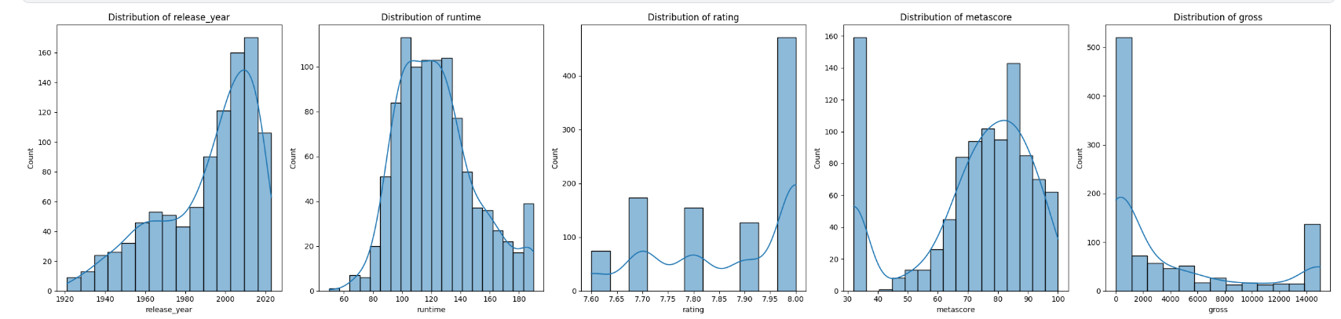

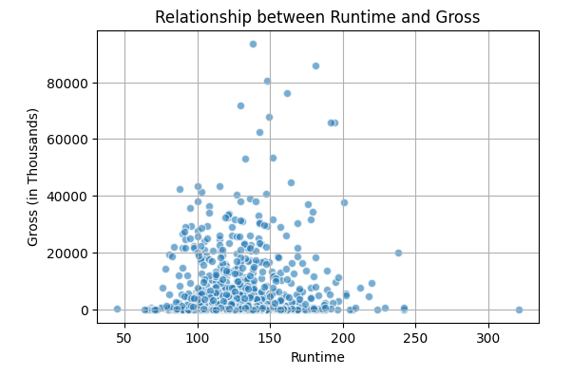
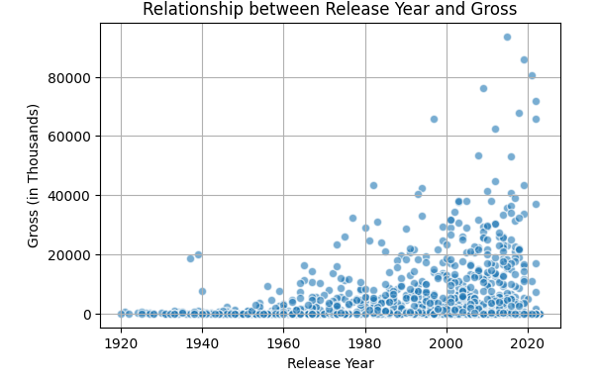

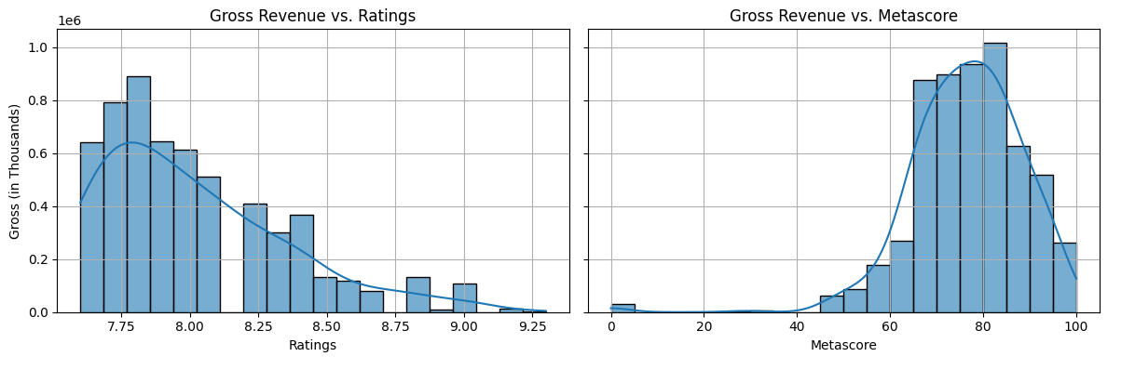
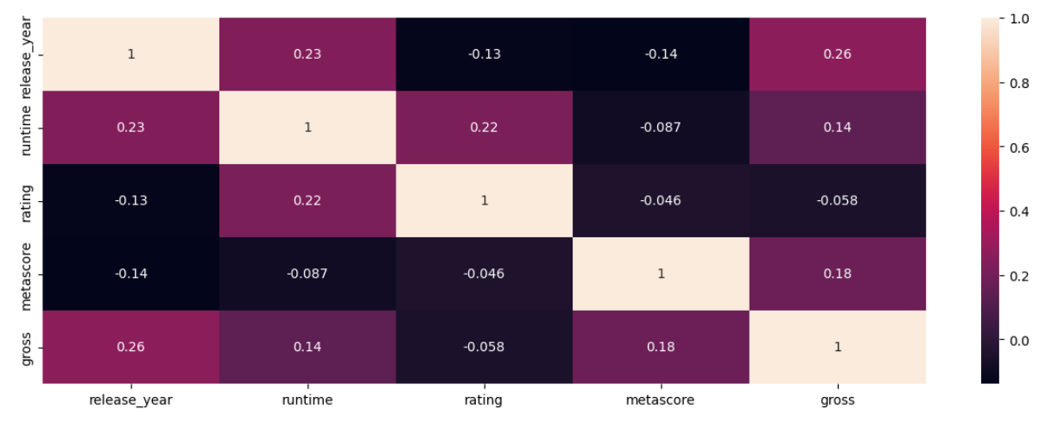

Conclusion & Future Work

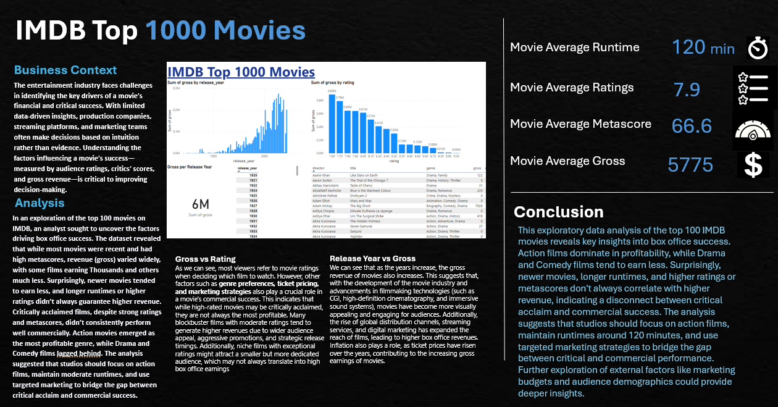
In conclusion, this exploratory data analysis of the top 100 IMDB movies reveals key insights into the factors influencing box office success. Revenue (gross) is highly variable, with action movies dominating in profitability, while Drama and Comedy films tend to earn less. Surprisingly, newer movies, longer runtimes, and higher ratings or metascores do not always correlate with higher revenue, highlighting a disconnect between critical acclaim and commercial success. The analysis suggests that studios should prioritize action films, maintain moderate runtimes (around 120 minutes), and employ targeted marketing strategies to bridge the gap between critical and commercial performance. While these findings provide valuable guidance, further exploration of external factors like marketing budgets, audience demographics, and regional trends could offer deeper insights and help the film industry better navigate the complexities of box office success.

