 

Faculty Of Engineering,

Helwan University.

**Metro Tickets Reservation System**

**Submitted By:**

Omar Zakaria (sec.3)

Omar Alaa El-din (sec.3)

Abdelrahman Mohamed (sec.3)

Table of Contents

1. Preface 1

1.1 Document Purpose 1

1.2 Target Users 1

1.3 Revision History 1

2. Introduction 1

2.1 Purpose 1

2.2 Scope 2

2.3 Overview 2

3. Glossary 3

3.1 Acronyms, Definitions, and Abbreviations 3

4. System Users 3

4.1 System Stakeholders 3

4.2 User Objectives 3

5. User Requirements Definitions 4

5.1 System Functions 4

5.2 Constraints 5

6. System Architecture 5

7. System Functional Requirements 5

8. Interface Requirements 8

8.1 User interface 8

8.2 Software Interface 12

9. Non-Functional Requirements 12

9.1 Availability 12

9.2 Security 13

9.3 Safety 13

10. System Models And Diagrams 13

1) ERD 13

2) DFD 14

3) Use Case Diagram 15

4) Class Diagram 16

5) Sequential Diagram 16

11. System Evolution 17

# Preface

## Document Purpose

The purpose of this document is to provide detailed and complete specification of Metro Tickets Reservation System (MTRS) for Cairo metro lines.

The document will provide an overview of the system in the first section , then each part will be explained in details.

## Target Users

This system is composed by System engineers based on the requirements gathered from metro reservation employees

This documents is intended to be approved by the MRM and the staff working on the developing the system

## 1.3 Revision History

|  |  |  |  |
| --- | --- | --- | --- |
| **Version** | **Author** | **Description** | **Date** |
| **0.1** | Abdelrahman | Initial | 1-11-2021 |
| **0.2** | Omar Alaa | Update structure | 31-12-2021 |
| **0.3** | Omar Zakaria | Update structure | 9-1-2022 |

# Introduction

## 2.1 Purpose

MTRS aims to automate the work of metro reservation system, to help achieve the following:

* Keep track of metro lines
* Keep records of all passengers
* Enables passengers to book tickets quickly
* Has an option to show metro map
* Shows subscriptions information

## 2.2 Scope

MTRS is a software for managing passengers data . It basically automates the work of tickets reservation. It will also show a guidance of subscription. The software will be a part of a bigger system that will manage passenger’s data, passenger’s surveys, suggestions, and complaints.

MTRS is the first block to be implemented in the whole system.

## 2.3 Overview

This document is organized as follows: first, an Overview description of the Metro Tickets Reservation System (MTRS) and its purpose are presented (section 1.1 and 1.2). Section 2 states types of users who can use MTRS. Then a list of general constraints that should be followed, assumptions and dependencies are presented in sections 2.5 and 2.6. Section 2.7 shows future work that should be done.

Section 3 in the document provides a detailed description of the system functions and requirements.

Finally, section 4 presents some helping information and diagrams that will facilitate the understanding of this document.

# Glossary

## 3.1 Acronyms, Definitions, and Abbreviations

* **MTRS:** metro tickets reservation system
* **MRM:** metro reservation manager

# System Users

## 4.1 System Stakeholders

* System Engineer:

- Responsible of data gathering

- Responsible of development

- Responsible of deployment and support

* Metro reservation Administrator :

- The most frequent user

- Add new passenger’s data

- Remove passenger’s data

- Edit passenger’s data

## 4.2 User Objectives

* System Engineer:

- Gain experience in software engineering and development

* Metro reservation Administrator :

- Avoid repeatable work

- Simplification in booking tickets

* Metro reservation Manager:

- Decrease passengers waiting times

- Enforce inspection of employees

- increase passenger satisfaction

- Decrease number of employees in tickets reservation department

- Ensure passengers data security

* Passenger :

- Can easily book tickets

- Decrease waiting time

- Has a detailed overview of metro lines

# User Requirements Definitions

## 5.1 System Functions

1. Data Base Connection

2. Remove records from data base

3. insert records into data base

4. Valid Email

5.Valid Password

6. Registration

7. Check Email

8. Check Password

9. Login

10. Price calculation

11. Check credit card

12. Insert credit card information

13. Order of Stations

14. Number of Stations

15. Colour of tickets

16. View data Base table of registered accounts

## 5.2 Constraints

## Metro policies

- All data should be secured

## Cultural Constraints

- All code must follow team standards

## Hardware Limitations

- No constraints.

# System Architecture

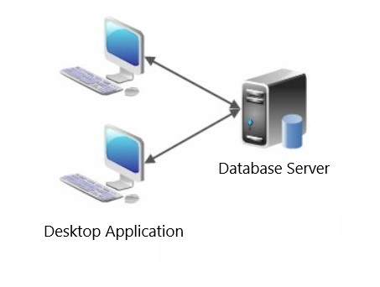

Figure 1 System Architecture

# System Functional Requirements

## 7.1 Data Base Connection : dbConnection ( )

This function is used to connect data base with the code

**7.2 Remove records from data base : remove ( )**

This function takes ID as an input to remove a specific record from data base

**7.3 insert records into data base : insert ( )**

This function takes ID, name, Email, password, job, age as inputs and insert these information into data base, it is also used in Registration function

**7.4 Valid Email : ValidEmail ( )**

This function takes Email as input and used to check validity of email, it is also used in Registration function

**7.5 Valid Password : ValidPassword ( )**

This function takes password as input and used to check validity of password, it is also used in Registration function

**7.6 Registration : Registration ( )**

The user can add a new passenger by adding the following information:

- Main information (Name, Email, Password, Job, Age)

**7.7 Check Email : checkEmail ( )**

This function is used to check if the email is already registered and stored in data base, it is used inside the login function,it takes Email as an input

**7.8 Check Password : checkPassword ( )**

This function is used to check if the password is already registered and stored in data base, it is used inside the login function,it takes password as an input

**7.9 Login : Login ( )**

This function is used to compare the data entered with the stored data in data base an hence decide if the account is already registered, it takes Email, password as inputs

**7.10 Price calculation : priceCalculation ( )**

This function takes the start , end stations as inputs then calculates the price of ticket, it is also used inside color() function

**7.11 Check credit card : Check ( )**

This function takes CVV, number, end Date as inputs, it checks if the inserted data are following the specified rules, it is also used inside insert function.

**7.12 Insert credit card information : Insert ( )**

This function takes CVV, number, end Date as inputs, it inserts the data in the data base

**7.13 Order of Stations : orderOfStations ( )**

This function takes the name of the station and returns the order of it, it is also used inside numberOfStations() function

**7.14 Number of Stations : numberOfStations ( )**

This function takes start, end stations and returns number of stations, it is also used inside color() function

**7.15 Colour of tickets : Color ( )**

This function takes start, end stations and return the color of the ticket depending on the price

**7.16 View data Base table of registered accounts : viewTable ( )**

This function is used to view the records registered in the data base for the admin

# Interface Requirements

## 8.1 User interface

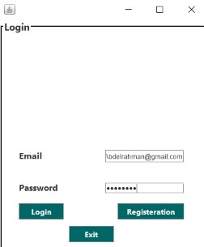

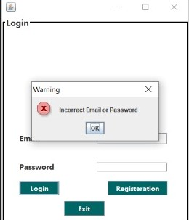

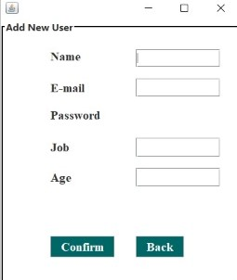

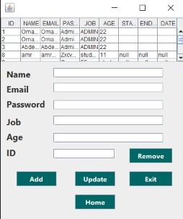

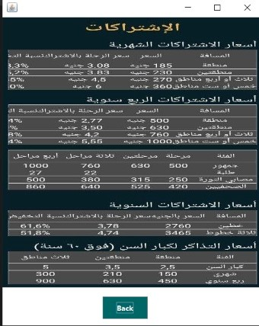

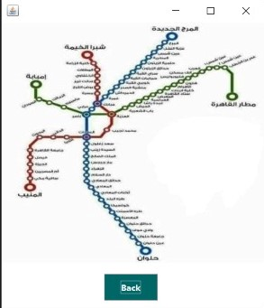

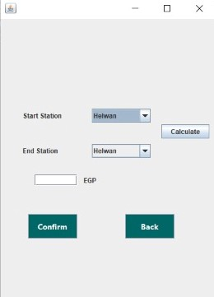

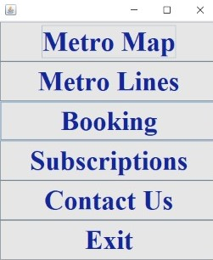

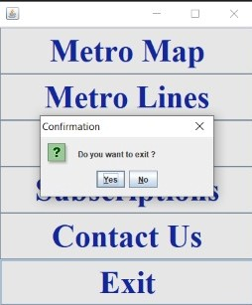

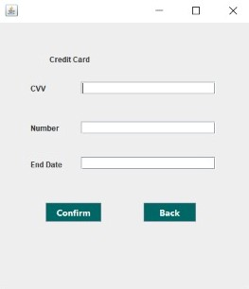

## 8.2 Software Interface

- Database Access will be wrapped through object relation mapping framework (Entity framework)

- Integration points will be handled in future versions

# 9. Non-Functional Requirements

# 9.1 Availability

The system should be available all day.

## 9.2 Security

No one can access the system outside Egypt.

## 9.3 Safety

Servers will be kept in the MRM office

# 10. System Models And Diagrams

## ERD

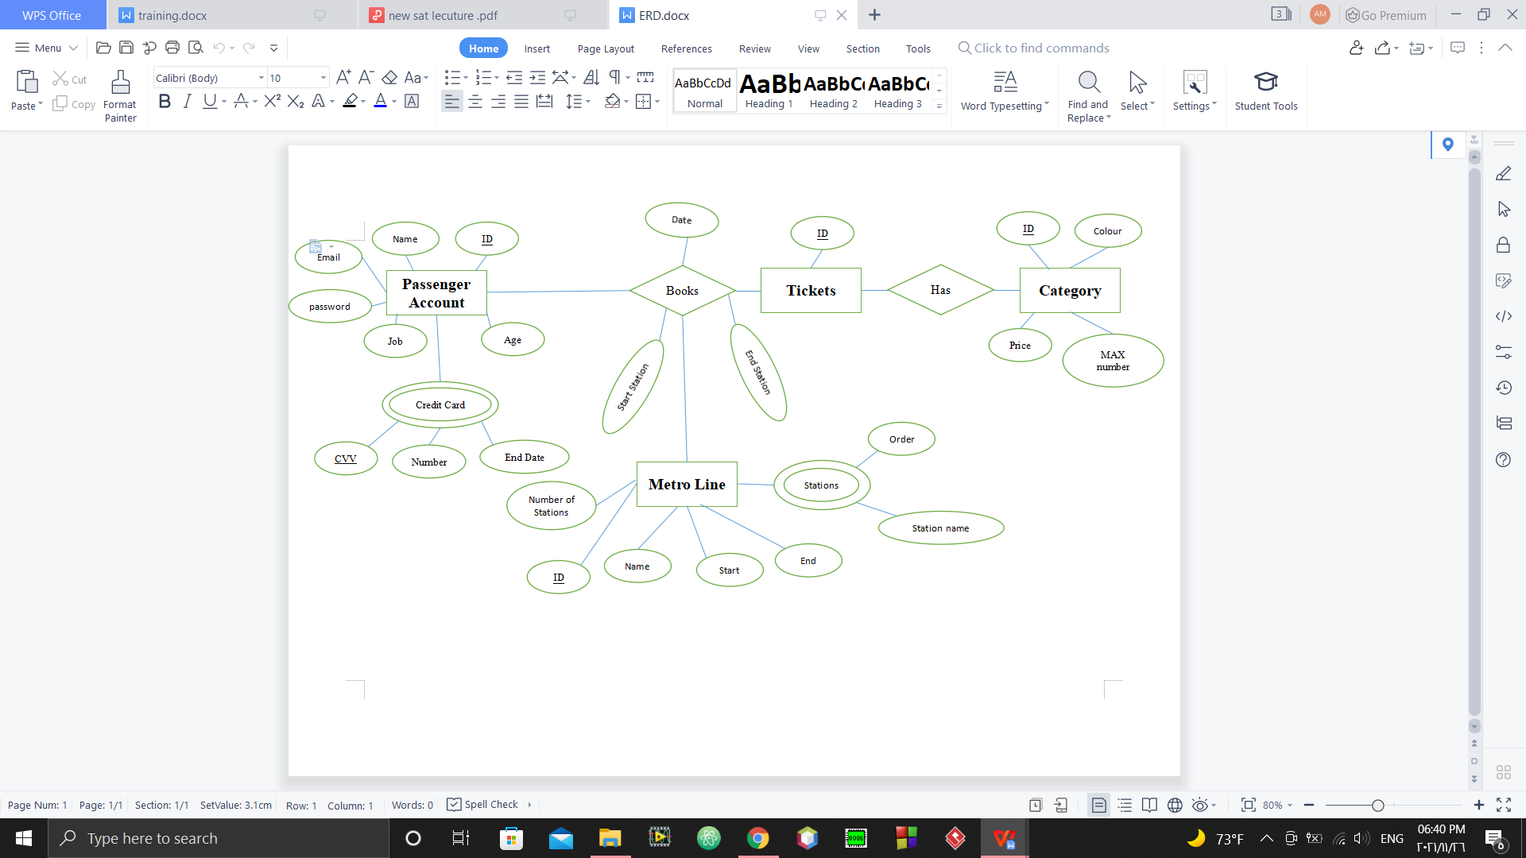

Figure 2 ERD

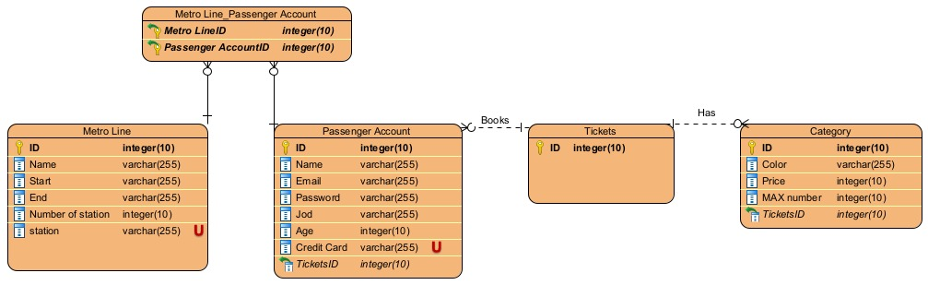

Figure 3 ERD using visual paradigm

## DFD

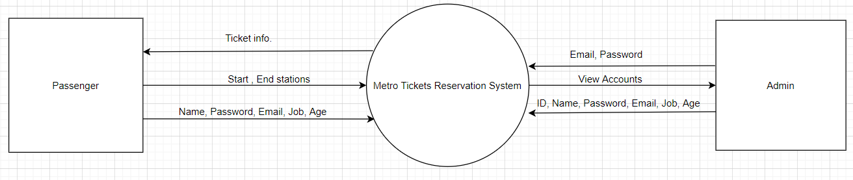

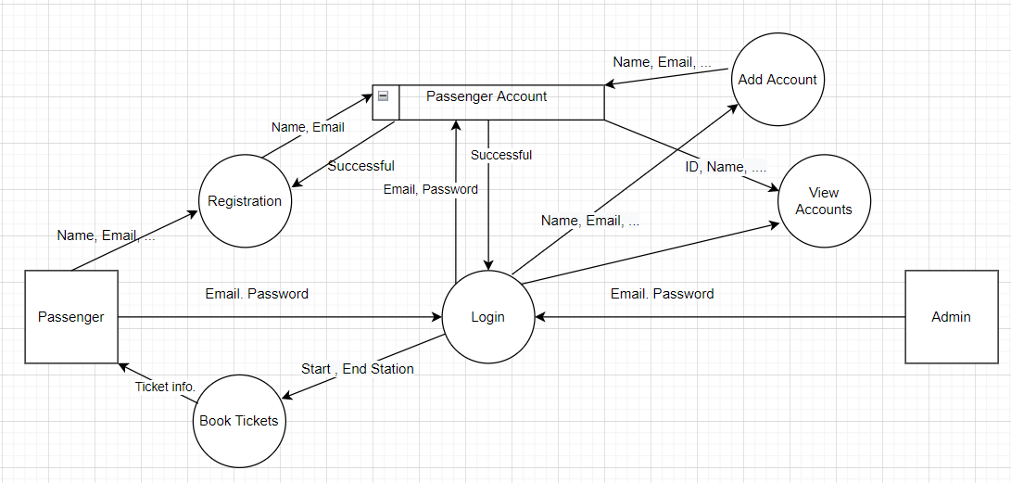

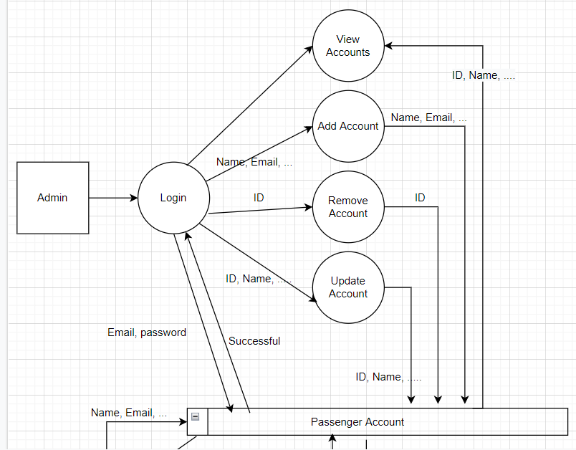

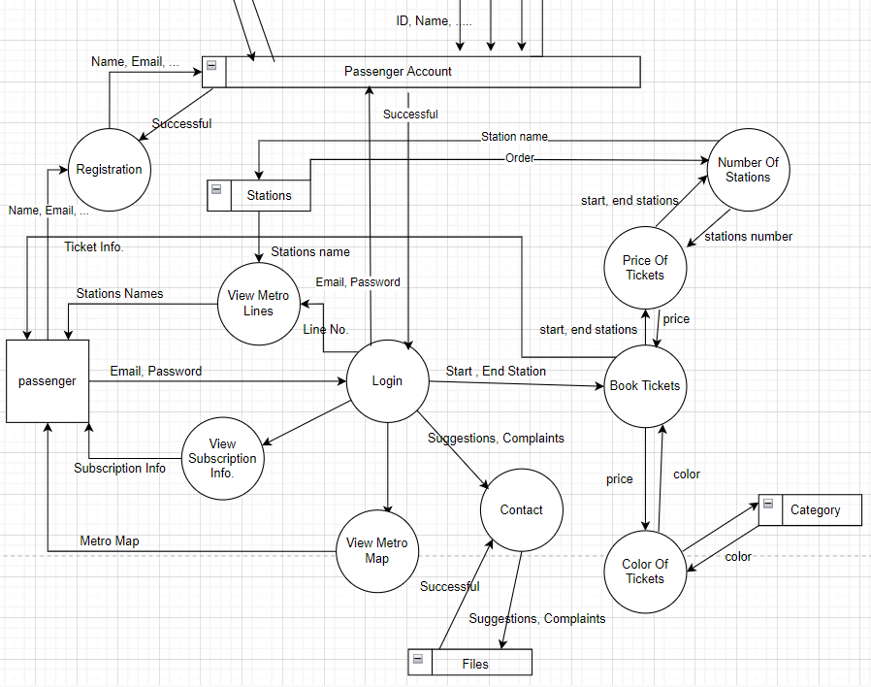

Figure 4 DFD Diagram

## Use Case Diagram

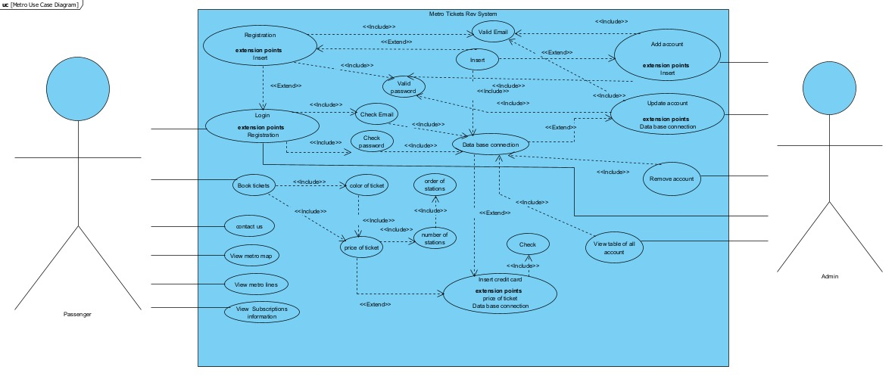

Figure 5 Use Case Diagram

## Class Diagram

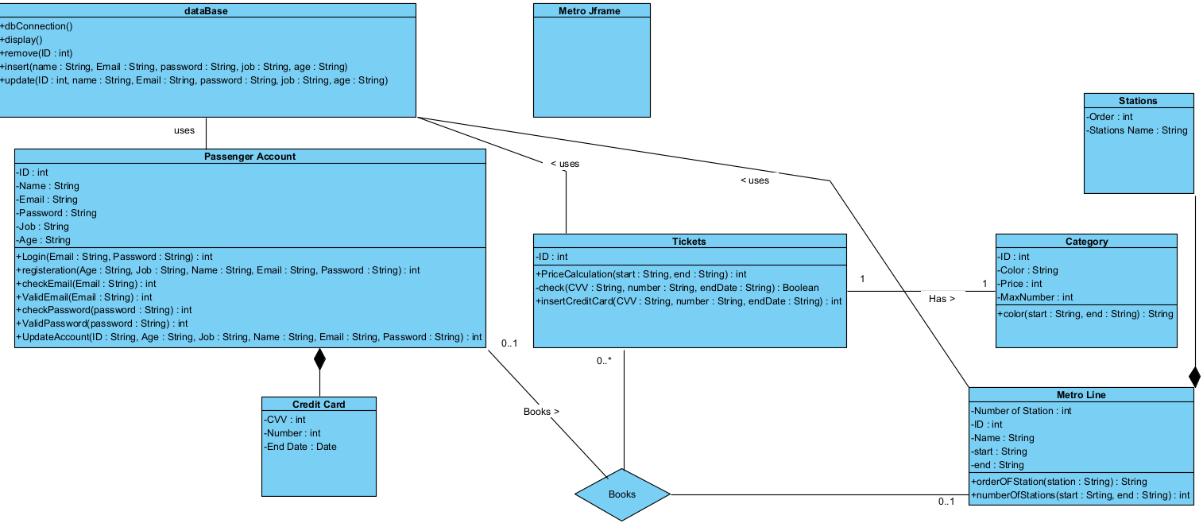

Figure 6 Class Diagram

## Sequential Diagram

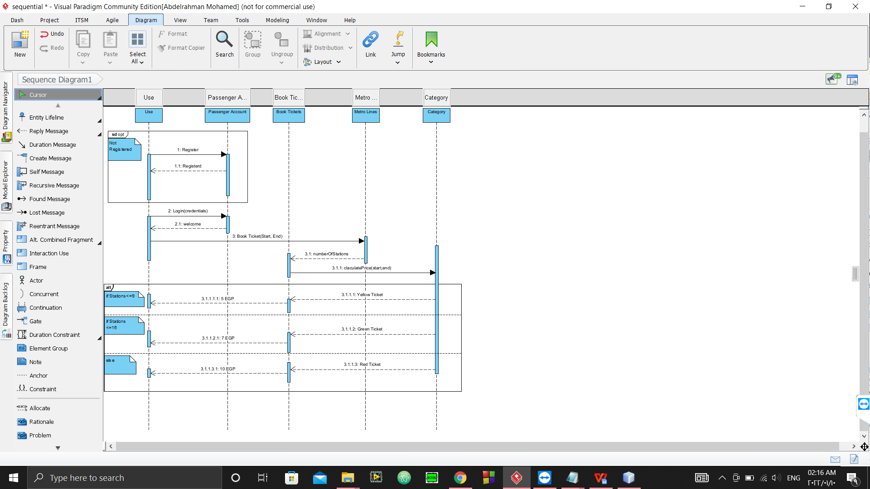

Figure 7 Sequential Diagram

# 11. System Evolution

* The system should be able to work on different operating systems (windows , linux, mac)
* It should work properly on devices with low specifications