Name: Abdelrahman Mohamed Elmahdy Mohamed

E-mail: [abdelrahman195514@feng.bu.edu.eg](mailto:abdelrahman195514@feng.bu.edu.eg)

Sitting number: 458

B.N/ 7

**https://abdelrahman-mohamed-elmahdy.github.io/ECE001/**

**Topic**: Artificial Intelligence

**Examiners committee**

1/ Dr. Ahmed Bayoumi

2/ Dr. Shady Elmashad

3/ Dr. Abdelhamid Attaby

**References:**

1/ Artificial Intelligence A Modern Approach.

2/ AI in early science fiction.

# Application brief: artificial intelligence refers to the simulation of human intelligence in machines that are programmed to think like humans and mimic their actions.

# Screenshots

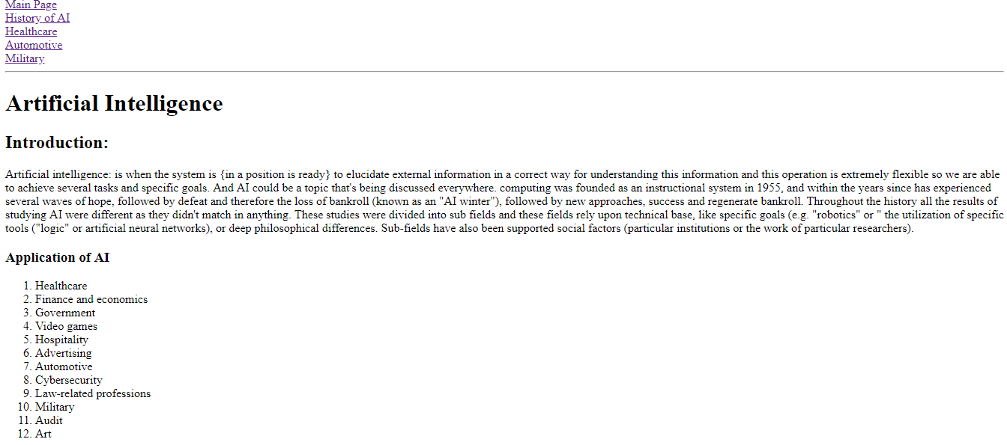

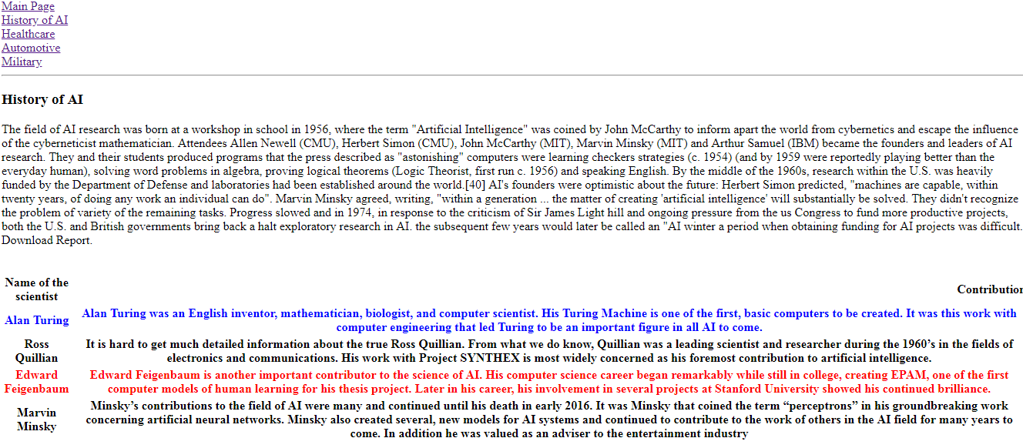

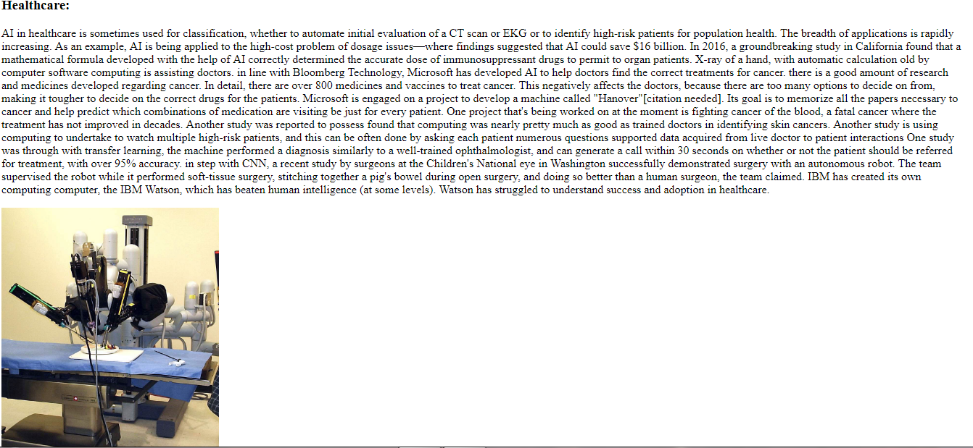

# Source code:

