**Motor Imagery based BCI**

**Team ID : SC_10**

|  |  |
| --- | --- |
| عبدالرحمن على محمد رشاد | 20191700342 |
| عبدالرحمن محمد حنفى محمود | 20191700346 |
| اسلام محمد محمد عبدالحميد | 20191700112 |
| الحسن ابراهيم جاد الرب | 20191700125 |
| احمد خالد محمد محمد | 20191700032 |

**Data preparation and Preprocessing**

Dataset consists of EEG data from 9 subjects. The cue-based BCI paradigm consisted of four different motor imagery tasks, namely the imagination of movement of the left hand (class 1), right hand (class 2), both feet (class 3), and tongue (class 4). Two sessions on different days were recorded for each subject. Each session is comprised of 6 runs separated by short breaks. One run consists of 48 trials (12 for each of the four possible classes), yielding a total of 288 trials per session. 22 EEG channels, 3 EOG channels

We apply 3 techniques for preprocessing the signals:

Band Pass Filter: Bandpass filtering is performed using a sixth order Butterworth bandpass filter with low cut of 8 Hz and high cut of 30 Hz . This choice is because of the fact that motor imagery features generally happen in alpha and beta band of EEG.

Common Average Referencing (CAR) Spatial Filtering: enhances the local activity at electrode i by subtracting the average over all electrodes.

Normalization: Each channel is used its own mean and standard deviation.

Before Preprocessing

After Preprocessing

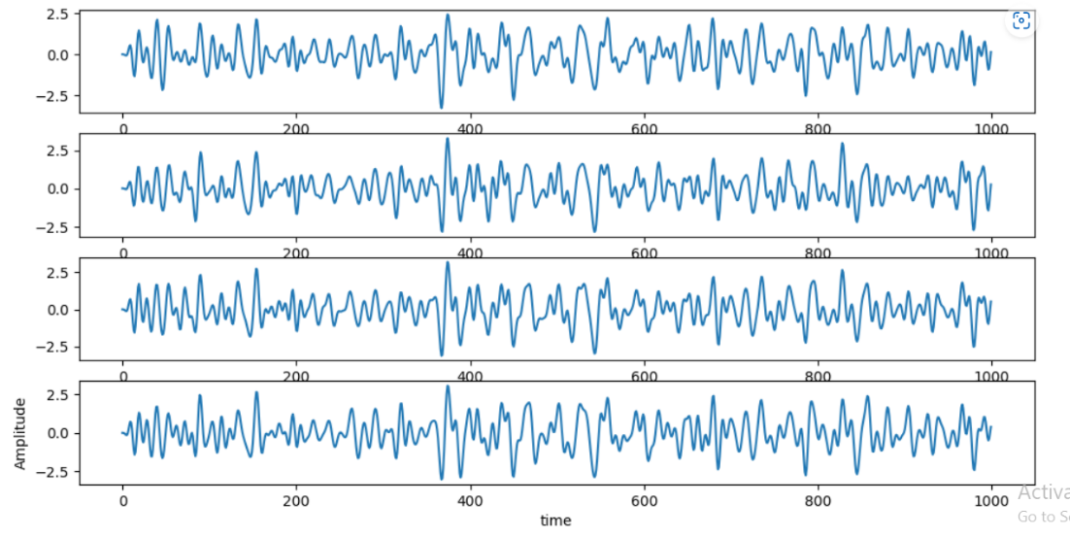

**Feature extraction**

The main idea is to use a linear transform to project the multichannel EEG data into low-dimensional spatial subspace with a projection matrix, of which each row consists of weights for channels.

1. We used Build in CSP from MNE library to extract features
2. We used Wavelet to extract features

**Classifier used and its parameters**

1. Random Forest
2. SVM ((decision_function_shape='ovo'),( kernel='rbf',gamma=0.5,C=0.1), (kernel='poly',degree=3,C=1))
3. KNN (n_neighbors=4)
4. Logistic Regression (multi_class='ovr', solver='liblinear')

**Classification results**

|  |  |  |  |  |
| --- | --- | --- | --- | --- |
| **Feature Extraction / classifier** | **Random Forst** | **SVM** | **KNN** | **Logistic Regression** |
| **CSP** | 85 | 85,81,74 | 76 | 86 |
| **Wavelet** | 58 | 62,25,73 | 49 | 76 |

**s**

